**NetGAN**

**generating graphs via random walks**

**By: Liraz Akiva -308288745**

**Amit Benita - 315949594**

**Sahar Shomer Hay - 39809470**

**Study flow:**

* Individually- reading the article.
* Team work- discussing the purpose and the main idea of the algorithm.
* Team work- time scheduling for each sub themes.
* Individually- online lectures and demonstrations of all sub themes.
* Team work- discussing core issues and difficulties.
* Team work- online lecture of core ideas which implemented in

The algorithm.

* Team work- learning the code: comparing algorithm theory to a python implementation.
* Team work- trying to run the code. We faced difficulties in adjusting a CPU run and not as a GPU run.
* Individually- preparing presentation's slides.
* Team work- a final merge of the presentation.
* Team work- a final discussion on the presentation and on the core ideas.

**Project flow:**

* First init to the random walker- including init for the LSTM gates and cells.
* Defining end condition to the training process: setting Val criteria or EO criteria.
* Generating reference array of real random walks from the input graph.
* Train the model with an input graph. (in each phase another random walk is generated by generator G and is passed to the discriminator D which calculates a final score (probability for it being a real walk from the input graph).
* Calculate final statistics and analysis: ROC curve, accuracy rate, comparing the real graph to the output graph etc.

**Obtained result:**

It can be seen from the table in the article that the netgan model is able to deal with common models in the field of graph modeling and achieves good results, which emphasizes that the model based on random steps is definitely effective.

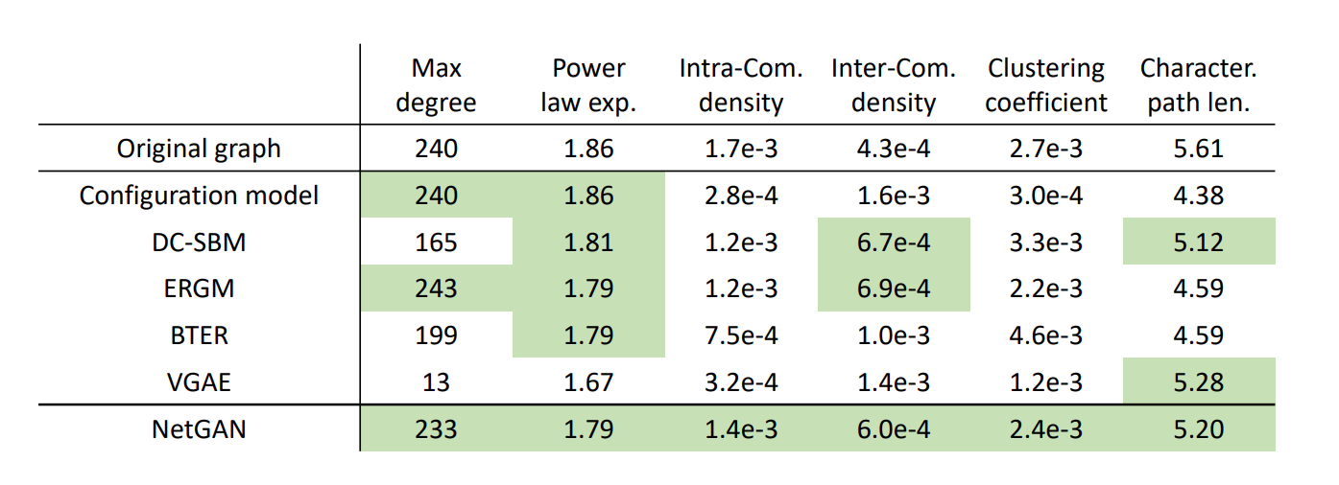

**Final conclusion:**

NetGAN is able to capture a graphs topology and structure without having to specify it or pre-define properties on it.

The model shows strong generalization properties and link prediction as been tested on several datasets.

Therefore, NetGAN is a strong implicit generative model which is suited for real-world networks.