AI-Driven Autonomous Drone Swarms for Disaster Management

Ms.Nidhi¹, Amit Bisht², Aditya Patel³, Mridul Yadav⁴and Utsav Tyagi⁵
¹AssistantProfessor, HMR Institute of Technology and Management, Hamidpur
^{2,3,4,5} Students, HMR Institute of Technology and Management, Hamidpur

¹nidhimalik2345@gmail.com,²amitbisht022003@gmail.com,³adityapatel123go@gmail.com,⁴Mr.yadav2003@gmail.com,⁵utsavtyagi3456@gmail.com

Abstract:
Natural and man-made disasters pose significant threats to human life, infrastructure, and the environment. Traditional disaster response strategies are often slow and resource-intensive. This paper explores the use of autonomous drone swarms as a transformative solution in disaster management. These intelligent aerial systems offer rapid deployment, real-time data collection, and collaborative capabilities in uncertain and hazardous environments. [1] This paper investigates the deployment of an autonomous drone network equipped with AI-driven coordination mechanisms for efficient disaster management. The novelty of this work lies in the design and evaluation of a modular AI-driven swarm coordination framework simulated over diverse disaster environments, integrating edge computing and bio-inspired algorithms to enhance decision-making and mission efficiency. The primary objective is to demonstrate the capabilities of AI-powered drones in disaster scenarios, focusing on tasks such as rapid reconnaissance, resource allocation, obstacle avoidance, and collaborative data sharing. Employing state-of-the-art AI algorithms, the autonomous drone network adapts to dynamic environments, optimizes flight paths, and communicates seamlessly to provide real-time information to emergency responders. [5] These drones are capable of hovering over disaster-stricken areas that may be challenging for rescue teams to access directly, enabling them to pinpoint potential locations where people might be trapped. Drones can cover larger areas in shorter timeframes compared to ground-based rescue efforts or even specially trained search dogs. Unmanned aerial vehicles (UAVs), commonly referred to as drones, are frequently deployed for search-and-rescue missions during disaster situations. [4] Unmanned Aerial Vehicle (UAV) swarms represent a transformative advancement in aerial robotics, leveraging collaborative autonomy to enhance operational capabilities. This paper also provides a comprehensive exploration of UAV swarm infrastructure, recent research advancements, and diverse applications. We examine swarm coordination algorithms, communication protocols, AI and ML integration, system architecture, and real-world applications. Additionally, we discuss the challenges and future directions for implementing drone swarm technology in large-scale disaster response efforts.

Keywords: Autonomous drone swarms, Disaster Management, Artificial Intelligence Algorithms ,Autonomous Drone Network, Unmanned Aerial Vehicles (UAVs), Machine Learning.

INTRODUCTION
In Disasters such as earthquakes, floods, hurricanes, and industrial accidents require timely responses to minimize loss of life and property. [5] Natural disasters represent dire situations that imperil the lives of numerous individuals. In these circumstances, telecommunication networks often suffer damage, impeding the effectiveness of search and rescue operations and necessitating significant time and resources for their restoration. However, accessibility, communication breakdowns, and resource constraints often hinder effective disaster management. Emerging technologies like Unmanned Aerial Vehicles (UAVs)—especially in coordinated swarms—present innovative capabilities for rapid situational awareness, search and rescue, supply delivery, and damage assessment.[2] According to the Directorate General of Civil Aviation (DGCA), an Unmanned Aerial Vehicles (UAVs) is defined as an aircraft that can operate autonomously or can be operated remotely without a pilot on board or can be a combination of both. Essentially, a drone is a flying robot that works in conjunction with onboard sensors and a global positioning system (GPS).
[4] Advancements in Swarm Robotics (SR), particularly within the field of aerial robotics, have introduced transformative capabilities embodied in Unmanned Aerial Vehicle (UAV) swarms. This research paper investigates the role of autonomous drone swarms in disaster scenarios, focusing on their benefits, mechanisms, and deployment strategies. The integration of AI and machine learning further enhances their decision-making and self-organization abilities, making them suitable for dynamic and uncertain environments.
“This paper proposes a modular AI-driven swarm coordination framework, integrating edge computing, bio-inspired algorithms, and decentralized mesh communication, and validates its effectiveness through detailed simulations across multiple disaster scenarios.”

- BACKGROUND
The use of drones in disaster management has gained traction over the past decade. Drones, or unmanned aerial vehicles (UAVs), can be equipped with various sensors and technologies, allowing them to perform tasks such as aerial mapping, surveillance, and delivery of supplies. The integration of swarm technology enhances these capabilities, enabling multiple drones to operate collaboratively, improving efficiency and coverage. [2] India is susceptible to various natural disasters including floods, droughts, cyclones, tsunamis, earthquakes, urban flooding, landslides, avalanches, and forest fires because of its particular geo climatic and socioeconomic conditions. According to the National Disaster Management Authority's (NDMA) Annual Report for 2020– 2021, 58.6% of the Indian landmass is vulnerable to earthquakes of moderate to very high intensity, and 12% of it is at risk of flooding and river erosion. Out of 7,516 km of Indian coastline, 5,700 km long stretch is vulnerable to cyclones and tsunamis. Further, 68% of India’s arable land is drought prone, 15% of the landmass, including hilly regions, are vulnerable to landslides and avalanches. With advancements in technology, modernization in the field of disaster management and control is also needed so as to equip people with better methods to cope with disasters. In this way, technology penetrates the heart of the disaster management as a normative practice so as to offer creative solutions for prevention, mitigation, aid and relief from disasters. Drone technology has advanced significantly in disaster management and is on a scale of progress. Unmanned aerial vehicles (UAVs)/Drones offer exhilarating advantages, such as timely outcomes and precise data collection, which can prove to be beneficial in disaster management.

- LITERATUREREVIEW

3.1 Introduction to Drone Swarms in Disaster Management
The integration of autonomous drone swarms into disaster management represents a convergence of swarm robotics, artificial intelligence (AI), and real-time communication technologies. [3] As disasters become more complex and unpredictable due to climate change and urbanization, the need for responsive, scalable, and intelligent systems has led researchers to explore swarm-based UAV systems. This section provides an in-depth review of the foundational research, technical advances, and evolving applications in this interdisciplinary field.
3.2 Foundations of Swarm Robotics
The concept of swarm intelligence was introduced by Beni and Wang (1989), emphasizing the advantages of decentralized, self-organized robotic systems inspired by biological collectives. In the context of UAVs, swarm robotics involves multiple drones operating collaboratively without centralized control. This decentralized coordination enhances robustness, fault tolerance, and scalability, making it well-suited for unpredictable disaster environments. [5]Although swarm robotics has established foundational principles for decentralized systems, their adaptation to disaster-specific challenges like dynamic obstacle avoidance and energy constraints remains underexplored. Our work addresses these aspects through AI-driven modular swarm architectures.
3.3 Algorithms and Coordination Strategies
Early implementations of swarm behavior in robotics used simplified models such as Reynolds' Boids (1987) for flocking simulations. These laid the groundwork for more sophisticated algorithms: Particle Swarm Optimization (PSO): Enables dynamic pathfinding and area coverage. Ant Colony Optimization (ACO): Facilitates task allocation and resource discovery. Consensus Algorithms: Ensure synchronization among swarm members. Behavior Trees and Finite State Machines: Used in real-time mission planning. Researchers like Ganganath et al. (2021) have applied these algorithms in simulated disaster scenarios, demonstrating enhanced efficiency and resilience. [3] While numerous algorithms like PSO and ACO have been used independently for navigation and task allocation, few studies integrate them into a unified, real-time swarm framework tailored for disaster management. This paper fills this integration gap.
3.4 AI Integration and Edge Intelligence
Modern drone swarms are increasingly autonomous, with onboard AI enabling perception, learning, and adaptation. Techniques such as reinforcement learning, convolutional neural networks (CNNs), and federated learning have allowed drones to: Detect and classify disaster features (e.g., fires, debris, human presence). Adapt formations and paths based on environmental feedback. Process visual and sensory data at the edge to reduce latency. Jiang et al. (2022) showed how CNN-based object detection significantly improves victim identification during search-and-rescue missions.[5] Despite advances in AI-enhanced UAVs, limited research has focused on fully edge-based, decentralized learning and decision-making within swarm deployments. We bridge this gap by implementing edge AI models such as YOLOv4 and Q-learning directly onto UAV nodes.

4. METHODOLOGY
4.1 Flow
This research employs a hybrid methodology that integrates simulation-based experimentation with analysis of real-world UAV swarm deployments. The overarching goal is to design, test, and evaluate a robust framework for autonomous drone swarm operations in disaster management. The methodology comprises four phases: architectural design, algorithm development, simulated testing, and performance evaluation. [3] A modular system architecture is developed, featuring UAV nodes equipped with GPS, thermal and optical cameras, and edge computing units. These UAVs are coordinated by a Swarm Control Unit (SCU) that processes AI-driven decisions and communicates with a Ground Control Station (GCS) and cloud infrastructure for data storage and analytics. A decentralized communication layer based on mesh networks and V2X (vehicle-to-everything) protocols supports real-time synchronization between drones. This design ensures operational flexibility and fault tolerance in unpredictable disaster environments. [5] For swarm coordination, multiple AI and bio-inspired algorithms are deployed. Formation control is managed using Reynolds’ Flocking Model, while task allocation is optimized through Ant Colony Optimization (ACO). Navigation and obstacle avoidance are handled by a hybrid Particle Swarm Optimization (PSO) and D* path planning algorithm. Object detection and scene classification tasks are performed using convolutional neural networks (CNNs) integrated into each UAV. These AI modules enable adaptive decision-making and efficient execution of search, mapping, and victim identification tasks.
The developed framework is tested in a simulation environment using Robot Operating System (ROS), Gazebo, and MATLAB. Disaster scenarios such as earthquakes, floods, and wildfires are simulated over a 2-square-kilometer area, incorporating features like collapsed buildings, fire zones, and human heat signatures. Simulation parameters include swarm sizes ranging from 10 to 50 drones, variable communication latency, and power consumption metrics.
Performance is assessed based on several quantitative metrics: mission completion time, area coverage, detection accuracy, communication reliability, and energy efficiency.[7] These metrics are compared against benchmarks from single-drone deployments and simpler swarm models lacking AI capabilities. The methodology also includes a feasibility review of recent real-world drone swarm deployments to ground the simulation results in practical experience. This includes disaster response operations during the Nepal Earthquake (2015), Australian bushfires (2020), and the Turkey–Syria Earthquake (2023), where UAVs were used for aerial reconnaissance and victim detection. The methodology is divided into four core phases: (1) system architecture design, (2) swarm algorithm development, (3) simulation and testing, and (4) performance evaluation.
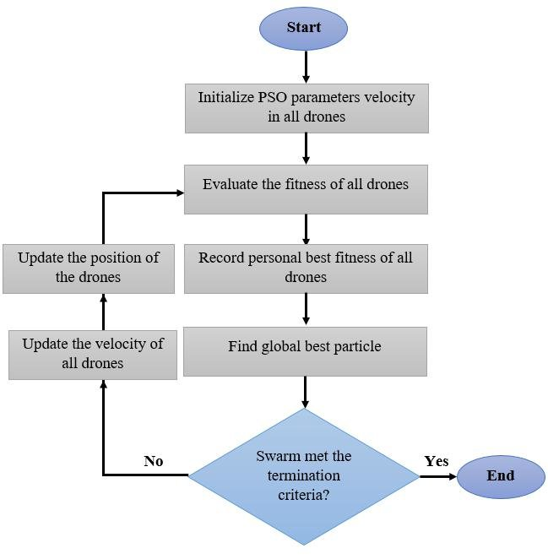
Fig.1.FlowchartofSwarming drones optimization
The developed framework is tested in a simulation environment using Robot Operating System (ROS), Gazebo, and MATLAB. Disaster scenarios such as earthquakes, floods, and wildfires are simulated over a 2-square-kilometer area, incorporating features like collapsed buildings, fire zones, and human heat signatures. Simulation parameters include swarm sizes ranging from 10 to 50 drones, variable communication latency, and power consumption metrics.
AI algorithms include:
• CNN-based object detection using YOLOv4,
• Navigation using PSO-D hybrid algorithm*,
• Task allocation via ACO,
• Decision-making with Q-Learning.
Evaluation metrics include:
• Mission completion time,
• Area coverage (%),
• Accuracy of victim detection,
• Communication reliability (packet loss %),
• Energy efficiency (battery drain rate).
Tools and Environment:
• Programming Language: Python
• AI Libraries: TensorFlow, PyTorch
• Communication: IEEE 802.11s Mesh Network, V2X Protocols
• Sensors: GPS, LIDAR, IMU, Thermal Cameras
• Edge Devices: NVIDIA Jetson Nano

4.2 Technologies Used
To facilitate the successful deployment of autonomous drone swarms in disaster management, a variety of technologies were integrated at different stages of the research and operational processes. Python was employed as the primary programming language due to its extensive support for robotics, AI libraries, and ease of integration with external tools. For swarm coordination, Robot Operating System (ROS) was used to manage the hardware abstraction and control communication between drones, allowing for seamless multi-agent cooperation. The Gazebo simulation environment was paired with ROS to test and visualize swarm behavior under various disaster scenarios.
[12] For the AI-driven decision-making and navigation of drone swarms, Machine Learning (ML) and Deep Learning (DL) algorithms were deployed. Specifically, Reinforcement Learning (RL) techniques were used to enable drones to learn optimal navigation policies through trial and error in dynamic environments. Convolutional Neural Networks (CNNs) were implemented for real-time object detection tasks such as victim identification, structural damage assessment, and hazard mapping. To simulate complex multi-agent coordination, bio-inspired algorithms like Ant Colony Optimization (ACO) and Particle Swarm Optimization (PSO) were applied to task allocation and path planning.
Communication between the drones was powered by Mesh Networking and V2X protocols to ensure that the swarm could operate efficiently even in disaster zones with limited infrastructure.[11] The IEEE 802.11s standard for wireless mesh networking was employed to establish a decentralized communication architecture, ensuring continuous connectivity and synchronization in environments where traditional cellular or Wi-Fi networks may be unavailable.
Drones were equipped with an array of sensors to aid in navigation and disaster response. These included Global Positioning System (GPS) for positioning, LIDAR for mapping, Thermal Cameras for heat detection (e.g., locating victims or fire zones), and Inertial Measurement Units (IMUs) to monitor movement and orientation. The data collected by these sensors were processed in real-time using onboard edge computing units, which reduced latency and the need for constant communication with ground stations. Finally, Cloud Computing infrastructure was used to support data storage, analytics, and real-time mission updates. This cloud-based system allowed for remote monitoring, data analysis, and potential reprogramming of the swarm, providing human operators with full situational awareness and control over drone operations.

4.3 Modules in Use
The In the deployment of autonomous drone swarms for disaster management, several specialized modules are integrated to ensure the drones can perform tasks efficiently and autonomously. One of the core modules is the Swarm Coordination Module, responsible for maintaining synchronized operation across all drones in the swarm. This module uses decentralized control algorithms, such as the Boids Algorithm and Particle Swarm Optimization (PSO), to enable the drones to work cooperatively while avoiding collisions, adjusting to environmental changes, and performing search-and-rescue tasks. The swarm's ability to work autonomously without a centralized control system enhances its resilience and scalability in dynamic disaster scenarios. Another critical module is the Navigation and Path Planning Module, which utilizes Reinforcement Learning (RL) to adapt drone movements based on real-time data from the environment. This module is responsible for determining the most efficient paths for the drones to navigate, avoiding obstacles, and adjusting flight trajectories dynamically as new information is received. Additionally, the Obstacle Detection and Avoidance feature, powered by LIDAR and computer vision, helps ensure that drones can operate safely in complex, unpredictable environments, such as collapsed buildings, floodwaters, or wildfire zones. [6] The Task Allocation and Resource Management Module employs Ant Colony Optimization (ACO) algorithms to distribute tasks efficiently across the swarm. This module ensures that drones are assigned to specific tasks such as mapping, victim detection, or damage assessment based on priority and environmental context.
It allows the swarm to adapt to changes in the situation on the ground, such as when additional drones are needed for a particular area, or when mission parameters change. Sensor Integration and Data Processing is another essential module in disaster management operations. Drones are equipped with a range of sensors, including thermal cameras, GPS units, LIDAR scanners, and IMUs (Inertial Measurement Units). This module processes sensor data in real-time, enabling the drones to perform object detection, locate survivors, and create accurate 3D maps of the disaster zone. The data is then transmitted to a Ground Control Station (GCS) for further analysis or real-time updates. To minimize communication delays and reliance on ground-based stations, Edge Computing is used to process data onboard the drones, making critical decisions without needing continuous communication with the cloud.

Finally, the Communication and Connectivity Module ensures seamless interaction between all drones in the swarm and with the external control systems. Utilizing Mesh Networking and V2X protocols, the module enables drones to communicate even in areas with limited connectivity or network disruptions. This ensures that the swarm remains synchronized and effective in disaster zones, where conventional communication infrastructure might be compromised.

4.4 Algorithms Used
In our research on a variety of specialized algorithms are used to enable autonomous drone swarms to perform complex tasks in disaster scenarios with precision and adaptability. One of the foundational algorithms employed is the Boids Algorithm, which simulates flocking behavior and governs drone movement through three key rules: separation (avoid crowding neighbors), alignment (steer towards the average heading of neighbors), and cohesion (move toward the average position of neighbors). This allows drones to maintain coordinated flight without direct centralized control. For dynamic path planning and navigation in environments with uncertain obstacles, the D* Lite and A* algorithms are widely used. These graph-based search algorithms help drones recalculate optimal paths in real-time when new obstacles are detected. [6] To optimize task distribution among multiple drones, Ant Colony Optimization (ACO) is used, inspired by the pheromone-laying behavior of ants.
This algorithm enables drones to find optimal routes and assign tasks such as search, surveillance, or victim localization efficiently across the swarm. Particle Swarm Optimization (PSO), another bio-inspired algorithm, is applied for formation control and collective decision-making, where drones adjust their trajectories based on the best-known positions of their peers and their own experiences. In terms of autonomous decision-making and adaptive learning, reinforcement learning (RL) algorithms such as Q-Learning and Deep Q-Networks (DQN) are implemented. These algorithms allow individual drones to learn from interactions with the environment by maximizing cumulative rewards, enabling them to navigate through unfamiliar or dynamically changing disaster zones.
For perception and object detection tasks, convolutional neural networks (CNNs) like YOLO (You Only Look Once) and Mobile Net are integrated into the drones’ onboard systems, providing real-time detection of humans, fire zones, and debris. [5] Additionally, consensus algorithms such as the Consensus-Based Bundle Algorithm (CBBA) are employed in certain scenarios to ensure conflict-free task allocation and cooperation between drones in decentralized settings. These algorithms, in combination with situational awareness systems and environmental mapping algorithms like Simultaneous Localization and Mapping (SLAM), provide the intelligence backbone that enables drone swarms to function efficiently in real-world disaster response.

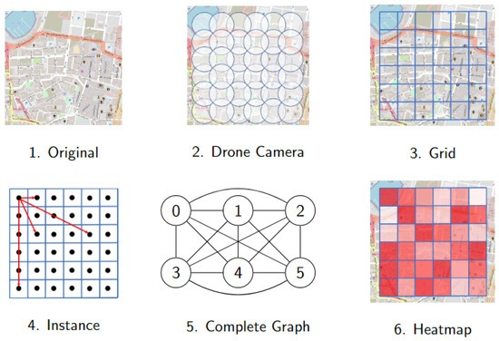

Fig.2.heatmap and transform it into a complete graph.
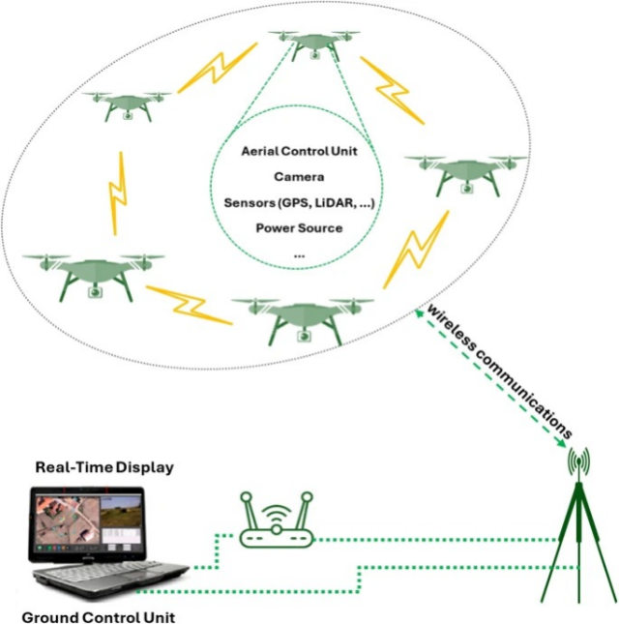

Fig.3. drone swarm communication and control system
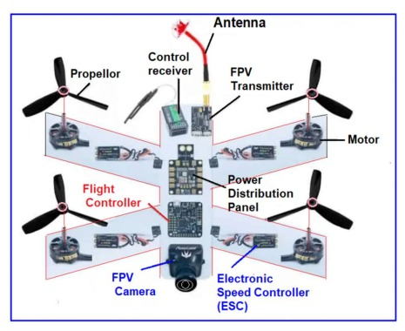

Fig.4. Components of Drone

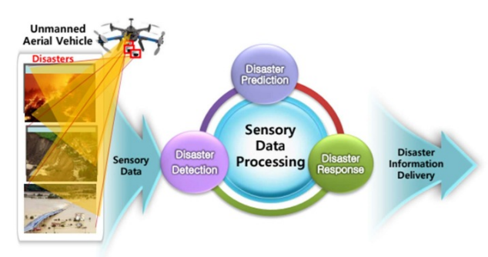

Fig.5. workflow of using Unmanned Aerial Vehicles (UAVs)

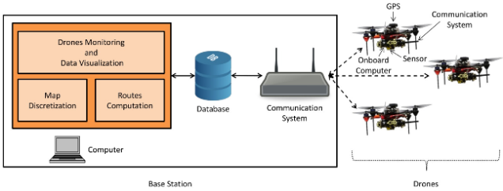

Fig.6. architecture of a drone fleet management system

5. FUTURE
Future of Autonomous Drone Swarms holds a number of promising avenues:
5.1 Scalability and Decentralized Swarm Intelligence: As drone swarms are deployed in larger and more complex disaster environments, ensuring scalable and resilient coordination becomes critical. Developing advanced decentralized swarm algorithms will enable real-time cooperation among hundreds of drones. This approach minimizes dependency on a central controller, enhancing flexibility and responsiveness in dynamic, infrastructure-deficient environments.
5.2 Integration of Edge AI and Onboard Learning: The incorporation of edge computing and onboard AI is expected to revolutionize autonomous operations. Drones equipped with lightweight AI models and processors (such as NVIDIA Jetson or Google Coral) will be able to process data locally, interpret the environment, and make decisions in real-time. Incorporating reinforcement learning and federated learning methods will allow these drones to adapt to novel scenarios while preserving privacy and reducing network bandwidth dependency.
5.3 Robust Communication and Global Connectivity: As disaster areas often lack conventional communication infrastructure, developing robust communication systems is essential. Future drone swarms will utilize
5.4 Mesh networking: 5G/6G communication, satellite uplinks, and Lo Ra protocols to ensure uninterrupted operation. These technologies will support inter-drone communication, cloud integration, and real-time mission updates even in disconnected or remote areas.

6. CONCLUSION
In this study, a world where natural and man-made disasters are becoming increasingly frequent and severe, the need for faster, smarter, and more adaptive response systems has never been greater. Autonomous drone swarms represent a powerful and transformative solution to this challenge. By leveraging technologies such as artificial intelligence, real-time communication, decentralized coordination, and advanced sensing, these drones can carry out tasks that are too dangerous, too vast, or too urgent for humans alone. Throughout this research, we explored how intelligent drone swarms can be used to locate survivors, map devastated areas, assess damage, and support first responders — all with minimal human intervention. The integration of modular systems, edge computing, and swarm-based algorithms makes it possible for these drones to not only act independently, but also collaborate efficiently as a unit, responding in real time to unpredictable and evolving conditions.
Looking forward, the potential for improvement is immense. With future advancements in AI learning models, communication systems, and ethical frameworks, drone swarms will become even more reliable, scalable, and human-aware. Ultimately, the goal is not just to automate disaster response, but to augment human efforts — to make emergency management faster, more effective, and above all, more compassionate interactions.

REFERENCES
[1] Narek Papyan, Michel Kulhandjian, HovannesKulhandjian, and LevonAslanyan,"AI-based Drone Assisted Human Rescue in Disaster Environments: Challenges and Opportunities ,"arXiv:2406.15875v2 [cs.SD] 12 Jul 2024. https://arxiv.org/html/2406.15875v2

[2] Y.Alqudsi YS, Kassem AH, El-Bayoumi GM (2021)” A robust hybrid control for autonomous flying robots in an uncertain and disturbed environment”. INCAS Bull 13(2):187–204, pp. 4567- 4576.
https://www.researchgate.net/publication/352136785_A_Robust_Hybrid_Control_for_Autonomous_Flying_Robots_in_an_Uncertain_and_Disturbed_Environment/fulltext/60bad5eca6fdcc22ead94911/A-Robust-Hybrid-Control-for-Autonomous-Flying-Robots-in-an-Uncertain-and-Disturbed-Environment.pdf

[3].Rejeb, A.; Rejeb, K.; Simske, S.; Treiblmaier, H. “Humanitarian drones: A review and research agenda”. Internet Things 2021, 16, 100434.
https://www.sciencedirect.com/science/article/pii/S2542660521000780

[4].Macrina, G.; Pugliese, L.D.P.; Guerriero,
F.; Laporte, G. “Drone-aided routing: A literature review”. Transp. Res. Part Emerg. Technol. 2020, 120, 102762
https://www.researchgate.net/publication/344235488_Drone-aided_routing_A_literature_review

[5]. Matheus Nohra Haddad, Andréa Cynthia Santos , Christophe Duhamel and Amadeu Almeida Coco “Intelligent Drone Swarms to Search for Victims in Post-Disaster Areas” Sensors 2023, 23(23), 9540

https://doi.org/10.3390/s23239540

[6]. Francis E. Chinda and Abel Williams Gin, “Autonomous Drones Network with AI-Enhanced Coordination for Disaster Management,” International Journal of Applied Research and Technology, 2023, 12(8), pp. 33–37.
https://www.researchgate.net/publication/373632704_Autonomous_Drones_Network_with_AI Enhanced_Coordination_for_Disaster_Management

[7]. Ahmed Alshahrani, Zubair Baig, and Elankovan A. Sundararajan, “A Secure and Scalable Architecture for AI-Driven Autonomous Drones in Disaster Response Scenarios,” Journal of Engineering and Applied Science, 2025, 72(1), Article No. 57.
https://jeas.springeropen.com/articles/10.1186/s44147-025-00582-3

[8]. International Telecommunication Union (ITU), “Autonomous Drones Saving Lives and Powering Disaster Preparedness,” AI for Good, 13 October 2022.
https://aiforgood.itu.int/autonomous-drones-saving-lives-and-powering-disaster-preparedness/

[9].Telecommunication Engineering Centre (TEC), “Study Paper on Use Cases of Drones in Disaster Management,” Department of Telecommunications, Government of India, April 2024.
https://www.tec.gov.in/pdf/Studypaper/study_paper_use_cases_of_drones_issued_copy.pdf

[10].A. Sharma, M. Kumar, and R. Singh, “AI-Enabled Drone Swarms for Enhanced Disaster Response and Management,” Procedia Computer Science, 2023, 218, pp. 123–130.
https://doi.org/10.1016/j.procs.2023.12.016

[11]M. Kumar, A. Sharma, and R. Singh, “Unmanned Aerial Vehicles (UAVs) for Disaster Management,” in Emerging Technologies for Disaster Management, Elsevier, 2023, pp. 123–130. https://doi.org/10.1016/B978-0-323-91166-5.00013-6

[12]S. Kumaran, V. A. Raj, S. J., and V. R. M. Raman, “IoT-based Autonomous Search and Rescue Drone for Precision Firefighting and Disaster Management,” International Journal of Advanced Computer Science and Applications (IJACSA), vol. 14, no. 11, pp. 438–445, 2023. Available: https://thesai.org/Downloads/Volume14No11/Paper_45-IoT_based_Autonomous_Search_and_Rescue_Drone.pdf​The Science and Information Organization

