Pimpri Chinchwad College of Engineering (PCCoE) Department of MCA

Advanced Data Science [MCA33PE17]
FA1 – Problem Solving Activity Topic: Feature Selection

Class / Year | SYMCA (Semester-I)
Academic Year | 2026-2027
Maximum Marks | 20
Assignment Date | 17/08/2026
Date of Submission | 02/09/2026
Student Name | Amit Chame
PRN | 125M1H020

Problem Statement
Real-world datasets often contain a large number of features, and not all of them are equally useful for building a machine learning model. Some features carry duplicate information (they are highly correlated with other features), and some features barely change across records (they have very low variance). Such features add complexity without adding much predictive value. In this FA1, feature selection is performed on a dataset to (1) explain the importance of feature reduction, (2) generate a correlation matrix and drop highly correlated features, (3) apply the variance threshold method to remove low-variance features, and (4) compare model performance before and after feature selection.

Objective
To understand why reducing the number of features is useful; to identify and remove redundant (highly correlated) features; to identify and remove low-variance (almost constant) features; and to train a simple model before and after feature selection in order to compare the results fairly.

Importance of Feature Reduction
Too many features increase complexity – the model takes longer to train and becomes harder to interpret. Redundant features that are highly correlated carry almost the same information twice; keeping both does not add new information, it only adds noise. Low-variance features are nearly constant across all rows, so they do not help the model separate one record from another. Removing such features can make the model simpler, faster, and sometimes more accurate, since it is no longer distracted by noisy or duplicate information.

Dataset Description
The Breast Cancer Wisconsin (Diagnostic) dataset (built into sklearn.datasets) is used for this assignment. It contains 569 records and 30 numeric features computed from digitized images of breast tissue (e.g. radius, texture, perimeter, area, smoothness, etc., along with their mean, error, and worst values). The target column is binary: 0 = malignant, 1 = benign. This dataset is well suited to the FA1 topic because many of its 30 features are naturally correlated (for example, mean radius, mean perimeter, and mean area all describe the size of the same tumor), which allows genuine
correlation-based and variance-based feature reduction to be demonstrated.
Shape: 569 rows × 31 columns (30 features + 1 target). Missing values: 0. Target distribution: 357
benign (1), 212 malignant (0).

Correlation Matrix
Correlation measures how strongly two features move together, on a scale of -1 to +1. A value close to
+1 or -1 means the two features carry almost the same information (they are redundant). The correlation matrix was computed for all 30 original features and visualized using a heatmap.
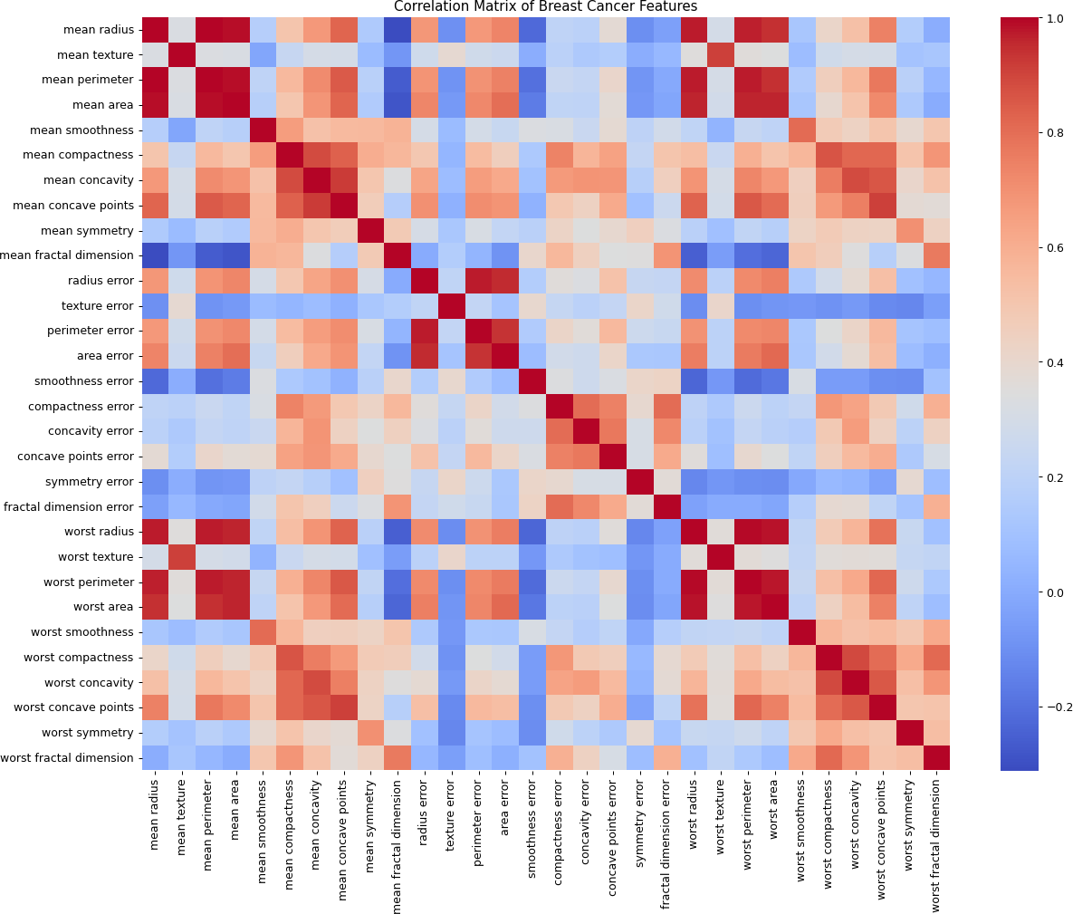
The heatmap shows dark red patches where two features are strongly positively correlated. Features related to the size of the tumor (radius, perimeter, area) form a clear red block, showing they carry very similar information.

Identifying & Removing Highly Correlated Features
A correlation threshold of 0.90 was used. Any pair of features whose correlation (positive or negative) was above this threshold was treated as redundant. 21 feature pairs exceeded this threshold in the actual dataset — most involved radius, perimeter and area (mean, error and worst versions), which makes sense since these measurements describe the same physical property (tumor size) in different ways.
From each correlated pair, one feature was dropped. This removed 9 features (mean area, mean perimeter, mean concave points, worst radius, worst perimeter, worst area, worst texture, perimeter error, area error), reducing the feature count from 30 to 21 without losing any unique information.

Variance Threshold
Variance tells us how spread out the values of a feature are. A feature with very low variance has almost the same value for every record, so it gives the model very little useful information. The VarianceThreshold selector from sklearn.feature_selection was applied to the 21 remaining features with a threshold of 0.001.
This removed 11 more features that had very little variation across patients (mean smoothness, mean symmetry, mean fractal dimension, smoothness error, compactness error, concavity error, concave points error, symmetry error, fractal dimension error, worst smoothness, worst fractal dimension), leaving 10 features: mean radius, mean texture, mean compactness, mean concavity, radius error, texture error, worst compactness, worst concavity, worst concave points, worst symmetry.
Combined with the correlation-based reduction, the feature set went from the original 30 features down to 10 — a reduction of about 67%.

Model Performance Before & After Feature Selection
Logistic Regression was chosen since this is a binary classification problem (malignant vs. benign) and it is the simplest classification model. To keep the comparison fair, the same model, the same random_state = 42, the same 80/20 train-test split, and the same evaluation metric (accuracy) were used both times — the only difference was the feature set.

Model | Number of Features | Accuracy
Before Feature Selection | 30 | 0.9561
After Feature Selection | 10 | 0.9561
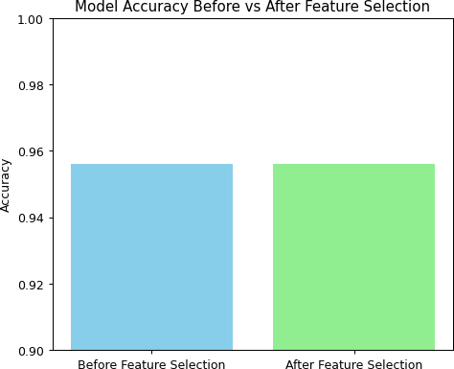

Results and Interpretation
The accuracy of the Logistic Regression model is exactly the same before and after feature selection (0.9561), even though the number of features was reduced by about 67% (from 30 down to 10). This indicates that the 20 features which were removed — either for being highly correlated with another feature, or for having very low variance — were not adding any new predictive information beyond what the remaining 10 features already captured. The model performs equally well with a much simpler, smaller feature set, showing that feature selection successfully reduced complexity without any loss in performance.

Conclusion
In this FA1, feature selection was performed on the Breast Cancer dataset. The importance of reducing the number of features was explained (less redundancy, less noise, simpler models). A correlation matrix was generated and 9 highly correlated features (correlation > 0.90) were dropped, reducing the feature count from 30 to 21. The variance threshold method (threshold = 0.001) was then applied and 11 more low-variance features were dropped, reducing the count from 21 to 10. A Logistic Regression model trained before and after feature selection — using the same train-test split, random state, and evaluation metric — showed that accuracy remained exactly the same (0.9561) with 67% fewer features. This confirms that feature selection can significantly simplify a dataset while preserving model performance, by removing features that are either redundant or carry very little information.

Declaration: I hereby declare that the work submitted in this FA1 assignment is my own and has not been copied from any other source.

