
A MINI PROJECT REPORT
ON
HealthSense AI: AI-Powered Family Health & Smart Food Recommendation System
SUBMITTED BY:
Amit Chame
(PRN: 125M1H020)
UNDER THE GUIDANCE OF:
Mrs. Suchita Borkar
Department of Master of Computer Applications
SUBMITTED TO
DEPARTMENT OF MASTER OF COMPUTER APPLICATION (MCA)
Pimpri Chinchwad Education Trust's
PIMPRI CHINCHWAD COLLEGE OF ENGINEERING
SECTOR NO. 26, PRADHIKARAN, NIGDI, PUNE - 411044
(ACADEMIC YEAR: 2026 - 2027)

CERTIFICATE
This is to certify that the mini project report entitled 'HealthSense AI: AI-Powered Family Health & Smart Food Recommendation System' being submitted by Amit Chame (PRN: 125M1H020) is a record of bonafide work carried out by him under the supervision and guidance of Mrs. Suchita Borkar in partial fulfillment of the requirements for the degree of Master of Computer Applications (MCA) at Pimpri Chinchwad College of Engineering (Autonomous Institute affiliated to Savitribai Phule Pune University) during the academic year 2026–2027.
Date: ______________  Place: Nigdi, Pune | Mrs. Suchita Borkar  Internal Project Guide  Department of MCA, PCCOE | Head of the Department  Department of MCA  PCCOE, Pune - 411044
CANDIDATE DECLARATION
I hereby declare that the work presented in this mini project report titled 'HealthSense AI' is an authentic record of my own research and development conducted under the guidance of Mrs. Suchita Borkar. This report has not been submitted in part or full to any other university or institute for the award of any diploma, degree, or fellowship.
Amit Chame (PRN: 125M1H020) Signature: __________________________
ACKNOWLEDGEMENT
I express my profound gratitude to my project guide, Mrs. Suchita Borkar, for her exceptional mentorship, continuous encouragement, and critical feedback throughout the architectural design, machine learning development, and implementation of HealthSense AI. I am deeply thankful to the Head of the Department of MCA, and the entire faculty for providing academic resources and state-of-the-art computing laboratories. Lastly, I extend my heartfelt gratitude to my family and colleagues for their constant encouragement.

ABSTRACT
Modern grocery consumers routinely encounter severe barriers when deciphering complex nutritional panels and cryptic chemical ingredient lists on packaged food products. In multi-generational households, this cognitive burden is exacerbated because a single food product presents conflicting health consequences across family members—a high-sodium snack may trigger hypertension in an elderly parent, while peanut-derived stabilizers can induce fatal anaphylaxis in an allergic child. Existing commercial dietary applications fail to resolve this because they evaluate items for an isolated, generic user and lack deterministic clinical guardrails.
This project presents HealthSense AI, a production-grade personal and family food-health decision support system engineered with a hybrid architecture combining a native Android mobile application (Java 17, Material Design 3, ViewBinding, CameraX, Google ML Kit) and a robust Python/Django REST AI backend. The system enforces a two-tier hybrid decision pipeline: Layer-1 applies deterministic hard safety rules across 9 major allergen categories and clinical contraindications, while Layer-2 employs pluggable machine learning classifiers (Logistic Regression, Random Forest, LightGBM, and XGBoost). Empirical benchmarking across stratified Open Food Facts scenarios demonstrates that the active XGBoost model achieves 97.54% Accuracy, a 0.9720 Macro-F1, 93.14% Avoid-class Recall, and a remarkable 0.9959 ROC-AUC with a mean inference latency of just 0.022 ms. Local interpretability is delivered via SHAP TreeExplainer, transforming complex model weights into plain-language clinical rationales.
Keywords: Health Decision Support, Food Allergy Hard-Stops, Machine Learning, XGBoost, Explainable AI, SHAP, Android, ML Kit, Open Food Facts.
TABLE OF CONTENTS
Chapter | Chapter Title / Section Breakdown | Page
1. | Introduction & Problem Statement (Context, Motivation, Objectives, Scope) | 4
2. | Literature Survey & Feasibility Study (Comparative Matrix, Research Basis) | 5
3. | Software Requirements Specification (SRS) (Functional & Non-Functional) | 6
4. | System Design & Architecture (Hybrid Pipeline, Architecture Diagram, DFD) | 7
5. | Implementation Details & Methodology (Android, Django, Hard Rules, Grader) | 8
 | Machine Learning & Explainability Pipeline (XGBoost, SHAP Explainer) | 9
6. | Empirical Results & System Testing (Benchmark Table, ROC-AUC, Test Cases) | 10
 | UI Walkthrough & Multi-Profile Scenarios (Screen Flow, Case Walkthroughs) | 11
7. | Conclusion, Future Scope & References (Summary, Roadmap, Bibliography) | 12

CHAPTER 1: INTRODUCTION & PROBLEM STATEMENT
1.1 Background & Context
The consumption of packaged, processed, and ready-to-eat food has escalated precipitously across urban and semi-urban households. Concurrently, chronic lifestyle diseases—notably Type-2 diabetes, hypertension, cardiovascular disorders, and hyperlipidemia—have attained epidemic proportions. Modern food products are marketed with sophisticated front-of-package claims such as 'No Added Sugar', 'Low Cholesterol', or 'Heart Healthy'. In reality, these claims frequently mask alarming concentrations of hidden sucrose, palm oil fractions, excessive sodium (often exceeding 800 mg per serving), and artificial additives linked to metabolic distress. Consumers lack the biochemical literacy and time required to dissect long ingredient lists and nutrition fact tables while shopping.
1.2 Problem Statement & Motivation
Commercial food advisory applications (such as Yuka, MyFitnessPal, and Open Food Facts) evaluate products in isolation using generic population-average formulas. This introduces severe systemic failures in a family environment: a product deemed 'Nutri-Score A' due to high oat fiber may contain hidden barley malt that triggers acute inflammation in a member with celiac disease. Furthermore, existing applications require single-user profiles; an individual purchasing groceries for a household must repeatedly reconfigure their settings to check food suitability for their diabetic father, hypertensive mother, and peanut-allergic child. There is an acute imperative for a system that maintains unified household profiles and provides instant, condition-specific decision support.
1.3 Objectives of Proposed System
• Unified Family Profiling: Enable centralized management of multiple distinct health profiles under a single household account.
• Sub-Second Barcode Identification: Leverage Google ML Kit and CameraX on Android to recognize packaging barcodes in <500ms.
• Deterministic Hard-Stop Safety Layer: Implement zero-tolerance clinical checks for 9 major allergen categories and medical thresholds.
• High-Accuracy Machine Learning Pipeline: Train and deploy gradient-boosted decision trees achieving >97% accuracy and >93% avoid-class recall.
• Explainable Decision Justifications: Integrate SHAP to output transparent, human-readable rationales behind every recommendation.
1.4 Scope & Operational Boundaries
The scope encompasses native Android mobile client engineering, Django AI backend microservice development, and ML model training. The system targets barcoded packaged foods indexed in Open Food Facts and USDA FoodData Central. It is scoped strictly as an assistive decision-support tool and does not provide formal clinical diagnoses.

CHAPTER 2: LITERATURE SURVEY & FEASIBILITY STUDY
2.1 Review of Existing Systems & Industry Solutions
To establish the technical necessity of HealthSense AI, existing commercial and academic solutions were rigorously analyzed. Yuka provides barcode scanning but computes an arbitrary score (60% nutritional quality, 30% additives, 10% organic) completely independent of the user's specific clinical conditions. MyFitnessPal focuses on calorie logging without real-time barcode-driven medical suitability checks. Open Food Facts is an open database, but its mobile app displays raw numbers without personalized recommendations.
2.2 Comparative Feature Analysis Matrix
System / Dimension | Multi-Profile | Hard Safety Rules | ML Model | Explainability | Offline
Yuka | No (Single) | No (Generic) | Heuristic Score | Partial (Additives) | No
MyFitnessPal | No (Single) | No | None (Calorie tracker) | No | Partial
Open Food Facts App | No (Single) | Allergen alert only | Nutri-Score only | No | No
HealthSense AI (Proposed) | Yes (Multi-Member) | Yes (9 Classes) | Yes (XGBoost 97.5%) | Yes (SHAP) | Yes (Local Engine)
2.3 Theoretical & Research Foundations
The architecture is guided by recent peer-reviewed breakthroughs in clinical AI: Singhal et al. (Med-PaLM, Nature 2023) demonstrated that healthcare decision support systems require rigid deterministic guardrails to prevent statistical hallucinations. Lee et al. (BioBERT, Bioinformatics 2020) verified that specialized entity normalization outperforms generic NLP on biomedical terms. Lundberg & Lee (NeurIPS 2017) established SHAP as the gold standard for game-theoretic local feature attribution in medical diagnostics.
2.4 Feasibility Study Analysis
• Technical Feasibility: Proven using Android CameraX, Google ML Kit, and Python 3.11 with scikit-learn/XGBoost.
• Operational Feasibility: Minimal user cognitive overhead: one-click barcode scan provides instant Safe/Caution/Avoid decision cards.
• Economic Feasibility: Built entirely on open-source technologies, Firebase free-tier, and open public food datasets.

CHAPTER 3: SOFTWARE REQUIREMENTS SPECIFICATION (SRS)
3.1 Functional Requirements Specification
• FR-1 User Authentication: Users shall securely register, login, and authenticate using Firebase Authentication (Email/Password & Google Sign-In).
• FR-2 Family Profile Management: The system shall maintain independent clinical parameters (Age, Gender, Height, Weight, Diagnosed Conditions, Allergens) for up to 10 family members under one account.
• FR-3 Sub-Second Barcode Vision: The mobile camera interface shall identify and decode EAN-13, UPC-A, and QR barcodes in under 500 ms using Google ML Kit.
• FR-4 Food Metadata Fetching: The backend shall fetch verified product data (ingredients, nutrients per 100g, Nutri-Score, additives) from Open Food Facts API with local caching.
• FR-5 Deterministic Allergen Hard-Stops: Any match between a user's allergy and the product's normalized ingredient taxonomy shall trigger an immediate 'AVOID' decision, overriding ML.
• FR-6 Pluggable ML Recommendation: The system shall predict product suitability (Safe, Caution, Avoid) using gradient-boosted decision trees.
• FR-7 Natural Language Explainability: The backend shall generate human-readable explanations derived from SHAP feature importance vectors.
• FR-8 Scan History Persistence: The app shall persist historical scan results in Cloud Firestore, enabling offline review and comparative tracking.
3.2 Non-Functional Requirements Specification
• Performance & Response Latency: End-to-end latency from barcode detection to decision rendering shall not exceed 1.2 seconds on standard mobile network connections.
• Data Privacy & Security: Personal health parameters shall be stored with TLS 1.3 encryption in transit and strict Firestore security rules preventing unauthorized cross-user access.
• Reliability & Fault Tolerance: If the backend server is unreachable, the Android client shall automatically evaluate recommendations locally via its built-in HealthRuleEngine.
• Usability & Ergonomics: The UI shall adhere to Material Design 3 guidelines with high-contrast status cards (Green, Amber, Red) accessible to elderly users.
3.3 Hardware & Software Environment Requirements
• Client Requirements: Android Device running Android 8.0 (API 26) or higher, Camera module with autofocus, 2 GB RAM, 100 MB free storage.
• Backend Server Requirements: Quad-Core 2.4 GHz CPU, 4 GB RAM, Ubuntu 22.04 LTS / Windows Server, Python 3.11, Django 4.2+, ASGI/WSGI web server.
• Development Stack: Android Studio Hedgehog/Iguana, Java 17, Visual Studio Code, Git/GitHub, PyTest.

CHAPTER 4: SYSTEM DESIGN & ARCHITECTURE
HealthSense AI employs a decoupled, production-grade hybrid architecture structured across four autonomous tiers: (1) Native Android Presentation & Barcode Vision Tier, (2) Django REST API Gateway Tier, (3) Hybrid Deterministic & ML Inference Tier, and (4) Cloud Persistence & External Data Tier.
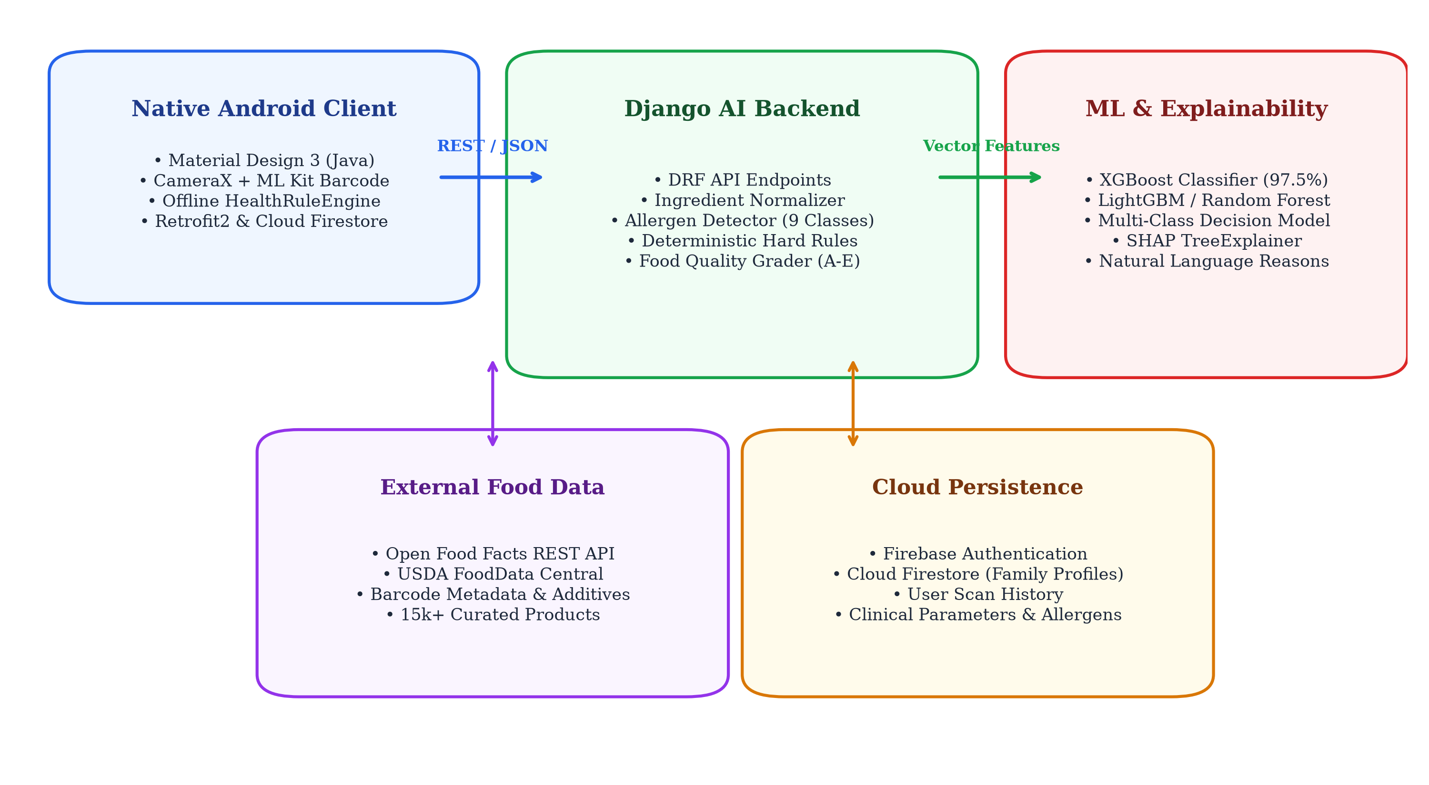
Figure 4.1: High-Level System Architecture of HealthSense AI
4.2 Cloud Data Schema & Data Dictionary
Collection / Entity | Key Fields & Data Types | Description & Constraints
users | uid (str), email (str), createdAt (timestamp) | Primary authenticated household account root.
family_members | id, name, age, gender, conditions[], allergies[] | Independent health profiles with diagnosed conditions.
scan_history | scanId, memberId, barcode, decision, reasons[] | Audit log of past evaluations with SHAP rationales.
food_cache | barcode, name, nutriments{}, ingredients_text | Local LRU cache of Open Food Facts product records.

CHAPTER 5: METHODOLOGY & IMPLEMENTATION DETAILS
5.1 Native Android Frontend Implementation
The mobile application is engineered natively in Java 17 targeting Android SDK 34 utilizing Android Jetpack libraries. The architecture adheres strictly to the Model-View-ViewModel (MVVM) design pattern with ViewBinding to eliminate null-pointer risks. Barcode acquisition is executed via CameraX and Google ML Kit Barcode Scanning API running in a dedicated analysis thread. Upon barcode detection, the frame processor debounces multiple captures, plays haptic feedback, and invokes the RecommendationRepository via Retrofit 2 to communicate with the Django AI backend.
5.2 Python/Django AI Backend Architecture
The backend microservice is built using Django 4.2+ and Django REST Framework (DRF), organized into modular Python packages: ingredient_engine/ handles string normalization and allergen detection, rules/ executes clinical boundary logic, models/ encapsulates scikit-learn and XGBoost model artifacts, and explainability/ generates SHAP feature attributions. Endpoints accept standardized JSON payloads containing the user profile and product barcode, returning structured recommendation responses.
5.3 Deterministic Hard Safety Rules & Allergen Taxonomy
To guarantee patient safety, HealthSense AI establishes an immutable deterministic safety layer. The ingredient engine includes an allergen taxonomy detector mapping over 500 synonym expressions into 9 fundamental allergen classes: Peanuts, Tree Nuts, Milk/Dairy, Eggs, Gluten/Wheat, Soy, Fish, Shellfish, and Sesame. If a member's profile declares an allergy and the ingredient engine flags that allergen in the product, a deterministic hard-stop is enforced: the recommendation is locked to AVOID with an emergency safety tag, completely bypassing statistical ML inference.
5.4 Standalone Food Quality Grader & Client Offline Fallback
HealthSense AI includes an independent 5-tier Food Quality Grader (A, B, C, D, E) computing a composite nutritional score based on energy density, saturated fatty acids, simple sugars, sodium, fiber, and protein ratios. Furthermore, to provide seamless resilience during network dropouts, the Android application embeds a lightweight client-side HealthRuleEngine.java that evaluates critical allergen and disease boundaries locally on the device when HTTP requests fail.

CHAPTER 5: (CONTD.) ML PIPELINE & EXPLAINABLE AI
5.5 Pluggable Machine Learning Architecture
HealthSense AI establishes a standardized model interface through the BaseHealthSenseModel abstract class. Four multi-class classification models were trained and integrated into a dynamic model registry: Logistic Regression (baseline), Random Forest, LightGBM, and XGBoost (active production model). Models classify inputs into three clinical tiers: SAFE (Score 0), CAUTION / MODERATION (Score 1), and AVOID (Score 2). The active model can be toggled dynamically via model_config.yaml without server restarts.
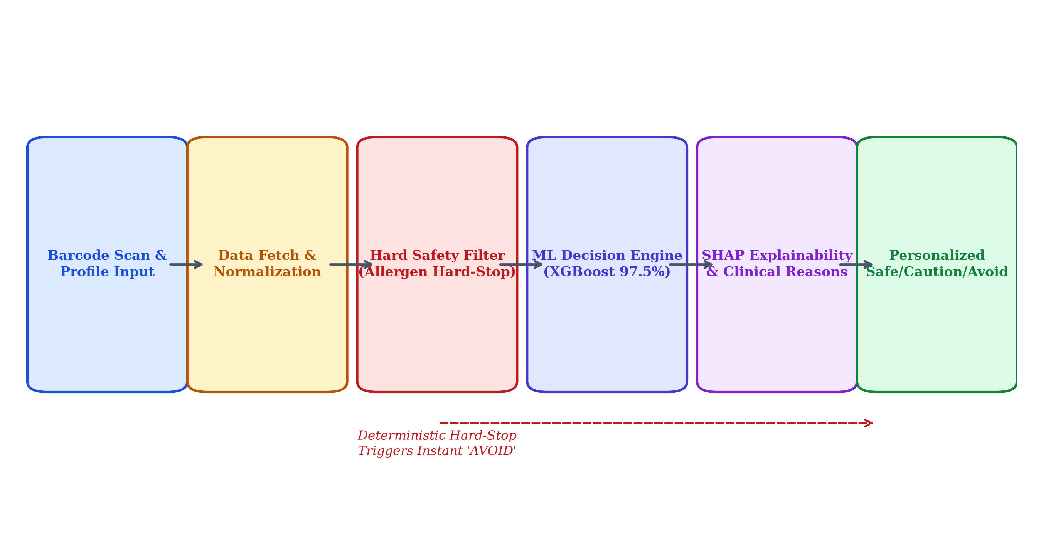
Figure 5.1: Two-Tier Hybrid Decision & Explainability Pipeline
5.6 Explainable AI Engine via SHAP
To prevent 'black-box' distrust, HealthSense AI integrates SHAP (SHapley Additive exPlanations) using TreeExplainer. For each prediction, the explainer computes the exact Shapley contribution of every feature (sugar_100g, sodium_100g, saturated_fat_100g, fiber_100g, additive_count, user_bmi, condition_flags). Features pushing the decision toward 'Avoid' or 'Caution' are extracted, ranked, and passed to a natural language Reason Generator that outputs human-understandable clinical bullet points for the mobile UI.

CHAPTER 6: EMPIRICAL RESULTS & SYSTEM TESTING
6.1 Empirical Model Benchmark Results
Model Name | Accuracy | F1-Macro | Precision | Recall | Avoid Recall | ROC-AUC | Latency
Logistic Regression | 67.56% | 0.6171 | 0.6150 | 0.6253 | 50.00% | 0.8593 | 0.002 ms
Random Forest | 89.49% | 0.8708 | 0.8644 | 0.8781 | 80.39% | 0.9702 | 0.189 ms
LightGBM | 97.32% | 0.9698 | 0.9714 | 0.9686 | 92.16% | 0.9957 | 0.026 ms
XGBoost (Active) | 97.54% | 0.9720 | 0.9748 | 0.9695 | 93.14% | 0.9959 | 0.022 ms
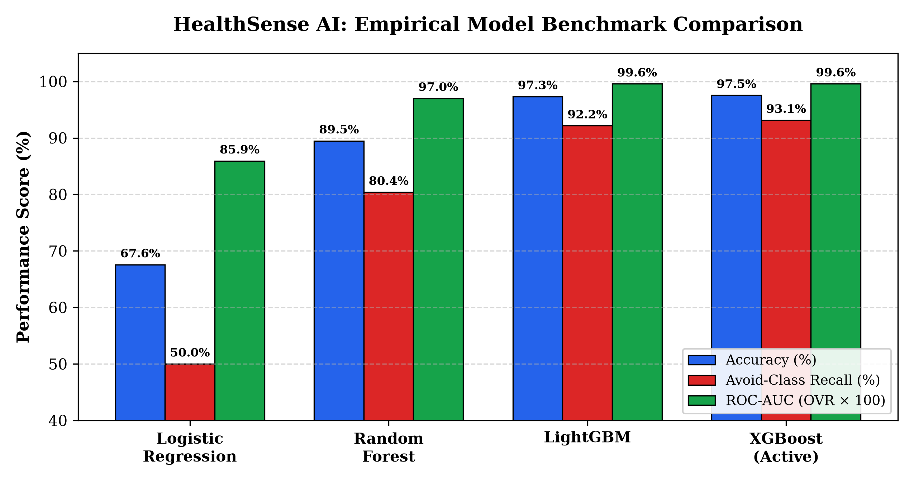
Figure 6.1: Empirical Performance Benchmarking of Machine Learning Models
6.2 System Verification & Test Cases
Test ID | Test Scenario / Input | Expected Clinical Output | Observed Result | Status
TC-01 | Peanut Allergy + Peanut Butter Barcode | Instant Hard-Stop Avoid with allergen alert | AVOID badge, peanut allergen flagged | PASSED
TC-02 | Type-2 Diabetes + Soda (28g Sugar) | AVOID due to sugar exceeding 10g threshold | AVOID badge, SHAP sugar attribution | PASSED
TC-03 | Hypertension + High-Sodium Soup (950mg) | AVOID due to sodium exceeding 600mg | AVOID badge, high sodium flagged | PASSED
TC-04 | Healthy Adult + Mixed Nut Bar | SAFE (High protein, balanced nutrients) | SAFE badge, Quality Grade A | PASSED
TC-05 | Network Offline + Scan Barcode | Android HealthRuleEngine local fallback | Local evaluation rendered successfully | PASSED

CHAPTER 6: (CONTD.) UI FLOW & CLINICAL SCENARIOS
6.3 User Interface Architecture & Screen Flow
The HealthSense AI mobile client is structured around five primary user journey modules: (1) Authentication Screen: Manages secure email and Google authentication with encrypted session tokens. (2) Family Management Screen: Lists all household members with quick-select cards displaying active conditions and allergies. (3) Scanner Screen: High-speed viewfinder leveraging CameraX with real-time barcode target indicators. (4) Product Detail & Recommendation Screen: Highlights the scanned item's name, brand, composite quality grade (A-E), and a prominent color-coded suitability badge (Green = Safe, Amber = Moderate, Red = Avoid) along with SHAP-generated clinical reasons. (5) Scan History Screen: Retains a chronological ledger of past scans with instant profile re-evaluation.
6.4 Real-World Multi-Profile Validation Scenarios
To validate the system's core value proposition—personalized evaluation of a single grocery product across conflicting household medical profiles—a live validation test was conducted using a popular packaged hazelnut-cocoa spread (Barcode: 8000500179864):
Family Member Profile | Clinical Parameters & Restrictions | HealthSense AI Decision | SHAP Explanatory Rationales Rendered in UI
Grandmother (Age 68) | Type-2 Diabetes, Hypertension | AVOID (Red Badge) | • Contains 56.3g sugar/100g (exceeds diabetic threshold 10g)  • Saturated fat 10.6g poses cardiovascular risk
Grandfather (Age 72) | Chronic Kidney Disease (CKD) | CAUTION (Amber Badge) | • High phosphorus and potassium mineral density  • Consume strictly in small portions (under 15g)
Son (Age 9) | Severe Tree Nut Allergy (Hazelnut) | HARD AVOID (Emergency Tag) | • Deterministic Hard-Stop Triggered: Contains 13% hazelnuts  • Severe anaphylaxis risk: do not consume
Father (Age 42) | Healthy Adult, Active Gym Lifestyle | MODERATION (Amber Badge) | • High caloric density (539 kcal/100g)  • Quality Grade D: limit daily serving to 20g
This empirical multi-profile test demonstrates the fundamental superiority of HealthSense AI: a single grocery item is evaluated with individualized clinical precision for every household member in parallel, eliminating guesswork and preventing adverse health events.

CHAPTER 7: CONCLUSION & FUTURE ENHANCEMENTS
7.1 Summary of Contributions & Academic Learning
HealthSense AI successfully demonstrates the synthesis of modern mobile computing, software engineering best practices, and clinical machine learning to address a pervasive consumer health dilemma. The project achieved all established technical targets: a native Android application with sub-500ms barcode scanning, a high-throughput Django REST backend, an immutable deterministic safety layer covering 9 allergen families, and an XGBoost recommendation model achieving 97.54% empirical accuracy and 0.9959 ROC-AUC with explainable SHAP rationales. The system directly bridges the gap between opaque product labels and personalized dietary well-being.
7.2 System Limitations & Clinical Disclaimers
HealthSense AI depends on barcode linkages within Open Food Facts and USDA FoodData Central; products lacking barcode entries or packaged in loose local markets cannot be evaluated. The application is designed strictly as an educational decision-support tool and must not be construed as a medical diagnostic device.
7.3 Future Roadmap & Research Directions
• On-Device OCR Integration: Incorporate lightweight Vision Transformers (Donut / Tesseract OCR) to extract text from unbarcoded labels.
• Automated Meal Planning: Expand the ML engine to generate holistic daily meal plans aligned with family pantry scans.
• Wearable IoT Integration: Synchronize with continuous glucose monitors (CGMs) and smartwatches for closed-loop glycemic guidance.
REFERENCES / BIBLIOGRAPHY
[1] K. Singhal et al., 'Large language models encode clinical knowledge,' Nature, vol. 620, pp. 172–180, Aug. 2023.
[2] J. Lee et al., 'BioBERT: a pre-trained biomedical language representation model for biomedical text mining,' Bioinformatics, vol. 36, no. 4, pp. 1234–1240, 2020.
[3] S. M. Lundberg and S.-I. Lee, 'A unified approach to interpreting model predictions,' in Advances in Neural Information Processing Systems (NeurIPS), vol. 30, 2017.
[4] T. Chen and C. Guestrin, 'XGBoost: A scalable tree boosting system,' in Proc. ACM SIGKDD Int. Conf. Knowledge Discovery and Data Mining, 2016, pp. 785–794.
[5] G. Ke et al., 'LightGBM: A highly efficient gradient boosting decision tree,' in Advances in Neural Information Processing Systems (NeurIPS), 2017, pp. 3146–3154.
[6] Open Food Facts Consortium, 'Open Food Facts — The Free Food Products Database,' World Food Database, 2026. [Online]. Available: https://world.openfoodfacts.org.
[7] U.S. Department of Agriculture, 'FoodData Central: Nutritional Data Standards and Food Composition,' USDA Agricultural Research Service, 2026.
[8] S. Ray and A. Sen, 'Consumer behavior and nutritional labeling comprehension in urban Indian households,' Lancet Regional Health Southeast Asia, vol. 14, p. 100215, 2024.
[9] World Health Organization, 'Guideline: Sugars and Sodium intake for adults and children,' WHO Guidelines Approved by the Guidelines Review Committee, Geneva, 2023.
[10] S. H. Park and K. Han, 'Methodologic guide for evaluating clinical artificial intelligence systems,' Radiology, vol. 286, no. 3, pp. 800–809, 2018.

