**Review on Histopathological Slide Analysis using Digital Microscopy**

As research into more effective picture segmentation algorithms grows, it is critical to classify existing techniques along with their philosophical underpinnings and overviews. The algorithms utilised in automated cancer diagnosis are systematically surveyed in this research.

Histopathology-based medical diagnosis Pre-processing, feature extraction, post-processing, and disease identification (classifying the area of malignancy) are a few of the computational procedures that are involved.

Typically, a biopsy sample is collected to look for malignant cells. To determine the severity of the condition, the biopsy sample is cut into tiny pieces and put onto a glass plate under a microscope.

A biopsy is a procedure that involves taking a sample of the damaged tissue for a pathologist to examine. A pathologist typically analyses a sample under a microscope to look for signs and the severity of disease. By definition, a biopsy requires that the tissue be removed from the subject's living tissue. An excisional biopsy is the surgical removal of the entire lump or afflicted area.

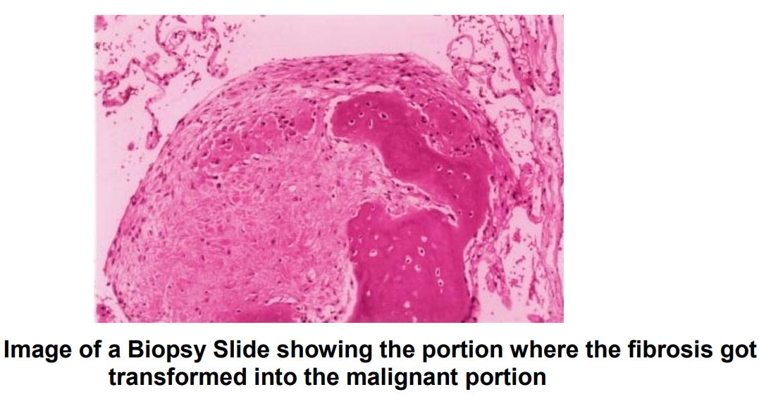

The image is divided into sections that correspond to the actual objects in the picture. In order to group individual pixels together into similar regions, i.e., of the same intensity (shade of grey), that form a texture, line up in a row, and make a shape, techniques like Histogram-based, manual, grey shade segmentation are utilised.

In comparison to segmenting using only grey shades, this segmentation achieves superior item separation.

