PolicyBot — Meridian Technologies Policy Assistant
User Guide
PolicyBot is a workshop application for spotting mistakes in AI-generated answers about a company's internal policies. You ask a question; PolicyBot answers using the official policy documents — but some answers are deliberately wrong, and your job is to catch them.

How it works
1. You ask a question about an internal policy (HR, IT, Finance, Travel, Performance, or Remote Work).
2. PolicyBot searches 10 official policy documents and retrieves the most relevant passages (a local FAISS vector index).
3. It sends those passages to an LLM (Anthropic Claude or OpenAI / Azure OpenAI GPT) and asks for a short answer based only on them.
4. The answer appears in a chat card, along with the exact source documents it used.
5. About 40% of answers contain a subtle, deliberately injected flaw. Compare the answer against the sources and decide whether it is correct.

Requirements
- Python 3.12.x
- An API key for Anthropic, OpenAI, or Azure OpenAI (for Azure: endpoint + API version).

Step 1 — Set up the environment
Open a terminal inside the PolicyBot folder(C:\Users\Administrator\Documents\GenAIAssurance\Training\Session-1\Demo_Apps\PolicyBot). The virtual environment (.venv) is already present, so you only need to activate it and install the dependencies. Run the following commands one at a time.

1.1 Activate the virtual environment
In PowerShell, run:
.venv\Scripts\activate
Once the virtual environment is active, your prompt shows (.venv) at the start of the line.
Note: If PowerShell shows a security error about running scripts, run this once first, then activate again: Set-ExecutionPolicy -Scope CurrentUser -ExecutionPolicy RemoteSigned
Terminal after activation — prompt now starts with (.venv)
Only n case of any error while activating the env follow the below step
pip install -r requirements.txt
Wait for the installation to finish — you'll see the packages download and a 'Successfully installed' line at the end. (If the environment was already populated, pip will simply report the requirements are already satisfied.)
Running pip install -r requirements.txt in the activated environment

1.3 Test Data
Test data and evaluation files: A ready-made set of test questions, along with two RAGAS multi-turn JSON files, is provided in the dataset folder inside the PolicyBot project directory (C:\Users\Administrator\Documents\GenAIAssurance\Training\Session-1\Demo_Apps\PolicyBot\dataset).

Step 2 — Launch the application
In the same terminal, run:
python run.py

When it is ready you will see the startup banner, “backend ready.”, and the URL to open:
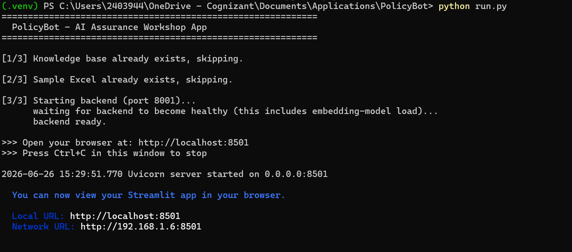
run.py output — backend ready and the http://localhost:8501 line
Note: Ports are fixed at 8001 (backend) and 8501 (frontend). Press Ctrl + C in this terminal to stop everything.
Your browser opens automatically at http://localhost:8501:
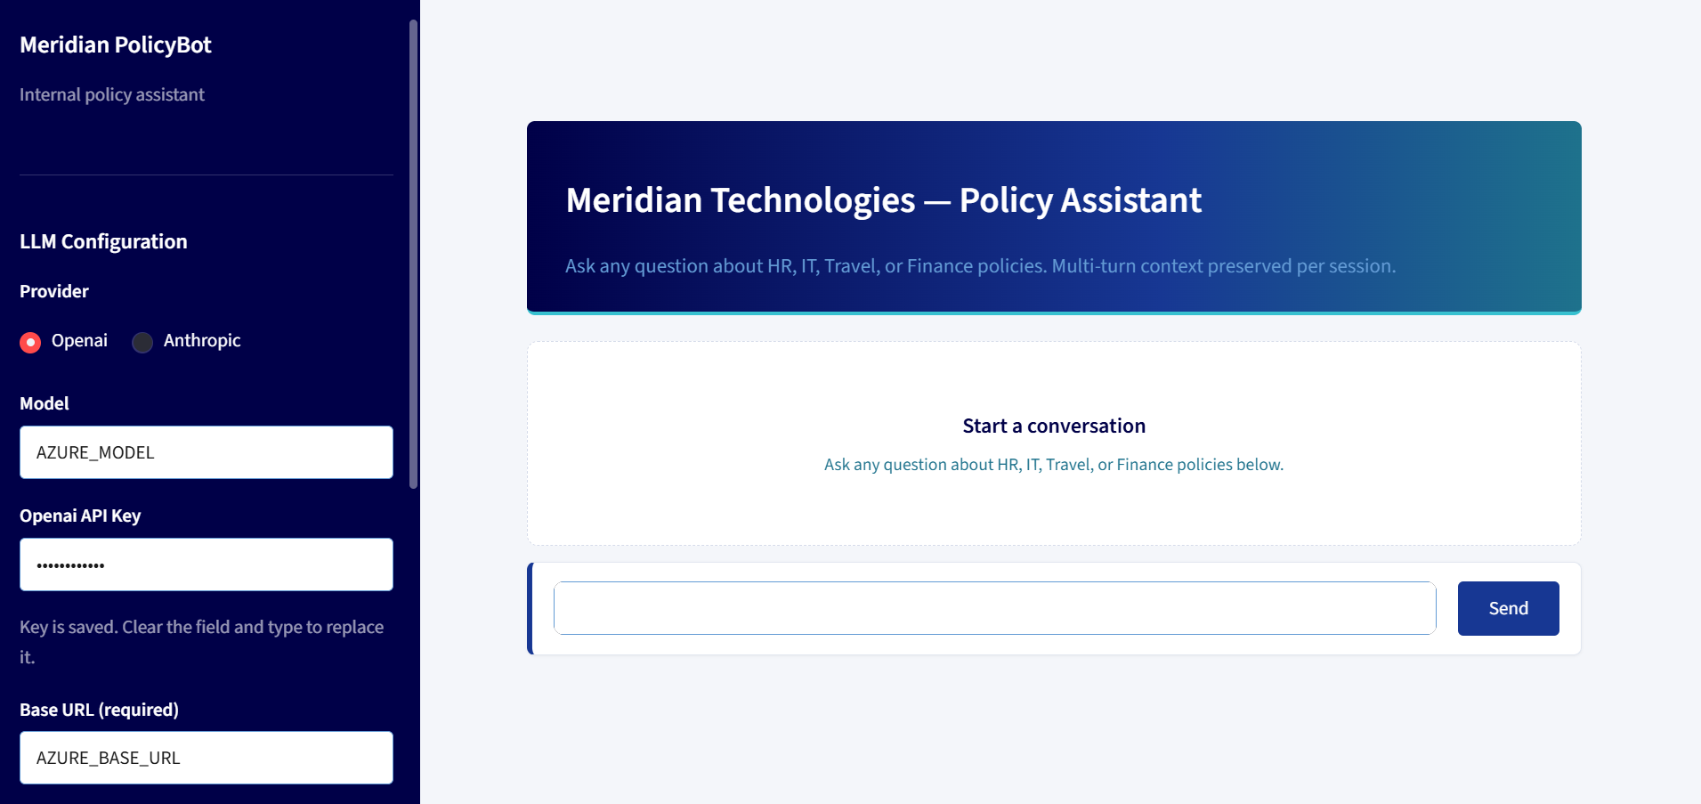
The PolicyBot application open in the browser

Step 3 — Configure your LLM (first time only)
All configuration is done in the left sidebar under LLM Configuration.
1. Pick a Provider — OpenAI or Anthropic.
2. (Optional) Set a Model — sensible defaults are used (gpt-4.1-nano for OpenAI, claude-sonnet-4-6 for Anthropic).
3. Paste your API Key.
4. For OpenAI / Azure OpenAI, also fill in Base URL and API Version. Anthropic needs neither.
5. Click Save Configuration. Your settings are stored in config.yaml and reused next time.
A “Configuration saved.” message confirms your settings were stored.
Prefer editing a file instead of the sidebar? The same settings live in config.yaml in the project folder. You can open it in any text editor and fill in the credentials directly — the app reads them on startup either way.
For OpenAI / Azure OpenAI:
provider: openai
api_key: YOUR_API_KEY_HERE
model: YOUR_MODEL_NAME
base_url: YOUR_API_URL
api_version: YOUR_API_VERSION
For Anthropic (Claude) — leave base_url and api_version blank:
provider: anthropic
api_key: YOUR_KEY_HERE
model: YOUR_MODEL_NAME
base_url: YOUR_API_URL
api_version: YOUR_API_VERSION
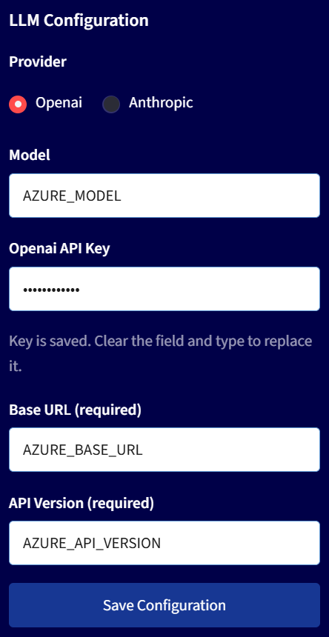
The LLM Configuration sidebar (the API key stays masked)
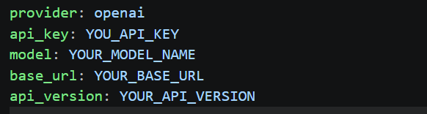
The LLM Configuration through config.yaml file

Step 4 — Ask a question
1. Type a policy question into the message box at the bottom and click Send.
Not sure what to ask? Try one of these:
- How many earned leave days do employees get per year?
- What is the reimbursement limit for business travel meals?
- Who needs to approve a software purchase?
- What is the company's data classification policy?
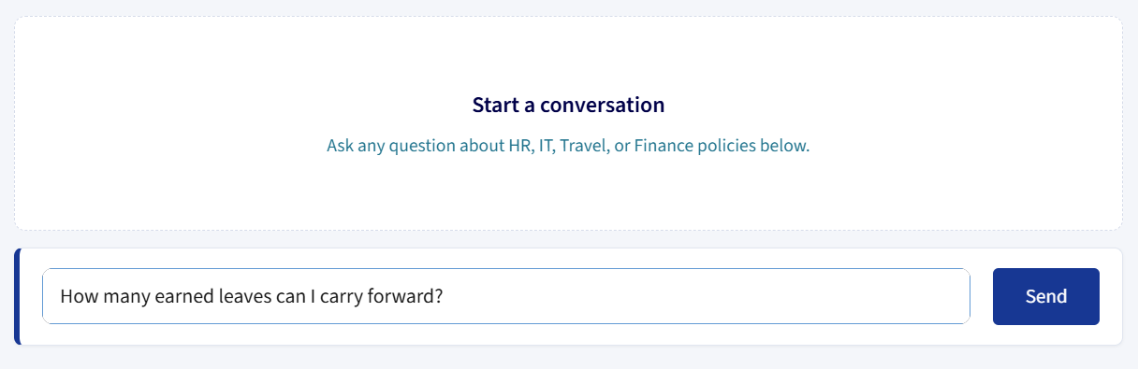
Type a question into the chat box and click Send
1. Read the PolicyBot answer card. Compare it carefully against what the policy actually says.
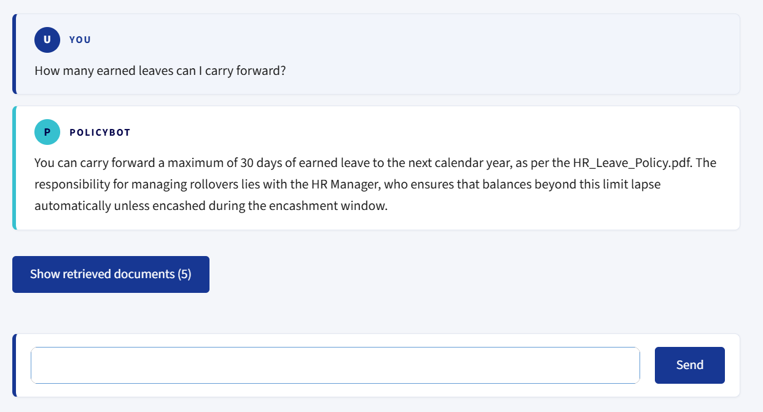
The PolicyBot answer card, with a “Show retrieved documents” button
1. Click Show retrieved documents to see the exact policy passages PolicyBot used — each with its document name and page number. Use these to verify the answer.
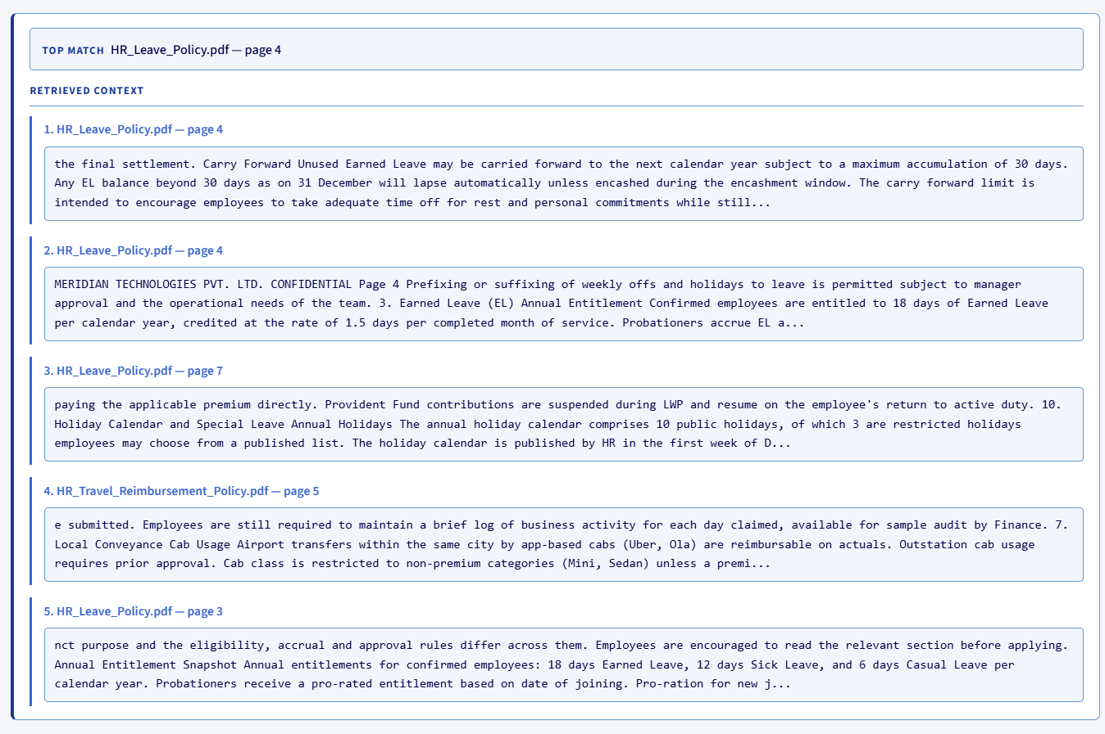
The retrieved-documents panel showing the source passages
1. Decide: did PolicyBot answer correctly, or sneak in a flaw?
Tip: PolicyBot keeps conversation context per session, so you can ask follow-up questions (for example, “And how many of those can I carry forward?”). To reset and start a fresh conversation, click Clear Chat in the left sidebar.

Step 5 — Using the CLI tool (terminal chat)
policybot_cli.py is an alternative way to chat with PolicyBot entirely from the terminal — no browser needed. It is useful when you want a record of your conversation exported as a structured file for evaluation.

Starting the CLI
Open a second terminal, activate the virtual environment (same command as Step 1.1), then run:
python policybot_cli.py
Note: The main application from Step 2 must still be running before you launch the CLI.

Example:
python policybot_cli.py
Launching the CLI in a second terminal — the backend from Step 2 must still be running

Asking questions
Once it starts you will see a You: prompt.
What you want to do | What to type
Ask a question | Type it and press Enter
Ask a follow-up | Just type it — context from earlier turns is remembered automatically
End the session | Type exit or 0 and press Enter

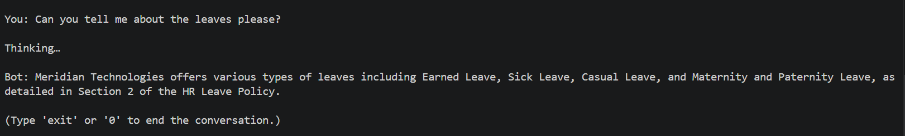
Asking a question in the CLI — type, press Enter, and read the Bot answer
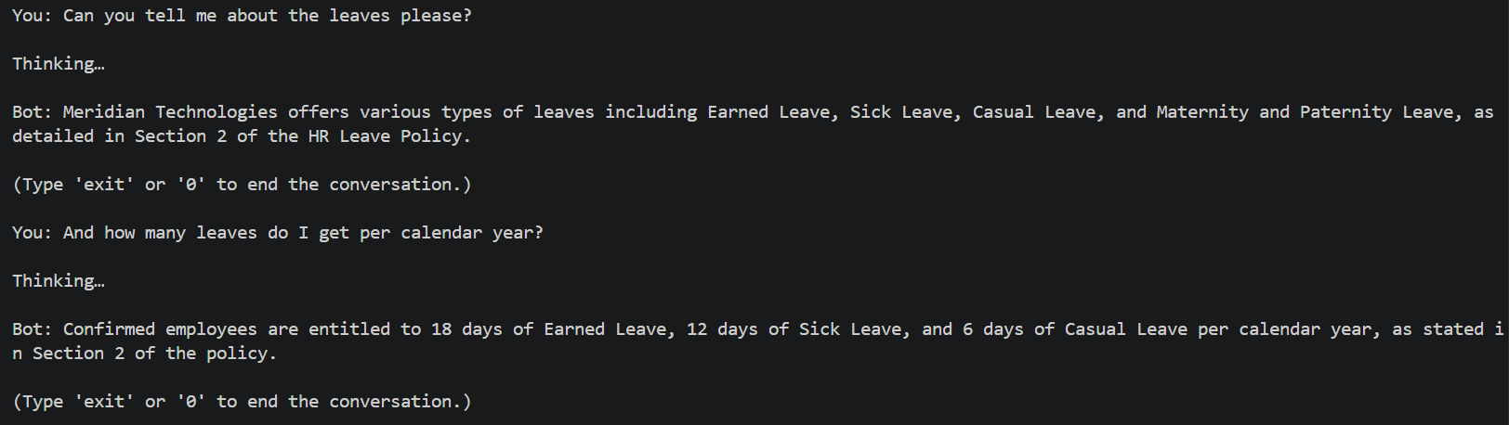
Follow-up questions reuse earlier context automatically

What happens when you exit
When you type exit or 0, the CLI saves the full conversation to a file called conversation.md in the PolicyBot folder, and prints a confirmation line. This file is overwritten each time you run the CLI, so save a copy elsewhere if you want to keep it.
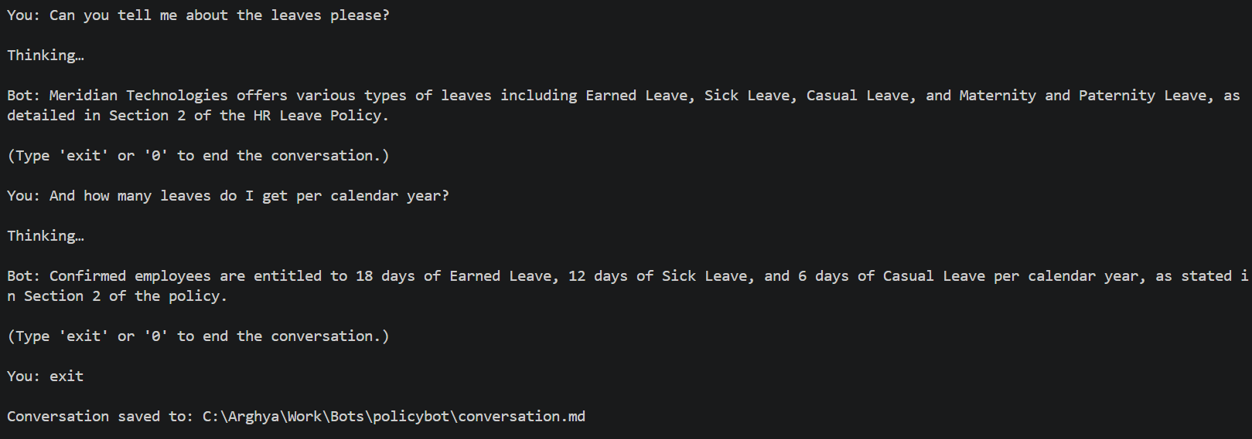
Type exit or 0 to end the session and export the transcript

Where to find conversation.md and how to open it
The file is written straight into the PolicyBot project folder – the same folder that contains run.py and policybot_cli.py. You don’t have to go hunting for it: the moment you type exit or 0, the CLI prints the exact, full path on screen, for example:
Conversation saved to: C:\Users\Administrator\Documents\GenAIAssurance\Training\Session-1\Demo_Apps\PolicyBot\conversation.md
Copy that path if you want to jump straight to the file. Opening it is simple – there are two easy ways:
- Double-click conversation.md – it opens automatically in VS Code.
- Or right-click conversation.md and choose Open with → Notepad to read it as plain text.

Understanding the conversation.md output
The file is split into two evaluation-ready sections:
- RAGAS section — formats the conversation as Python-style HumanMessage / AIMessage objects, plus the text chunks retrieved for the last question (Retrieved Contexts) and an auto-generated reference answer (Ground Truth).
- DeepEval section — formats each question–answer pair as an LLMTestCase object, with its own input, actual_output, retrieval_context, and expected_output.
You do not need to understand or use these formats during the workshop — they are there for the facilitator to use after the session.
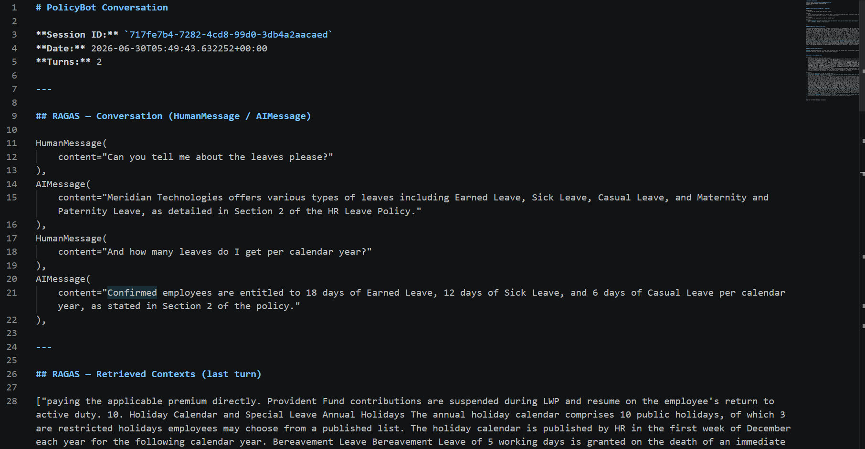
conversation.md — the exported transcript in RAGAS / DeepEval format

The workshop exercise — spotting flaws
Roughly 40% of generated answers are deliberately sabotaged with one subtle, plausible flaw. The four flaw types are:
- Wrong number — a figure, date, or limit is shifted slightly (e.g. a day count off by 2–3, a percentage off by 5, an amount nudged up or down).
- Missing clause — an important eligibility condition, restriction, or qualifying clause is silently left out, making the answer incomplete.
- Wrong approver — an approval, ownership, or responsibility is attributed to the wrong department or role (e.g. HR instead of Finance, Manager instead of VP).
- Hallucination — invented but official-sounding details (numbers, named procedures, references to non-existent sections) when the documents don't actually cover the question.
The flaws are designed to be subtle — read the answer line by line against the retrieved documents.
(For facilitators: every flaw decision is recorded in flaw_log.jsonl so answers can be audited afterwards.)

Customizing the knowledge base (optional)
PolicyBot answers only from the PDF documents in the knowledge_base/ folder, so you are encouraged to experiment with it. Edit one of the existing policies, replace it, or add a document of your own, rebuild the index, and watch how PolicyBot’s answers change. This is a great way to see the retrieval step in action.
How to do it:
1. Edit, replace, or add policy documents in the knowledge_base/ folder.
2. (Optional) Delete the vector_store/ folder to force a clean rebuild from scratch.
3. Restart the app with python run.py. PolicyBot rebuilds the index from the current PDFs on startup — this takes a little longer than a normal start while it re-reads and embeds the documents.
4. Ask a question about your new content to confirm the change took effect.
Good to know:
- Only PDF files are indexed — PolicyBot only reads .pdf files from the knowledge_base/ folder. Other file types (.txt, .docx, .md) are ignored, so any document you want PolicyBot to use must be a PDF.
The index rebuilds automatically when the PDFs change — You do not have to delete vector_store/ after editing the policy PDFs. PolicyBot detects the change and rebuilds the index on the next start. Deleting the folder simply forces a clean rebuild.

Useful endpoints (for testing the backend directly)
GET http://localhost:8001/health
POST http://localhost:8001/query
POST http://localhost:8001/batch
POST http://localhost:8001/session/clear
GET/POST http://localhost:8001/config
If api_key / provider are omitted from the request body, the backend falls back to the values saved in config.yaml. See api_client.py for a ready-made Python client (PolicyBotClient), and api_spec.md for the full request/response specification.

File reference
File / Folder | What it is
run.py | Single entry point — starts the backend and the chat UI together
config.yaml | Your provider, model, and API key settings
policybot_cli.py | Terminal chat tool — exports conversations to conversation.md
requirements.txt | The Python packages the app needs
knowledge_base/ | The 10 policy PDF documents
conversation.md | The transcript exported by the CLI tool

Troubleshooting
- “Cannot reach backend” — run.py isn't running, or port 8001 is busy. Stop other processes and re-run python run.py.
- “Invalid API key” — re-check the key in the sidebar and click Save Configuration (or correct it in config.yaml).
- Backend never becomes healthy — usually the embedding model is still loading on the first run. Wait a minute, or run python fetch_model.py first.
- Azure / OpenAI errors — both Base URL and API Version are required; Anthropic needs neither.
- Port already in use — change BACKEND_PORT / FRONTEND_PORT in run.py.
- Want to rebuild the index — delete the vector_store/ folder and restart.
- PowerShell will not run the activation script — run Set-ExecutionPolicy -Scope CurrentUser -ExecutionPolicy RemoteSigned, then activate again.

