SignIn
Details: Dropdown of userNames
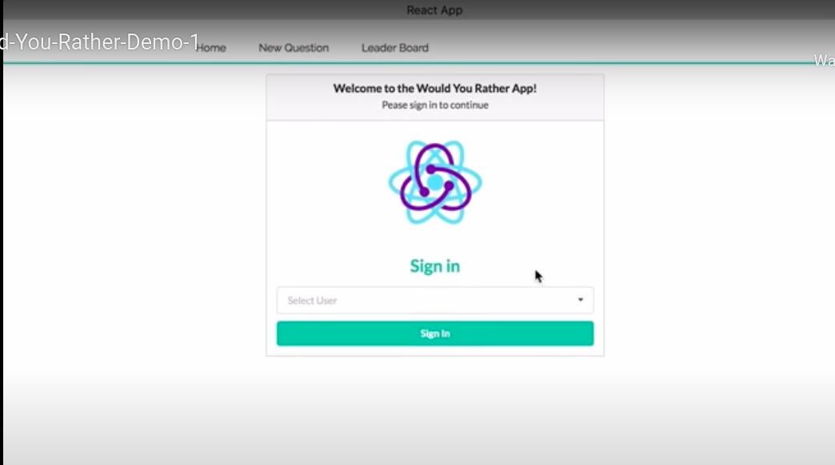

Home Screen: (Unanswered Questions)
Details:
Each Question has: name, avatar,question text, button(view poll)

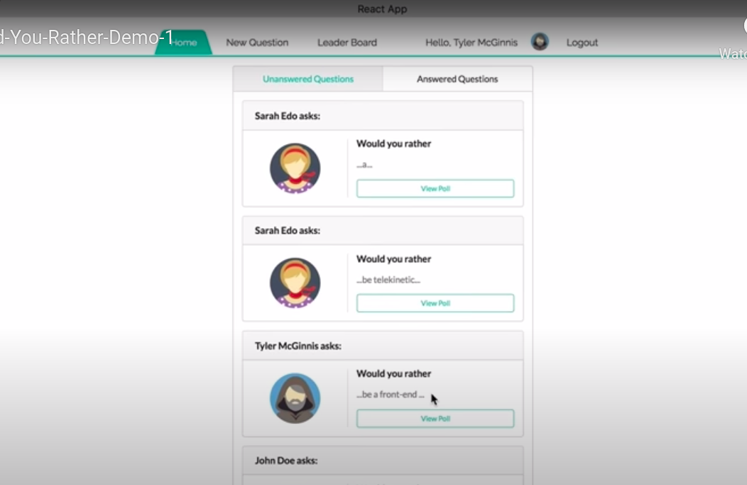

Home Screen : (Answered Questions):
Details:
Each Question has: name, avatar, question text, button(view poll)
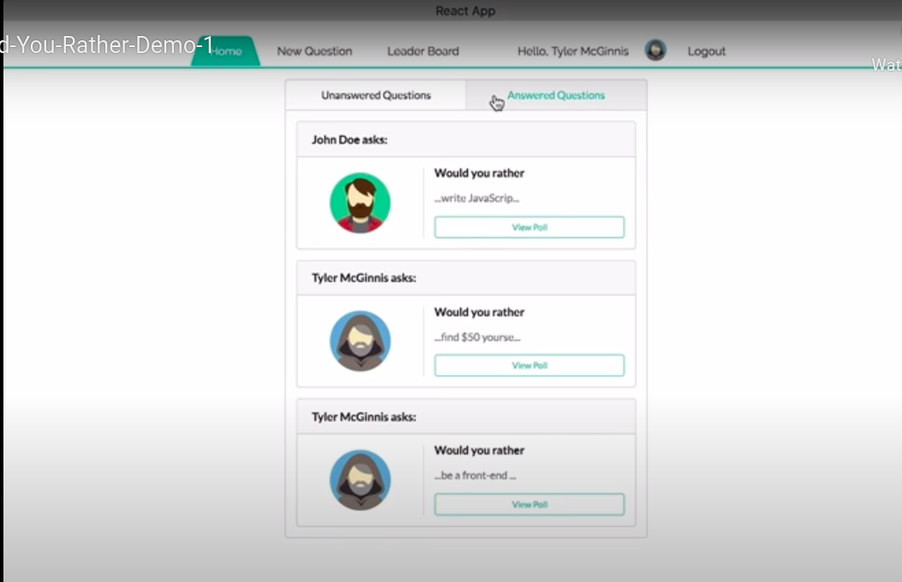

Question screen (View Poll from unanswered question)
URL: questions/:question_id

Details:
name, avatar, question text, answer options, button(Submit)
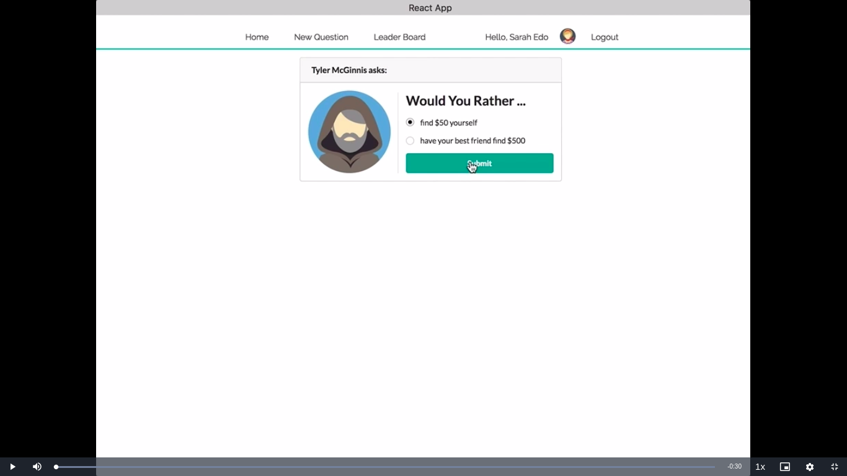
Poll Screen (On Submit from Question page OR on “View Poll” from answered questions)
URL: questions/:question_id
Details:
name, avatar, answer options, polling ratio,your choice
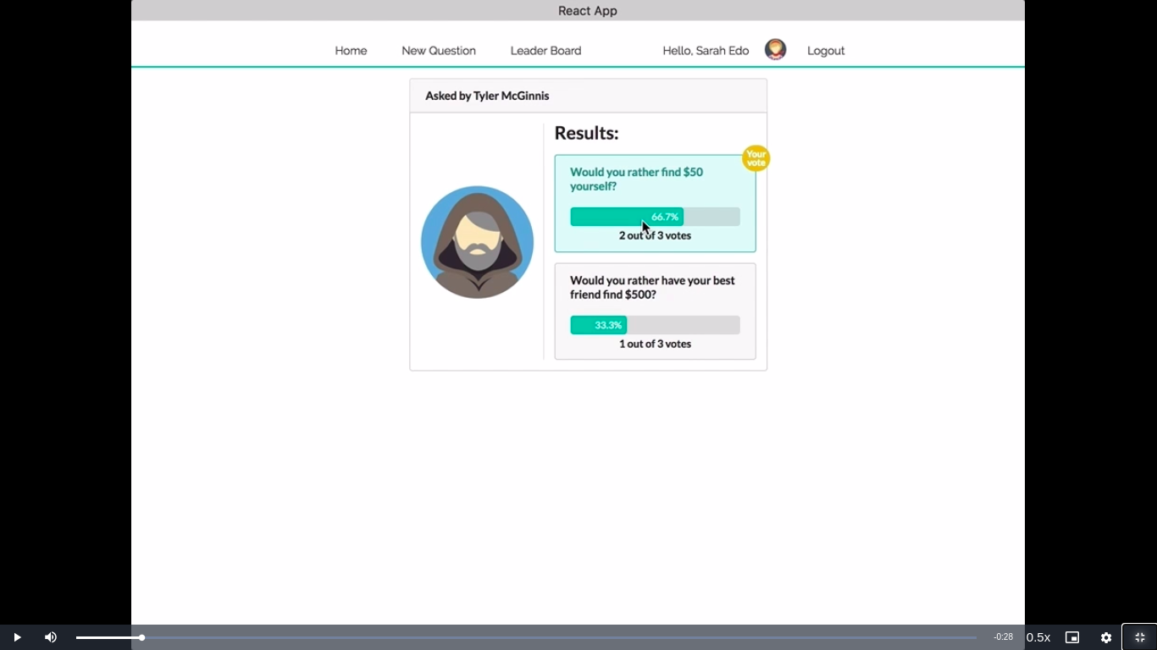

New Question
URL: /add
Details:
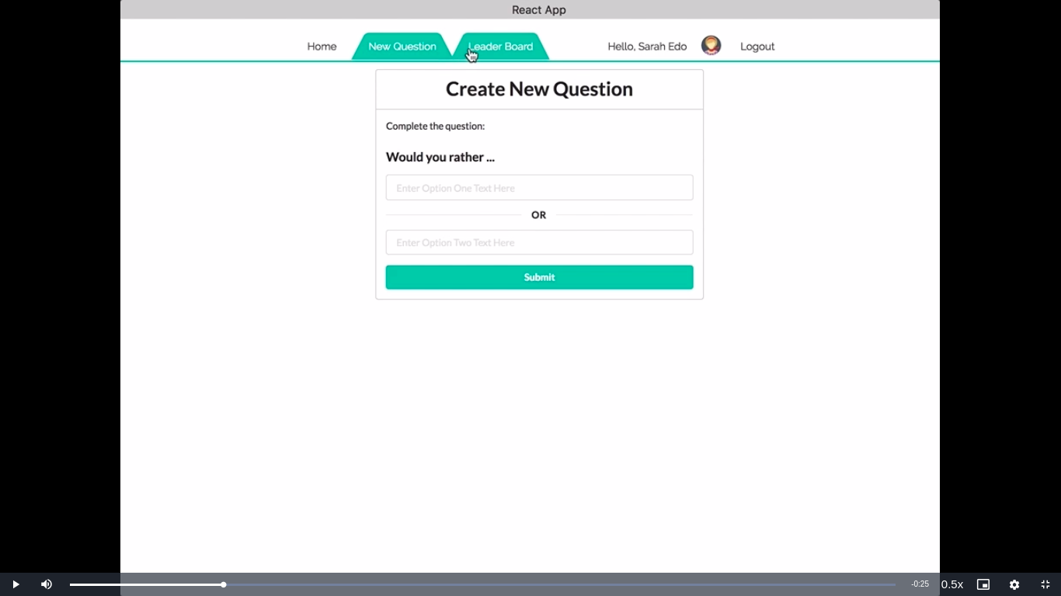
textboxes, Submit button

Leader Board:
URL: /leaderboard
Details:
name, avatar, answered questions, createdQuestions, total score
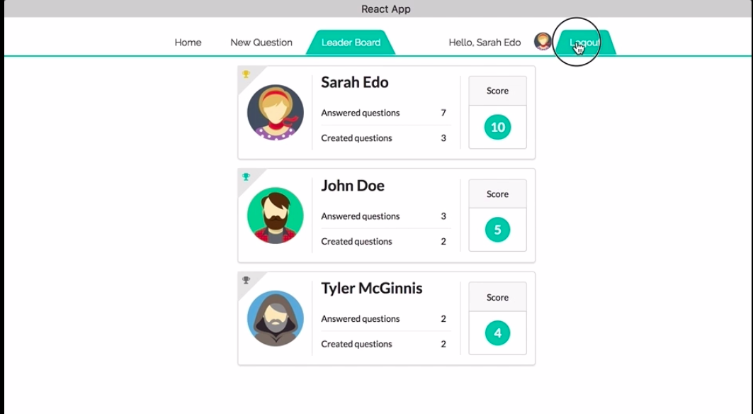

Components
- Nav
- SignIn
  - getUsers
- QuestionList
  - getQuestions, getUsers
- Question
  - getQuestion
- Results
  - getQuestion
- AddQuestion
  - saveQuestion
- LeaderBoard
  - getUsers
- User

