

Select Location Login / Sign Up

Shop by Categories

* Exotic Fruits & V...
* Tea
* Ghee
* Nandini
* Fresh Vegitable
* >>

 

     

My Smart Basket

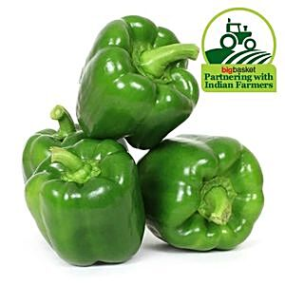

Fresho

Capsicum - Green (Loose)

###### 1 Kg 2 Kg 3 Kg

₹64 **~~₹120.55~~**

Add

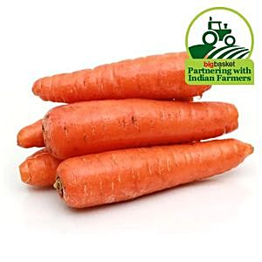

Fresho

Carrot - Orange (Loose)

###### 1 Kg 2 Kg 3 Kg

₹38 **~~₹84.93~~**

Add

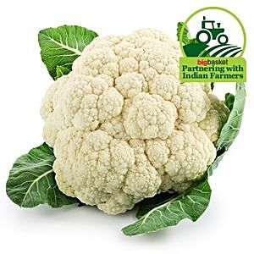

Fresho

Cauliflower

###### 1 pc - (approx. 400 to 600 g)

₹31 **~~₹42.37~~**

Add

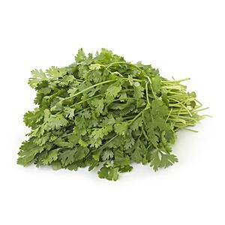

Fresho

Coriander Leaves

###### 1 Kg 2 Kg 3 Kg

₹200 **~~₹273.97~~**

Add

Bank Offers

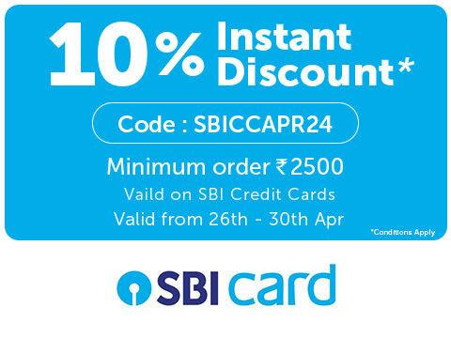







Best Sellers

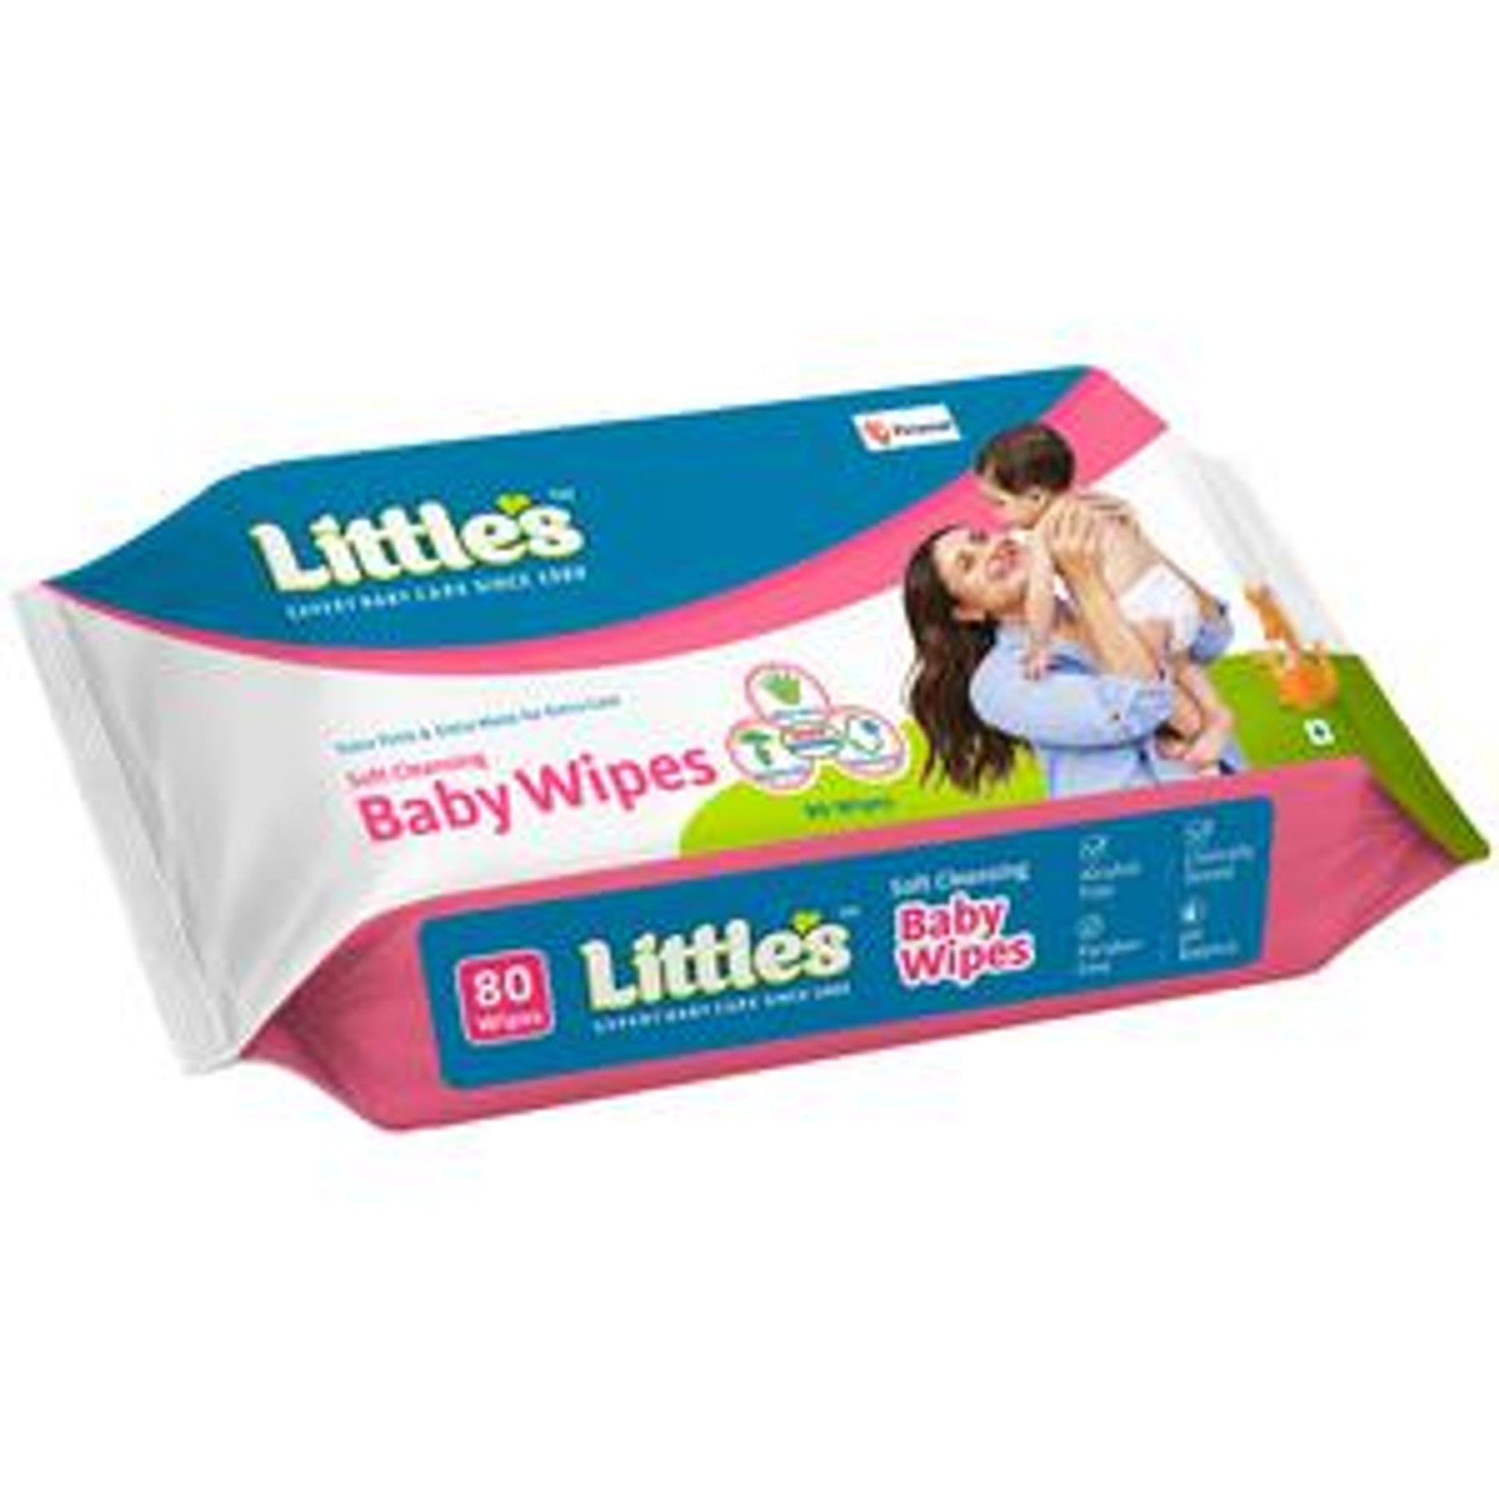

Littles

Baby Wipes - With Aloe Vera, Jojoba Oil & Vitamin

###### 80 Pcs 2x 80 Pcs 3x 80 Pcs

₹79 **~~₹190~~**

Add



Pampers

Baby Wipes - With Aloe, Vitamin & No Paraben

###### 72 Pcs 2x 72 Pcs 3x 72 Pcs

₹184 **~~₹299~~**

Add



Bigbasket

Baby Wipes - Sea Breeze, No Paraben, Double Moisturising

###### Tea 3x 80 Pcs

₹105 **~~₹199~~**

Add



Bigbasket

Baby Wipes - Sea Breeze, No Paraben, Double Moisturising

###### 80 Pcs 2x 80 Pcs 3x 80 Pcs

₹105 **~~₹199~~**

Add

Top Offers









Fruits and Vegetables

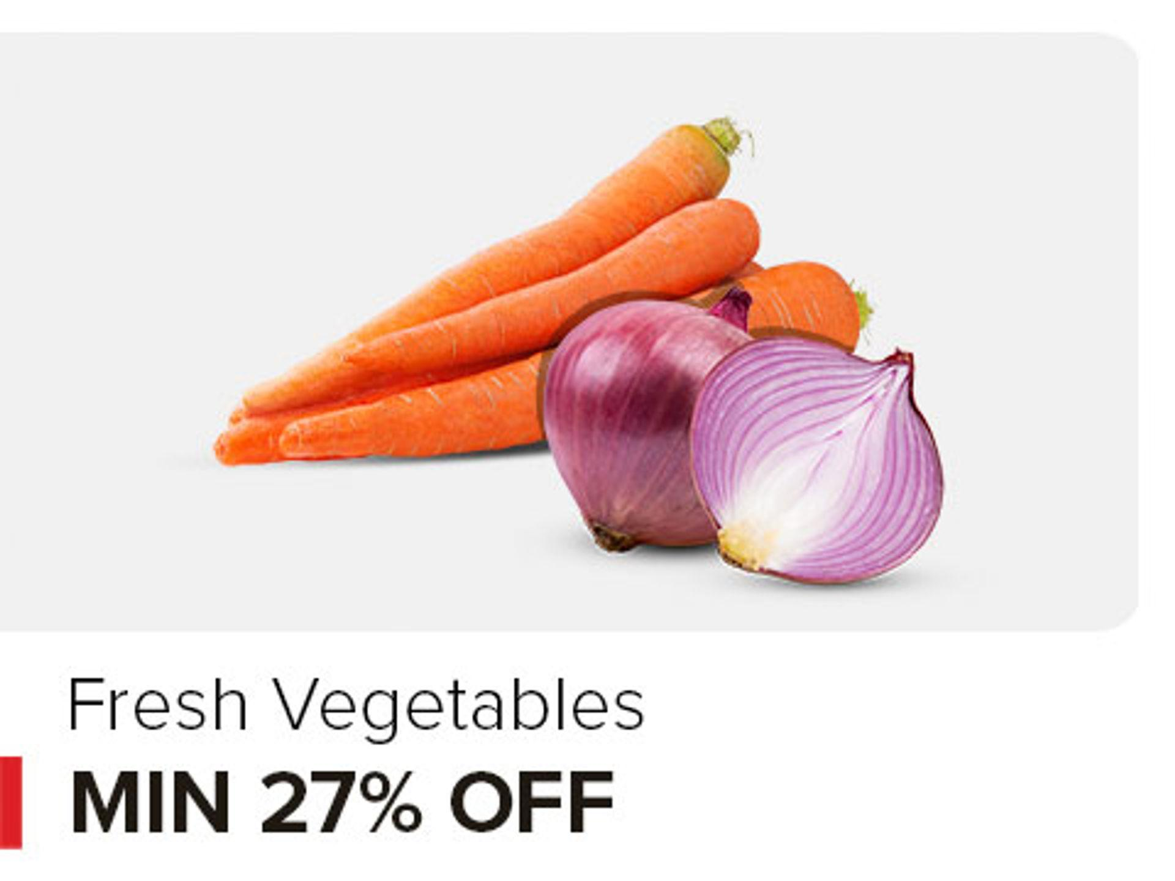

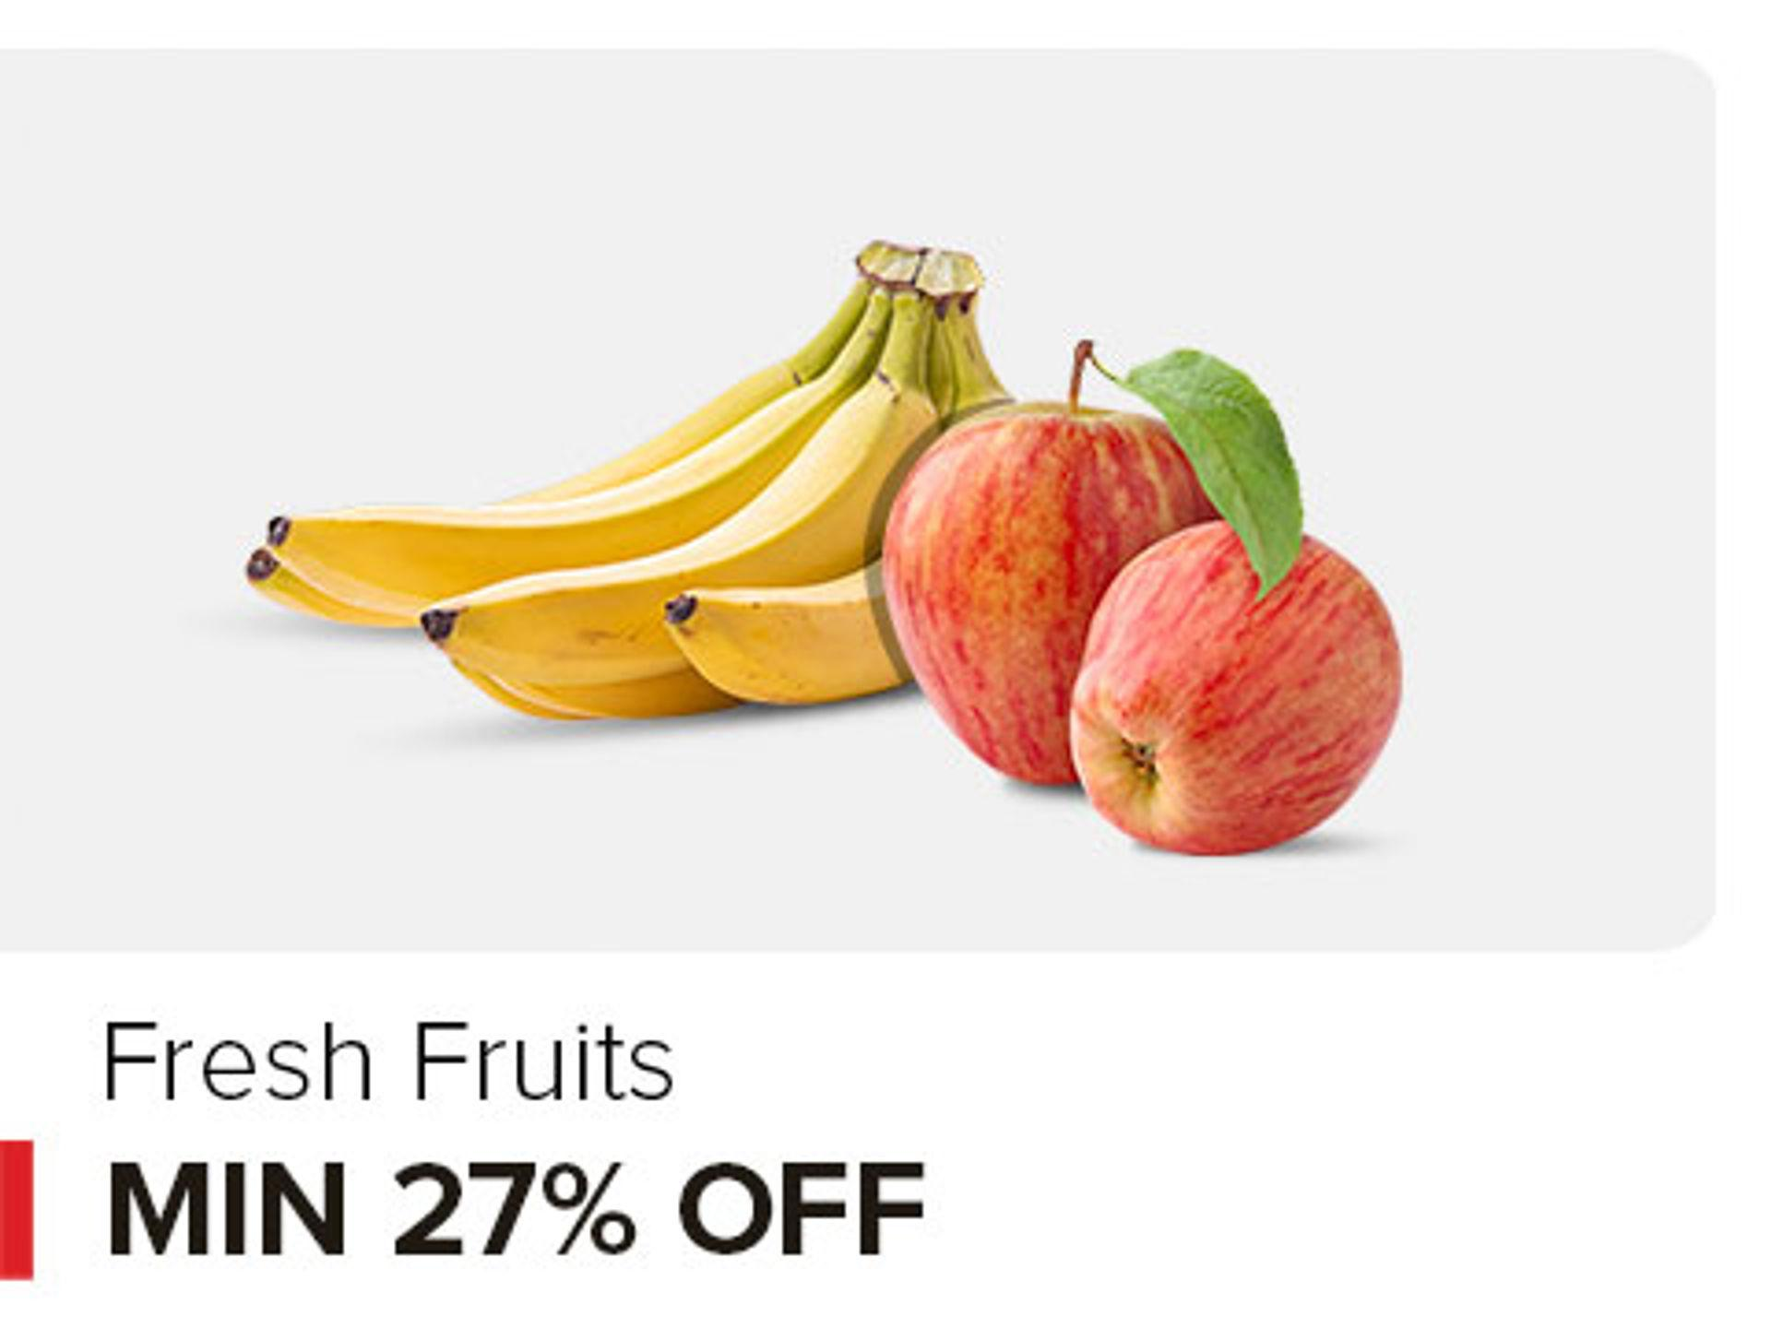

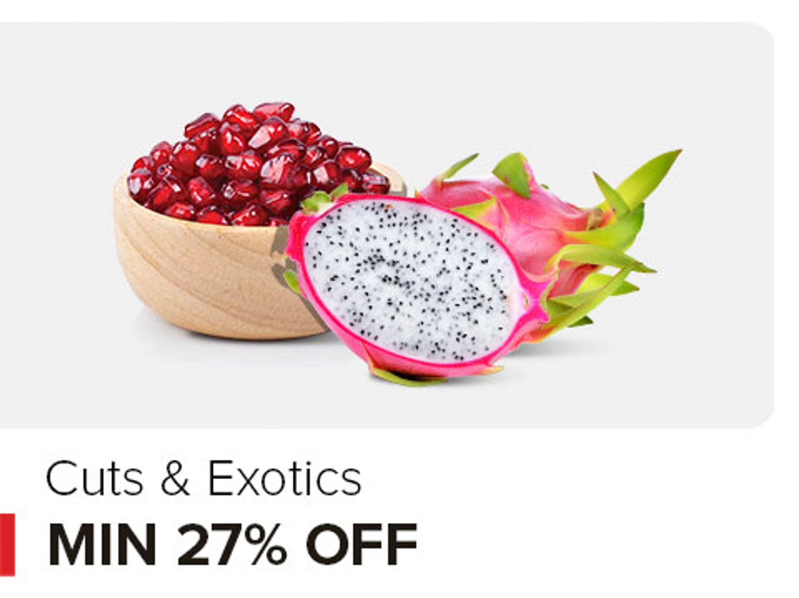



Your Daily Staples

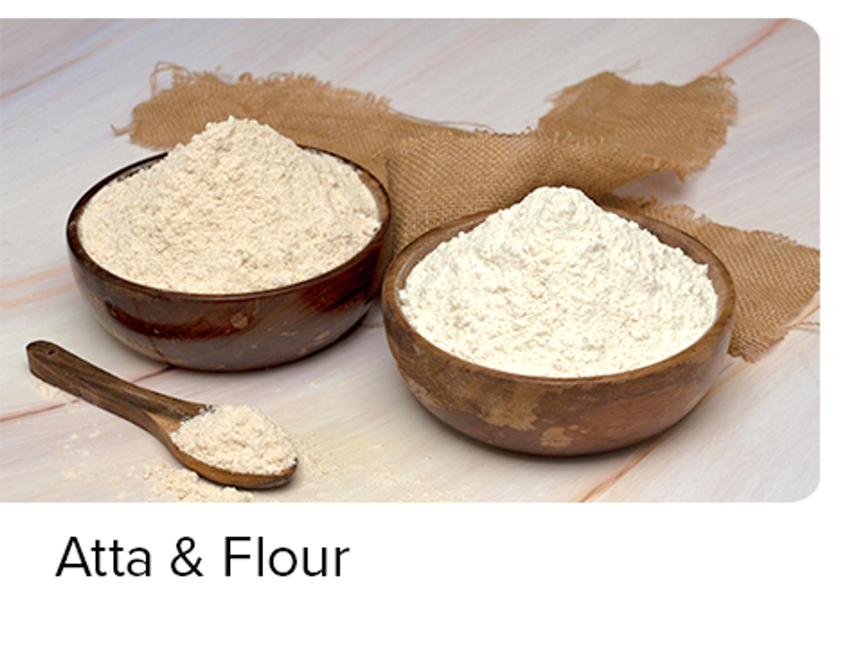

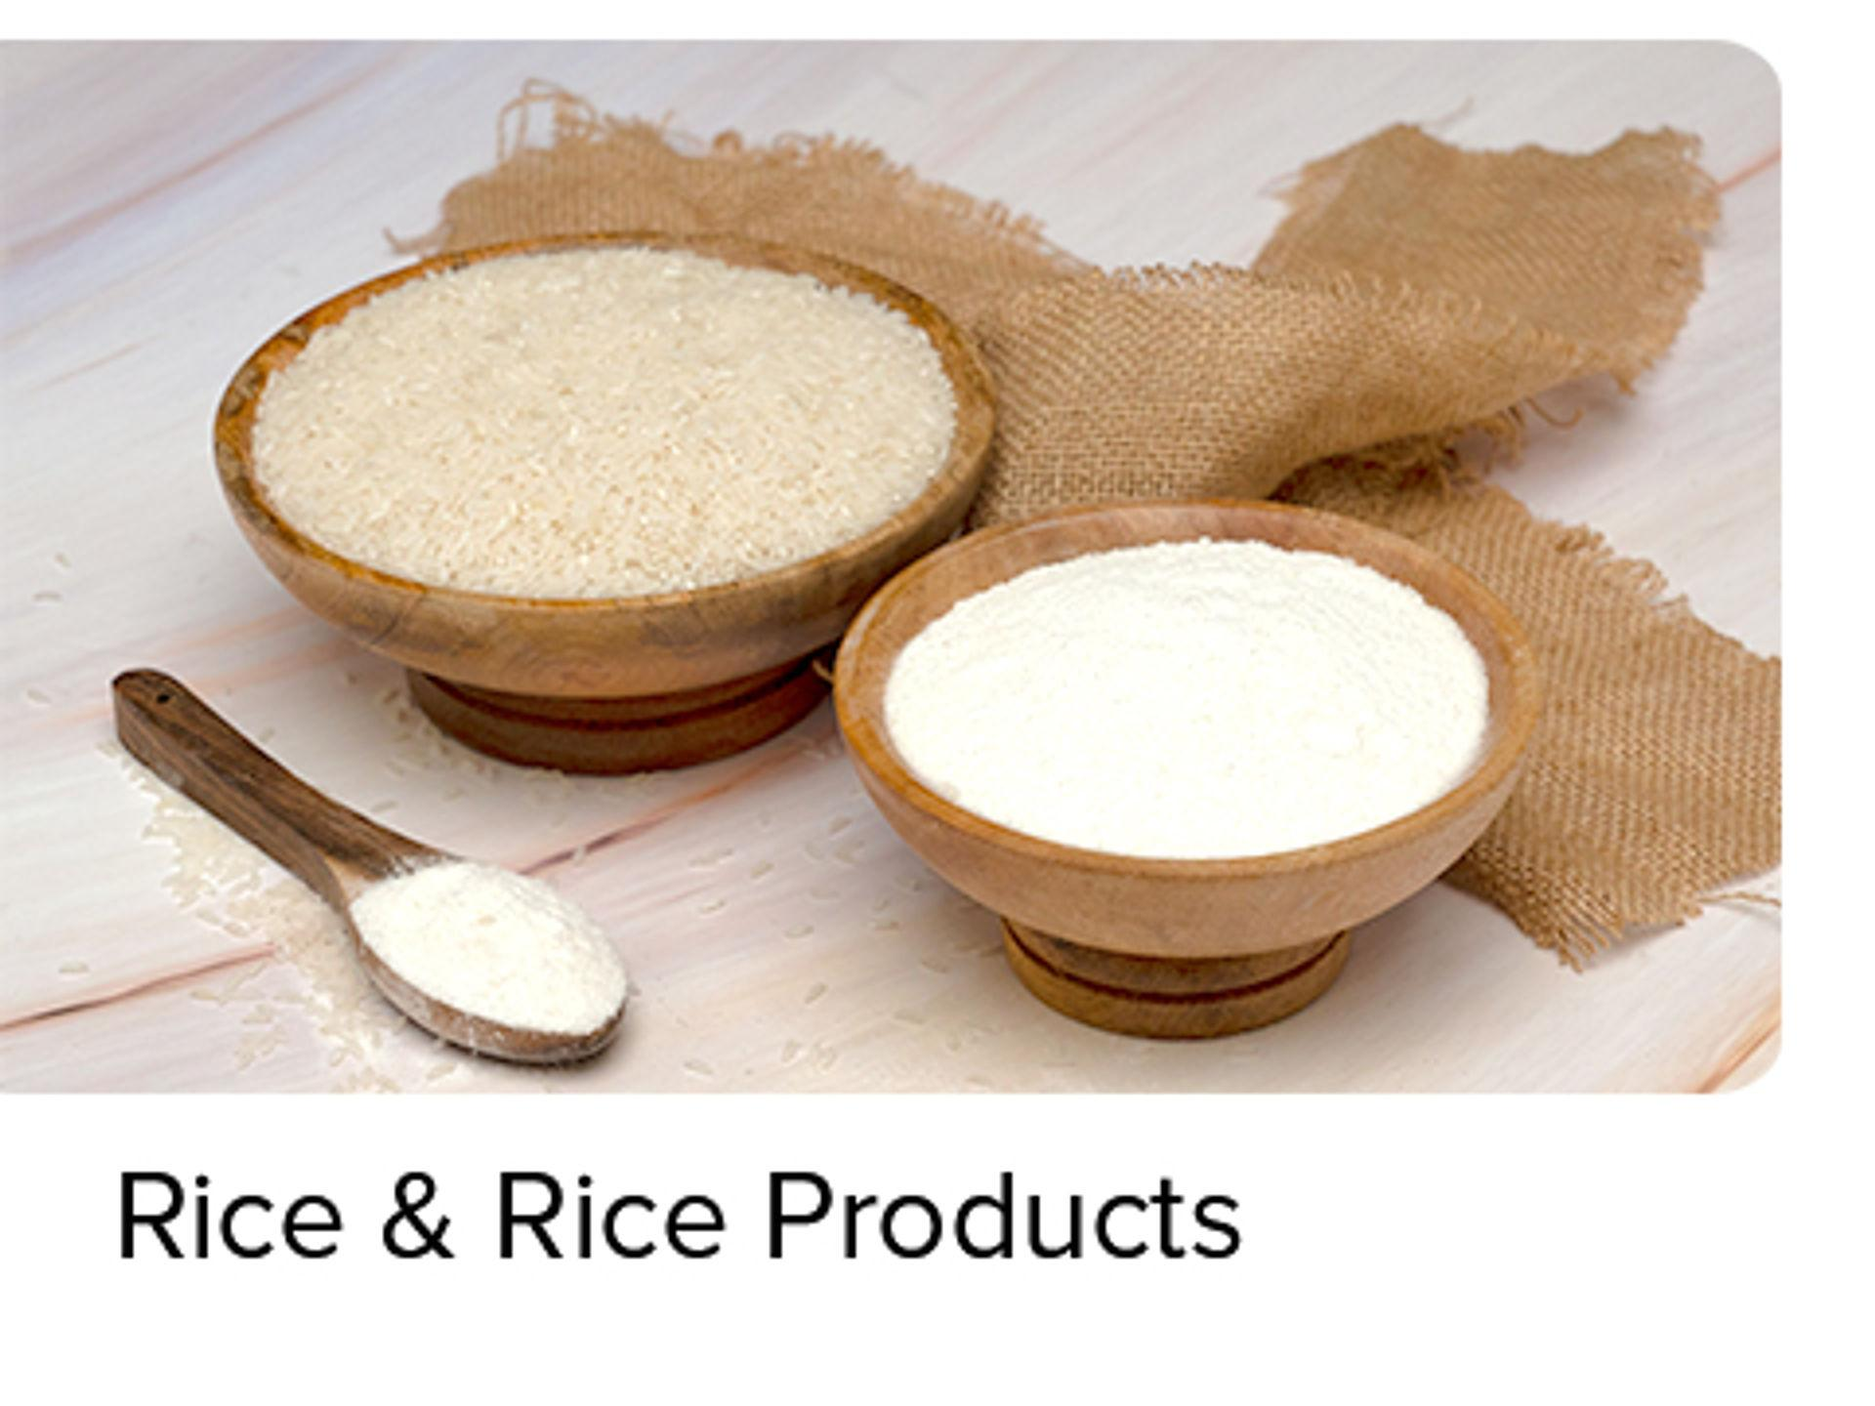





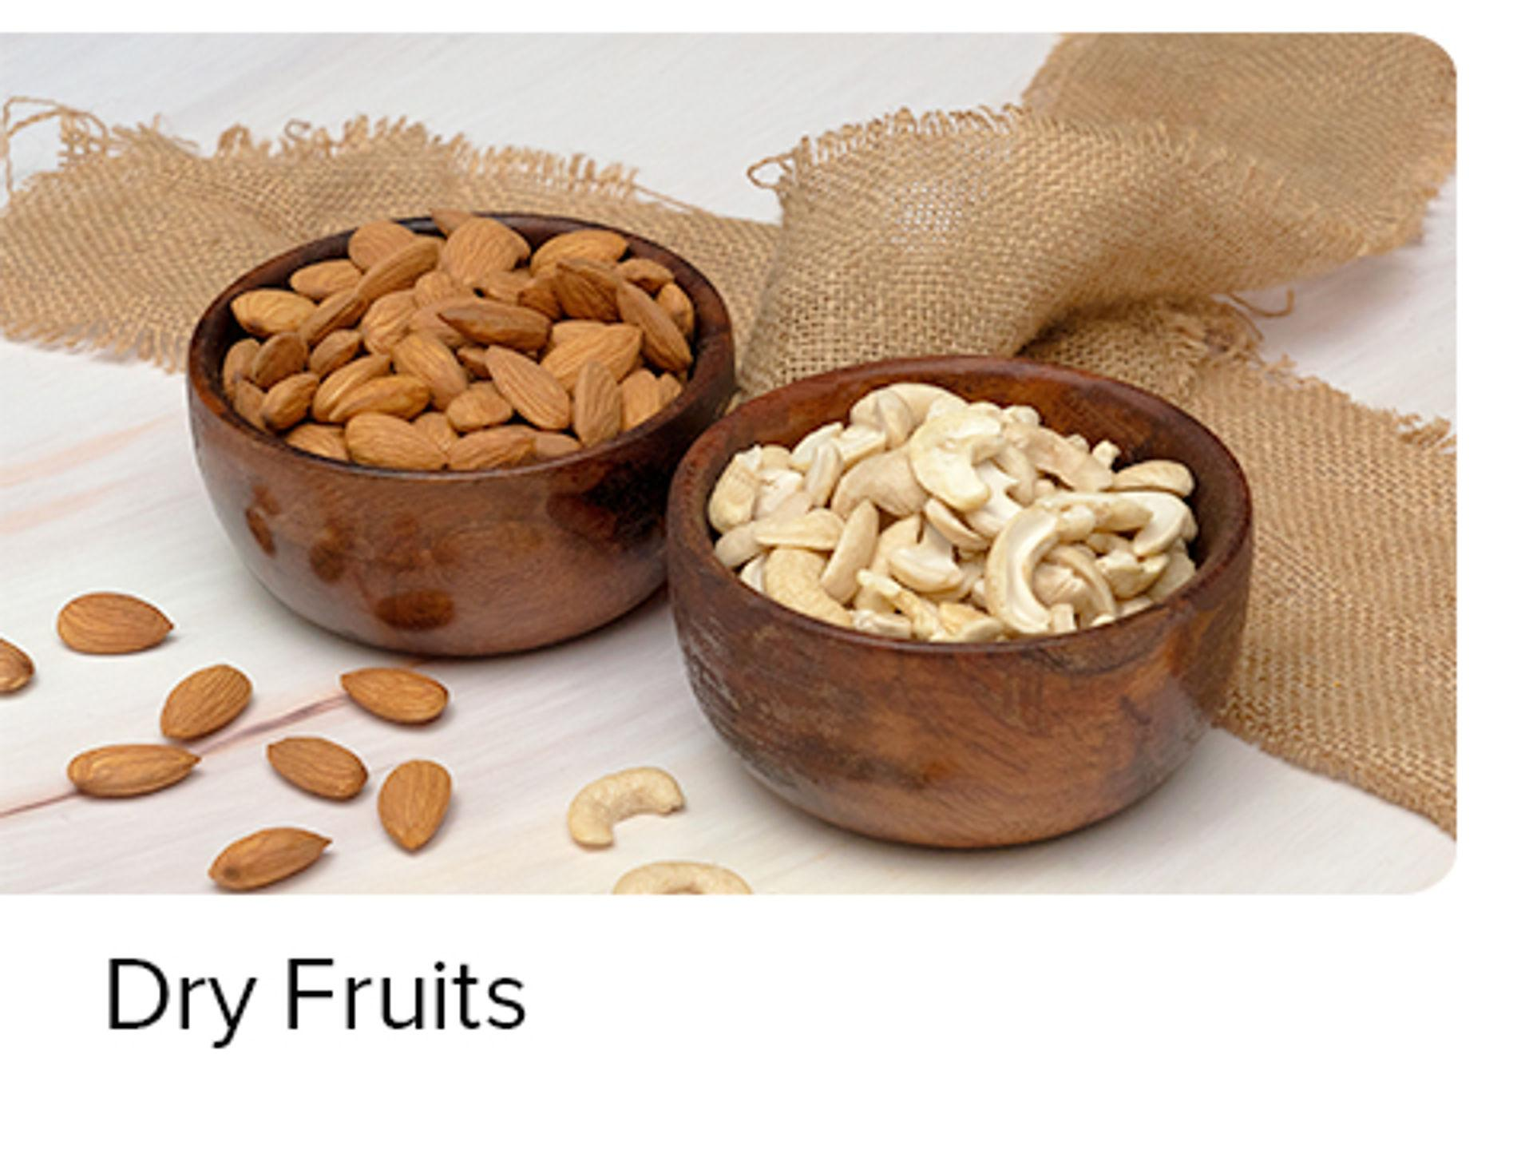

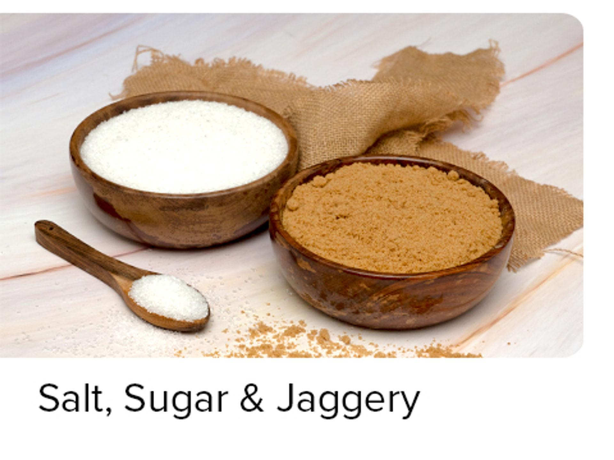

Beverages

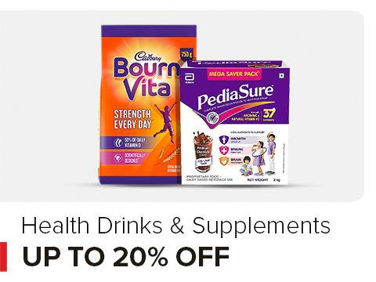

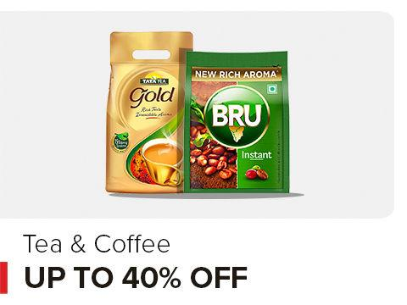

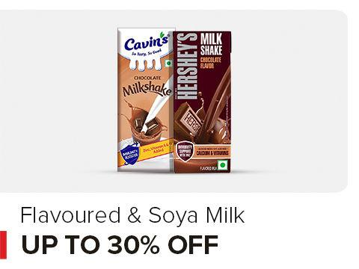

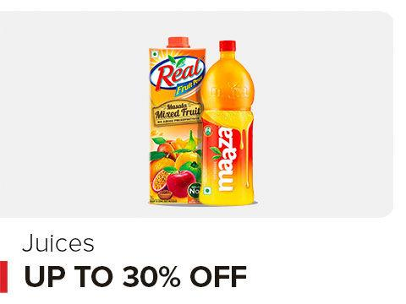



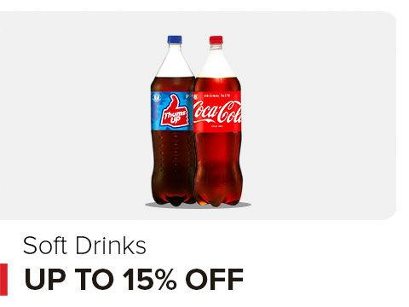

Snacks Store

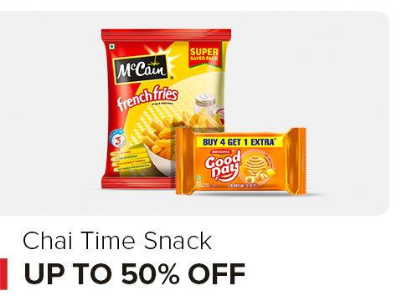

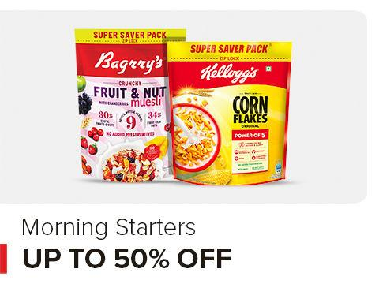

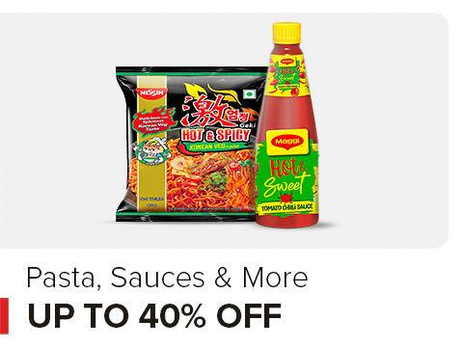

https://www.bigbasket.com/media/uploads/p/l/10000070_15-fresho-carrot-orange.jpg 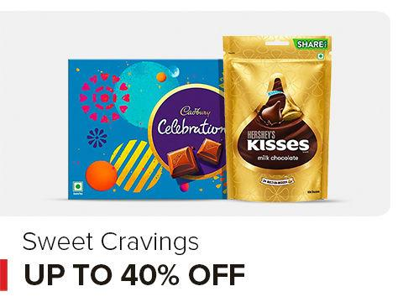

Cleaning & Household





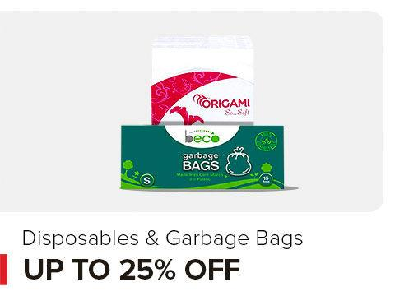



Beauty and Hygiene













Home and Kitchen

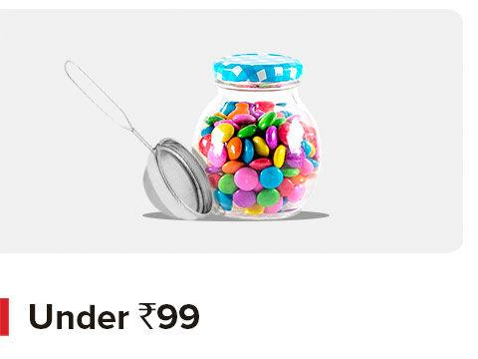



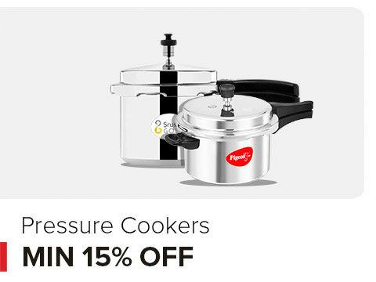

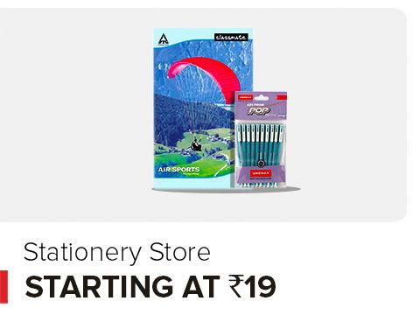

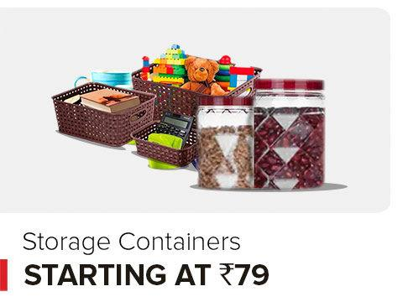





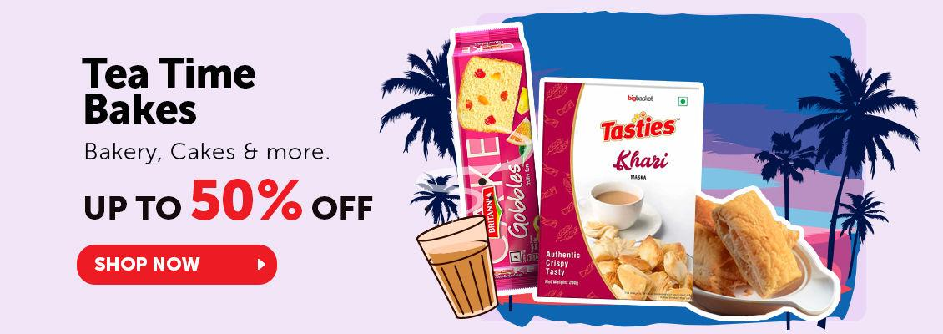





bigbasket – online grocery store

Did you ever imagine that the freshest of fruits and vegetables, top-quality pulses and food grains, dairy products, and hundreds of branded items could be handpicked and delivered to your home, all at the click of a button? In today's fast-paced world, bigbasket.com, India's pioneering online grocery store, continues to bring a staggering array of over 40,000 products from more than 1,000 brands to the doorsteps of over 10 million satisfied customers. From essential household cleaning products to the latest beauty and makeup trends, bigbasket remains your one-stop shop for daily needs.

In these times, we've eliminated the stress associated with shopping for daily essentials. You can now effortlessly order all your household products and groceries online. Plus, the added convenience of finding all your requirements at a single source, coupled with substantial savings, demonstrates that bigbasket, India's largest online supermarket, has transformed the way we shop for groceries. Online grocery shopping has become second nature. And when it comes to freshness, whether it's fruits and vegetables or dairy and meat, we've got you covered! Easily obtain fresh eggs, meat, fish, and more with just a few clicks.

We now serve 300+ cities and towns across India and ensure swift delivery times, guaranteeing that all your groceries, snacks and branded foods reach you on time.

Slotted Delivery: Choose the most convenient delivery slot to receive your groceries, ranging from early morning delivery for early birds to late-night delivery for those on the night shift. bigbasket caters to every schedule.

Instant delivery from bbnow: In response to the ever-increasing demand for convenience, bbnow by bigbasket offers lightning-fast grocery delivery, ensuring that your essentials are at your doorstep within 15-30 minutes. Our quick delivery service has revolutionized the way you shop for groceries. Choose from 5000+ grocery essentials. bbnow is available only in select cities.

Whether it's a last-minute dinner party or you simply need something urgently, we've got you covered. This service exemplifies our commitment to providing you with not just the widest range of products but also the fastest and most efficient shopping experience, making bigbasket.com the go-to destination for all your immediate grocery needs.

* Bigbasket
* About Us
* Become A bigbasket Rider
* In News
* Green bigbasket
* Privacy Policy
* Affiliate
* Terms and Conditions
* Careers At bigbasket
* bb Instant
* bb Daily
* bb Blog
* bbnow
* Help
* FAQs
* Contact Us
* bb Wallet FAQs
* bb Wallet T&Cs
* Vendor Connect





Copyright © 2023-2025 Supermarket Grocery Supplies Pvt Ltd