Assignment Documentation On ECS Terraform

**Documentation Understanding: -**

In this documentation assignment, we are going to deploy the fargate service on the AWS ECS cluster through code pipeline and code deployment. It consists of a VPC with 2 public subnets in different Availability Zones. The desired tasks are 2 and each task is deployed on each public subnet with Fargate and each task belongs to the same ECS service.

Requirements:-

* VPC
* IAM Role and Policies
* Load balancer
* ECS and ECR
* S3 Bucket
* Code build and code pipeline

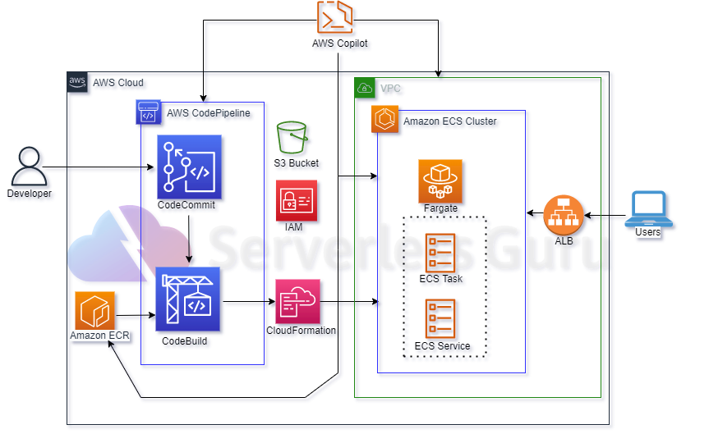

Point 01 **-** Create an IAM Role and CodeCommit Credentials and Create a Service Role for Elastic Container Service Task

#### Point 02: Terraform scripts to build the infrastructure

#### VPC

* Creating a vpc,it has a subnet and an internet gateway.
* It is a private cloud computing environment contained within a public cloud.
* Essentially, a VPC provide logically isolated environment in the cloud inside the VPC we have created different services such as,
* The file contains the Resource of the application load balancer which distribute the load among the different servicesapart form it consists of the target groups which target the two subnet created at different availability zone and a listener group.

IAM Role and Policies

contains the basic IAM Roles and Policies that are required the purpose is to allow access to user or services to have compliance ,have basic polices and Roles

ECS-ECR

Consist of the ECR repository where the docker image will be stored once it is build through code-deploy

ECS service consist of task definition or the basic requirement of the cluster such as family, network used ,CPU and the memory required