**Documentation on creating CI/CD pipeline on AWS ECS**

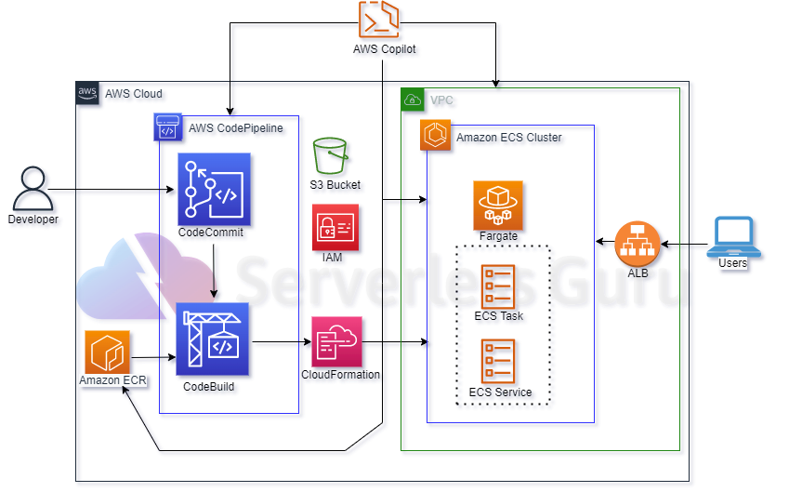

In this documentation we are going to explain steps to create an AWS infra to create a CI/CD pipeline on Amazon ECS(Elastic Container Service) using terraform. So the basic requirements we need to create this infra are : AWS VPC , ECR(Elastic Container Repository) , ECS cluster, Load balancer , IAM role and policies , Code build , Code commit and code pipeline.

Here are the steps that we’ll follow to create an infra :

* We’ll create VPC with public subnets and attach an internet gateway
* IAM role and policies that have the access of code build to use objects of s3 and ECR
* Load Balancer – to access containers on ECS cluster
* ECR – Docker image will be pushed into ECR repo and that repo will be used in ECS (we’ll create ECS cluster, ECS task and ECS service)
* Codebuild – to build an image on ECS cluster
* S3 – used to store artifacts build by codebuild
* Code pipeline – for building, testing,updating and deploying on ECS cluster