*CLOUDFRONT*

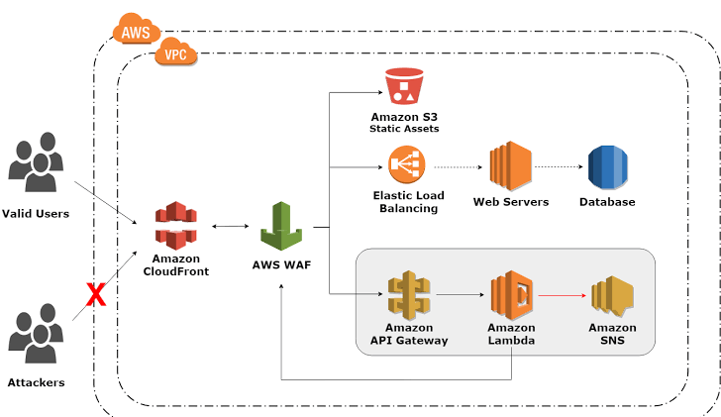

In this Task,

* we create web server and implemented CICD on this server.
* Create VPC, attach public subnet and Internet gateway.
* Load Balancer with target group attached with EC2 Instance (web server).
* Attach S3 bucket so that after code build process the artifacts store in bucket and make it for web site hosting and also give public ready only policy.
* WAF (Web Application Firewall) to setup the rule as per required, (In this task I use [Ip set] rule) and associated with load balancer.
* CloudFront (CDN) attach with load balancer and s3 that will be hosted.
* Code Deploy make process that code will be deploy on web server.