**Deploying web application on AWS Cloudfront**

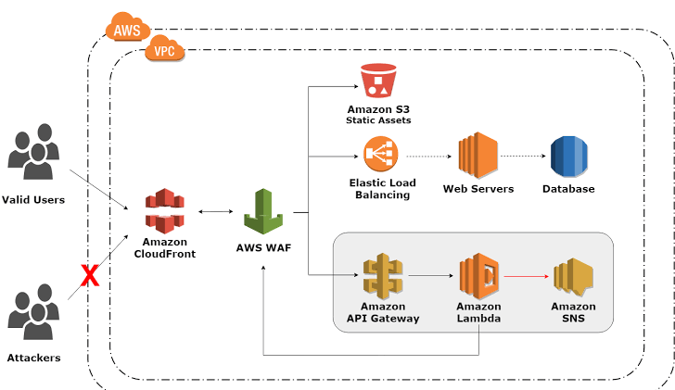

In this documentation, we will be creating a web application on AWS cloud front that has been using CI/CD pipeline.

We have using such services Amazon cloud front, S3 bucket for static website hosting and we will be using a Terraform to creating an Infrastructure.

AWS resources, security groups using web, instance.

Internet gateway, VPC creation, subnets, In this only traditional network that operate in your own data center.

Autos calling services role has attached policy to managing EC2 instance, load balancer.

Load balancer have some target groups where we have to attached EC2 instance.

Elastic load balancer to handle HTTP requests to web server, load balancer comes into the process.

We were using Code deploy to ensure that code has been deployed on server and codepipleine build with code build and deploy.