######### ASSIGMENTS ###########

1. 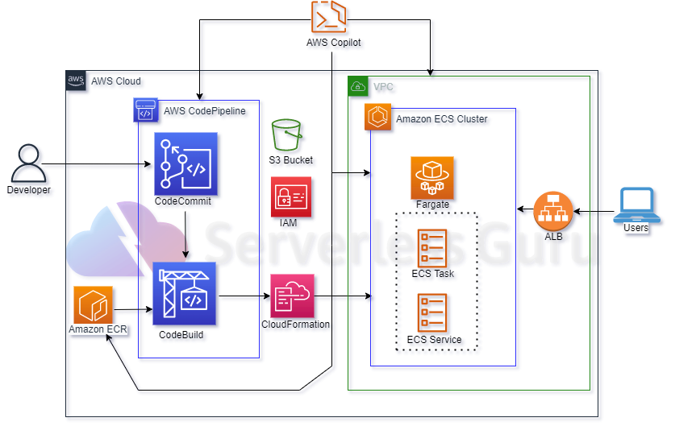

Using copilot:

<https://drive.google.com/drive/folders/1pxMhDV3pW68GvbI3dmak2yliICKYcARy>

Using Terraform:

<https://github.com/Vikrant1020/ECS_pipeline.git>

<https://drive.google.com/drive/folders/1pxMhDV3pW68GvbI3dmak2yliICKYcARy>

1. Laradock: - <https://github.com/laradock/laradock.git>

<https://drive.google.com/drive/folders/1pxMhDV3pW68GvbI3dmak2yliICKYcARy>