##################### ECS-CPOILOTE ##################

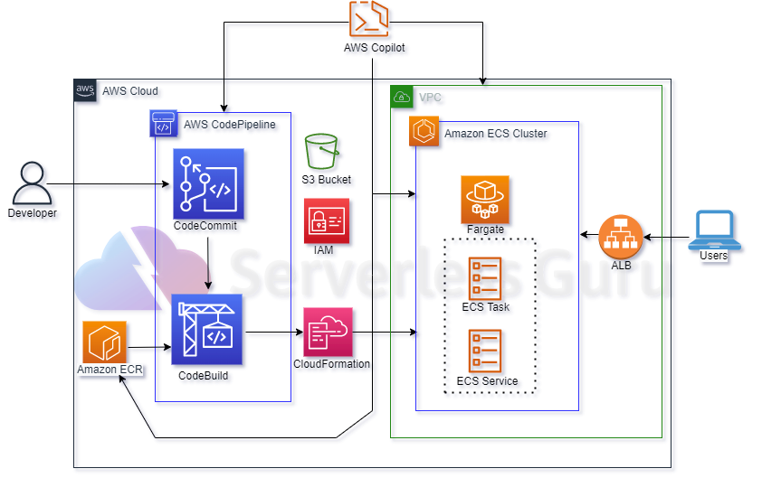

**Using Copilot**

AWS Copilot is a command line interface (CLI) that you can use to quickly launch and manage containerized applications on AWS. It simplifies running applications on Amazon Elastic Container Service (ECS), AWS Fargate, and AWS App Runner.

So we have to use AWS Copilot CLI to create Infra on AWS and also create a CI/CD pipeline. On AWS using AWS Copilot

We need a containerized applications to be deploy on ECS Cluster (Fargate). With its dockerfile.

While using AWS Copilot it makes all the infra related to it by itself (ECR repo, ECS task, Loadbalancer etc.). It first creates CloudFormations stack’s then it deploys those stacks.

While creating a CI/CD pipeline it creates it’s own buildspec.yml that is use to be work creating a pipeline.

Video: - <https://drive.google.com/drive/folders/1pxMhDV3pW68GvbI3dmak2yliICKYcARy>

Video name: - copilot.mkv

GitHub link: - <https://github.com/Vikrant1020/copilate_cli.git>

**Using Terraform**

Using terraform we have to create an infra that have ECS CI/CD pipeline in to and source will be AWS Codecommite. Service that we will be creating using Terraform.

* **VPC** that have public **subnets** attached with internet gateway.
* **ECS cluster on fargate** on which we will be deploying our application.
* **ECS task and services** that are required to run a container on ECS cluster.
* **Loadbalancer** to access deployed containers on ECS Cluster.
* **ECR repo** that will store our docker images that we will be deploying on ECS Cluster.
* **Codebuild** that will push our updated docker image on ECR repo.
* **CodeCommit** repo to store our application with buildspec.yml file.
* **S3** to store artifact made by CodeBuild.
* **Codepipeline** have source as **CodeCommit** and build with **CodeBuild** and deploy on **ECS Cluster.**
* **Policy’s and role’s** as per these services required.

Video: - <https://drive.google.com/drive/folders/1pxMhDV3pW68GvbI3dmak2yliICKYcARy>

Video name: - ecs-pipeline.mkv

GitHub Link: - <https://github.com/Vikrant1020/ECS_pipeline.git>