############### CLOUDFRONT-WAF ###############

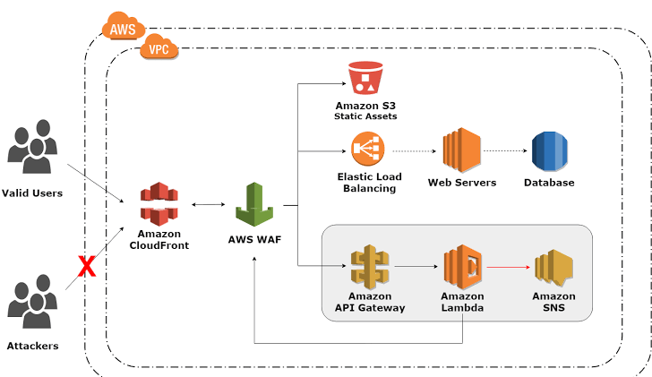

Hear we will be creating a web server that has a CI/CD pipeline implemented on it. we will be attaching a CloudFront on it for low latency. A WAF (Web Application Firewall) to protect against attackers on server. And will be using S3 bucket for static web site hosting. We will be using a Terraform for creating this infra.

Services we will be using.

* **VPC** that have public **subnets** attached with internet gateway.
* **EC2 instance (Web server)** as our server.
* **Load Balancer** that has **target group** attached with **EC2 instances**.
* **WAF (Web Application Firewall)** that has the rules as per required.
* **CloudFront** attached with Load Balancer and S3 that will be hosted.
* **Codebuild** that create artifact that will be stored on S3 for hosting and to be deploy on server
* **S3** to store artifact made by CodeBuild and static web hosting.
* **CodeDeploy** that will ensure that the code will be deploy on right server.
* **Codepipeline** have build with **CodeBuild** and deploy on server using **CodeDeploy.**
* **SNS (Simple Notification service)** will be using server so that we get alert whenever our server changes its state.
* **Policy’s and role’s** as per these services required.

Video: - <https://drive.google.com/drive/folders/1pxMhDV3pW68GvbI3dmak2yliICKYcARy>

Video name: - terraform_assigment.mkv

GitHub Link: - <https://github.com/Vikrant1020/Terraform_Assigment.git>