Name: Amit Mishra

Roll no: A040

SapId: 86062300051

Msc SDS Batch 2

Cloud Computing Prac 2

1) Uploading a file, video, etc

Steps:

Open Amazon Web Services (AWS) and login in the

services.Search S3 on the search tab.

Click on S3.

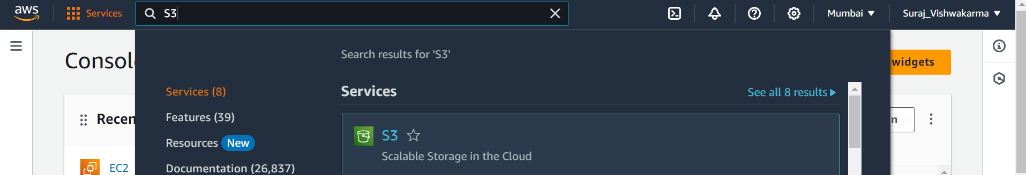

Then Click on Create Bucket

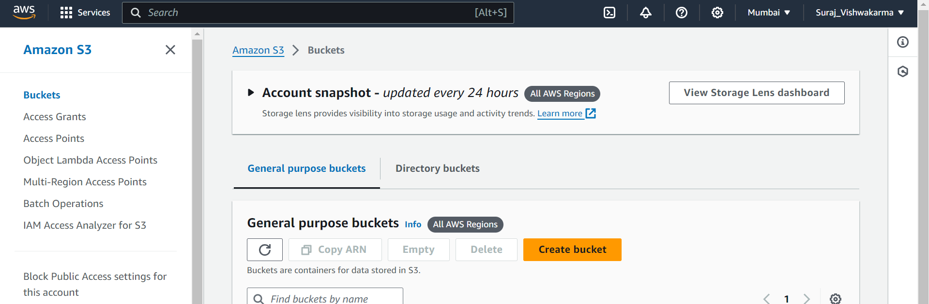

Give name to the bucket

Then click on block all parties if it is not turned on and let the other options be in default.

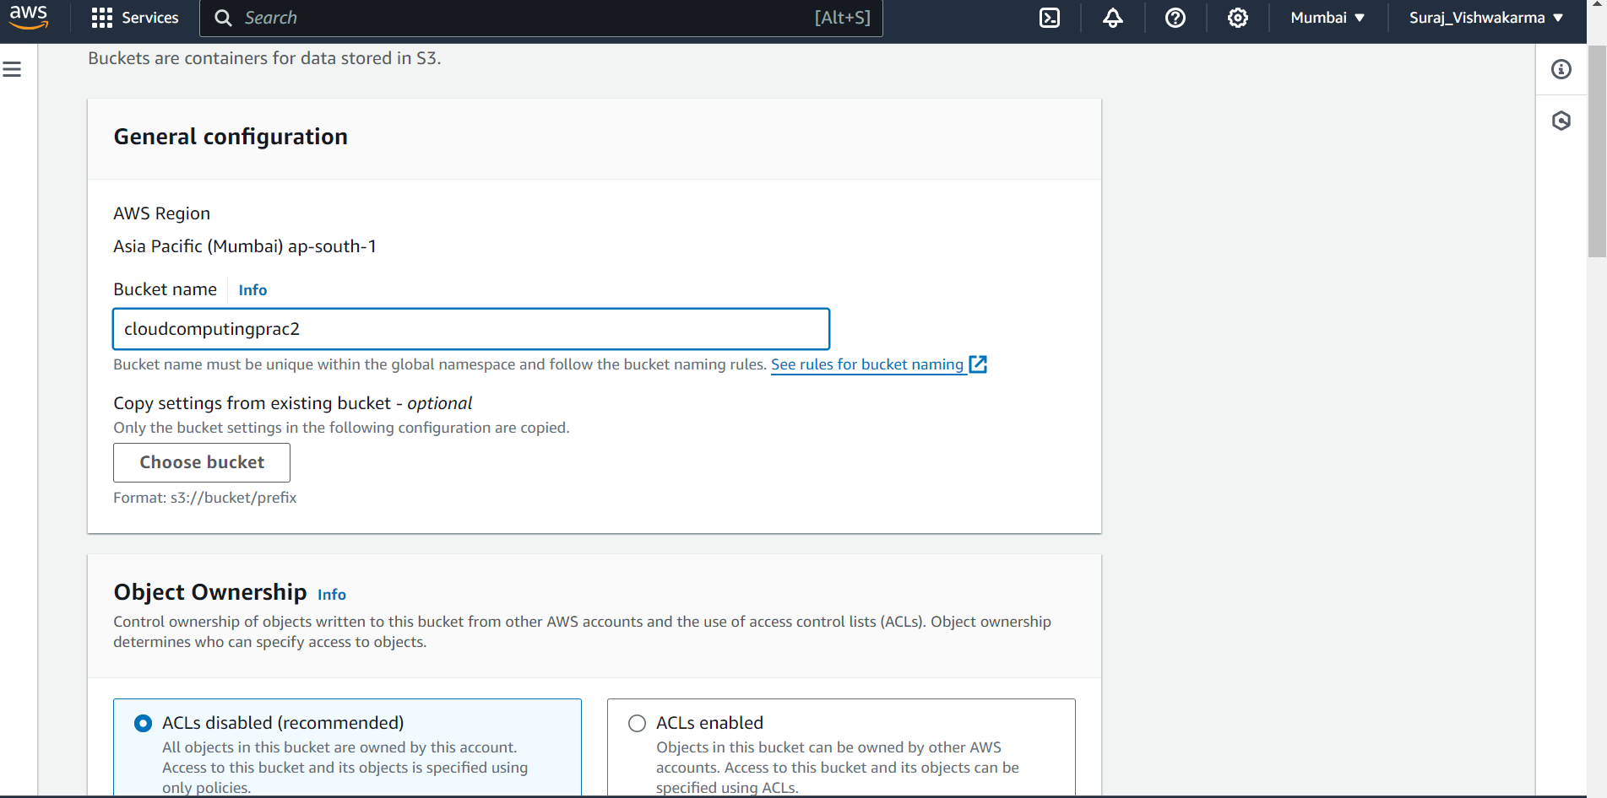

Then click on Create Bucket.

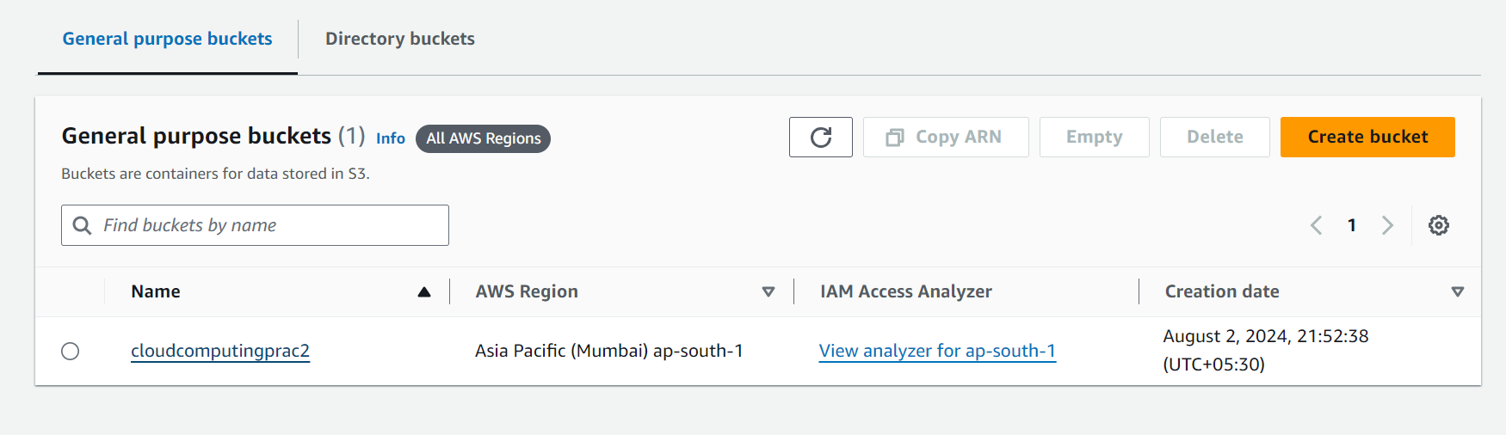

Click on Upload.

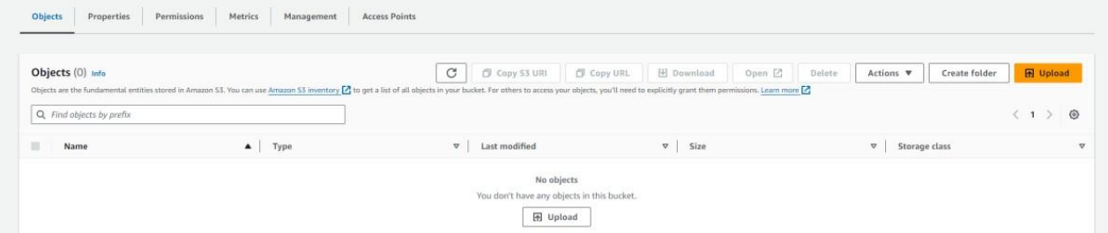

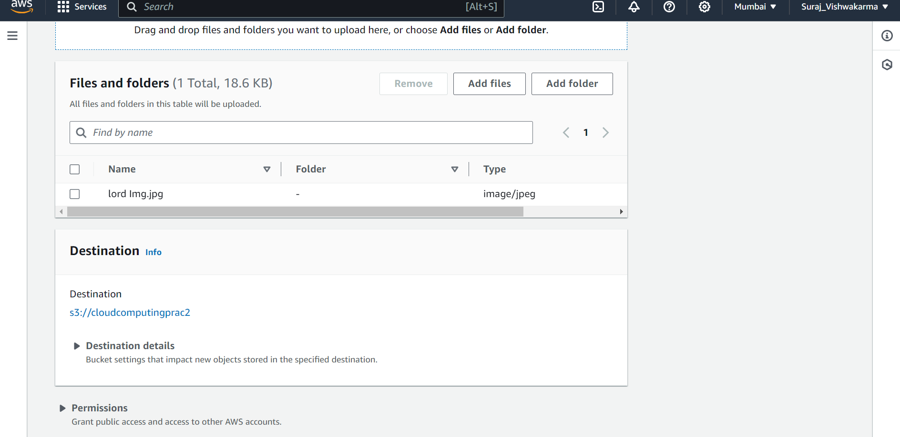

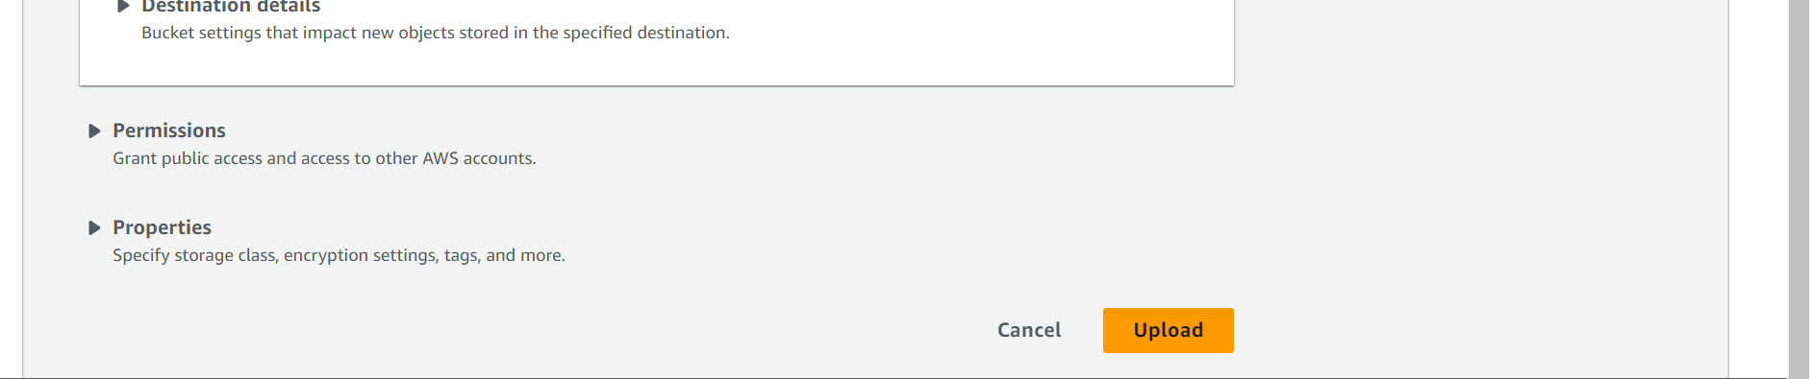

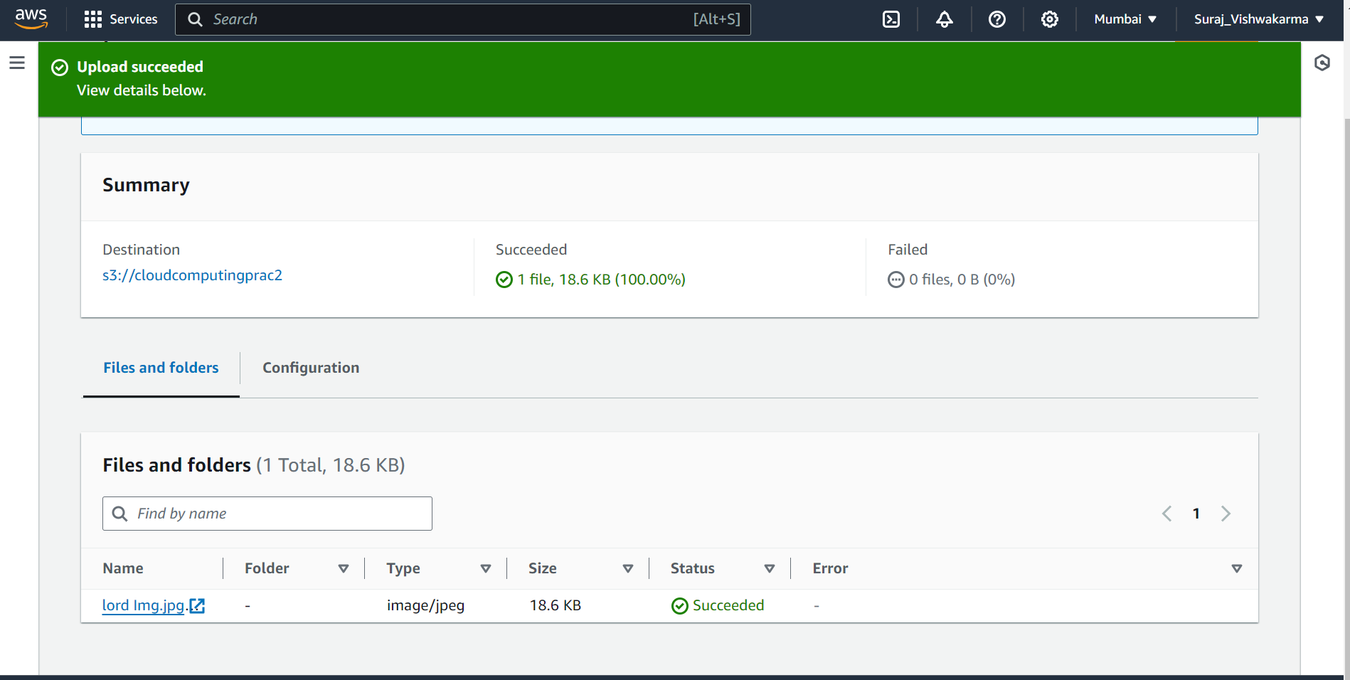

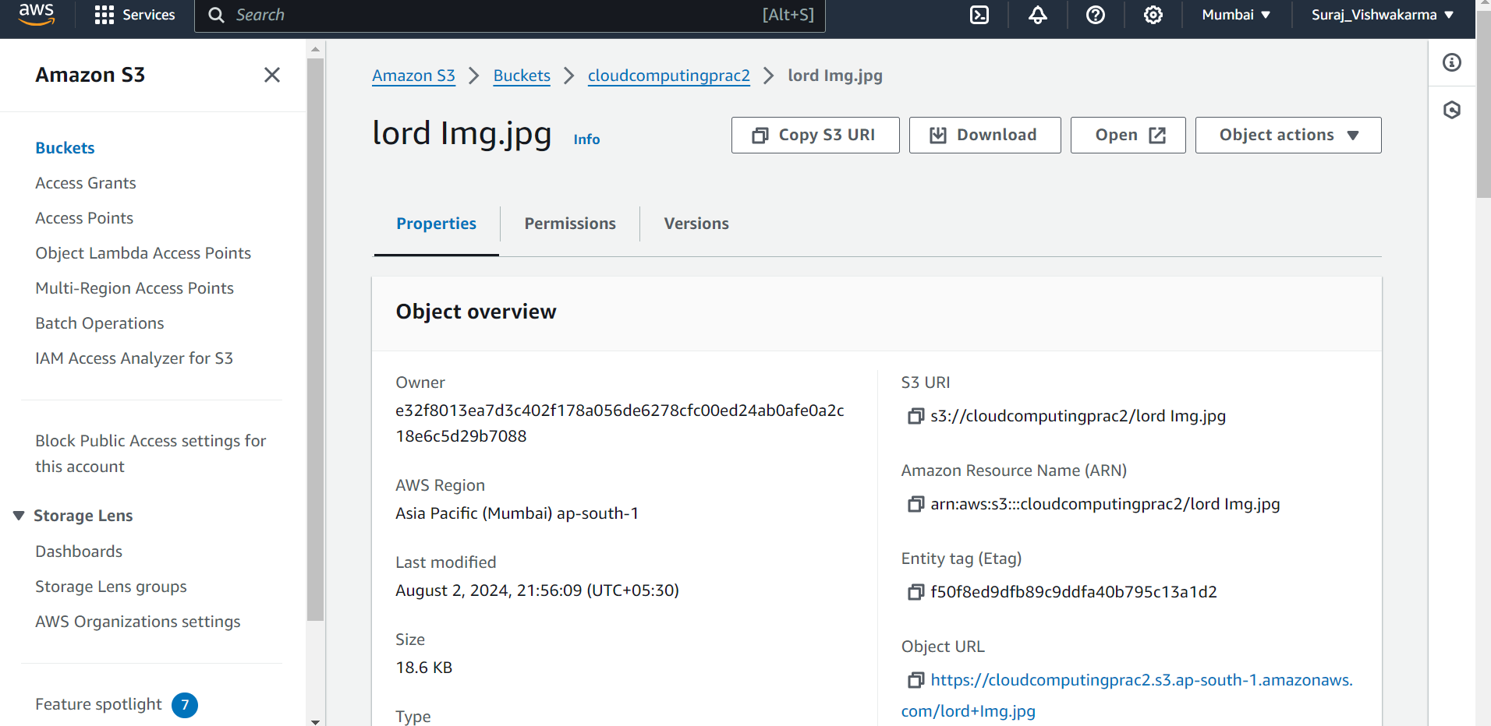

Click on the open button then you will get the uploaded image.



Uploading a static website:

Click on Create other bucket for creating another bucket for creating an html webpagethat will open in the AWS. Proceed the above process again.

