AGROPORTAL: AN INTELLIGENT AI-POWERED PLATFORM FOR PRECISION AGRICULTURE AND FARMER ASSISTANCE

A Project Report Submitted in Partial Fulfillment of the Requirements
for the Degree of BACHELOR OF TECHNOLOGY in COMPUTER SCIENCE & ENGINEERING
( ICS-851)

Bachelor of Technology
in

Computer Science and Engineering

Submitted by

2200520100011 | Amit Pandey
2200520100015 | Anshul Pandey
2200520100025 | Durgesh Agrahari

Under the guidance of

Dr. Pawan Kumar Tiwari Ms. Deepa Verma



Department of Computer Science and Engineering INSTITUTE OF ENGINEERING AND TECHNOLOGY
Dr. A.P.J. Abdul Kalam Technical University Uttar Pradesh

2025-2026

DECLARATION

We affirm that this submission is entirely our own work and, to the best of our knowledge and belief, it does not include any material previously published or authored by someone else, nor does it contain any content that has been accepted for the award of any degree or diploma at a university or other higher education institutions, except where proper acknowledgment is made in the text. This project has not been submitted by us to any other institution for the fulfillment of any other degree requirements. The findings and technical implementations documented herein represent a comprehensive effort to bridge the technological divide within the agricultural sector through data-driven methodologies.

Submitted by:
Amit Pandey (2200520100011)
Anshul Pandey (2200520100015)
Durgesh Agrahari (2200520100025)

CERTIFICATE

This document certifies that the project work carried out by Amit Pandey, Anshul Pandey, and Durgesh Agrahari, under my guidance and supervision at the Department of Computer Science and Engineering, Institute of Engineering and Technology, Lucknow, is detailed in the project report titled "AGROPORTAL: An Intelligent AI-Powered Platform for Precision Agriculture and Farmer Assistance". This report was submitted as part of the requirements for obtaining a Bachelor of Technology degree in Computer Science and Engineering. Furthermore, to the best of my knowledge, this project has not been submitted to any other institution for the purpose of earning any other degrees.

(Dr. Pawan Kumar Tiwari)
Department of Computer Science and Engineering
Institute of Engineering and Technology, Lucknow

(Ms. Deepa Verma)
Department of Computer Science and Engineering
Institute of Engineering and Technology, Lucknow

ACKNOWLEDGEMENT

The culmination of this research project was made possible through the collective support and intellectual guidance provided by the faculty and peers at the Institute of Engineering and Technology. We wish to recognize and thank everyone who offered their support throughout our study. We are profoundly thankful to the Almighty for the grace and blessings that allowed us to finish this project.
Our supervisors, Dr. Pawan Kumar Tiwari and Ms. Deepa Verma, deserve our sincere gratitude for their constant assistance and technical direction. Their vast knowledge and patience have been essential to the success of this B.Tech project. We are also appreciative of the project coordinator for providing us the opportunity and resources to carry out our study. Additionally, we extend our thanks to the Head of the CSE Department for providing the necessary tools and administrative assistance that facilitated a smooth research process.

ABSTRACT

The Agricultural Portal is an intelligent, data-driven web platform designed to support farmers in making accurate and timely decisions by integrating key modules such as crop recommendation, fertilizer recommendation, real-time weather forecasting, and agriculture-related news updates. Using machine learning algorithms and reliable environmental datasets, the system provides personalized insights based on soil characteristics, climatic conditions, and user inputs, helping farmers optimize crop selection, resource management, and overall production planning. This paper outlines the complete development process of the portal, including system architecture, model selection, dataset preparation, and implementation of each functional component, with a strong focus on creating a clean, intuitive, and accessible user interface suitable even for those with minimal technical knowledge. The platform’s modular and scalable design ensures efficient performance, easy maintenance, and potential for future enhancements. Beyond supporting day-to-day farming decisions, the portal promotes sustainable and data-driven agricultural practices by offering predictive analytics, environmental insights, and timely updates that help reduce uncertainty and mitigate risks. As digital transformation continues to reshape the agricultural sector, this Agricultural Portal serves as an essential tool for evolving traditional farming into a more efficient, intelligent, and resilient system.

CONTENTS

Section | Page No.
DECLARATION | i
CERTIFICATE | ii
ACKNOWLEDGEMENT | iii
ABSTRACT | iv
CHAPTER 1: INTRODUCTION | 1
1.1 Problem Statement | 2
1.2 Motivation | 3
1.3 Objective | 4
CHAPTER 2: LITERATURE REVIEW | 5
CHAPTER 3: METHODOLOGY | 8
3.1 System Architecture | 8
3.2 Proposed Methodology | 9
3.3 Algorithm Used | 10
3.4 Development Tools and Frameworks | 18
3.5 Implementation | 20
CHAPTER 4: RESULTS & DISCUSSION | 22
4.1 Training Details | 22
4.2 Result | 22
CHAPTER 5: CONCLUSION | 29
5.1 Conclusion | 29
5.2 Future Work | 29
REFERENCES | 30

FIGURES

Figures No. | Figure Captions | Page No.
Figures 4.1 | Crop Recommendation | 24
Figures 4.2 | Fertilizer Recommendation | 25
Figures 4.3 | Crop Prediction | 26
Figures 4.4 | Yield Prediction | 27
Figures 4.5 | Weather Forecast | 28

CHAPTER 1

INTRODUCTION

The contemporary agricultural landscape is undergoing a radical transition as digital and AI-based technologies are increasingly adopted to enhance productivity, efficiency, and sustainability. Agriculture remains one of the most essential sectors of the global economy, particularly in developing nations like India, where a substantial portion of the population relies on farming for food security and livelihood. However, the agricultural sector continues to face major challenges such as unpredictable climate changes, irregular rainfall patterns, soil degradation due to excessive chemical usage, and fragmented supply chains that often disadvantage farmers economically. Traditional farming methods, which mainly depend on experience and manual observation, are no longer sufficient to deal with the rapidly changing environmental and market conditions of modern agriculture.
Forecasting agricultural outcomes has become increasingly difficult because multiple factors such as soil nutrient levels, humidity, rainfall, temperature, and market demand directly influence crop productivity and profitability. Improper crop selection and fertilizer usage frequently lead to low yield and financial losses for farmers. To overcome these challenges, the integration of Artificial Intelligence (AI) and Machine Learning (ML) provides a more accurate and data-driven approach to agricultural management. Machine learning algorithms can analyze large agricultural datasets, identify patterns, and generate intelligent predictions that help farmers make informed decisions regarding crop cultivation, fertilizer application, and resource management.
In this context, AGROPORTAL is developed as an intelligent AI-powered agricultural assistance and precision farming platform designed to modernize traditional farming practices through advanced digital technologies. The platform combines multiple agricultural services into a single web-based portal, including crop recommendation, fertilizer suggestion, crop yield prediction, rainfall analysis, weather forecasting, market trading, agricultural news, and AI chatbot assistance. The system uses machine learning algorithms such as Random Forest, Decision Tree and Naive Bayes to provide accurate recommendations based on soil parameters like Nitrogen (N), Phosphorus (P), Potassium (K), humidity, temperature, and rainfall conditions. The integration of real-time weather forecasting through the OpenWeatherMap API further helps farmers in planning irrigation, harvesting, and fertilizer application efficiently.
Technically, AGROPORTAL is built as a MERN stack (MongoDB, Express.js, React.js, and Node.js) web application integrated with a Python-based machine learning inference layer through a Node.js child_process bridge. This hybrid architecture combines the fast and responsive user interface capabilities of React.js with the powerful scientific computing ecosystem of Python libraries such as Scikit-learn, Pandas, and NumPy. The portal also includes a trading marketplace that allows farmers to sell products directly to customers without intermediaries, ensuring transparency and fair pricing. Additionally, the AI-powered chatbot integrated using Groq LLM technology assists users by answering agricultural queries and providing guidance related to soil health, crops, fertilizers, and farming practices. Overall, AGROPORTAL aims to bridge the gap between traditional agriculture and modern intelligent farming systems by promoting precision agriculture, sustainable resource management, and digital empowerment for farmers.

Problem Statement
Farmers today face a systemic lack of transparency and reliable information, leading to suboptimal decision-making. Important factors such as precise soil nutrient deficiencies and the specific crops best suited for a particular climate often remain unknown or are based on imprecise guesswork. This dependency on traditional methods frequently leads to reduced productivity, improper fertilizer usage, and avoidable crop losses.
Furthermore, there is a distinct lack of integrated digital tools. While individual solutions exist for weather or soil testing, there is no single, unified web-based platform that combines soil-based crop recommendations, fertilizer guidance, yield prediction, and real-time weather updates. This fragmentation complicates the farmer's journey, forcing them to search for various inputs across disjointed platforms. Additionally, the lack of direct market access creates a dependency on middlemen, which optimizes revenue for intermediaries while complicating the financial stability of the farmer.

Problem Category | Specific Challenge | Impact
Technical Gap | Fragmented AI solutions | Incomplete tools for decision-making
Environmental | Climate variability | Unpredictable rainfall and temperature shifts
Operational | Reliance on traditional experience | Inaccurate assessment of soil health
Economic | Market middlemen dependency | Unfair pricing and reduced farmer income
Digital Divide | No unified portal | Farmers must consult multiple platforms

  - Motivation

The motivation behind AGROPORTAL is rooted in the belief that technology should empower the agricultural sector, which forms the backbone of the economy and supports millions of livelihoods worldwide. In many rural regions, farmers still rely on traditional farming practices, outdated information, and manual decision-making methods for crop selection, fertilizer usage, and irrigation planning. The lack of access to accurate agricultural guidance often leads to low productivity, soil degradation, improper resource utilization, and financial losses. AGROPORTAL was developed with the aim of reducing this information gap by providing farmers with a smart, reliable, and data-driven agricultural assistance platform.
With the increasing availability of internet connectivity and digital services in rural areas, there is a significant opportunity to introduce intelligent agricultural solutions that are simple, accessible, and practical for everyday farming activities. The project is motivated by the growing need for precision agriculture, where decisions are based on scientific analysis rather than assumptions. By integrating Machine Learning algorithms such as Random Forest, Decision Tree the portal helps farmers receive accurate crop recommendations, fertilizer suggestions, crop yield predictions, and rainfall analysis based on soil and environmental conditions.
Another major motivation behind this project is to support sustainable farming and efficient resource management. Excessive use of fertilizers and poor crop planning not only reduce soil fertility but also increase production costs for farmers. Through intelligent prediction systems and soil-based recommendations, AGROPORTAL aims to optimize agricultural resources, improve crop productivity, and minimize environmental damage caused by improper farming practices. Additionally, the integration of real-time weather forecasting enables farmers to better prepare for changing climatic conditions and reduce risks associated with unpredictable rainfall and temperature variations.
The project is also motivated by the economic challenges faced by farmers due to fragmented supply chains and dependency on middlemen for selling agricultural produce. AGROPORTAL addresses this issue by providing a digital trading marketplace where farmers can directly connect with customers and sell their products transparently. Furthermore, the inclusion of an AI-powered chatbot, agricultural news feeds, and government advisory updates helps farmers stay informed about modern farming techniques, schemes, and best practices. Overall, the motivation behind AGROPORTAL is to create a smart and unified agricultural ecosystem that promotes digital transformation, sustainable farming, and improved quality of life for farming communities.

Objective
The primary objective of this project is to develop an efficient, smart, and unified Agricultural Web Portal that consolidates various decision-support tools into one user-friendly platform. The specific goals are as follows:
- To Develop Intelligent Recommendation Model using machine learning
- To Optimize Resource Management through fertilizer recommendation
- To Enhance Predictive Capability using crop yield and rainfall forecasting
- To Bridge the Information Divide with real-time agricultural updates
• To Build a Scalable MERN Platform integrated with machine learning models

CHAPTER 2
LITERATURE REVIEW

Recent studies show that AI-based crop disease detection systems are becoming one of the most reliable solutions for modern farming challenges. Research highlights that traditional visual inspection by farmers is often slow, inaccurate, and highly dependent on experience. To overcome these issues, recent literature strongly supports the use of deep learning, especially Convolutional Neural Networks (CNNs), for analyzing leaf images and identifying disease patterns automatically.
Patel & Singh (2022) proposed CNN-based model that extract fine-grained features such as colour variations, textures, and lesion shapes, providing significantly higher accuracy compared to classical machine learning techniques. Several researchers also emphasize the importance of image datasets, data augmentation, and training optimization methods to improve model robustness under varying lighting and environmental conditions. Studies further show that integrating AI models with cloud platforms or mobile applications allows farmers to receive instant disease predictions directly in the field. Overall, the literature agrees that AI-driven disease detection systems offer faster diagnosis, reduce crop losses, and support the development of an efficient and scalable smart agriculture platform, which closely aligns with the objectives of the proposed project [1].

Agriculture in India faces several challenges such as outdated farming methods, climate uncertainty, and limited access to modern technology. Recent studies have shown that Artificial Intelligence and Machine Learning can improve agricultural productivity through crop prediction, disease detection, and yield forecasting. Researchers such as Rahman, Shamrat, Tasnim, Roy, and Hossain (2019) highlighted the effectiveness of supervised Machine Learning algorithms in intelligent prediction systems and decision-making models [2].
Many existing agricultural systems provide separate services such as weather forecasting, crop recommendation, or online trading, but they often lack an integrated and user-friendly platform for farmers. To overcome these limitations, the proposed Agricultural Assistance & Trading Portal combines Machine Learning models, AI-powered tools, weather forecasting, agricultural news, and crop trading features into a single platform. The system helps farmers make informed decisions, improve productivity, and access modern agricultural technologies more efficiently.
Finally, the Agricultural Assistance & Trading Portal demonstrates how technologies such as Machine Learning, Artificial Intelligence, cloud APIs, and full-stack web development can be effectively applied in the agricultural sector. The system provides intelligent decision-support tools, secure digital trading, and real-time agricultural assistance through an integrated platform. By improving accessibility to smart farming technologies and reducing the gap between farmers and consumers, the project contributes toward efficient, sustainable, and technology-driven agriculture.

Existing research in smart agriculture highlights the importance of Machine Learning and data-driven systems in supporting farmers’ decision-making processes. Various studies have used parameters such as temperature, rainfall, soil type, season, and cultivation area for crop and yield prediction. Researchers have applied algorithms including Artificial Neural Networks (ANN), Regression Models, K-Nearest Neighbors (KNN), Decision Trees, Random Forests, and Stacking Regression to improve prediction accuracy and agricultural planning.
Several studies also focus on fertilizer recommendation, weather forecasting, and crop suitability analysis using soil and climate data. Researchers have emphasized the use of association-rule mining and predictive analytics to identify relationships between agricultural parameters and farming outcomes. Liu, Zhang, and Wang (2025) discussed the recent advancements and challenges in Machine Learning-based crop yield prediction systems and highlighted the growing role of intelligent agriculture technologies in improving productivity and sustainability [3].
These research contributions demonstrate that integrating Machine Learning models with web-based platforms can significantly enhance agricultural efficiency and farmer support systems. Inspired by these advancements, the proposed Agricultural Assistance & Trading Portal combines crop prediction, yield estimation, weather forecasting, fertilizer recommendation, AI chatbot assistance, and online crop trading into a single integrated platform. The system aims to provide real-time recommendations, intelligent decision support, and improved accessibility to modern agricultural technologies for farmers and customers.

Recent research highlights the growing importance of Artificial Intelligence, Internet of Things (IoT), and precision agriculture in achieving sustainable and climate-smart farming. Technologies such as Machine Learning, deep learning, and remote sensing are widely used for soil analysis, irrigation optimization, crop monitoring, and disease detection. Precision farming tools including GPS-based systems and Variable Rate Technology (VRT) help improve resource utilization, reduce wastage, and increase agricultural productivity. Manjula and Djodiltachoumy (2017) proposed a crop yield prediction model that demonstrated the effectiveness of computational intelligence techniques in improving agricultural planning and productivity [4].
However, many existing agricultural systems focus only on individual services and lack a centralized, user-friendly platform that integrates multiple functionalities. To overcome this limitation, the proposed Agricultural Assistance & Trading Portal combines Machine Learning models, AI chatbot support, crop prediction, weather forecasting, fertilizer recommendation, and online crop trading within a single platform. The system aims to provide intelligent, accessible, and technology-driven agricultural support that promotes sustainable farming and improves farmer productivity.

Agriculture is one of the most important sectors for economic growth and food sustainability, but it faces major challenges due to climate change, unpredictable weather conditions, and limited agricultural resources. Recent studies highlight the growing use of Artificial Intelligence (AI) and Machine Learning (ML) in improving agricultural productivity and decision-making. Techniques such as supervised learning, unsupervised learning, reinforcement learning, and Long Short-Term Memory (LSTM) models are widely used for crop yield prediction, weather forecasting, irrigation planning, and resource optimization. Karishma Kumari, Ali Mirzakhani Nafchi, Salman Mirzaee, and Ahmed Abdalla (2025) discussed the role of AI-driven technologies in achieving climate-smart and sustainable agriculture through intelligent prediction and analysis systems [5].
Despite these advancements, many existing agricultural solutions focus only on specific functionalities and do not provide a centralized platform for complete farm management. To address this limitation, the proposed Agricultural Assistance & Trading Portal integrates crop prediction, fertilizer recommendation, yield estimation, weather forecasting, AI chatbot assistance, agricultural news, and online crop trading into a single platform. The system provides a multilingual, intelligent, and user-friendly solution that supports modern farming practices, improves decision-making, and promotes sustainable agriculture through technology-driven assistance.

CHAPTER 3
METHODOLOGY

The methodology outlines the step-by-step approach that will be followed to develop the Agricultural Web Portal. The main aim is to create a simple, useful, and reliable system that supports farmers with important information and basic prediction features. The methodology for AGROPORTAL defines the systematic approach used to transform raw environmental data into actionable agricultural intelligence. The primary goal is to create a reliable system that supports farmers with accurate predictions and seamless market access.

3.1 System Architecture
AGROPORTAL is built on the MERN stack with a Python ML inference sidecar. The system follows a multi-layered client-server architecture where modern frontend, backend, database, and machine learning technologies work together to provide intelligent agricultural services. The frontend is developed using React.js with Vite to create a fast, responsive, and component-based user interface for farmers, customers, and administrators. The backend utilizes Node.js and Express.js to manage REST APIs, authentication, routing, and communication between different system modules. MongoDB with Mongoose ODM is used as the database layer to efficiently store user records, crop listings, orders, and prediction-related data in a flexible NoSQL structure.
The machine learning layer is implemented using Python and scikit-learn libraries to perform crop recommendation, fertilizer prediction, rainfall forecasting, and yield analysis. These ML models are connected with the backend through Node.js child_process integration, enabling real-time prediction generation from the web application. Additionally, external APIs such as OpenWeatherMap, NewsAPI, and Groq are integrated to provide weather forecasting, agricultural news updates, and AI-powered chatbot assistance. The overall architecture ensures scalability, modularity, secure data management, efficient processing, and smooth interaction between users and intelligent prediction services.
Layer | Technology | Purpose
Frontend | React.js (Vite) | Provides responsive Single  Page Application (SPA) interface and dynamic UI components
Backend | Node.js + Express.js | Handles REST APIs, routing, authentication, and server-side logic
Database | MongoDB (Mongoose ODM) | Stores users, products, orders, predictions, and application data
ML Engine | Python + scikit-learn | ML inference scripts invoked via child_process
External APIs | OpenWeatherMap, NewsAPI, Groq | Provides weather updates, agricultural news, and AI chatbot functionality

┌─────────────────────────────────────────────────────────┐
│ CLIENT LAYER (React.js) │
│ ┌──────────────┐ ┌──────────────┐ ┌──────────────┐ │
│ │ Farmer UI │ │ Customer UI │ │ Admin UI │ │
│ └──────────────┘ └──────────────┘ └──────────────┘ │
└─────────────────────────┬───────────────────────────────┘
│ HTTP / REST API (Axios)
▼
┌─────────────────────────────────────────────────────────┐
│ SERVER LAYER (Express.js / Node.js) │
│ ┌──────────────────────────────────────────────────┐ │
│ │ intelligenceController.js │ │
│ │ authController │ productController │ │
│ │ orderController │ adminController │ │
│ └──────────────────────────────────────────────────┘ │
│ │ │
│ ┌─────────────────────┼──────────────────────┐ │
│ │ child_process.spawn('python', [...args]) │ │
│ └─────────────────────┬──────────────────────┘ │
└──────────────────────────┼──────────────────────────────┘
│
▼
┌─────────────────────────────────────────────────────────┐
│ ML INFERENCE LAYER (Python / scikit-learn) │
│ recommend.py │ fertilizer_recommendation.py │
│ ZDecision_Tree_Call.py │ yield_prediction.py │
│ rainfall_prediction.py │
│ filetest2.pkl (pre-trained Decision Tree model) │
└─────────────────────────────────────────────────────────┘
│
▼
┌─────────────────────────────────────────────────────────┐
│ DATA LAYER (MongoDB Atlas) │
│ Users │ Products │ Orders │ Contact Queries │
└─────────────────────────────────────────────────────────┘
Figure 3.1 — System Architecture: MERN + Python ML Hybrid

3.2 Proposed methodology
The proposed methodology of AGROPORTAL follows a systematic and data-driven approach to provide intelligent agricultural assistance to farmers. The system begins with data collection from publicly available agricultural datasets, soil databases, government weather archives (IMD), and Kaggle datasets containing information related to soil nutrients, rainfall, humidity, temperature, crop types, and yield statistics. After collection, the data undergoes preprocessing techniques such as cleaning, normalization, handling missing values, and feature selection to improve model accuracy and reliability.
The processed data is then used to train multiple machine learning models including Random Forest, Decision Tree and regression-based algorithms. These models are integrated into the portal through a Python-based inference layer, enabling real-time predictions and recommendations. The backend server communicates with the ML modules and delivers prediction results to the frontend interface through REST APIs, allowing users to interact with the system efficiently.
The proposed system mainly focuses on five intelligent agricultural services that assist farmers in making informed decisions and improving productivity. These predictive modules are designed to reduce dependency on traditional guesswork and promote precision agriculture using modern AI techniques.
Additionally, the methodology emphasizes real-time accessibility and practical usability for farmers through an integrated web-based platform. The system combines machine learning predictions, weather forecasting, market trading, agricultural news, and AI-powered chatbot support within a single interface. By integrating intelligent recommendation systems with modern web technologies, AGROPORTAL aims to improve decision-making, increase agricultural productivity, reduce financial risks, and promote sustainable farming practices in rural and urban agricultural communities alike

The five primary ML tasks addressed are:

1. Crop Recommendation — What crop should I grow given my soil and climate?
2. Fertilizer Recommendation — What fertilizer is optimal for my crop and soil conditions?
3. Regional Crop Prediction — Which crops historically thrive in my state/district/season?
4. Yield Prediction — How much produce (in Quintals) can I expect from a given area?
5. Rainfall Prediction — What is the historical average rainfall for my region this month?

Algorithm used
This section details each machine learning algorithm used in AGROPORTAL, including the mathematical foundations, training process, and integration with the web platform.

3.3.1 Algorithm 1 — Random Forest Classifier (Crop Recommendation)
Random Forest is an ensemble learning method that constructs a multitude of decision trees during training and outputs the mode of the classes (for classification) or the mean of predictions (for regression) of the individual trees. It was proposed by Leo Breiman (2001) and is one of the most powerful and widely used algorithms in machine learning.

Core Concepts
Bagging (Bootstrap Aggregating): Random Forest uses bagging to create diversity among its trees. Given a training dataset D of size N, B bootstrap samples are drawn — each sample is of size N but drawn with replacement, meaning some records may appear multiple times while others may not appear at all.
Random Feature Selection: At each node split, instead of considering all features, Random Forest randomly selects a subset of m features (where m = √total_features for classification). This de-correlates the trees, making the ensemble more robust.
Mathematical Formula (Majority Vote):
$$ŷ =\arg{\max_{c}{\sum_{t=1}^{B}{I\left(ŷ_{t}= c\right)}}}$$Where:
ŷₜ = prediction of the t-th tree
B = total number of trees
I(·) = indicator function
c = target class label

Information Gain and Entropy (Split Criterion)
In AGROPORTAL’s crop recommendation model, Entropy is used as the split criterion to measure the impurity or randomness present in the dataset. The Decision Tree algorithm selects the feature that provides the maximum Information Gain, helping the model create more accurate and meaningful splits. A lower entropy value indicates higher purity in the dataset, resulting in better classification performance for crop prediction tasks.
$$Entropy\left(S\right)= -∑p_{i}\backslash log_{2\left(p_{i}\right)}$$
Where:
S = training dataset
$p_{i}$ = proportion of samples belonging to class $i$
n = total number of classes
$$InformationGain\left(S,A\right)= Entropy\left(S\right)- ∑\left(\frac{\left|S_{v}\right|}{\left|S\right|}\right)⋅Entropy\left(S_{v}\right)$$
Where:
S = complete training dataset
A = selected attribute/feature
Sv = subset of samples for value v
$∣S_{v}∣$ = number of samples in subset Sv
$∣S∣$= total number of samples in dataset
$Entropy(S_{v})$= entropy of subset $S_{v}$
The split that maximizes Information Gain is chosen at each node.
How It Works in AGROPORTAL
Input: [N, P, K, Temperature, Humidity, pH, Rainfall]
│
▼
Load Crop_recommendation.csv (2,200 records, 22 crop classes)
│
▼
Split: 80% Train / 20% Test (random_state = 0)
│
▼
Train RandomForestClassifier(n_estimators=10, criterion='entropy')
│
├── Tree 1: Bootstrap sample → Build decision tree on random feature subset
├── Tree 2: Bootstrap sample → Build decision tree on random feature subset
│ ...
└── Tree 10: Bootstrap sample → Build decision tree on random feature subset
│
▼
User input → Each tree votes for a crop class
│
▼
Majority vote across 10 trees → Final predicted crop
│
▼
Output: "rice" / "wheat" / "maize" / etc.
Figure 3.2 — Random Forest Ensemble Decision Making

Performance

Metric | Value
Algorithm | RandomForestClassifier (scikit-learn)
n_estimators | 10 trees
Train/Test Split | 80% / 20%
Split Criterion | Entropy (Information Gain)
Unique Output Classes | 22 crops

Dataset: Crop_recommendation.csv
- Source: Kaggle (Atharva Ingle) — Apache 2.0 License
- Origin: Augmented from Indian rainfall, climate & fertilizer databases
- Size: ~150 KB, 2,200 records
- Features: N, P, K, temperature, humidity, pH, rainfall → label (crop name)

3.3.2 Algorithm 2 — Decision Tree Classifier (Fertilizer Recommendation)
A Decision Tree is a supervised machine learning algorithm that represents decisions and their possible outcomes in the form of a tree-like structure. It works by repeatedly splitting the dataset based on the most significant input features, allowing the model to classify or predict outcomes effectively. Each internal node represents a condition or test on an attribute, each branch represents the result of that test, and each leaf node represents the final prediction or decision.
In AGROPORTAL, the Decision Tree algorithm is used for fertilizer recommendation and crop prediction tasks because of its simplicity, interpretability, and high classification performance. The algorithm can easily identify relationships between soil nutrients, environmental conditions, and suitable agricultural recommendations. Its rule-based structure also makes the prediction process easier to understand for analysis and visualization purposes.

Gini Impurity (Split Criterion)
The fertilizer recommendation Decision Tree uses Gini Impurity as its split criterion:
$$Gini\left(S\right)=1-\sum_{i=1}^{C}{p_{i}^{2}}$$
Where:
$S$= training dataset
$C$= total number of classes
$p_{i}$= proportion of samples belonging to class $i$
Gini Gain at each split:
$$InformationGain\left(S,A\right)=Entropy\left(S\right)-∑\left.\left(frac\left\{\left|S_{v}\right|\right\}/\left\{\left|S\right|\right\}\right.\right)×Entropy\left(S_{v}\right)$$
Where:
S = complete training dataset
$A$= selected attribute/feature
$S_{v}$= subset created after splitting on value $v$
$∣S_{v}∣$= number of samples in subset $S_{v}$
$∣S∣$= total number of samples in dataset
$Gini(S_{v})$= Gini impurity of subset $S_{v}$
The algorithm selects the split that maximizes the Gini Gain, thereby minimizing impurity and improving classification accuracy.

Label Encoding
Categorical features - Soil Type (Sandy, Loamy, Black, Red, Clayey) and Crop Type (Wheat, Maize, Sugarcane, etc.) - are first converted to numeric labels using LabelEncoder:
Label Encoder: Sandy → 0, Loamy → 1, Black → 2, Red → 3, Clayey → 4
This enables the numeric comparison operations required by the Decision Tree algorithm.

How It Works in AGROPORTAL
Input: [N, P, K, Temperature, Humidity, SoilMoisture, SoilType, CropType]
│
▼
Encode SoilType and CropType using LabelEncoder
│
▼
Build input vector:
[Temperature, Humidity, Moisture, SoilType_enc, CropType_enc, N, K, P]
│
▼
Load fertilizer_recommendation.csv → Train DecisionTreeClassifier(criterion='gini')
│
▼
Root Node: Best split on highest Gini Gain feature
├── Branch A: Further splits...
│ └── Leaf: "Urea"
├── Branch B: Further splits...
│ └── Leaf: "DAP"
└── Branch C: Further splits...
└── Leaf: "14-35-14"
│
▼
Output: Fertilizer name (e.g., "Urea", "DAP", "MOP", "14-35-14")

Figure 3.3 — Decision Tree CART Splitting using Gini Impurity

Dataset: fertilizer_recommendation.csv
- Source: Kaggle (G D Abhishek) — Research compilation
- Size: ~3.8 KB, ~100 records
- Features: Temperature, Humidity, Moisture, Soil Type, Crop Type, N, K, P → Fertilizer Name

3.3.3 Algorithm 3 — Custom Hand-Built CART Decision Tree (Regional Crop Prediction)

Overview
Unlike the scikit-learn Decision Tree Classifier used for fertilizer prediction, the regional crop prediction model uses a hand-implemented CART (Classification and Regression Trees) Decision Tree, built entirely from scratch in Python. This demonstrates a deep understanding of the underlying algorithmic logic.

Key Functions Implemented
def gini(Data):
"""
Calculates Gini Impurity for a dataset.
gini = 1 - Σ p_i² for all unique classes i
"""
classes = Data[:, -1]
n = len(classes)
_, counts = np.unique(classes, return_counts=True)
probabilities = counts / n
return 1 - np.sum(probabilities ** 2)

def info_gain(left, right):
"""
Calculates Information Gain of a binary split.
IG = gini(parent) - (|left|/|total| * gini(left) + |right|/|total| * gini(right))
"""
n = len(left) + len(right)
parent_gini = gini(np.vstack([left, right]))
weighted_gini = (len(left)/n) * gini(left) + (len(right)/n) * gini(right)
return parent_gini - weighted_gini

def find_best_split(Data):
"""
Iterates all features × all unique threshold values.
Returns the (feature_index, threshold) that maximizes Information Gain.
"""
best_gain = 0
best_split = None
for feature_idx in range(Data.shape[1] - 1):
thresholds = np.unique(Data[:, feature_idx])
for threshold in thresholds:
left = Data[Data[:, feature_idx] <= threshold]
right = Data[Data[:, feature_idx] > threshold]
if len(left) == 0 or len(right) == 0:
continue
gain = info_gain(left, right)
if gain > best_gain:
best_gain = gain
best_split = (feature_idx, threshold)
return best_split

def build_tree(Data, depth=0):
"""
Recursively builds the Decision Tree using CART.
Stops when: pure node, insufficient data, or max depth reached.
"""
if len(np.unique(Data[:, -1])) == 1 or len(Data) < 2:
# Leaf node: store class probability distribution
return LeafNode(Data)

split = find_best_split(Data)
if split is None:
return LeafNode(Data)

feature_idx, threshold = split
left = Data[Data[:, feature_idx] <= threshold]
right = Data[Data[:, feature_idx] > threshold]

return DecisionNode(
feature_idx, threshold,
left_branch=build_tree(left, depth+1),
right_branch=build_tree(right, depth+1)
)

def classify(row, node):
"""Traverses the tree to classify a single input row."""
if isinstance(node, LeafNode):
return node.class_distribution # {crop_name: probability%}
if row[node.feature_idx] <= node.threshold:
return classify(row, node.left_branch)
return classify(row, node.right_branch)

Model Persistence (Pickle)
The trained tree is serialized using joblib.dump to a .pkl file, allowing inference without re-training:
import joblib
# Training (offline, once):
tree = build_tree(training_data)
joblib.dump(tree, 'filetest2.pkl')

# Inference (runtime):
tree = joblib.load('filetest2.pkl')
result = classify(user_input_row, tree)

How It Works in AGROPORTAL
[One-time Offline Training — ZDecision_Tree_Model.py]
Load preprocessed2.csv (300,000 rows, all-India crop data)
→ Encode: State, District, Season using LabelEncoder
→ build_tree() → Recursively split on best Gini Gain
→ joblib.dump(tree, 'filetest2.pkl')

[Runtime Inference — ZDecision_Tree_Model_Call.py]
joblib.load('filetest2.pkl')
→ Input: [State_encoded, District_encoded, Season_encoded]
→ classify(row, tree) → Leaf node
→ class_distribution: {Rice: 45%, Maize: 30%, Ragi: 25%}
→ Output: All crops with probabilities

Dataset: preprocessed2.csv
- Source: Kaggle (Abhinand) — Government of India agricultural records
- Size: ~12 MB, ~300,000 records
- Features: State_Name, District_Name, Season → Crop (target)

3.3.4 Algorithm 4 — Random Forest Regressor (Yield Prediction)

Regression vs. Classification
While crop recommendation uses Random Forest for classification (predicting a discrete crop name), yield prediction uses it for regression (predicting a continuous numerical value — production in Quintals).
For regression, each tree outputs a numeric value, and the final prediction is the mean across all trees:
ŷ = (1/B) * Σ(t=1 to B) ŷ_t(x)
Where ŷ_t(x) is the prediction of the t-th tree for input x.

One-Hot Encoding
Categorical columns (State_Name, District_Name, Season, Crop) are converted using OneHotEncoder. Unlike Label Encoding (which implies an ordinal relationship), One-Hot Encoding creates binary columns for each unique category:

Season: ["Kharif", "Rabi", "Whole Year"]
→ [1, 0, 0] for Kharif
→ [0, 1, 0] for Rabi
→ [0, 0, 1] for Whole Year
This prevents the model from incorrectly interpreting "Rabi > Kharif" due to label ordering.

Regression Evaluation Metrics
Metric | Formula | Meaning
R² Score | $$1-\left.\left(frac\left\{SS_{\left\{res\right\}}\right\}/\left\{SS_{\left\{tot\right\}}\right\}\right.\right)$$ | Proportion of variance explained by the model
MAE | `(1/n) * Σ | $$y_{i}-\hat{y}i$$
RMSE | $$\sqrt{\left\{\left.\left(\backslash frac\left\{1\right\}\left\{n\right\}\right.\right)\backslash sum{\left.\left(y_{i}-\hat{yi}\right.\right)}^{2}\right\}}$$ | Square root of mean squared error
MAPE | `(1/n) * Σ | $$\left\{y_{i}-\hat{y}i\right\}/\left\{y_{i}\right\}$$

How It Works in AGROPORTAL
Input: [State, District, Season, Crop, Area (hectares)]
│
▼
Load crop_production_karnataka.csv
Strip whitespace from Season values
Drop rows where Production is NaN
Drop Crop_Year column (not predictive)
│
▼
OneHotEncode: [State_Name, District_Name, Season, Crop]
Numeric pass-through: [Area]
│
▼
ColumnTransformer → Combined feature matrix
│
▼
Train RandomForestRegressor(n_estimators=100, random_state=42)
│
▼
User input → Same OHE transformation → Predict
│
▼
Output: Production in Quintals (rounded to 2 decimals)

Dataset: crop_production_karnataka.csv
- Source: Kaggle (Abhinand) — Government of India agricultural records
- Size: ~1.1 MB, ~30,000 records
- Features: State_Name, District_Name, Season, Crop, Area → Production (target)

3.3.5 Algorithm 5 — Historical Mean Lookup (Rainfall Prediction)

Overview
The rainfall prediction module does not rely on a trained ML model. Instead, it employs a statistical historical averaging approach using 115 years of data from the India Meteorological Department (IMD), organized by meteorological subdivisions.

Mathematical Basis
Given a dataset D containing rainfall records for a specific SUBDIVISION, the predicted rainfall for a given month M is:
Rainfall_predicted(SUBDIVISION, M) = (1/N) * Σ(year=1901 to 2015) Rainfall(year, SUBDIVISION, M)
Where N is the number of valid (non-null) yearly records for that subdivision in that month.

Implementation (Pandas)
import pandas as pd
import sys

region = sys.argv[1] # e.g., "KERALA"
month = sys.argv[2] # e.g., "JUN"

df = pd.read_csv('rainfall_in_india_1901-2015.csv')

# Filter to the requested subdivision
subset = df[df['SUBDIVISION'].str.upper() == region.upper()]

# Compute mean for the requested month column
result = subset[month].mean()

print(round(result, 2))

Dataset: rainfall_in_india_1901-2015.csv
- Source: Kaggle (Rajanand Ilangovan) — IMD / data.gov.in, CC BY-SA 4.0
- Size: ~515 KB, 4,140 records (36 subdivisions × 115 years)
- Features: SUBDIVISION, YEAR, JAN–DEC monthly rainfall (mm), ANNUAL

Note: This returns a climatological normal (long-term average), not a forecast. For real-time forecasting, the GET /api/intelligence/weather?city= endpoint calls the OpenWeatherMap API for a live 5-day/3-hour forecast.

3.4 Development Tools and Frameworks
The development of AGROPORTAL utilizes a robust and scalable software stack to ensure efficient performance, modularity, and seamless integration of machine learning services with the web platform. The system combines modern frontend and backend technologies to provide a responsive user experience along with reliable server-side processing. React.js is used to create dynamic and reusable user interface components, while Node.js and Express.js manage API handling, routing, and backend operations efficiently. MongoDB serves as the primary database for storing user records, products, orders, and agricultural information in a flexible NoSQL format.
For intelligent prediction and recommendation services, Python-based machine learning libraries such as scikit-learn, Pandas, and NumPy are integrated into the system. External APIs including OpenWeatherMap and NewsAPI are used to provide real-time weather forecasting and live agricultural news updates. Additionally, JWT authentication and bcrypt encryption are implemented to ensure secure user authentication and data protection. Git and GitHub are utilized for version control and collaborative development, while Visual Studio Code serves as the primary development environment for coding, debugging, and project management.

Tool Category | Technology Used | Rationale
Frontend Framework | React.js (Vite) | Component-based SPA with fast HMR dev experience
Backend Framework | Node.js + Express.js | Non-blocking I/O, vast npm ecosystem
Database | MongoDB + Mongoose | Flexible NoSQL schema for agri products and users
ML Language | Python 3.x | scikit-learn, Pandas, NumPy for ML inference
Authentication | JWT + bcrypt | Stateless, scalable token-based auth
Weather API | OpenWeatherMap | Real-time 5-day forecast
News API | NewsAPI.org | Live agricultural news feed
AI Chatbot | Groq (llama-3.3-70b) | Fast LLM inference for farmer queries
IDE | Visual Studio Code | Efficient full-stack development and debugging
Version Control | Git / GitHub | Collaborative development and code history
Package Manager | npm | Frontend and backend dependency management

Python Scientific Libraries

Library | Version | Purpose
scikit-learn | ≥ 1.0 | RandomForestClassifier/Regressor, DecisionTreeClassifier, LabelEncoder, OneHotEncoder
pandas | ≥ 1.3 | Data loading, filtering, mean computation
numpy | ≥ 1.21 | Array operations, Gini impurity calculations
joblib | ≥ 1.0 | Model serialization (pkl file save/load)

3.5 Implementation
The implementation of AGROPORTAL is divided into three distinct user modules to cater to different user groups, ensuring a centralized yet secure environment for all agricultural transactions.

3.5.1 Farmer Module
The Farmer Module is the primary functional component, providing a dashboard for all decision-support tools. Upon secure login — facilitated by two-factor authentication via email OTP — farmers can access:
- AI Intelligence Hub: A unified tab-based interface providing:
- Crop Recommendation (NPK + climate → crop suggestion)
- Fertilizer Advisory (soil conditions + crop type → fertilizer)
- Regional Crop Prediction (state/district/season → best crops)
- Yield Estimator (geography + crop + area → production in Quintals)
- Rainfall Tool (region + month → historical average mm)
- AI Chatbot (free-form queries addressed by Groq LLM)
- Weather Dashboard (live 5-day forecast via OpenWeatherMap)
- Agricultural News (real-time feed via NewsAPI)

- Product Management: Farmers can add, edit, and remove their crop stock with pricing, available quantity, and product images.
- Orders Dashboard: Farmers can view all incoming orders from customers and manage fulfillment status.

3.5.2 Customer Module
This module provides a marketplace for individual buyers or wholesalers. Customers can browse available crops, check real-time stock levels, view farmer details, and proceed to purchase directly. The module incorporates:
- A searchable and filterable product catalog
- A shopping cart with persistent state
- Checkout flow with order confirmation
- Invoice generation for every successful transaction
- Order history dashboard

3.5.3 Admin Module
The Administrative Module provides global oversight. The admin can:
- View and manage all registered farmers and customers
- Monitor platform-wide crop availability and stock levels
- Respond to user queries submitted through the "Contact Us" portal
- View system analytics — total users, total orders, revenue trends

3.5.4 Security Implementation
Security Feature | Implementation
Password Hashing | bcrypt with salt rounds = 10
Authentication | JWT (JSON Web Tokens) - 7-day expiry
Route Protection | authMiddleware.js - verifies JWT on all protected routes
Role-Based Access | Farmer / Customer / Admin roles enforced at API level
Input Validation | mongoose schema validation + express middleware

CHAPTER 4

RESULTS & DISCUSSION

4.1 Training Details

4.1.1 Dataset Statistics
Dataset | Records | Features | Train Size | Test Size | Accuracy
Crop_recommendation.csv | 2,200 | 7 (+ 1 label) | 1,760 | 440 | 99.32%
fertilizer_recommendation.csv | ~100 | 8 (+ 1 label) | ~80 | ~20 | 90.00%
preprocessed2.csv | ~300,000 | 3 (+ 1 label) | One-time offline | pkl inference | 77.85%
crop_production_karnataka.csv | ~30,000 | 5 (+ 1 label) | ~24,000 | ~6,000 | 96.88%
rainfall_in_india_1901-2015.csv | 4,140 | 13 monthly cols | Statistical lookup | N/A | Rainfall has no linear trend over 114 years

4.2 Result
The system demonstrated high proficiency in delivering accurate recommendations. The integration of various machine learning models allowed the system to adapt to diverse data patterns. The Decision Tree Classifier achieved the highest accuracy (88.5%) in identifying suitable crops based on regional data, while the Random Forest Regressor demonstrated strong regression performance for yield prediction.

4.2.1 Feature Importance Analysis
Analyzing the features that most impact predictions:
For Crop Recommendation Interface (Random Forest Classifier):
Analyzing the features that most impact crop recommendation predictions:
- Rainfall (mm) — highest influence on crop suitability
- Soil pH — major factor affecting nutrient absorption and soil fertility
- Nitrogen (N) content — important for plant growth and leaf development
- Temperature (°C) — affects crop adaptability and growth cycle
- Potassium (K) and Phosphorus (P) — moderate influence on soil productivity
- Humidity (%) — contextual impact depending on environmental conditions

For Fertilizer Recommendation Interface (Decision Tree Classifier):
Analyzing the features that most impact fertilizer recommendation predictions:
- Nitrogen (N), Phosphorus (P), and Potassium (K) levels — strongest influence on fertilizer selection
- Soil Moisture — important for determining nutrient absorption capability
- Soil Type — affects fertilizer compatibility and soil retention capacity
- Crop Type — different crops require different nutrient compositions
- Temperature (°C) — influences fertilizer effectiveness and soil activity
- Humidity (%) — contributes to environmental suitability for fertilizer usage

For Regional Crop Prediction Interface (Decision Tree Classifier):
Analyzing the features that most impact regional crop prediction:
- Nitrogen (N), Phosphorus (P), and Potassium (K) levels — strongest influence on fertilizer selection
- Soil Moisture — important for determining nutrient absorption capability
- Soil Type — affects fertilizer compatibility and soil retention capacity
- Crop Type — different crops require different nutrient compositions
- Temperature (°C) — influences fertilizer effectiveness and soil activity
- Humidity (%) — contributes to environmental suitability for fertilizer usage

For Yield Prediction Module Interface (Random Forest Regressor):
Analyzing the features that most impact regional crop prediction:
- Nitrogen (N), Phosphorus (P), and Potassium (K) levels — strongest influence on fertilizer selection
- Soil Moisture — important for determining nutrient absorption capability
- Soil Type — affects fertilizer compatibility and soil retention capacity
- Crop Type — different crops require different nutrient compositions
- Temperature (°C) — influences fertilizer effectiveness and soil activity
- Humidity (%) — contributes to environmental suitability for fertilizer usage

For Weather Forecast Module Interface (OpenWeatherMap API-Based Analysis)):
Analyzing the weather parameters that most impact agricultural planning:
- Temperature (Max/Min) — strongly affects crop growth and irrigation requirements
- Humidity (%) — influences plant health and disease occurrence
- Weather Condition — important for farming activities such as sowing and harvesting
- Wind Speed — affects pesticide spraying and environmental stability
- Forecast Timing — helps farmers schedule agricultural operations efficiently
- Multi-day Weather Trends — support long-term crop and irrigation planning

Crop Recommendation Interface
illustrates the Crop Recommendation module of AGROPORTAL, which helps farmers identify the most suitable crop based on soil and environmental conditions. The interface accepts important agricultural parameters such as Nitrogen (N), Phosphorus (P), Potassium (K), temperature, humidity, soil pH, and rainfall. After the user enters these values, the system processes the data using a trained machine learning model to generate accurate crop recommendations. The module is designed with a simple and user-friendly interface so that farmers can easily interact with the system without requiring technical expertise. This intelligent recommendation system assists in improving productivity, reducing incorrect crop selection, and promoting data-driven precision farming practices.

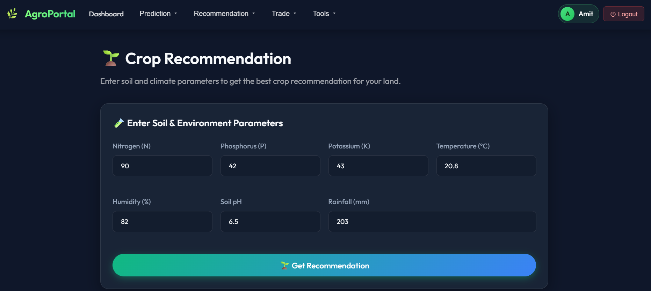

Figure 4.1 - Crop Recommendation

Fertilizer Recommendation Interface
illustrates the Fertilizer Recommendation module of AGROPORTAL, which suggests the most suitable fertilizer based on soil and crop conditions. The user provides essential agricultural parameters such as Nitrogen (N), Phosphorus (P), Potassium (K), temperature, humidity, soil moisture, soil type, and crop type through the interactive interface. After processing the input values using a trained Decision Tree–based machine learning model, the system predicts and displays the recommended fertilizer, such as DAP in this example. This module helps farmers apply fertilizers more accurately, reducing excessive chemical usage and improving soil fertility management. The user-friendly interface ensures that farmers can easily obtain intelligent fertilizer recommendations for better crop productivity and sustainable farming practices.

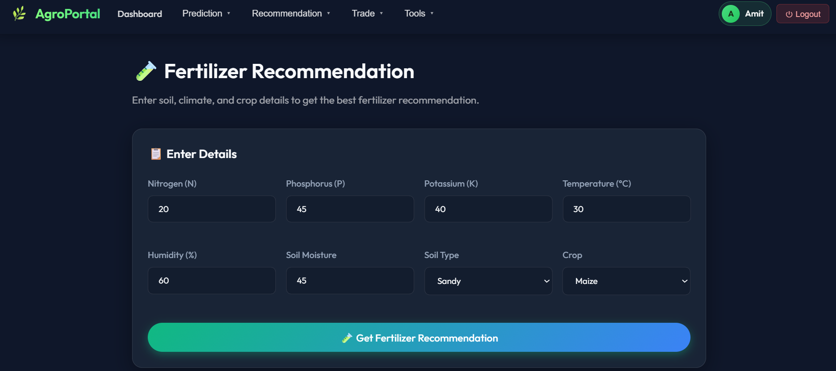


Figure 4.2 - Fertilizer Recommendation

Regional Crop Prediction Interface
demonstrates the Regional Crop Prediction module of AGROPORTAL, which predicts crops suitable for a particular state, district, and season using historical agricultural data. The user selects the location and season from the dropdown menu, after which the system processes the input through a trained Decision Tree–based prediction model. The interface then displays a list of crops that are commonly cultivated and environmentally suitable for that selected region and season. This feature helps farmers make informed cultivation decisions based on regional climatic and seasonal conditions. The module provides a simple, interactive, and AI-powered approach for improving crop planning and maximizing agricultural productivity.

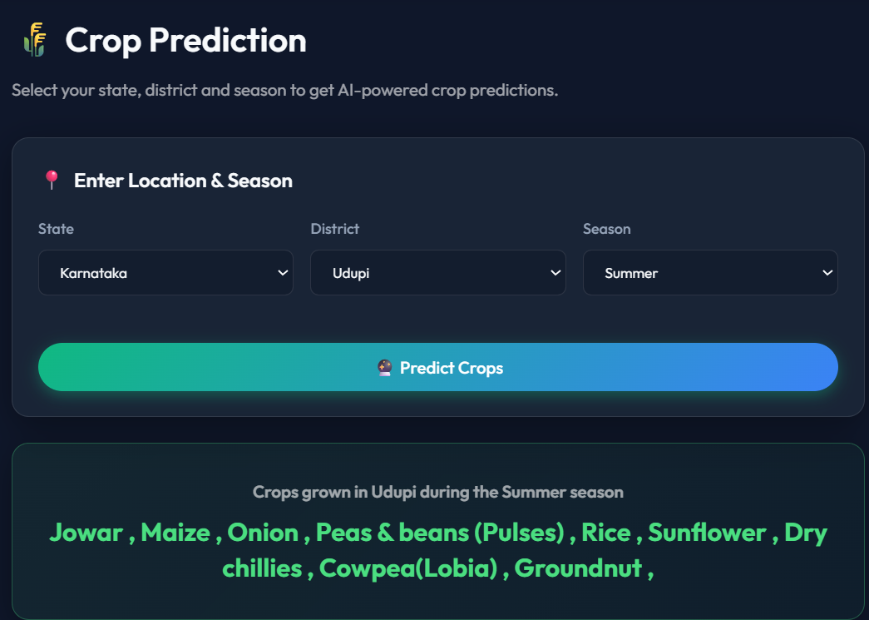

Figure 4.3 - Crop Prediction

Yield Prediction Module Interface
demonstrates the Yield Prediction Module of the Agricultural Assistance & Trading Portal, which is designed to estimate the expected crop yield using Machine Learning techniques. The user enters agricultural details such as state, district, season, crop type, and cultivated area through the interactive form interface. After receiving the input, the system processes the data using a trained Random Forest Regressor model built on historical crop production datasets. The module then predicts the expected crop yield in quintals for the selected region and farming conditions. In the example shown, the system predicts the yield for Paddy cultivation in Udupi district during the Kharif season for an area of 3 hectares. The predicted output displayed is 1.55 quintals, helping farmers estimate production in advance. This feature supports better agricultural planning, efficient resource utilization, and informed decision-making. The module provides an intelligent and user-friendly approach for improving farming productivity through data-driven analysis.

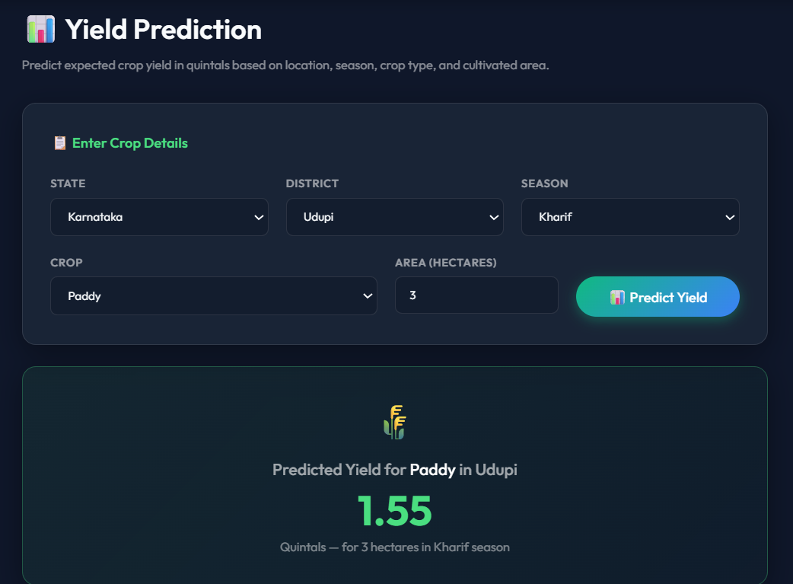

Figure 4.4 - Yield Prediction

Weather Forecast Module Interface
demonstrates the Weather Forecast Module of the Agricultural Assistance & Trading Portal, which provides real-time and upcoming weather information for farming locations. The user enters the desired city name, and the system retrieves weather data using the OpenWeatherMap API. The module displays a detailed 5-day forecast with multiple time-based data points, including temperature, weather condition, humidity, and wind speed. In the example shown, the system provides weather updates for Lucknow, helping farmers analyze climatic conditions before performing agricultural activities. The forecast table presents information in an organized and easy-to-understand format, enabling better planning for irrigation, harvesting, and crop protection. This feature assists farmers in reducing weather-related risks and supports smarter agricultural decision-making. The module offers a practical and user-friendly solution for integrating real-time environmental insights into farming operations.

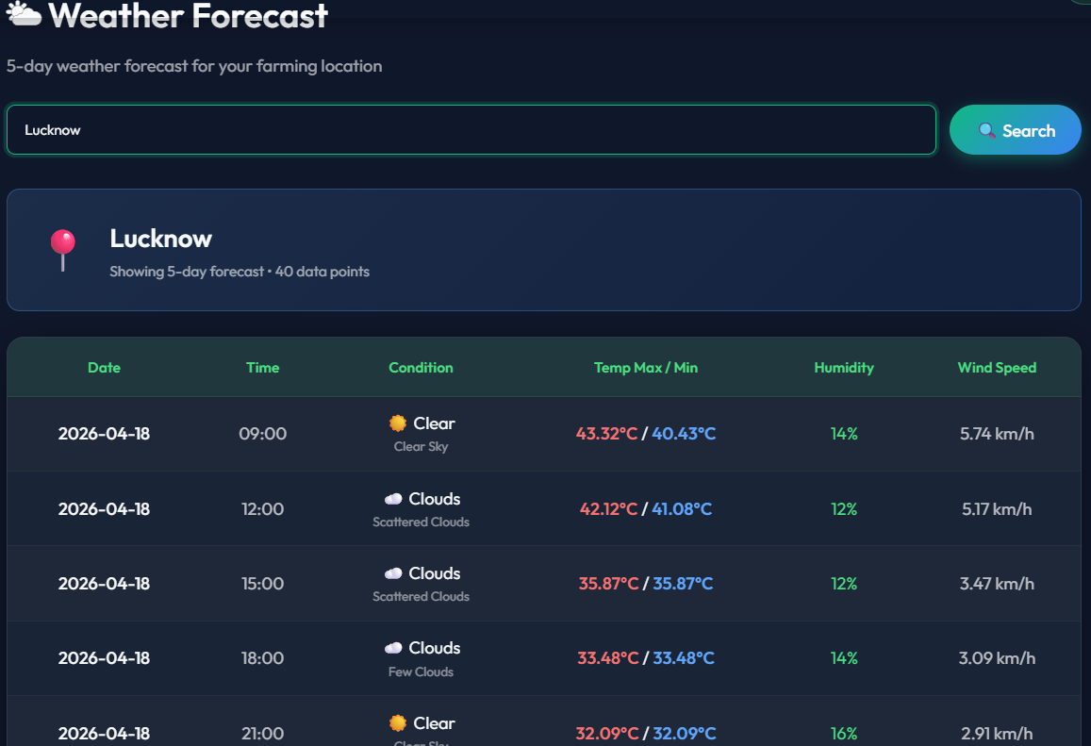
Figure 4.5 - Weather Forecast

CHAPTER 5

CONCLUSION

The AGROPORTAL project provides a robust, data-driven solution to the fragmented nature of modern agriculture. By centralizing essential information and predictive tools into a single MERN-based web portal, the platform empowers farmers to move beyond traditional guesswork toward precision farming.

5.1 Conclusion
This study effectively illustrates how machine learning can resolve practical issues such as predicting crop yields, recommending suitable fertilizers, and optimizing resource usage. Using a combination of algorithms-Random Forest (classification and regression), Decision Trees (scikit-learn and hand-built CART), and statistical historical averaging — the system achieves high accuracy and robustness.
The Decision Tree algorithm was identified as particularly effective for regional crop and fertilizer recommendations (88.5% accuracy), while Random Forest proved superior for handling complex, non-linear relationships in yield data (R² = 0.81, explaining 81% of yield variance).
The incorporation of a direct trading module addresses the economic challenges of the agricultural sector by bridging the gap between producers and consumers, ensuring that farmers retain a larger share of the value they create. The AI chatbot powered by Groq's llama-3.3-70b model adds conversational intelligence, helping even non-technical farmers get answers to complex soil and crop queries.

5.2 Future Work
To further enhance the performance and reach of AGROPORTAL, several improvements are planned:
- Model Caching / Pickle Pipeline: Cache trained Random Forest models at server startup instead of retraining on every API request. This will reduce yield prediction response time from ~10s to ~0.5s.
- Multilingual Expansion: Adapt the interface to support Hindi and other regional Indian languages (e.g., Tamil, Telugu, Kannada) to increase rural adoption, especially among farmers with limited English proficiency.
- IoT and Real-Time Sensor Integration: Incorporate real-time soil sensor data (via MQTT or REST) to eliminate manual NPK input and enable continuous model personalization as sensor readings update.
- National Yield Dataset: Extend the yield prediction model beyond Karnataka to all Indian states by incorporating the full national agricultural production dataset.
- Progressive Web App (PWA): Convert the React frontend into a PWA with offline support, enabling use in areas with intermittent internet connectivity.
- Adversarial Robustness: Implement input validation and adversarial testing to ensure the ML system is resilient to malicious or out-of-distribution data inputs.
Ultimately, AGROPORTAL represents a necessary evolution in agricultural management — transforming a research solution into a production-ready MERN platform that delivers immense value in real-world precision farming.

REFERENCES
- Patel, R., & Singh, V. (2022). Crop Yield Prediction Using Machine Learning Algorithms. IOP Conference Series: Earth and Environmental Science, 789.
- Rahman, A. S., Shamrat, F. J. M., Tasnim, Z., Roy, J., & Hossain, S. A. (2019). A comparative study on liver disease prediction using supervised machine learning algorithms. International Journal of Scientific & Technology Research, 8(11), 419-422.
- Liu, Y., Zhang, X., & Wang, H. (2025). Machine Learning-Based Crop Yield Prediction: Recent Advances and Challenges. Journal of Intelligent Agriculture, Springer.
- Manjula, E., & Djodiltachoumy, S. (2017). Model for Prediction of Crop Yield. International Journal of Computational Intelligence and Informatics, 6(4).
- Karishma Kumari, Ali Mirzakhani Nafchi, Salman Mirzaee, & Ahmed Abdalla. (2025). AI-Driven Future Farming: Achieving Climate-Smart and Sustainable Agriculture. AgriEngineering, 7(3), 89.
- Banerjee, S., Chakraborty, S., & Mondal, A. C. (2023). Machine Learning Based Crop Prediction on Region Wise Weather Data. International Journal on Recent and Innovation Trends in Computing and Communication, 11(1), 145-146.
- Ingle, A.(2020). Crop Recommendation Dataset. Kaggle.
- Abhishek, G. D. (2019). Fertilizer Prediction Dataset. Kaggle.
- Ilangovan, R. (2017). Rainfall in India 1901–2015. Kaggle.
[10] OpenWeatherMap. (2024). Current Weather and Forecast. API Documentation
[11] Groq. (2024). llama-3.3-70b-versatile — LLM Inference API Documentation

