1. Create the following tables with the following attributes and constraints on them.

a. Employee (Fname, mname, lname, Ssn, Bdate, address, gender, salary, Super_Ssn, Dept_num) Lname, Ssn, Dept_num should be not null
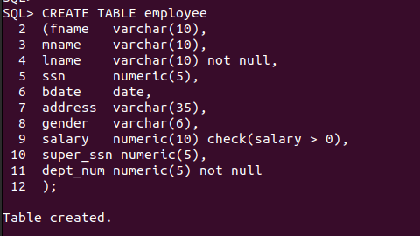

b. Department (Dept_num, Dept_name, Mgr_Ssn, Mgr_startdate) Dept_name should be unique

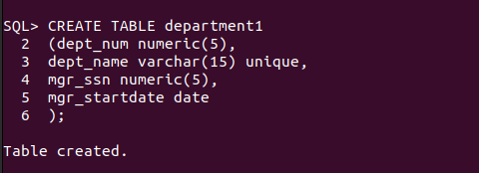

c. Department_locations (Dept_num, location) Dept_num and location both are primary key Dept_num is foreign key

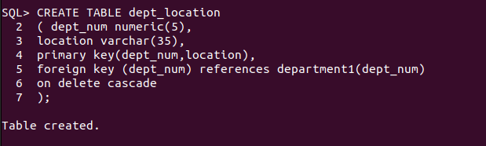

d. Project (Proj_num, Proj_name, Proj_location, Dept_num)

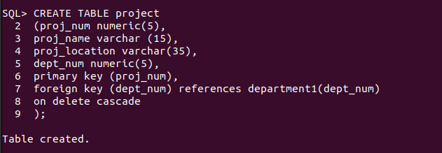

e. Employee_Project (Ssn, Proj_num, Hours)

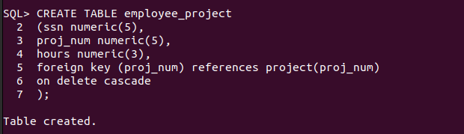
f. Dependent (Ssn, Dept_name, gender, bdate, relationship)


2. Add two column blood group and hobbies to employee table.
SQL> ALTER TABLE EMPLOYEE
2 ADD BLOOD_GROUP VARCHAR(5);

Table altered.

SQL> ALTER TABLE EMPLOYEE
2 ADD HOBBIES VARCHAR(15);

Table altered.

3. Increase the size of column blood group to 15 to the employee table.
SQL> ALTER TABLE EMPLOYEE
2 MODIFY BLOOD_GROUP VARCHAR(15);

Table altered.

4. Drop column hobbies from the employee table.

SQL> ALTER TABLE EMPLOYEE
2 DROP COLUMN HOBBIES;

Table altered.

6. Insert atleast five records in each table.

------DONE----

7. Give 1000 rupees bonus to each employee.

SQL> UPDATE EMPLOYEE
2 SET SALARY=SALARY+1000;

5 rows updated.

8. Increase the salary of the employees having salary <5000 by 1000 rupees.

SQL> UPDATE EMPLOYEE
2 SET SALARY=SALARY+1000
3 WHERE SALARY<5000;

0 rows updated.

9. Give 100 rupees bonus to employees having birth date before 1990.
SQL> UPDATE EMPLOYEE
2 SET SALARY=SALARY+100
3 WHERE BDATE<'01-JAN-1990';

1 row updated.

10. Give 100 rupees bonus to employees having salary less than 10000 rupees or birth date before 1990.

SQL> UPDATE EMPLOYEE
2 SET SALARY=SALARY+100
3 WHERE BDATE<'01-JAN-1990' AND SALARY<10000;

0 rows updated.

11. Give 100 rupees bonus to employees having salary between 1000 to 5000 rupees and birth date before 1990.

12. Give 100 rupees bonus to employees having salary between 1000, 3000 and 5000 rupees.

SQL> UPDATE EMPLOYEE
2 SET SALARY=SALARY+100
3 WHERE SALARY IN (1000,3000,5000);

0 rows updated.

13. Update phone number with 0000 where NULL.

14. Give 100 rupees bonus to employees having salary not between 1000 to 5000 rupees and birth date before 1990.

SQL> UPDATE EMPLOYEE
2 SET SALARY=SALARY+100
3 WHERE (SALARY NOT BETWEEN 1000 AND 5000) AND BDATE<'01-JAN-1990';

1 row updated.

15. Give 100 rupees bonus to employees having salary between 1000, 3000 and 5000 rupees.

SQL> UPDATE EMPLOYEE
2 SET SALARY=SALARY+100
3 WHERE SALARY IN (1000,3000,5000);

0 rows updated.
16. Delete from employee the rows having bdate less than 1970.

SQL> DELETE FROM EMPLOYEE
2 WHERE BDATE<'01-JAN-1970';

0 rows deleted.

17. List the name and age of all employees.

SQL> SELECT FNAME,MNAME,LNAME,(2025-EXTRACT(YEAR FROM BDATE)) AGE
2 FROM EMPLOYEE;

19. List the Bdate and Salary of Employee ‘Smith’.

SQL> SELECT BDATE , SALARY
2 FROM EMPLOYEE
3 WHERE LNAME='Smith';

no rows selected

20. Find the location of Project ‘SUPER’.

SQL> SELECT PROJ_LOCATION
2 FROM PROJECT
3 WHERE PROJ_NAME ='SUPER';

no rows selected

21. Find the dependent details of Employee with Ssn number 482928.

SQL> SELECT * FROM EMPLOYEE
2 WHERE SSN=482928;

no rows selected

22. List the employees having salary > 2000 and bdate before 1/1/1990.

SQL> SELECT FNAME,LNAME
2 FROM EMPLOYEE
3 WHERE SALARY>2000 AND BDATE<'01-JAN-1990';

23. List the employees belonging to dept_num 1.

SQL> SELECT *
2 FROM EMPLOYEE
3 WHERE DEPT_NUM=1;

24. List the project details of dept_num 5.

SQL> SELECT *
2 FROM PROJECT
3 WHERE DEPT_NUM=5;

25. List the employee details with their department name.

SQL> SELECT E.*,D.DEPT_NAME
2 FROM EMPLOYEE E
3 JOIN DEPARTMENT1 D ON E.DEPT_NUM=D.DEPT_NUM
4 ;

26. List the employee details with their project names.

SQL> SELECT E.*,P.PROJ_NAME
2 FROM EMPLOYEE E
3 JOIN PROJECT P ON E.DEPT_NUM=P.DEPT_NUM;

27. List the employees belonging to Marketing department.

SQL> SELECT E.*
2 FROM EMPLOYEE E
3 JOIN DEPARTMENT1 D ON D.DEPT_NUM=E.DEPT_NUM;

28. List the project details belonging of Sales department.

SQL> SELECT P.*
2 FROM PROJECT P
3 JOIN DEPARTMENT1 D ON P.DEPT_NUM=D.DEPT_NUM;

29. List the dependent details of employee ‘Smith’.

SQL> SELECT D.*
2 FROM DEPENDENT D
3 JOIN EMPLOYEE E ON D.SSN=E.SSN;

30. List the various locations of ‘Marketing’ department.

SQL> SELECT L.LOCATION
2 FROM DEPT_LOCATION L
3 JOIN DEPARTMENT1 D ON D.DEPT_NUM=L.DEPT_NUM;

31. List the employees in the descending order of their salary.

SQL> SELECT * FROM EMPLOYEE
2 ORDER BY SALARY DESC;

32. List the dependents in the descending order of their names.

SQL> SELECT * FROM DEPENDENT
2 ORDER BY DEPT_NAME DESC;

