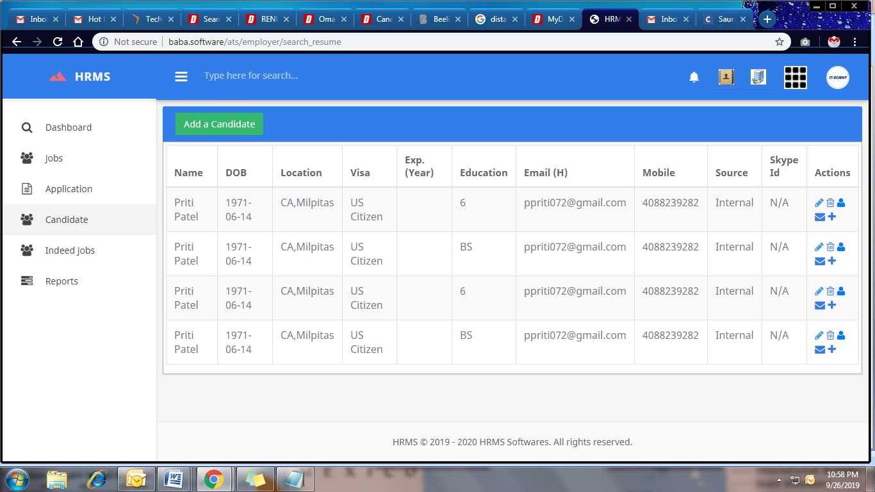

Submitted 4 at a time, no delete option