Corrspell(spelling Corrector system)

***Wireframe Documentation***

**Overview**

This wireframe documentation outlines the key components and interactions of the Spell Corrector application.

Home Page

Input Text Box: A text box where users can input a sentence or phrase with spelling errors.

"Predict" Button: A button to initiate the spelling correction process.

Results Box: An area to display the corrected sentence or phrase.

Workflow:

User inputs a sentence with spelling errors into the "Input Text Box."

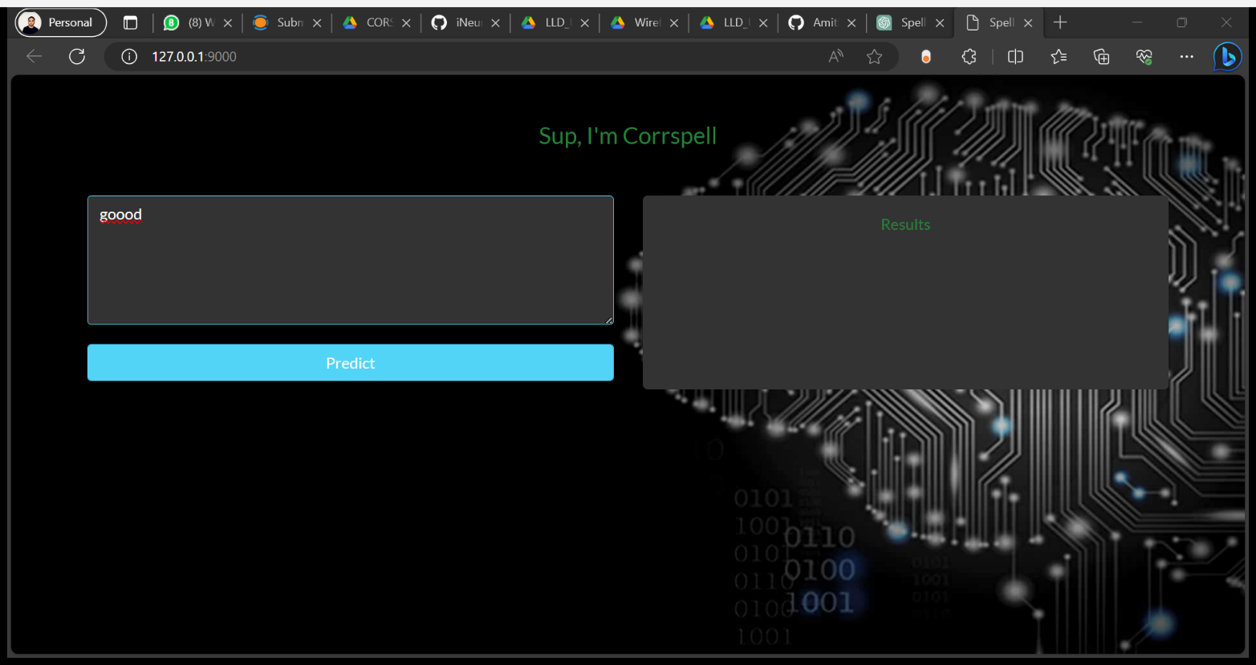

User clicks the "Predict" button to initiate the correction process.

The corrected sentence or phrase is displayed in the "Results Box."

**Visual Representation:**

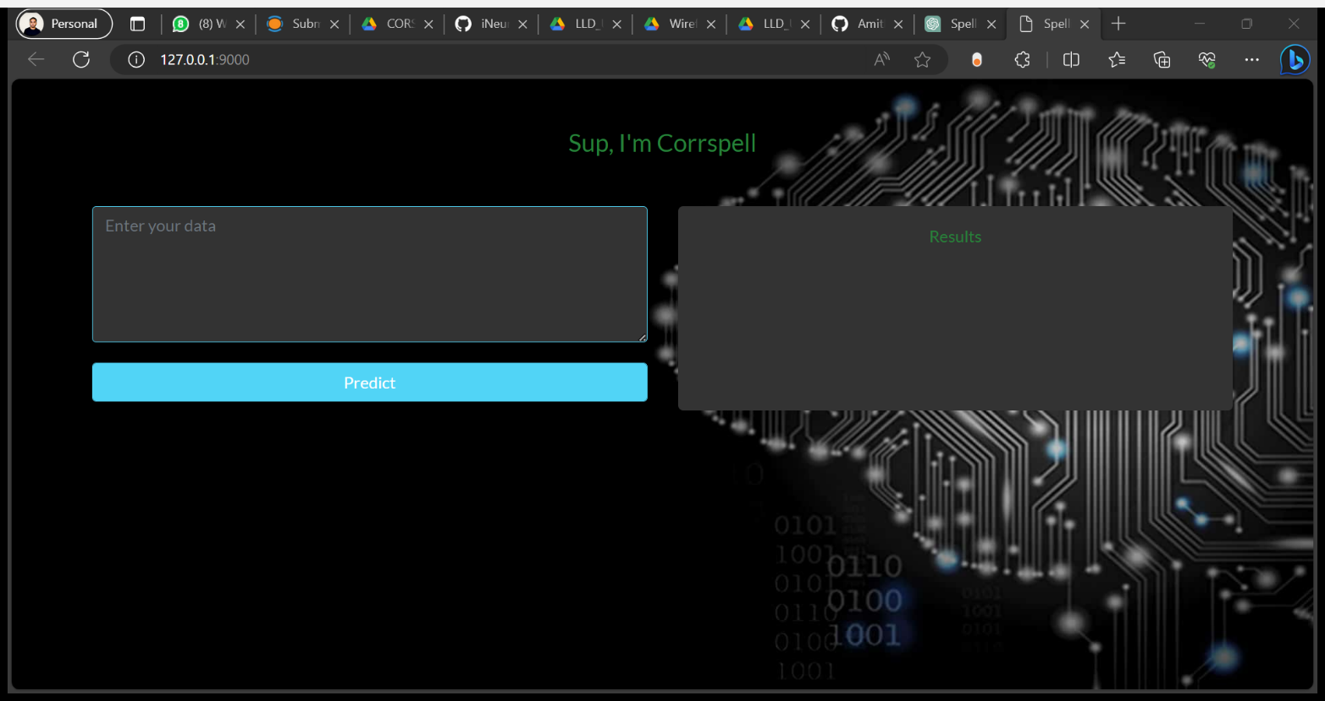

**Workflow:**

User enters input text.

User clicks "Predict."

Corrected text is displayed. 