EEG configuration guide

The headset configuration was changed to the followings:

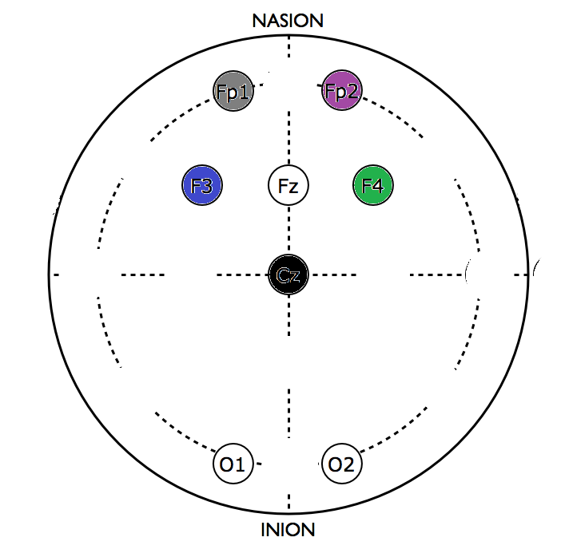

|  |  |  |  |
| --- | --- | --- | --- |
| **OpenBCI index** | **Channel (10-20)** | **Wire color** | **Old config (color)** |
| 1 | Fp1 | gray | Fp1 gray |
| 2 | Fp2 | purple | Fp2 purple |
| 3 | F3 | blue | C3 red |
| 4 | Cz | white | T3 yellow |
| 5 | F4 | green | C4 green |
| 6 | Fz | black | T4 orange |
| 7 | O1 | red | O3 red |
| 8 | O2 | brown | O4 brown |

To configure the LSL, use:

!!BECAUSE IN THE PIPELINE, WE USE CHANNEL NAMES (INSTEAD OF INDICES), IT IS IMPORTANT TO SET THE NAMES BEFORE STARTING THE STREAMING!!

python openbci_lsl.py --stream

/loc Fp1,Fp2,F3,Cz,F4,Fz,O1,O2

/start

In neuropype, I’ve made a pipeline that produces 3 features:

The file is called

*3band_features.ows*

The output is three different LSL streams:

* **Default** (FEA): Frontal alpha asymmetry (8-12Hz, (Fp1+F3)/2-(Fp2+F4)/2): approach/withdrawal motivation, i.e. attraction, avoidance
* **FMT**: Frontal midline theta (5-7 Hz, Fz): mental workload, concentration
* **Occ-BG**: Occipital beta+gamma (13-30 Hz, O3, O4), should represent visual processing

All features are:

* Timestamp corrected
* Artefact cleaned
* After bandwidth selection, squared, calculated a moving average (100 sample window), and log( x+1) transformed