**SDF: Hinge Position**

Hinge Position

**3 Hinges**

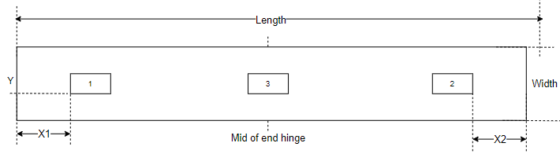

**4 Hinges**

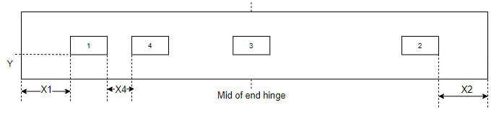

**5 Hinges (A)**

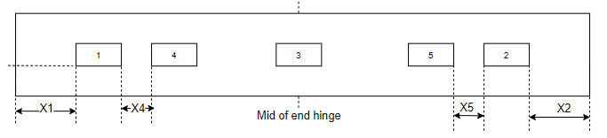

**5 Hinges (B)**

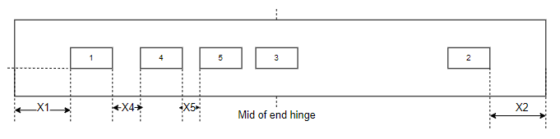

**Variable**

|  |  |  |  |
| --- | --- | --- | --- |
| **No** | **Parameter** | **Value/Equation** | **Comment** |
| 1 | Hinge Length | 100.5 |  |
| 2 | Hinge width | 32.5 |  |
| 3 | X1 (Top Hinge) | Architrave1 + 230 |  |
| 4 | X2 (Btm Hinge) | 250 |  |
| 5 | X3 | (X2 – X1)/2 | Refer PPT |
| 6 | X4 | Customer Choice (99.5) |  |
| 7 | X5 (From Right) | Customer Choice |  |
| 8 | X5 (From Left) | Customer Choice | Alternative for X5 |
| 9 | Y (Mark to front) | Return1 + Architrave1 - (1.1:2.4 / 1.5:2.9) |  |

|  |  |
| --- | --- |
| Class | Method |
| HingeTools | GetHingPoints() |
| DrawPocket() |