Slot Position

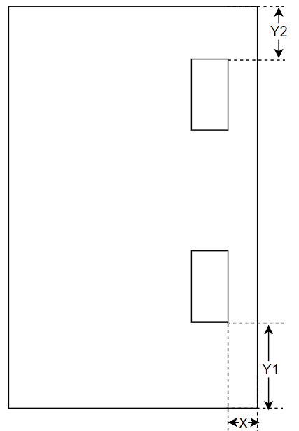

SDF: Slot Position

**Variable**

|  |  |  |
| --- | --- | --- |
| **No** | **Parameter** | **Value/Equation** |
| 1 | Slot Length | 20 |
| 2 | Slot width | 2.5 |
| 3 | X | 4 |
| 4 | Y1 | Return1 + Architrave1 + 15.5 + (tabBase / 2) - (slotHeight / 2) |
| 5 | Y2 | Width – (Return2 + Architrave2 + 15.5 + (tabBase / 2) - (slotHeight / 2)) |

*15.5: Always same before tab length.

|  |  |
| --- | --- |
| Class | Method |
| HingeTools | GetSlotPoints() |
| DrawPocket() |