**Deep Neural Network Inference on FPGA using TF**

Research project about Xilinx's Vitis-AI framework. Xilinx developed a unique and special ecosystem with dedicated software and hardware for accelerating deep neural networks and artificial intelligence applications. Our goal was to evaluate and validate this platform for future use.

**Description**

Machine Learning & AI are major academic fields that are integral part of many modern researches and high-tech cutting edge developments such as: autonomous cars, image processing and medical research. Therefore, many companies are trying to make a foothold in this world.

Xilinx created Vitis AI development environment for AI inference on Xilinx hardware platforms. It consists of optimized IP, tools, libraries, models, and example designs. It is designed with high efficiency and ease-of-use in mind, unleashing the full potential of AI acceleration on Xilinx FPGA.

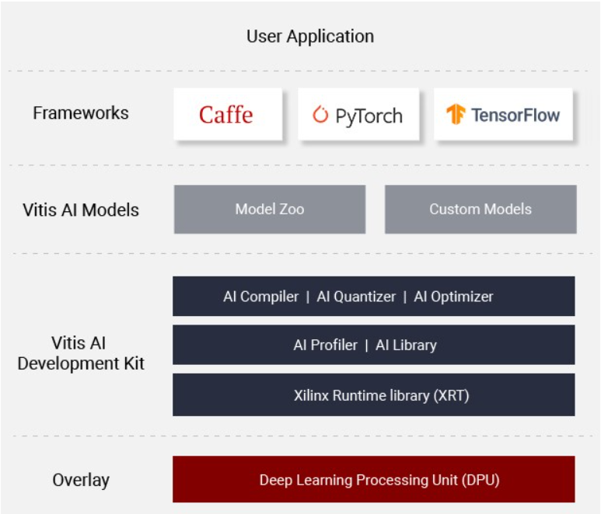

Our main project goal was to evaluate and validate the Xilinx Vitis-AI ecosystem. That includes understanding Vitis-AI ecosystem and running full flow from Tensorflow to the FPGA. Also, evaluate and modify, when possible, each step in the process of the ecosystem in order to understand it's limits and capabilities in terms of both logic and performance. Our final product is a detailed guide on how to work with the VitisAI ecosystem. It includes tutorial on how to create model from scratch, inference performance comparison and guidelines on how the ecosystem can be utilized to get the most out of it and avoid any knows problems in advanced.

