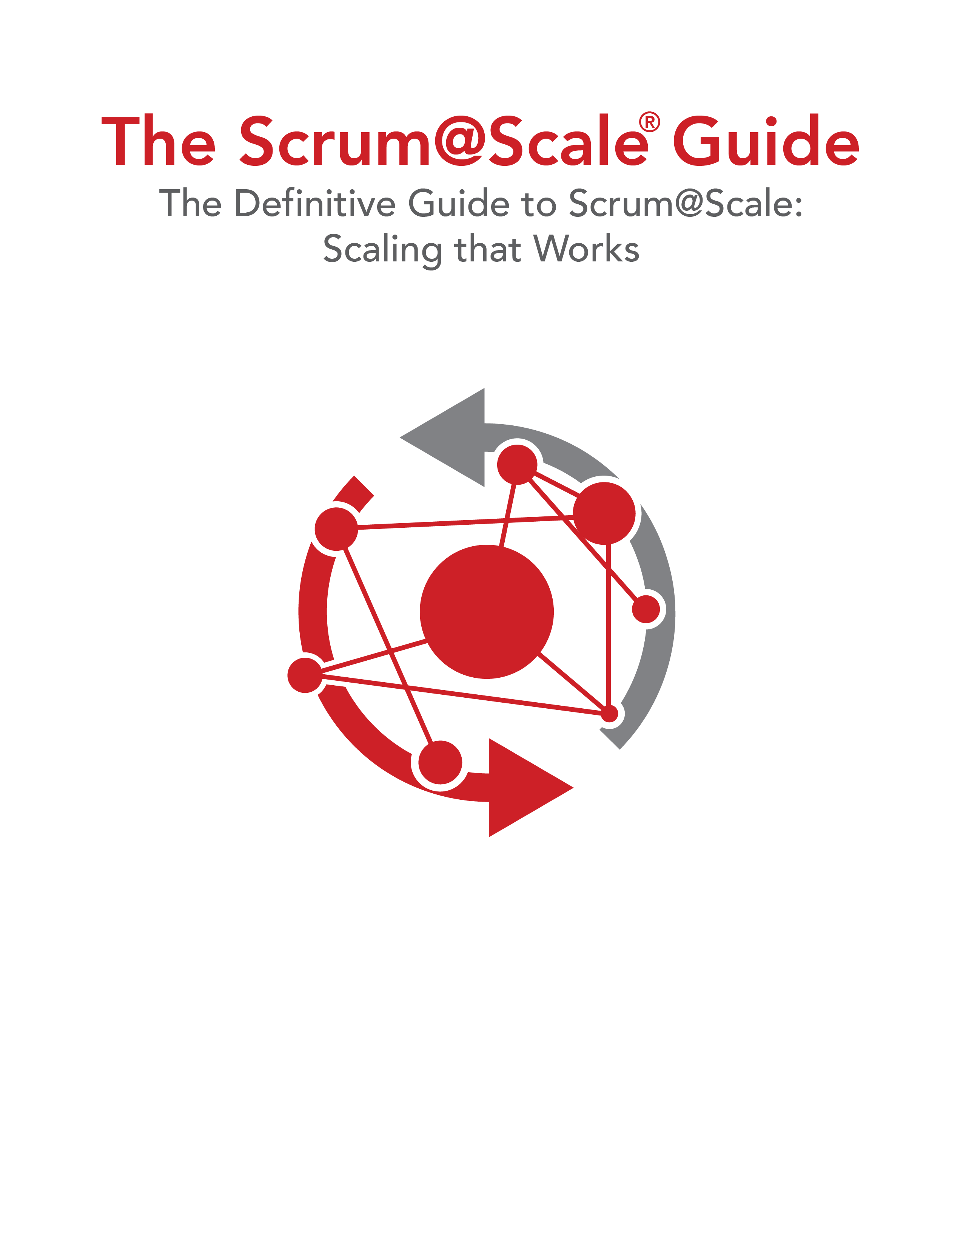

Version 1.03 — 25 October 2018

©2006-2018 Jeff Sutherland and Scrum Inc., All Rights Reserved   
Scrum@Scale is a registered trademark of Scrum Inc.   
Released under Creative Commons 4.0 Attribution-Sharealike License