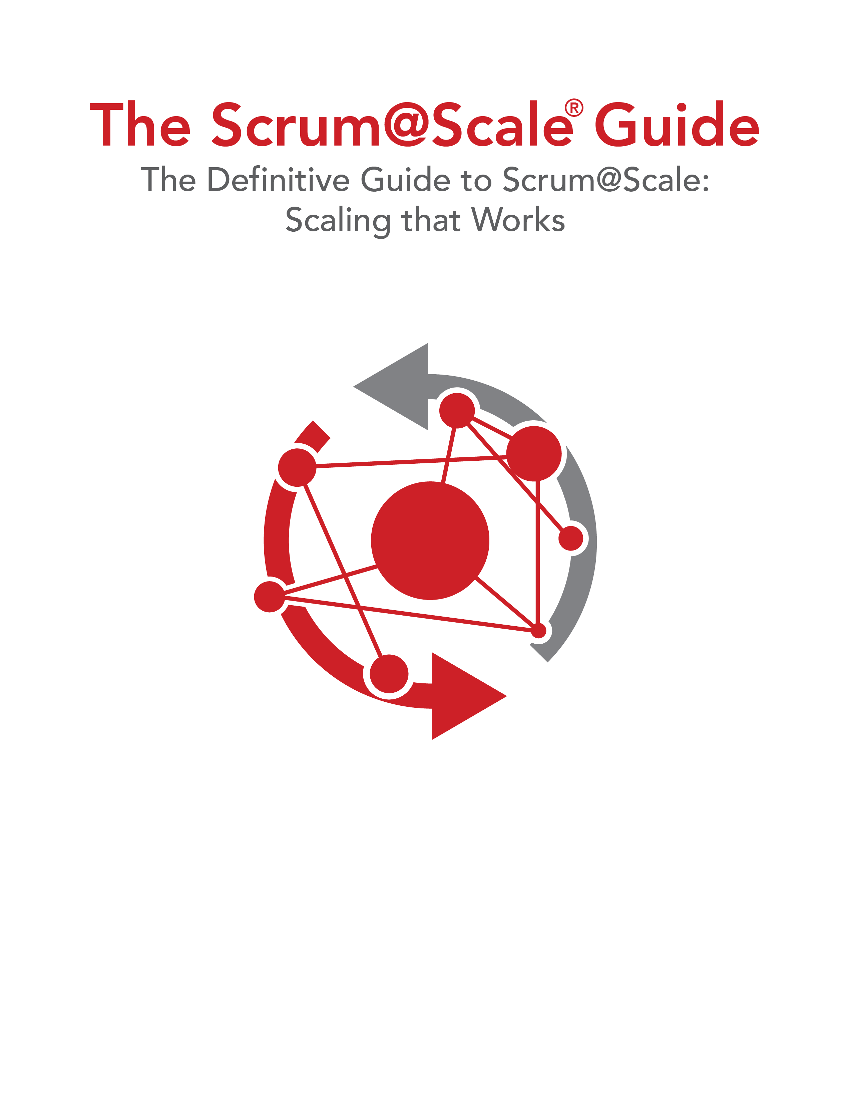

Version 1.05 — 29 April 2019

©2006-2019 Jeff Sutherland and Scrum Inc., All Rights Reserved   
Scrum@Scale is a registered trademark of Scrum Inc.   
Released under Creative Commons 4.0 Attribution-Sharealike License