GeoAlarms
Óscar Ramírez Jiménez
Alejandro Gómez García

Index
- Introduction
- Requirements
  - Map view
  - Alarm view
- Source code overview
  - GeoAlarms
  - activity
    - Map
    - AlarmList
    - AlarmEditor
    - Preferences and Help
  - database
    - AlarmDatabaseHelper
    - AlarmManager
  - location
  - map
  - model
- Known bugs

Introduction

The purpose of the project is to implement an Android application that allows its users to store alarms associated with geographical locations. Each alarm would have a radius within a notification would be triggered.

The applications uses the geolocating API, as well as Google Maps libraries for
embeding maps in the different activities.

Requirements

This section is a review of the original requirements, highlighting what we have
achieved and explaining why we have failed to meet some of them. We also include
some of our thoughts on future directions of the project.

Map view

We planned to make Map View the core of our application, stating that the user
would be able to:
- visualize the alarms;
- obtain information about the alarms tapping on them;
- use touch gestures to manipulate existing alarms and create new ones.

The visualization of the alarms has been implemented, we can see at a glance what
the nearby alarms are and what is their radius by opening the map view:

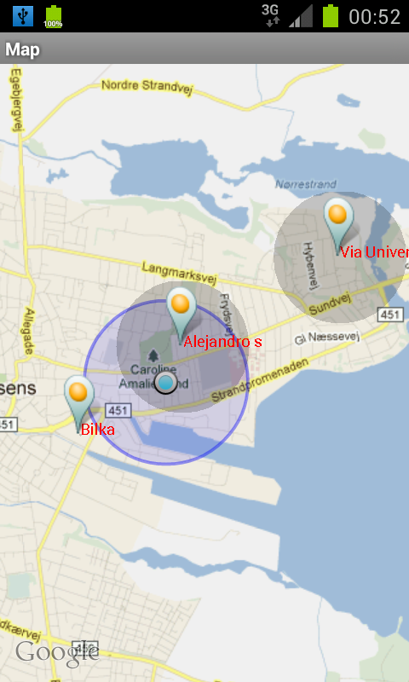
The creation, edition and deletion of the alarms has not been implemented using
touch gestures. Those operations have been implemented in the alarm list for
convenience.

Alarm view

We stated that, apart from visualizing a list with all the alarms, the user would
be able to create, edit and delete alarms from the alarm view and that requirement
has been met.

The components of the list only show the name of the alarm, but we have some
improvements in mind, such as:
- sort the alarms by distance to the current position (closest goes first);
- show more information about the alarm than just the name;
- use of slide gestures to operate on the alarms.

Here's a screenshot of the alarm edition activity:

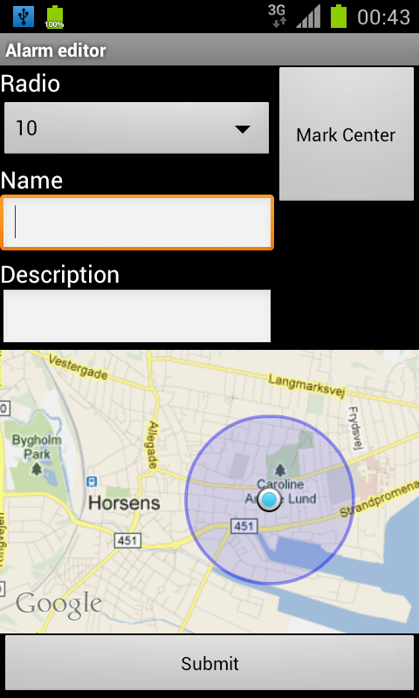

Source code overview

src/main/java/
└── com
└── geoalarms
├── GeoAlarms.java
├── activity
│ ├── AlarmEditor.java
│ ├── AlarmList.java
│ ├── Help.java
│ ├── Home.java
│ ├── Map.java
│ └── Preferences.java
├── database
│ ├── AlarmDatabaseHelper.java
│ └── AlarmManager.java
├── location
│ ├── LocListener.java
│ └── ProximityIntentReceiver.java
├── map
│ ├── AlarmOverlay.java
│ └── PointOverlay.java
└── model
├── Alarm.java
└── Coordinates.java

7 directories, 15 files

GeoAlarms

For storing the global application data we choose to subclass Activity instead
of implementing a Singleton. GeoAlarms subclasses android.app.Application. This class gets
instantiated when the application starts, after specifying it in AndroidManifest.xml:

<application android:name="com.geoalarms.GeoAlarms"
...

GeoAlarm contains several static members, which can be divided in:
- Global application data.
  - An android.content.Context object representing the application context.
  - A com.geoalarms.database.AlarmManager object, which is the interface to the alarm database.
  - An android.location.LocationListener subclass used for monitoring the location changes.
- Activity IDs. These integer constants are used to represent activities in the intents.
- Intent return codes. We use them when firing an intent with startActivityForResult.

activity

The activity package contains all the program activities.

Dashboard

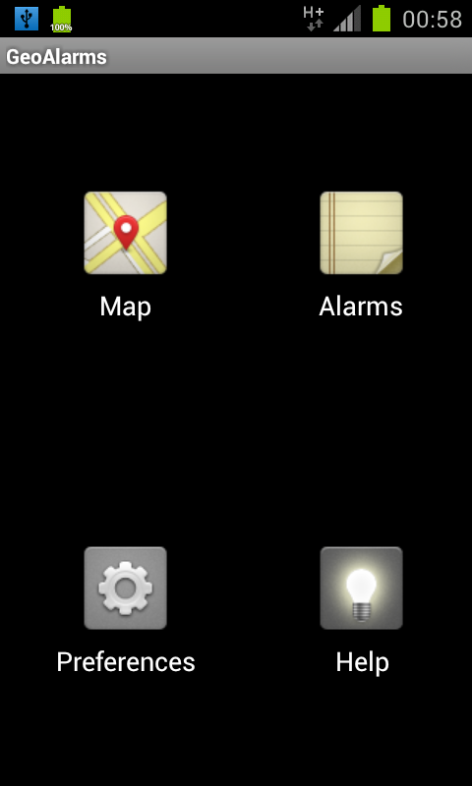
The com.geoalarms.activity.Home activity is the applications entry point. It shows a dashboard with icons for navigating to all the other activities in the application.

Map

The com.geoalarms.activity.Map activity shows a map with the alarms plotted into it. Each alarm is displayed showing a pin, its name and a circle with the radius in which is activated.

The user location is also monitored and marked in the map:
We add user's location in the maps onCreate method. For keeping the map always up to date what we do is query for all the alarms in the onStart method, and plot them.

@Override
public void onCreate(Bundle savedInstanceState) {
…

this.layers = this.mapView.getOverlays();

// add user's location
this.addMyLocation();
}

@Override
public void onStart() {
super.onStart();

this.drawAlarms();
}

…

public void drawAlarms() {
this.layers.clear();
this.addMyLocation();
this.alarms = GeoAlarms.alarmManager.getAllAlarms();

for (Alarm alarm: alarms) {
AlarmOverlay alarmOverlay = new AlarmOverlay(alarm);
// force view to refresh
mapView.invalidate();
this.layers.add(alarmOverlay);
}
}

public void addMyLocation() {
MyLocationOverlay myLocation = new MyLocationOverlay(GeoAlarms.context,
this.mapView);
myLocation.enableMyLocation();
this.layers.add(myLocation);
}

AlarmList

This activity shows an android.widget.ListView with all the alarms that are stored in the
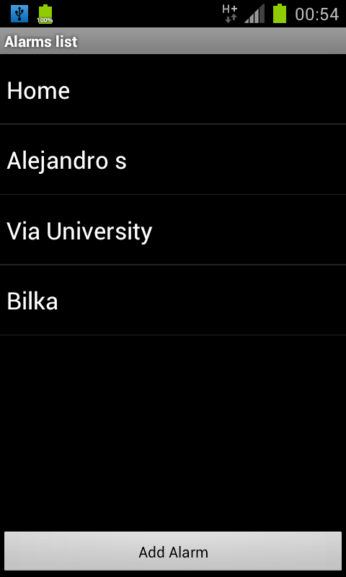
database. It is possible to open a new activity for creating, editing orvdeleting alarms from this activity.

We use the same approach than in com.geoalarms.activity.Map for keeping alarms up to date.
This activity also starts the com.geoalarms.activity.AlarmEditor for adding new alarms or when touching one of the alarms of the list (it opens a editor with the alarm information to edit it). Here's the code that starts the alarm editor and processes its return values.

public void addAlarm(View v) {
Intent in = new Intent(AlarmList.this, AlarmEditor.class);
in.putExtra("activity_type", "add");
this.startActivityForResult(in, GeoAlarms.NEW_ALARM_ACTIVITY);
}

protected void onActivityResult(int requestCode, int resultCode, Intent data) {
super.onActivityResult(requestCode, resultCode, data);

switch (requestCode) {
// data has been returned from `AlarmEditor`
case GeoAlarms.NEW_ALARM_ACTIVITY:
if (data != null) {
// radius
int radius = data.getIntExtra("radius", 100);
// coordinates
int latitude = data.getIntExtra("latitude", 0);
int longitude = data.getIntExtra("longitude", 0);
Coordinates coords = new Coordinates(latitude, longitude);

// name and description
String name = data.getStringExtra("name");
String description = data.getStringExtra("description");

Alarm alarm;

// add alarm
if (resultCode == GeoAlarms.NEWALARM) {
alarm = new Alarm(radius, coords, name, description);
GeoAlarms.alarmManager.add(alarm);
// update proximity alerts
GeoAlarms.locationListener.resetProximityAlerts();
return;
}

// edit or remove
String oldName = data.getStringExtra("oldName");
alarm = GeoAlarms.alarmManager.getAlarm(oldName);

if (resultCode == GeoAlarms.REMOVEALARM) {
// delete
GeoAlarms.alarmManager.delete(alarm);
} else {
// update
alarm.update(radius,
coords,
name,
description);
GeoAlarms.alarmManager.update(oldName, alarm);
}
...
AlarmEditor
The com.geoalarms.activity.AlarmEditor activity is used for creating new alarms and editing or deleting existing ones. It has text boxes for writing the name and description, a small map to select the location for the alarm and a spinner for selecting the notification radius.

Preferences and Help

This activities are intended to allow customization of the application and show
program usage information respectively.

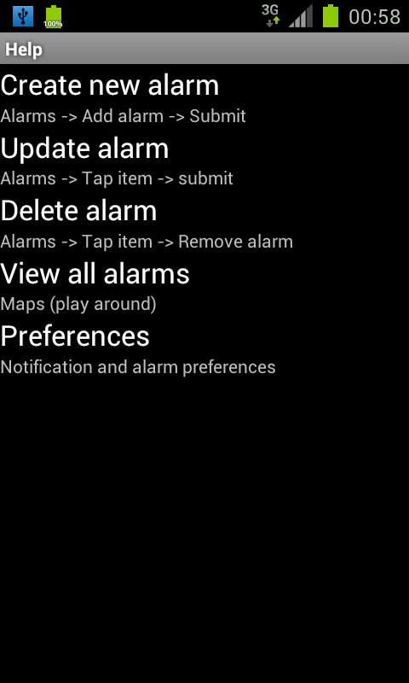
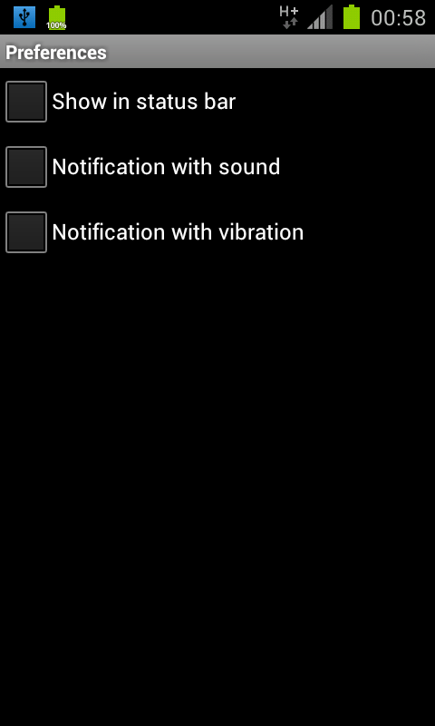
database

This package is intended to encapsulate the persistence logic of GeoAlarms. It
contains only two classes: AlarmDatabaseHelper and AlarmManager.

AlarmDatabaseHelper
AlarmDatabaseHelper extends android.database.sqlite.SQLiteOpenHelper and contains
the database information and the basic operations: insert, update and delete.

// SQL query to create database
private static final String ALARMS_TABLE_CREATE =
"CREATE TABLE " + DATABASE_NAME + " (" +
KEY_RADIUS + " INTEGER NOT NULL," +
KEY_LATITUDE + " INTEGER NOT NULL," +
KEY_LONGITUDE + " INTEGER NOT NULL, " +
KEY_NAME + " TEXT UNIQUE, " +
KEY_DESCRIPTION + " TEXT);";

One of the problems that arised when storing data was the lose of precision that latitude and longitude values experienced when inserting them into de database. The first version stored latitude and longitude as REAL, but we decided to use an INTEGER and store the coordinates in microdegrees. This way, we have a high precision and we are not afraid of losing it when inserting or retrieving alarms.

AlarmManager
AlarmManager is the high-level interface to the database, it exposes CRUD (Create, Read, Delete and Update) operations and takes care of the necessary conversions between relational data and Java objects.

Here are some interesting snippets from this class:

public List<Alarm> getAllAlarms() {
List<Alarm> alarms = new ArrayList<Alarm>();
// get database
SQLiteDatabase db = this.databaseHelper.getReadableDatabase();
Cursor cursor;

try {
cursor = db.query(this.databaseHelper.DATABASE_NAME,
this.databaseHelper.KEYS,
null,
null,
null,
null,
null,
null);

} catch (SQLiteException e) {
return alarms;
}

if (cursor.moveToFirst()) {
do {
Alarm alarm = this.alarmFromCursor(cursor);
alarms.add(alarm);
} while (cursor.moveToNext());
}

db.close();

return alarms;
}

public Alarm getAlarm(String name) {
SQLiteDatabase db = this.databaseHelper.getReadableDatabase();
String nameField = "'" + name + "'";
Cursor cursor = db.query(this.databaseHelper.DATABASE_NAME,
this.databaseHelper.KEYS,
this.databaseHelper.KEY_NAME + "=" + nameField,
null,
null,
null,
null,
null);

if (cursor.moveToFirst()) {
Alarm alarm = this.alarmFromCursor(cursor);
return alarm;
}

...

private Alarm alarmFromCursor(Cursor cursor) {
// convert to `com.geoalarms.model.Alarm`
int id = cursor.getInt(0);
int radius = cursor.getInt(1);

int latitude = cursor.getInt(2);
int longitude = cursor.getInt(3);
Coordinates coords = new Coordinates(latitude, longitude);

String name = cursor.getString(4);
String description = cursor.getString(5);

Alarm alarm = new Alarm(id,
radius,
coords,
name,
description);

return alarm;
}
location
This package encapsulate the custom LocationListener, which has the LocationManager, and the BroadcastReceiver. This package also manages the notifications.

map

The classes contained here are related to the map plotting. They are no more than
custom overlay items:

- AlarmOverlay is the overlay used for painting the alarm. It's the representation
of Alarm objects in a map. This class takes care of drawing a pin in the exact point
where the alarm is located, and also draws a circle representing the radius of the notification.
- PointOverlay is the overlay used for painting a colorful dot in the map.

Here's the PointOverlay's draw method:

@Override
public void draw(Canvas canvas, MapView mapView, boolean shadow) {
if (shadow == false) {
// get point
Projection projection = mapView.getProjection();
Point center = new Point();

// coordinates to convert
Coordinates coords = this.alarm.coordinates;
GeoPoint point = coords.toGeoPoint();

// put in `center` the coordinates in pixels
projection.toPixels(point, center);

// draw radius
float radius = projection.metersToEquatorPixels(
(float) this.alarm.radius);
Paint circlePaint = new Paint();
circlePaint.setColor(0x30000000);
circlePaint.setStyle(Style.FILL_AND_STROKE);
canvas.drawCircle(center.x,
center.y,
(int) radius,
circlePaint);

// draw alarm name
Paint textPaint = new Paint();
textPaint.setColor(Color.RED);
canvas.drawText(alarm.name, center.x, center.y, textPaint);

// draw map pin
canvas.drawBitmap(this.alarmIcon,
center.x - alarmIcon.getWidth() / 2,
center.y - alarmIcon.getHeight(),
null);

super.draw(canvas, mapView, shadow);
}
}
model

This package contains the data structures used in the application:

- Alarm objects store information about an alarm.
- Coordinates objects encapsulate the alarm coordinates.

Known bugs

- Editing alarms and changing their name inserts a new alarm instead of updating the edited alarm.

