**Report on the applications of AI and Data Science in**

**Formula One**

### Under the guidance of

### Dr. Uma Sheshadri

**And**

### Dr.Bam Bahadur Sinha

**Group Members**

**Amit Appanna Talawar - 20BCS011**

**Anant Terkar - 20BCS014**

**Annamaneni Rohit - 20BCS019**

**Jain Udit - 20BCS061**

**Prateek Agarwal - 20BCS101**

**Pratham Harshvardhan Dave - 20BCS102**

**Rahul Pentamsetty - 20BCS106**



**Report on the applications of AI and Data Science in**

**Formula One**

**Abstract**

This comprehensive report aims at discussing the impact of Artificial Intelligence and Data Science on F1 car racing which is one of the fastest pacing sports today. This report would be dealing with the various aspects of the sport some of which are outcome prediction, post-race data analysis, driver safety and analysis.

**Introduction to F1 racing**

Since the inauguration of “The World Driver’s Championship” back in 1950 till today, Formula One racing popularly known as F1 racing has seen some drastic changes over the years. With the introduction of precise measuring equipment, the competition has grown to be tougher and tougher each year.

In the year 2017, F1 racing cars underwent some major changes which increased the speeds up to 325kmph! A F1 season consists of a series of races, known as [*Grand Prix*](https://en.wikipedia.org/wiki/List_of_Formula_One_Grands_Prix), which take place worldwide on purpose-built [circuits](https://en.wikipedia.org/wiki/List_of_Formula_One_circuits) and closed public roads.

**How has data analysis made an impact in real-time F1 racing?**

A modern F1 car generates 30-40 Terabytes of data each race through its 200 sensors. To process and analyse such huge amounts of data F1 uses AWS cloud services to store and compute it. Researchers preserve and process 60 years of data using AWS to develop tactics, to make favorable decisions and predictions. **Artificial Intelligence** is deployed in *pit stop timing* and *selection of tire* to configure which set of decisions or action are to be taken in the next lap to decrease the lap time. AI sets up feedback loops which collects data and gives feedback to the system every second.

The rules have been shaped in a way that out of the 7 types of tires, an F1 team is only allowed to bring in 3 types out of which it can use 2 mid race.

Here comes the role of AI and Data Analysis as simulations have to be done on a track-to-track basis and data from the F1 car being stored to the databases mid-race to find the optimal decisions for the fastest lap possible and the least possible number of pit-stops.

Reinforcement learning is an alternative to Monte Carlo, essentially rewarding the computer for a successful task and the goal is to maximize the reward. This works through trial and error, the action made is decided by the machine.

• Action 0 – Pit stop with Tire type 1.

• Action 1 – Pit stop with Tire type 2.

• Action 2 – Pit stop with Tire type 3.

• Action 3 – No pit stop.

Here is a basic outlook of how the neural network would look like:

Input layer – Represents state of the race (positions, speeds).

Hidden layers – Formulas and certain biases that give us an output layer of percentages.

Output Layer – A series of percentages of each of the actions mentioned above. The percentages resemble what action should be taken for winning the race.

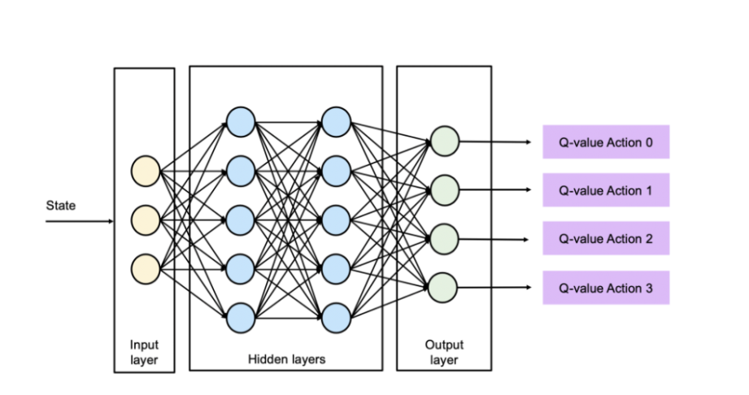

**Result Predictions using Machine Learning**

With the beginning of a new season of F1 racing, people tend to look at predictions for the outcomes of the race. The process of finding neutral predictions is purely based on previous outcomes which can be achieved with machine learning. Machine learning can help predict the outcome of a race using the method of supervised learning. **Artificial Neural Networks** does exactly this for us. It is a system with a set of inputs and multiple layers of units called neurons. The inputs are connected a layer of neurons. Each neuron is connected to every neuron of the next layer. The connections have a value called a bias which affects the probability of the connection being triggered. This system allows accurate predictions of an outcome by setting biases based on previous races. The huge amount of data available along with techniques of supervised machine learning can help make accurate predictions in order to meet the demand during F1 seasons.

**Post-race data analysis**

Post-race analysis includes optimizing car design, analyzing data of previous races and equipment testing. Subject Matter Experts assist the teams to refine data and provide professional insights on how the vehicle reacts in different kinds of conditions. Computation Fluid Dynamics is used to analysis the vehicle’s aerodynamic nature to help minimize drag. Some teams utilize AI based software like T.I.B.C.O. for data visualization and graphing to preserve the data as a useful set of information.

**Unreliability of ML in F1 racing**

Machine learning assists in race predictions and important decisions which have to be very accurately otherwise the consequences can result in loss of life. ML predictions could go wrong majorly due to **uncertain weather conditions**. Even though we have the live access of live weather data, it is still hard to predict the exact weather condition during a race. The Hungarian Grand Prix (2020) was forecasted to rain, yet it did not, which impacted strategies in terms of tires and pit stops for racers. The Baku circuit in Azerbaijan is the least predictable circuit though the ML model which tells the probability of winning from outside the front row which is quite unpredictable. **So not all circuits are easy to predict as others might be.**

There are many track changes which have occurred since 1950 which makes collecting and analyzing data much more difficult. Grand Prix can be considered as a case of constant track change as it has hosted over 70 tracks since 1950 .The car design and power and all other specs have changed hugely so even having data of old races may not help to predict in the current time and also, there might be changes in the aerodynamics as the cars travel at very high speeds behind each other so that point must be taken care of while implementing the ML model. The other hindrances are change of tire material used, rack temperature (night races have generally lower temperatures), power units, brakes, suspension, fueling. So individual predictions as to how each component will perform along with the probability of it failing are possible but when we combine it would be unreliable. However despite all this problems ML and AI will eventually help the sport to a great extent, the only question is how long it will take and how reliable it will become.

**Safety of Drivers**

All F1 cars have an Accident Data Recorder which films at about 400 frames per second, which captures information about crashes and how well the safety equipment has worked during it. This data useful for the medical team to know the severity of an impact at the scene of the accident and is used to ensure the drivers safety after the crash.

It also gives a close-up view of the **HANS (**[**Head and Neck Support system**](http://www.formula1-dictionary.net/hans.html#:~:text=Head%20and%20Neck%20Restrain%20System,(frontal%2Dhead%20restraint)&text=Basal%20skull%20fracture%20is%20the,of%20head%20and%20neck%20injuries.)) device, headrest, and seat-belt, which helps to evaluate any weaknesses. The camera is fully integrated into the cockpit to prevent it from interrupting the driver.3mm biometric sensors in the driver's gloves were introduced, which transmit the driver's pulse and blood oxygen levels.

The **Total Human Model for Safety** (THUMS) which is used by the FIA Instituteto test simulated rear impact collisions and to improve crash structure design.Burst telemetry fires signals from the car to the garage while a race is going on which gives the crew a warning of the physical situation of the car for pit stops.

**References**

* <https://analyticsindiamag.com/the-formula-of-using-artificial-intelligence-in-f1-races/>
* <https://towardsdatascience.com/reinforcement-learning-for-formula-1-race-strategy-7f29c966472a>
* <https://www.intel.co.uk/content/www/uk/en/it-management/cloud-analytic-hub/big-data-powers-f1.html>
* <https://digitalcommons.calpoly.edu/cgi/viewcontent.cgi?article=1330&context=imesp>
* <https://www.capgemini.com/gb-en/2020/09/the-unreliability-of-machine-learning-in-formula-1/>
* <https://becominghuman.ai/formula-1-and-machine-learning62d1f7166c41>
* <https://analyticsindiamag.com/the-formula-of-using-artificial-intelligence-in-f1-races/>
* <https://intellipaat.com/blog/how-data-analytics-drives-the-best-formula-one-teams-ahead/>
* https://www.kaggle.com/jonathanbouchet/f1-data-analysis