# Home work 1: Name: Amit Teich Id:208221986

**Question 1:**

def Max3(file):  
 f= open(file)  
 #read file, split the file to list of numbers (string), casting to int  
 numbers = [float(number) for number in f.read().split()]  
 f.close()  
 max3 = [float('-inf')]*3  
  
 for number in numbers:  
 if (number>max3[0]) :  
 max3[2] = max3[1]  
 max3[1] = max3[0]  
 max3[0] = number  
 elif (number>max3[1]):  
 max3[2] = max3[1]  
 max3[1] = number  
 elif (number>max3[2]):  
 max3[2] = number  
 return max3  
  
  
def main():  
 print(Max3('data1.txt')) #[1 2 3 4 5]  
 print(Max3('data2.txt')) #[10 3 5 2 6 8 1]  
  
if __name__ == '__main__':  
 main()

**Run Console:**

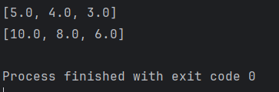

**Question 2:**

def Contains(sublist, lst):  
 index = 0  
 for num in sublist:  
 found = False  
 for i in range(index, len(lst)):  
 if num == lst[i]:  
 index = i+1  
 found = True  
 break  
 if not found:  
 return False  
 return True  
  
def main():  
 print(f"[1,2],[0,1,5,4,3,1,2,3]:")  
 print(Contains([1,2],[0,1,5,4,3,1,2,3]))  
 print(f"[2,1],[0,1,5,4,3,1,2,3]:")  
 print(Contains([2,1],[0,1,5,4,3,1,2,3]))  
 print(f"[1,1],[0,1,5,4,3,1,2,3]:")  
 print(Contains([1,1],[0,1,5,4,3,1,2,3]))  
 print(f"[4,4],[0,1,5,4,3,1,2,3]:")  
 print(Contains([4,4],[0,1,5,4,3,1,2,3]))  
 print(f"[],[0,1,5,4,3,1,2,3]:")  
 print(Contains([],[0,1,5,4,3,1,2,3]))  
  
if __name__ == '__main__':  
 main()

**Run Console:**

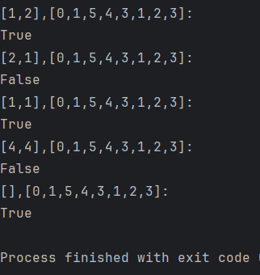

**Question 3:**

def Build_student_records(studentFile,gradesFile):  
 f1 = open (studentFile)  
 students_dic = {}  
 for line in f1:  
 line = line.strip().split(" ",1)  
 students_dic[line[0]] = line[1]  
 f1.close()  
 f2 = open(gradesFile)  
 student_grades = list()  
 for line in f2:  
 line = line.strip().replace(",","").split()  
 student_grades.append(line)  
 f2.close()  
 student_records = list()  
 for entry in student_grades:  
 student_id = entry[0]  
 grades = [x.split(":") for x in entry[1:]]  
 dic = {key: val for key,val in grades}  
 student_records.append([student_id, students_dic[student_id], dic])  
 student_records.sort(key = lambda x:x[0])  
 return student_records  
  
  
def main():  
 student_records = Build_student_records('students.txt','grades.txt')  
 for student in student_records:  
 print(f"{student[0]} {student[1]}")  
 print(f" ", end="")  
 grade = [f"{key}:{student[2][key]}" for key in sorted(student[2])]  
 print(", ".join(grade))  
  
if __name__ == '__main__':  
 main()

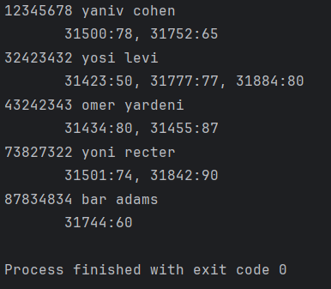  
**Run Console:**