Mesh - cook with what you have

Product Requirements Document

Company name

# Objective

For children, adolescents, women and men who is interested in recipe sites and cooking, the "Mesh - cook with what you have" is a unique online recipe site that includes a variety of recipes in a variety of categories. The site offers its customers to choose recipes according to the ingredients they have at home and thus they will have recipes tailored accordingly, without having to leave the house for shopping. Unlike many recipe sites like Foody and Rotev. which only display a variety of recipes with no option to focus on specific ingredients, our product allows users to search for recipes by products that are in their home. My main goal is widespread use of the app, with a large number of users including professionals like chefs who will raise the level of recipes in the app. The means I will use are automatic scanning of cooking sites, saving the appropriate ingredients and links to recipes and presenting them by user queries in an effective manner.

# Release

The estimated date for releasing the site is 17/4/22.

We will have some milestones during the work:

Our first milestone will be the design of the application - login page and registration and a personal area for the user, this milestone should be done until 1/2/22. Our second milestone would be to gather the information from different recipes sites into the database, this milestone should be done until 1/3/22. Our third and final milestone will be the implementation - finding recipes according to specific types of food / ingredients and saving searches and analyzing them for the benefit of the customer, this milestone should be done until 1/4/22.

# Features

1. Login / register to the system- Registration to the system includes analysis of the user profile, the user will enter ingredients that we do not want to use when preparing the recipe, in addition, characterizing the customer such as: vegetarian, vegan, gluten free, etc. – **essential.**

2. Collecting information from recipe sites - the app will collect information from selected recipe sites, put the recipes in a database while analyzing the ingredients in each recipe. **– essential.**

3. Finding recipes according to specific types of food / ingredients - the user will enter specific food ingredients and the system will search the database for selected recipes according to the user's choice. **– essential.**

4. Saving searches and analyzing them for the benefit of the customer - analyzing the user's searches and proposing relevant recipes according to the user's search history. **– desirable.**

5. Personal area - A user who is connected to the system will be able to enter the personal area, where data about the user profile will appear. **– desirable.**

# User flow and design

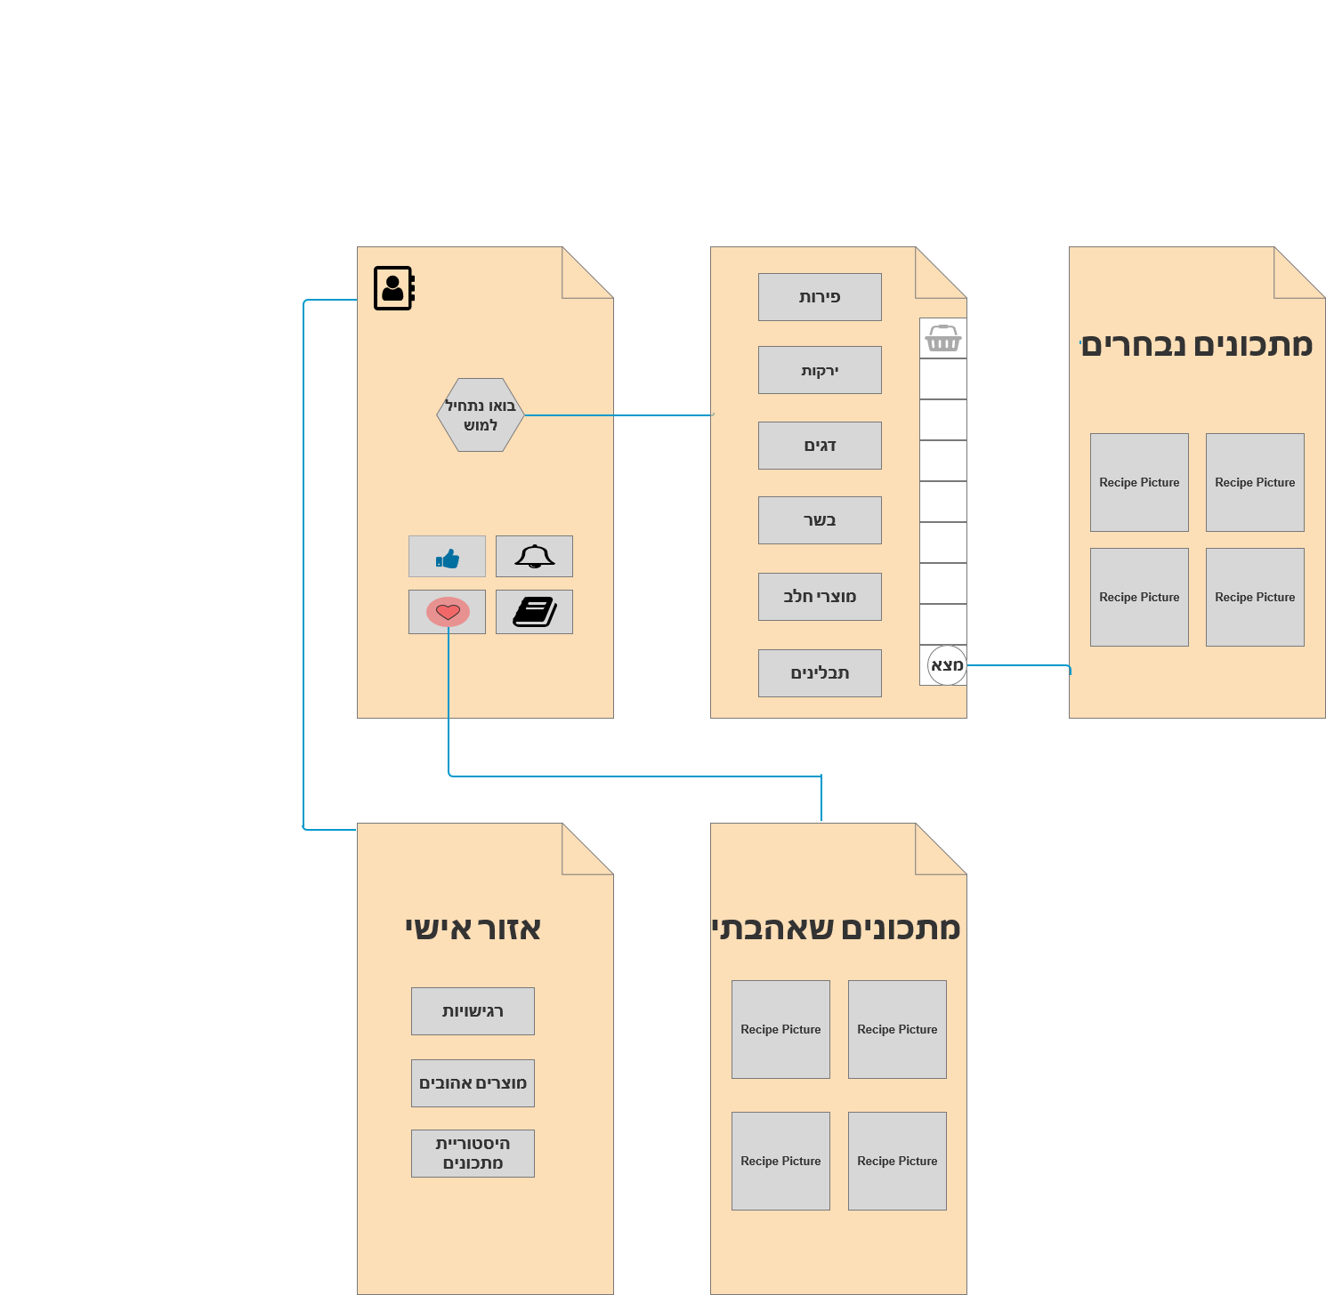

1. Login page - when initial logging in to the site, the user will perform a registration process, enter basic details and set culinary preferences.

2. Main page - in the center of the page will appear navigation buttons for "recipes I liked", recipe history, etc.

3. Personal area - allows you to update the user's personal settings.

4. Ingredient selection page - defines the desired ingredients according to built-in categories, specific types of foods or according to a free search.

5. Results page - appears after data processing, shows selected recipes and their suitability for input.