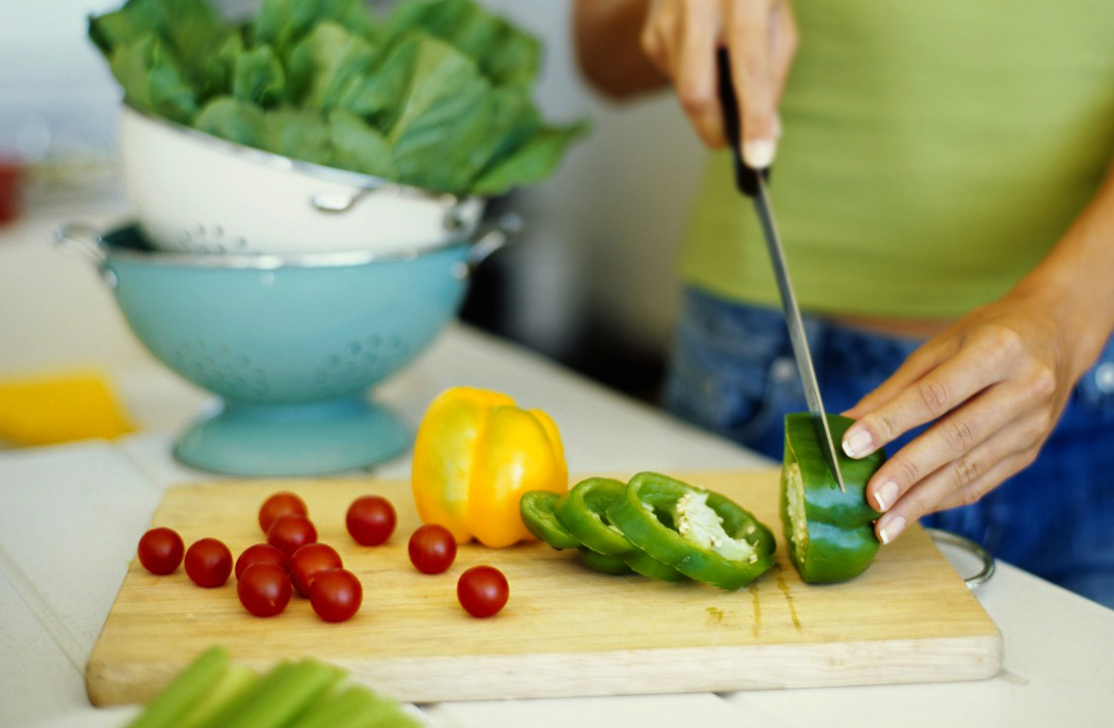

[Chef Challenge]

Coming soon…

# Great Taste Every Time

Embassy chefs showcase an authentic taste from their country in a friendly, delicious, culinary competition, featuring a sips and sweets pavilion with wine, cocktails and desserts!

*Taste the Authenticity!*

**EXPERIENCE AUTHENTIC FOOD, DRINK, MUSIC, DANCE & MORE.**

Food

Sample more than 55 authentic dishes representing a variety of regions prepared by a master chef hand selected by the Ambassador.

Drink

Sip on exotic cocktails, wines, beers and beverages unique to countries around the globe.

Culture

Experience the mix of global cultures through live performances by musicians and dancers throughout the evening.

Music

Enjoy a variety of culturally diverse musical performances throughout the evening culminating in a live performance at the after party.

**What to Expect:**

During the evening, guests will mix and mingle and enjoy small plate portions of dishes from area chefs and buddy pairs, visit the specialty drink bar, partake in an exclusive silent auction, and witness first-hand the powerful impact they have had in our community! After the silent auction closes, the live auction will begin. This year, the live auction features privately prepared dinners from restaurant chefs, tickets to highly desired sporting events, vacation getaways and more new, exciting experiences. The event typically wraps up close to 11:00, making it a perfect weekday evening event

Event Details

**Date:** Friday, October 6, 2018

**Timing:** 6:00-11:00 PM

**Dress Code:**Business Casual

**Location:** A04, Street2, CA

*Parking available