**Color Tutorial Topics**

What is encoded 'in' image code values?

...Image state explained

When to encode for print?

...Early binding vs. late binding workflows

Why doesn’t "perfect" math always yield a usable profile or desirable imaging result?

...Color processing computational quality

How are white point, black point, and gamut extent rendered or re-rendered?

...Essentials of color management

Color preference vs. color matching?

...Building rendering intent transforms

Re-rendering to another output? ...Device to device profile construction for interoperability





*Understand how to take and preserve great photos!*

**Give and take:**

“From the trenches” expert user Q&A: Color managed use case examples from creative and prepress workflows

Audience recommendations on future directions for color management

Wine & Cheese Networking Event:

Products and Applications ⎯ Industry

Color Management Demonstrations

Ms. Jane Smith



999 Standards Way

Cooperativeville, UN 00000

Mr. K.D. Sang

333 Good Fortune Avenue

Exploration Point, UN 11111

Dear Mr. Sang,

International Standards and their development process support:

* facilitation of global trade,
* improvement of quality, safety security, environmental and consumer protection, as well as the rational use of natural resources,
* global dissemination of technologies and good practices, all if which contribute to economic and social progress.

Through the network and collaboration of national member bodies, international liaisons, industry consortia, and dedicated experts, the international standards bodies constitute a leading platform for the production of global, market relevant international standards.

The consensus-building mechanisms employed in the development of these international standards are recognized and relied upon by industry, public authorities, consumers, and other stakeholders, thus helping to accomplish the aim of “one standard, one test, and one conformity assessment procedure accepted everywhere.”

In this way, international standards organizations and their standards products contribute to a more efficient and sustainable world economy.

Sincerely,

Jane Smith

**Summary Sheet Version 3.2**

**Intermediate Results**

**Final Report finished by time of final reporting.**

# EU NA/SA LA Asia AF/AU EUE NW SW ME SE MW IST

**First** 99.0 17.6 51.9 112.2 142.9 10.4 199.1 6.6 173.0 178.0 153.4 124.5

**Second** 153.2 147.8 126.6 143.6 121.4 138.4 50.9 188.6 139.0 45.5 32.3 133.4

Y M T Z O I R Q L C P G

**Third** 32.5 57.3 175.7 91.4 84.0 56.6 163.1 67.5 85.4 53.5 185.5 29.0

**Fourth** 46.7 93.7 24.2 172.2 47.9 132.6 26.7 128.9 163.1 103.9 162.3 55.6

**Estimate:** 203.2 197.8 225.7 222.2 192.9 188.4 249.1 238.6 223.0 228.0 235.5 183.4

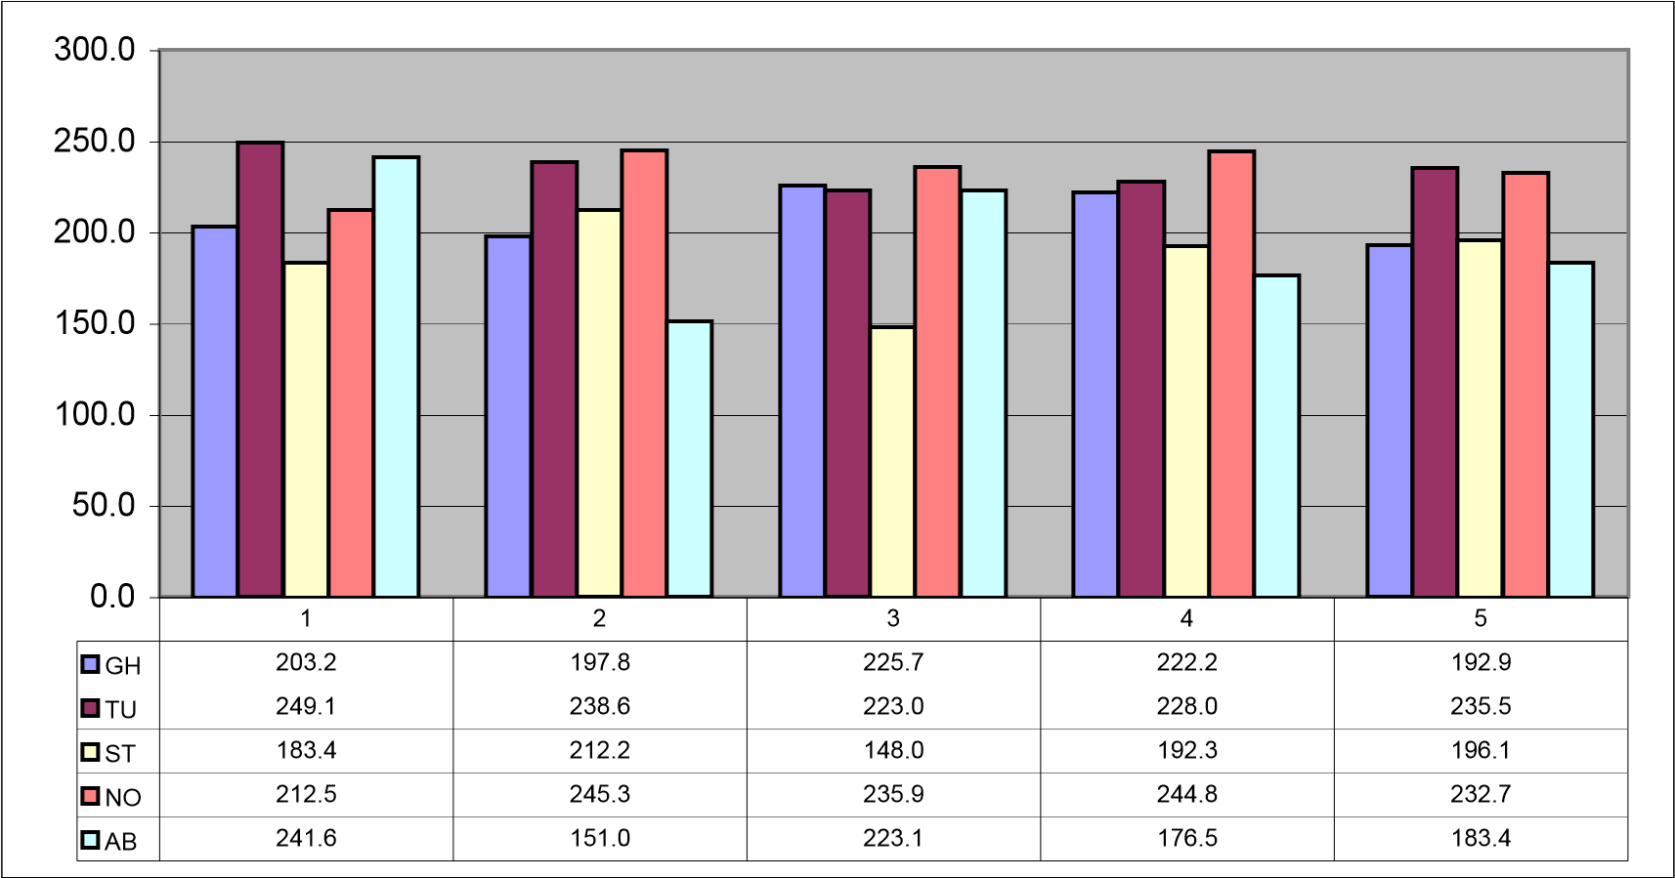

# EU NA/SA LA Asia AF/AU EUE NW SW ME SE MW IST

**Ein** 158.5 98.0 84.8 146.1 186.0 114.9 20.9 168.6 155.8 174.7 191.6 35.0

**P G T O Z I R Q L C Y M Zwei** 88.1 12.1 69.5 119.6 99.2 162.5 90.6 106.2 194.8 79.6 160.5 31.0

**Drie** 79.7 6.0 93.8 13.6 178.5 33.5 195.3 32.6 75.6 136.3 43.2 15.2

**I R O T Z P G C L Q M Y**

**Funf** 162.2 67.9 142.3 117.5 31.1 73.1 156.0 38.8 47.4 182.7 25.9 74.6

**Vier** 34.5 79.3 44.4 144.7 64.5 132.4 85.5 185.9 117.7 117.7 22.1 101.0

**Estimate:** 212.2 148.0 192.3 196.1 236.0 212.5 245.3 235.9 244.8 232.7 241.6 151.0

# EU NA/SA LA Asia AF/AU EUE NW SW ME SE MW IST

56.3 196.4 194.7 590.1 287.5 189.4 5.0 186.1 360.9 254.0 528.6 396.0

**Total** 415.4 345.8 418.0 418.3 428.8 400.9 494.4 474.5 467.8 460.7 477.1 334.4



Adjust

Capture

Color

Convert

Assemble

Capture originals

and Color-Render

to Wide Gamut

Standard RGB

Print first proofs

& adjusted proofs

Print production

Create layout

Select objects

Normalize formats

Combine objects

Softproof layout

Configure job

Adjust RGB objects

Visualize softcopy



Iterate



Iterate

**Workflow Primitives**

Consider sequences

image states

user functions

content formats

job control

transform intent

Color

Convert

Color

Convert

Color

Convert

Visualize

Visualize

Visualize