**************************************************************************************************************

************************** TEST-05 : START OF MS WORD PRINTING TEST CASE *************************

**************************************************************************************************************

**************************************************************************************************************

**************************** BASIC COMPATIBILITY - TEST PARAMETERS *********************************

**************************************************************************************************************

Test_filename => Test-05_MsWord_5page.docx

Description => 5page mixed Color content with text and images.

**Job Properties:**

Paper_size => Letter

Orientation => Portrait

Copies => 2

Duplexing => None

Page range => 1,2-3

Color => Color

Pages per sheet=> 2 Pages Per Sheet

**************************************************************************************************************

**************************** BASIC COMPATIBILITY - TEST PARAMETERS *********************************

**************************************************************************************************************

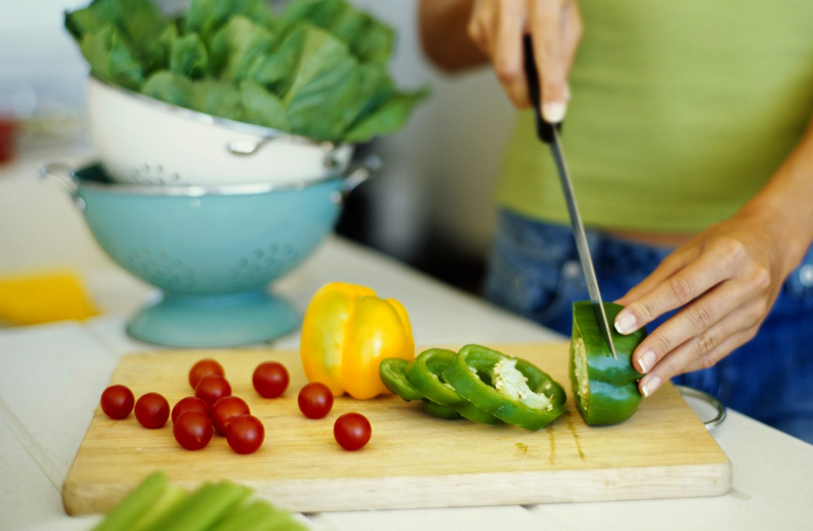

[Chef Challenge]

Coming soon…

# Great Taste Every Time

Embassy chefs showcase an authentic taste from their country in a friendly, delicious, culinary competition, featuring a sips and sweets pavilion with wine, cocktails and desserts!

*Taste the Authenticity!*

**EXPERIENCE AUTHENTIC FOOD, DRINK, MUSIC, DANCE & MORE.**

Food

Sample more than 55 authentic dishes representing a variety of regions prepared by a master chef hand selected by the Ambassador.

Drink

Sip on exotic cocktails, wines, beers and beverages unique to countries around the globe.

Culture

Experience the mix of global cultures through live performances by musicians and dancers throughout the evening.

Music

Enjoy a variety of culturally diverse musical performances throughout the evening culminating in a live performance at the after party.

**What to Expect:**

During the evening, guests will mix and mingle and enjoy small plate portions of dishes from area chefs and buddy pairs, visit the specialty drink bar, partake in an exclusive silent auction, and witness first-hand the powerful impact they have had in our community! After the silent auction closes, the live auction will begin. This year, the live auction features privately prepared dinners from restaurant chefs, tickets to highly desired sporting events, vacation getaways and more new, exciting experiences. The event typically wraps up close to 11:00, making it a perfect weekday evening event

Event Details

**Date:** Friday, October 6, 2018

**Timing:** 6:00-11:00 PM

**Dress Code:**Business Casual

**Location:** A04, Street2, CA

*Parking available

# Lorem Ipsum

#### "Neque porro quisquam est qui dolorem ipsum quia dolor sit amet, consectetur, adipisci velit..."

##### **"There is no one who loves pain itself, who seeks after it and wants to have it, simply because it is pain..."**

Lorem ipsum dolor sit amet, consectetur adipiscing elit. Nunc efficitur quis sem in tincidunt. Curabitur eget malesuada nibh. Duis fringilla at enim vitae posuere. Lorem ipsum dolor sit amet, consectetur adipiscing elit. Sed a tortor vel leo mollis porta et ultrices metus. Praesent consectetur lacus quis est elementum, non cursus nibh scelerisque. Interdum et malesuada fames ac ante ipsum primis in faucibus. Vestibulum lacinia finibus augue et consectetur. Nam consectetur neque ac lacus aliquet dapibus. Sed auctor consectetur commodo. Nullam rhoncus turpis libero, ac consequat ante pretium eget. Vivamus sed sapien commodo, tincidunt arcu quis, varius ligula. Curabitur vitae egestas erat, eu bibendum odio. Vestibulum accumsan orci ante, eu scelerisque nisl ullamcorper a. Praesent faucibus sapien at lectus cursus, ut tincidunt neque elementum. Phasellus dapibus, orci non scelerisque facilisis, enim magna efficitur arcu, id tincidunt tortor leo lobortis arcu.

Phasellus at posuere enim, vitae vulputate sapien. Nam id commodo purus. Donec luctus ligula vitae velit gravida pretium. Morbi at augue aliquet, faucibus velit a, consectetur lacus. Nullam in egestas eros, non condimentum ex. Vestibulum risus nisi, laoreet ac tincidunt non, aliquet aliquet metus. Sed ex sapien, tincidunt in dui vel, imperdiet dignissim nibh. Nulla a nunc dictum, commodo tellus et, aliquet dolor.

Pellentesque vel enim ornare leo varius convallis placerat sit amet risus. Quisque aliquam rutrum lorem, a fringilla felis venenatis sed. Suspendisse potenti. Pellentesque sed tortor hendrerit, porta libero et, pretium turpis. Pellentesque gravida mauris id nulla tempor, sit amet sollicitudin libero placerat. In eu hendrerit libero. Nam sed arcu nec dui varius venenatis. Aenean mollis quam quis laoreet interdum. Pellentesque commodo placerat urna, eu egestas ligula lacinia non. Integer eu tincidunt dui. Vivamus efficitur purus eget venenatis dignissim.

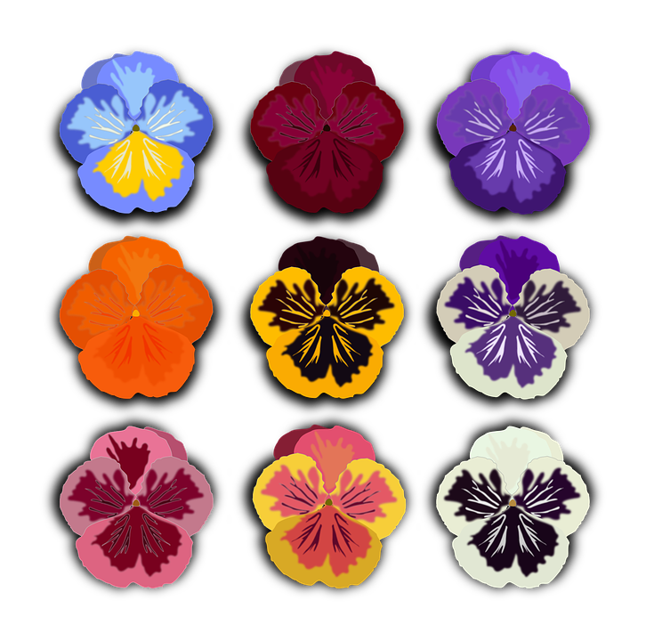

**************************************************************************************************************

************************** TEST-05 : END OF MS WORD PRINTING TEST CASE ***************************

**************************************************************************************************************