*********************************************************************************************

************************ TEST-06 : START OF MS WORD PRINTING TEST CASE ************************

*********************************************************************************************

*********************************************************************************************

**************************** BASIC COMPATIBILITY - TEST PARAMETERS ***************************

*********************************************************************************************

Test_filename => Test-06_MSWord_4page.docx

Paper_size => Letter

Orientation => Landscape

Copies => 1

Duplexing => Long Edge.

Page range => 1,2,3

Color => Color

*********************************************************************************************

**************************** BASIC COMPATIBILITY - TEST PARAMETERS ****************************

*********************************************************************************************

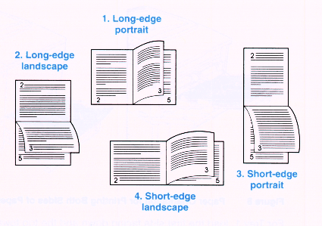

PDF TEST PAGE

3 Pages (2 sheets) with pictures, text, to check duplexing and 3rd page issues.

Some of the tests we would like to do are:

* Walk Up and Print WUP <steps, excessive time from content to page in hand>

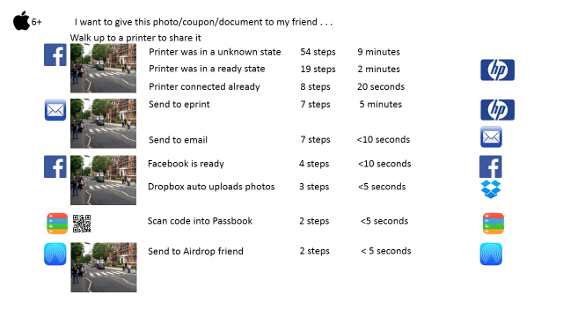

* Ease of Use Device Bubbles EUDB <steps, barriers>

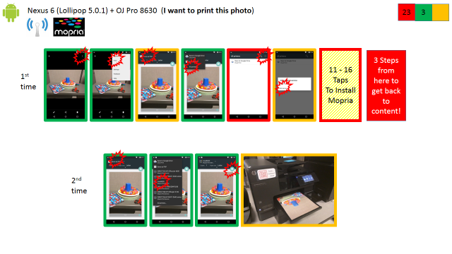

* Page Q <report list of issues, unexpected as a customer>
  + This is about page layout as it comes out of the printer. I am not an HP engineer, I am a customer and I just want things to work. Was it the expected outcome? Did ink cover most of the media? Was the image centered properly? Was it OK as it came out in landscape or portrait? Are the border excessive? Anything cropped away? Blah blah blah blah blah blah blah blah blah blah blah blah blah blah blah blah blah blah blah blah blah blah blah blah blah blah blah blah blah blah blah blah blah blah blah blah blah blah blah blah blah blah blah blah blah blah blah blah blah blah blah blah blah blah blah blah blah blah blah blah blah blah blah blah blah blah blah blah blah blah blah blah blah blah blah blah blah blah blah blah blah blah blah blah blah blah blah blah blah blah blah blah blah blah blah blah blah blah blah blah blah blah blah blah blah blah blah blah blah blah blah blah blah blah blah blah blah blah blah blah blah blah blah blah blah blah blah blah blah blah blah blah blah blah blah blah blah blah blah blah blah blah blah blah blah blah blah blah blah blah blah blah blah blah blah blah blah blah blah blah blah blah blah blah blah blah blah blah blah blah blah blah blah blah blah blah blah blah blah blah blah blah blah blah blah blah blah blah blah blah blah blah blah blah blah blah blah blah blah blah blah blah blah blah blah blah blah blah blah blah blah blah blah blah blah blah blah blah blah blah blah blah blah blah blah blah blah blah blah blah blah blah blah blah blah blah blah blah blah blah blah blah blah blah blah blah blah blah blah blah blah blah blah blah blah blah blah
  + blah blah blah blah blah blah blah blah blah blah blah blah blah blah blah blah blah blah blah blah blah blah blah blah blah blah blah blah blah blah blah blah blah blah blah blah blah blah blah blah blah blah 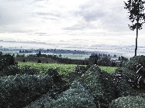blah blah blah blah blah blah blah blah blah blah blah blah blah blah blah blah blah blah blah blah blah blah blah blah blah blah blah blah blah blah blah blah blah blah blah blah blah blah blah blah blah blah blah blah blah blah blah blah blah blah blah blah blah blah blah blah blah blah blah blah blah blah blah blah blah blah blah blah blah blah blah blah blah blah blah blah blah blah blah blah blah blah blah blah blah blah blah blah blah blah
* Print Q <report list of issues, unexpected>
* Connectivity Punch Card (NoTouch, iPerf, Mobile) <freq, duration>
* Mobile Big Data Validation
* Apps EoU <steps, barriers, time>
* Adhoc Requests
* IoT EoU Competitive <TBD, A3 to report on things found>
* IoT Connectivity Q <freq, duration>

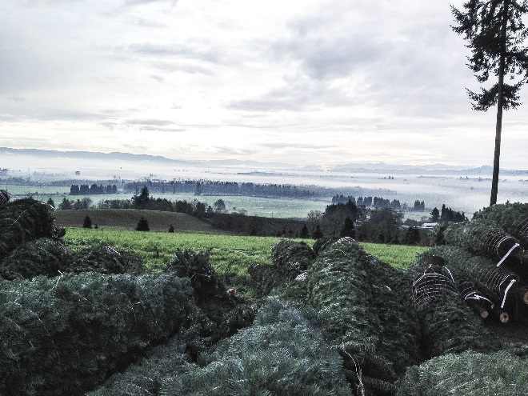

Page break right below here . . .

Page Break right above this line . . .

* Print Q <report list of issues, unexpected>
  + Very high level view. Is it acceptable in a general photo way. Is it OK or really bad?
* Connectivity Punch Card (NoTouch, iPerf, Mobile) <freq, duration>
  + No Touch like punchcard and a daily test to show how well connectivity is working.
* 
* Mobile Big Data Validation
  + Big data and the data analyst want to validate the data they get. For example when Pony Express sends data up do the page counts match at the printer and at the big data report?
* 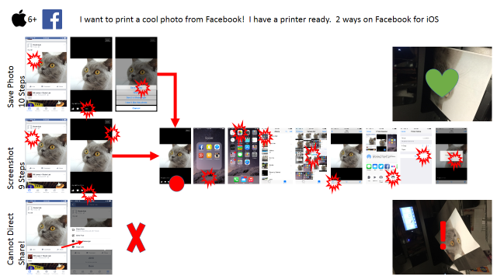
* IoT EoU Competitive <TBD, A3 to report on things found>
  + A3 TBD but check this link for short reviews from our team.
  + <https://plus.google.com/u/0/b/105141813915203363736/communities/104196818502369407350>
* IoT Connectivity Q <freq, duration>

Much like the no touch and other connectivity testing where we want to compare to other devices out there and learn from them. We do this to make the best product for offer to customers.

*********************************************************************************************

************************* TEST-06 : END OF MS WORD PRINTING TEST CASE *************************

*********************************************************************************************