Chimera X
Press middle mouse or the wheel to pan (move it anywhere in the window) the structure.
How to open command line
Go to tools General Command Line or Press Ctrl + Shift + C

The MMP1 structure shows solvent, water visible as red dots
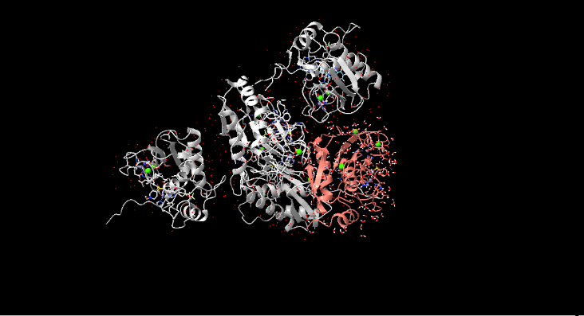
Go to tools General Model panel and close unwanted models OR
- close #model for example close #1.
After this only one structure for MMP-1 was visible
- Select solvent
- Info solvent
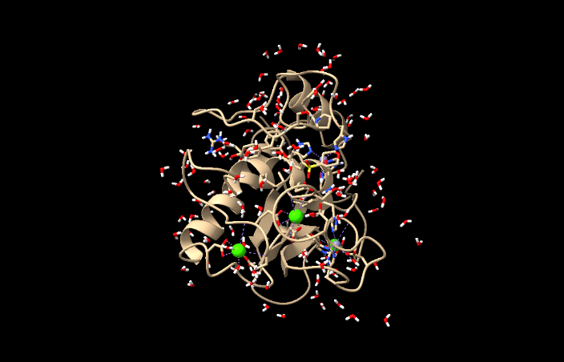
The red and white ball and stick residues are of water and left side output window showed the following: 399 atoms, 266 bonds, 133 residues, 1 model selected. Which indicates 133 water molecules

- Delete solvent
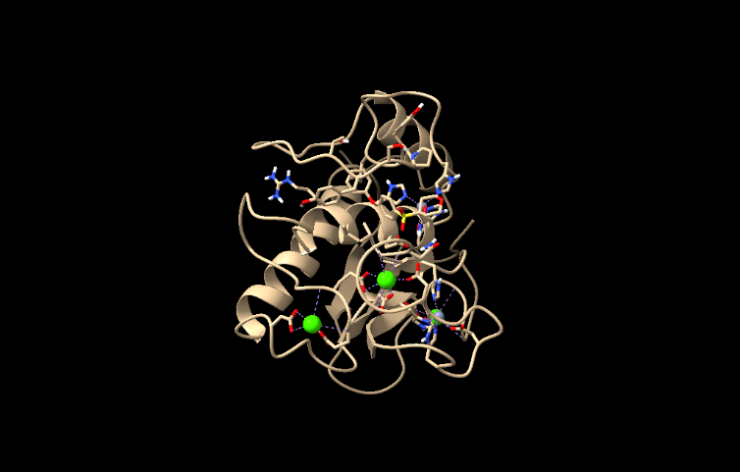
Still few water molecules are visible. But most are removed.
- Select ligand
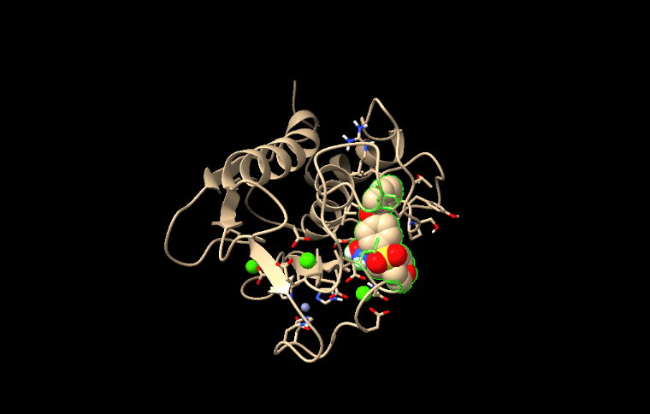
Changed from ball stick atoms display to sphere for easy visualization
- Delete sel
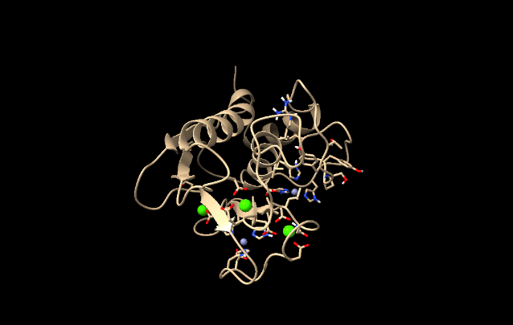
The ligand deleted.

- Select ion
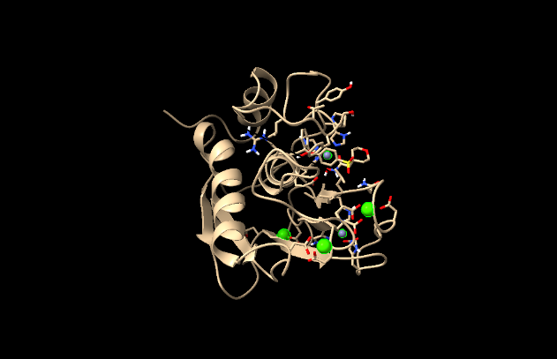
5 atoms, 5 residues, 1 model selected: 3 zinc (green) and 2 calcium (grey)
- addh
Addition of hydrogen
A warning appeared
Both O and OXT missing from C-terminal residue /A GLN 264; cannot complete teminus
Not adding hydrogens to /A SER 263 CB because it is missing heavy-atom bond partners
Not adding hydrogens to /A GLN 264 C because it is missing heavy-atom bond partners
Not adding hydrogens to /A GLN 264 CB because it is missing heavy-atom bond partners
Notes
Termini for MMP-1.pdb (#1) chain A determined from SEQRES records
Chain-initial residues that are actual N termini: /A ARG 108
Chain-initial residues that are not actual N termini:
Chain-final residues that are actual C termini: /A GLN 264
Chain-final residues that are not actual C termini:
118 hydrogen bonds
869 hydrogens added
Since 263 & 264are far away from the catalytic site, this warning can be ignored. However, verify these conclusions using the following steps.
The N terminus starts at ARG 108 and C terminus is at GLN 264
For further verification that the residues are away from binding site. Type the following commands.
- Select :263-264
- Color sel green
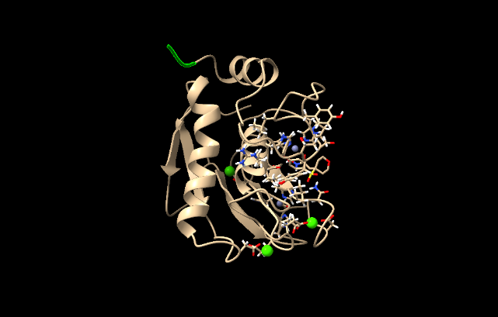
The green selected residues are far away from the catalytic residues hence can be ignored.
- addcharge
The structure should have total charge.

MMP13
Showed 4 chains A, B, C, D to check whether all chains are identical type
- Info
It showed that all chains are identical hence
- select /A
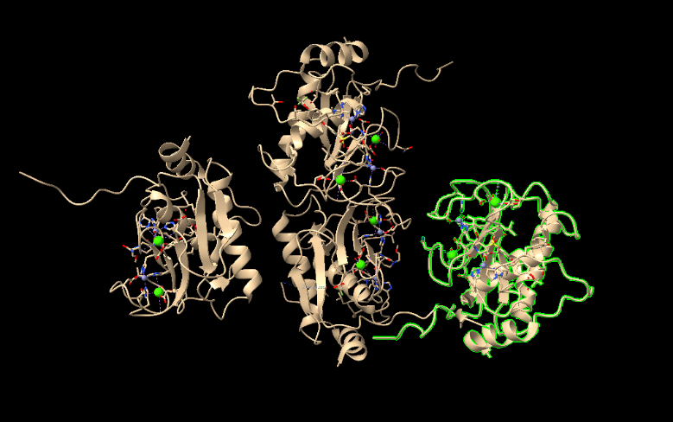

- Delete /B,C,D
Difference between close and delete commands, the close command closes models when multiple models are open, whereas delete command removes part of a model.
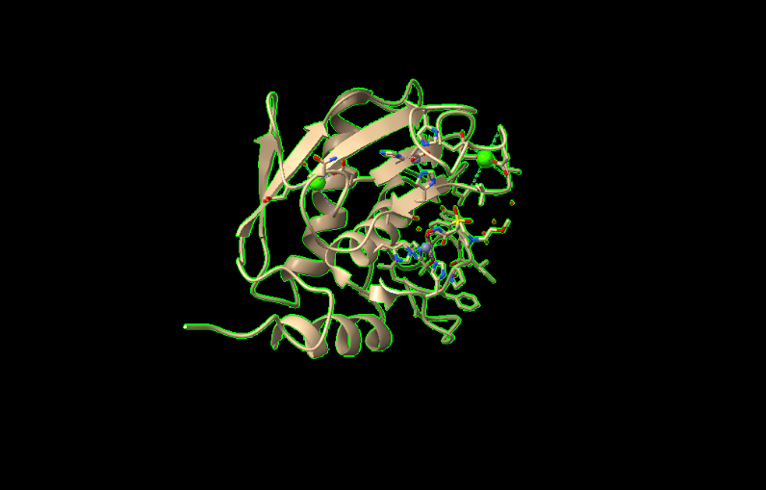
Only one chain A is visible now. To remove selection type in command.
- select clear
- select ~protein
this will select any non-protein such as ligands ions
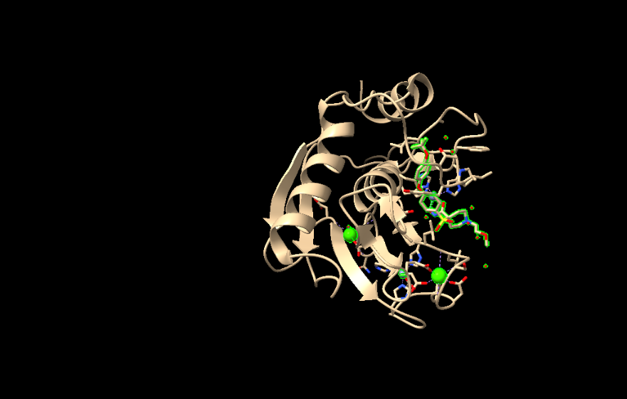
- select ligand
only select the ligand
- color sel green
this will color the selected ligand green
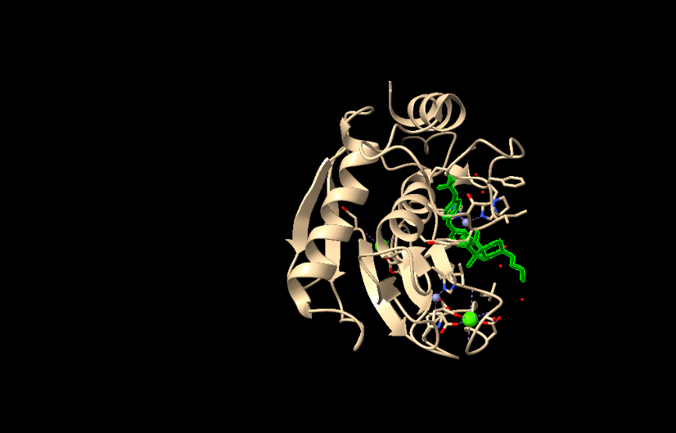

- delete sel

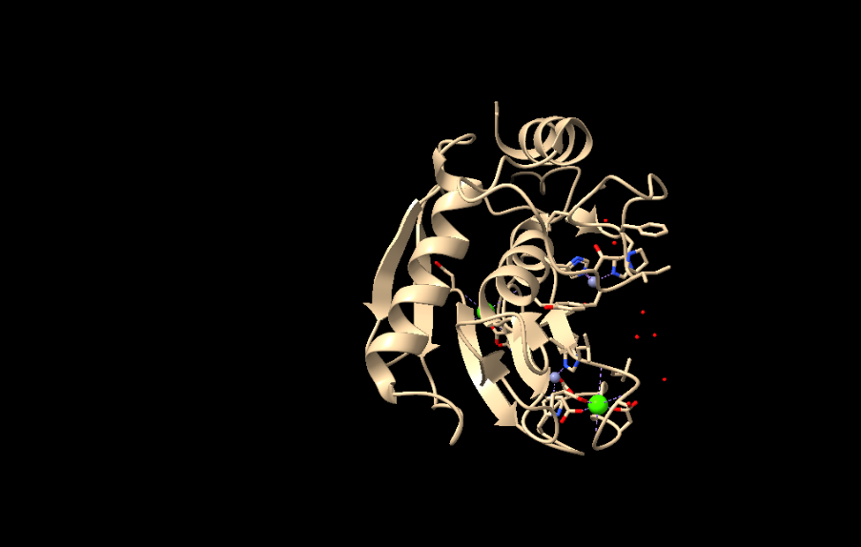
The ligand of MMP13 was deleted
- select solvent
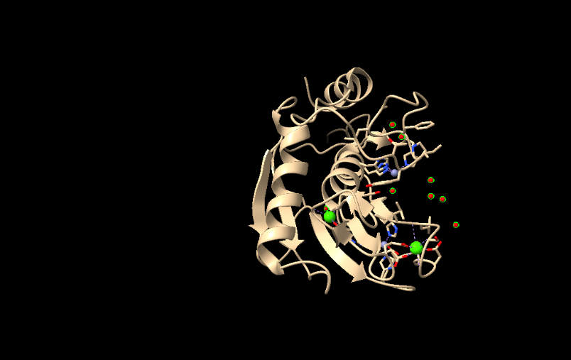
141 atoms, 141 residues, 1 model selected. Red and green selection of water molecules
- info
1445 atoms, 1346 bonds, 309 residues, 1 chains (A)
- info solvent
- delete solvent
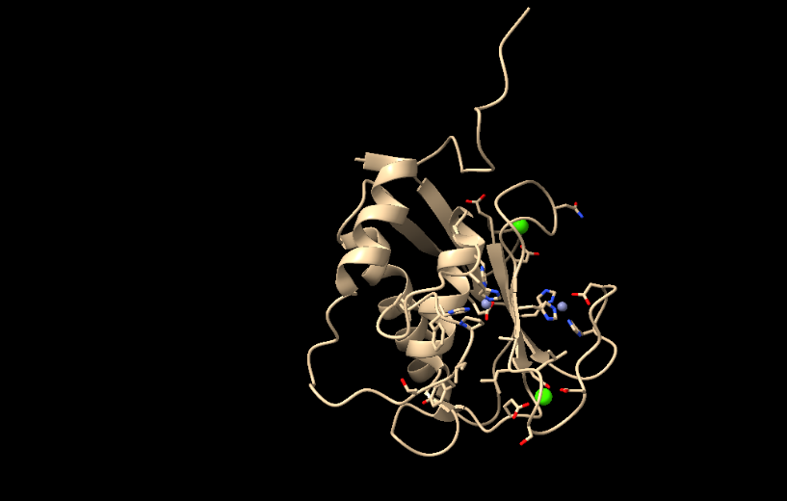
Water molecules deleted
- select :ZN or CA
Go to Action, Color, select color as lime or yellow
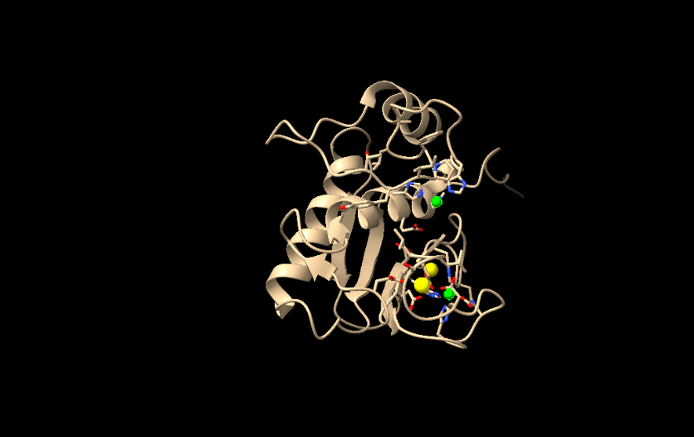

Go to select, structure, secondary structure, coil/helix/strands
Go to Action, color, red/orange/magenta
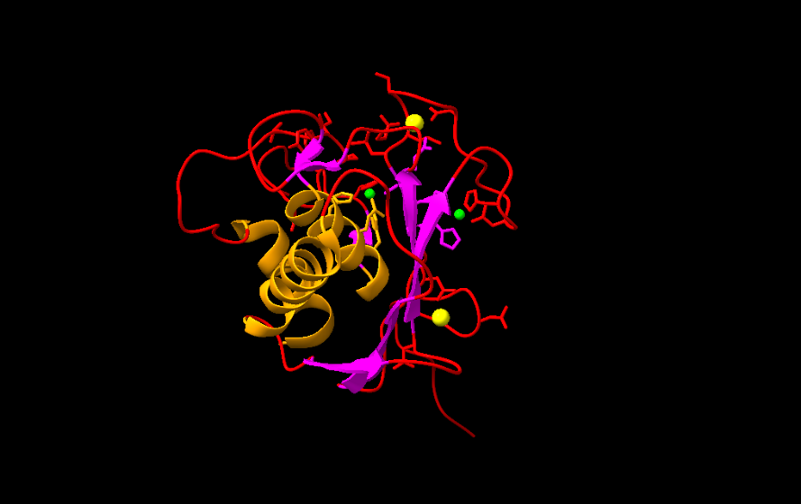
- addh
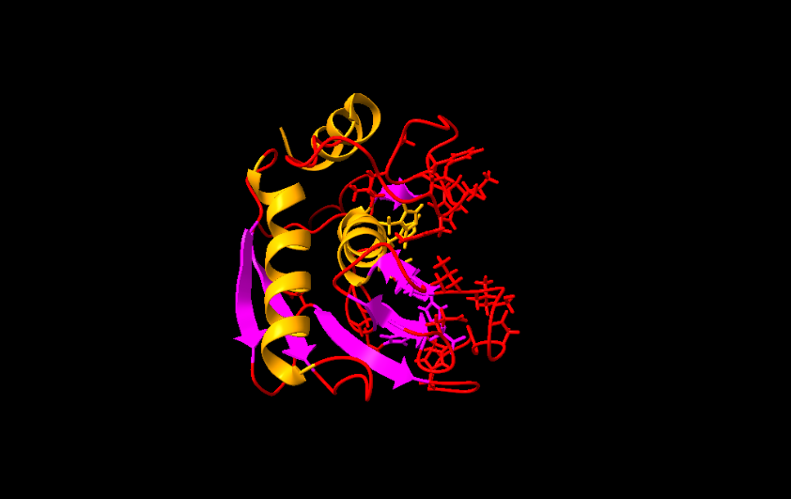
Summary of feedback from adding hydrogens to MMP-13.pdb #1
warnings
Not adding hydrogens to /A TYR 104 CB because it is missing heavy-atom bond partners
Not adding hydrogens to /A LYS 249 CB because it is missing heavy-atom bond partners
notes
Termini for MMP-13.pdb (#1) chain A determined from SEQRES records
Chain-initial residues that are actual N termini: /A TYR 104
Chain-initial residues that are not actual N termini:
Chain-final residues that are actual C termini: /A GLY 267
Chain-final residues that are not actual C termini:
120 hydrogen bonds
1211 hydrogens added
- select :104,249
to see if they are away from the catalytically active site.
Further
Go to Tools, Binding Analysis, Find Cavities
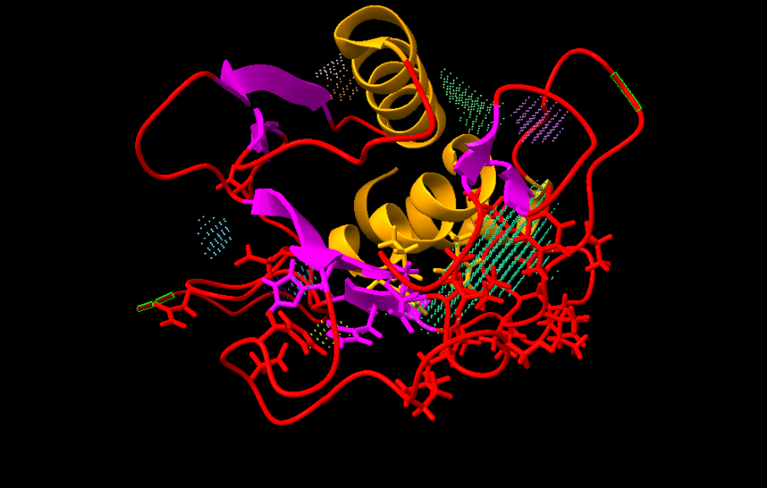

Cavity ID | Volume (Å³) | Area (Å²) | Maximum Depth (Å)
1.1.1 | 246.46 | 200.65 | 4.91
1.1.4 | 31.10 | 42.74 | 1.20
1.1.2 | 29.59 | 34.52 | 1.20
Others | <15 | <20 | <1.2

A total of 9 cavities were detected. The largest cavity and the binding site is 1.1.1 (4.91 Å) and the two residues seems to be far away from this cavity.
To remove cavities for the final step of adding charge use the following commands
- info
- close #model
Using Amber 20 recommended default charges and atom types for standard residues
Assigning partial charges to residue ZN (net charge +2) with am1-bcc method
Assigning partial charges to residue CA (net charge +2) with am1-bcc method
1 structure has non-integral total charge.
Details in log.

Here are the structures will non-integral total charge along with the particular residues from those structures with non-integral total charge:
MMP-13.pdb #1: /A TYR 104: 1.0181 and /A LYS 249: -0.0353

