CURCUMIN
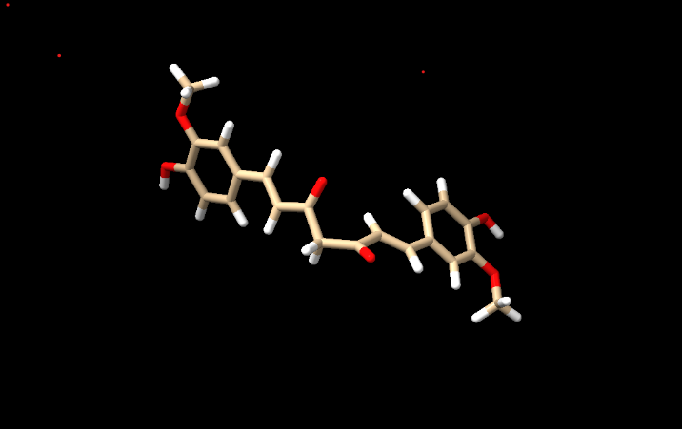
- Info
1 models
#1, pubchem:969516, shown
47 atoms, 48 bonds, 1 residues, 0 chains ( )

- Tools Structure Editing Add Hydrogens
Select also consider H bonds over steric only and press OK.
Summary of feedback from adding hydrogens to pubchem:969516 #1
notes Chain-initial residues that are actual N termini:
Chain-initial residues that are not actual N termini:
Chain-final residues that are actual C termini:
Chain-final residues that are not actual C termini:
0 hydrogen bonds
0 hydrogens added
pH need not be entered in chimera since it takes the charge at pH 7.0. so all the protonated states in option section of the addh dialogue box have to left at default.
- Tools Structure Editing Add Charges
Assigning partial charges to residue UNL (net charge +0) with gasteiger method
These messages mean:
- ChimeraX recognized the ligand as UNL (unknown ligand).
- The ligand was assigned a net charge of 0.
- Gasteiger partial charges were calculated using ANTECHAMBER.

- Select solvent
Nothing selected. Typically, ligands obtained from PubChem have no solvent.

- Delete sel
- Tools Structure Editing Minimize structure
step 100: energy -206.7
step 200: energy -206.9
decrease in energy i.e. more negative means the structure is more stable since the change is energy is not large, which indicates the structure was fairly stable to begin with.

