ASSIGNMENT 3
(SCHEDULING)
Name : Amitabh Srivastava
Roll number : 2301410016

- First Come First Serve Scheduling
CODE
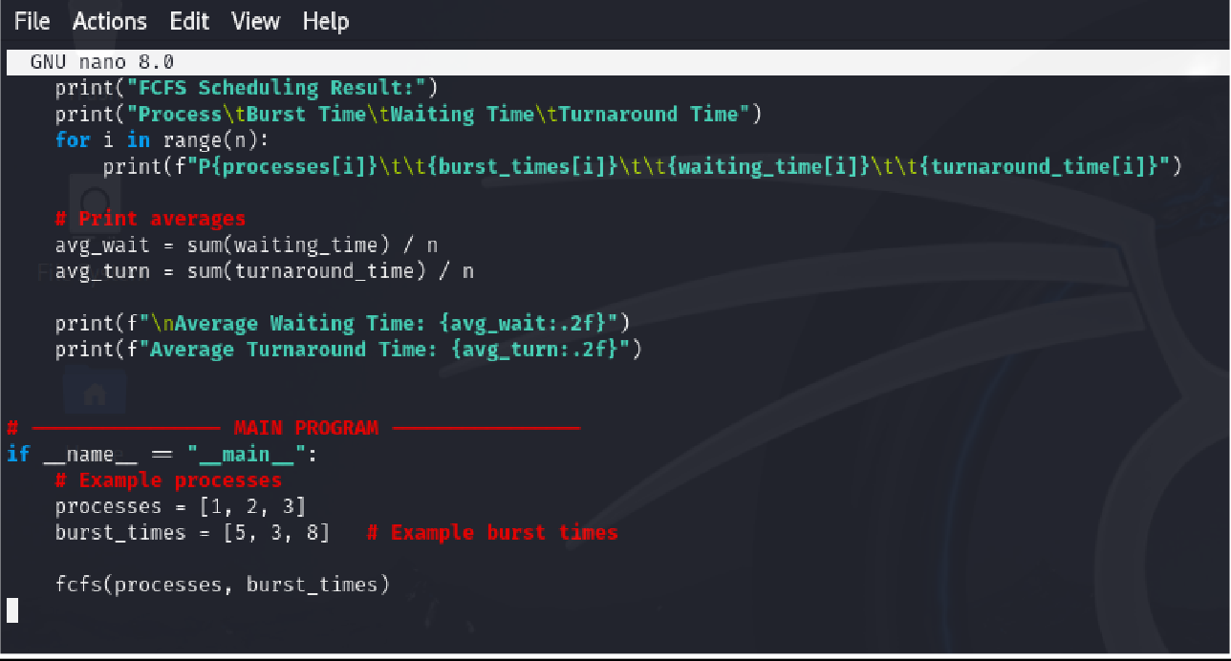

OUTPUT
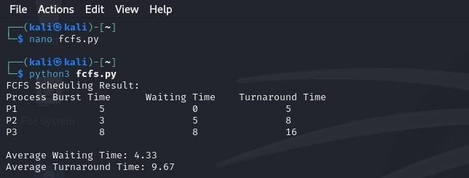

- SJF (Shortest Job First)
CODE
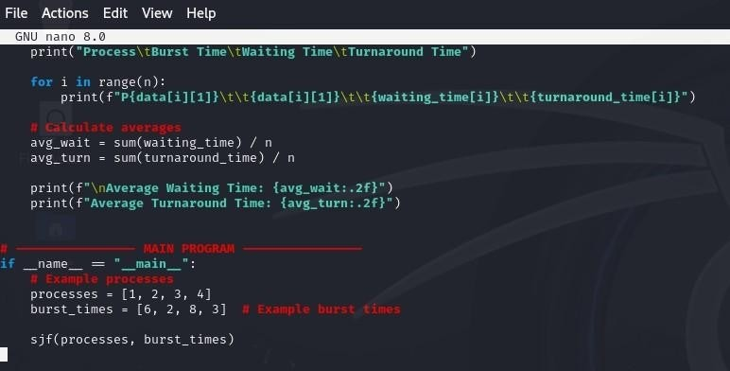

OUTPUT
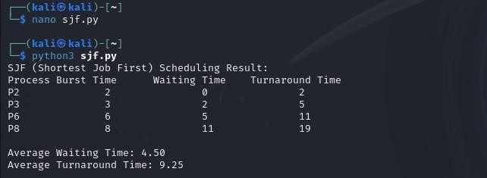

- Robin Round
CODE
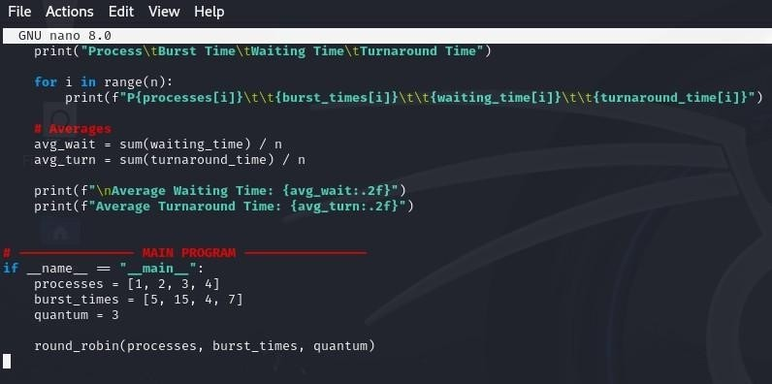

OUTPUT
