Name : Amitabh Srivastava
Roll number : 2301410016
Problem Statement:

ASSIGNMENT 2

Modern operating systems are responsible for initializing system components, creating processes, managing execution, and gracefully shutting down. This lab aims to simulate these core concepts using Python, helping students visualize how processes are handled at the OS level. The focus is on creating a simplified startup mechanism that spawns multiple processes and logs their lifecycle using the multiprocessing and logging modules. This hands-on simulation enhances conceptual clarity and promotes coding proficiency in scripting real-world OS behavior.
Sub-Task 1: Initialize the logging configuration
CODE :
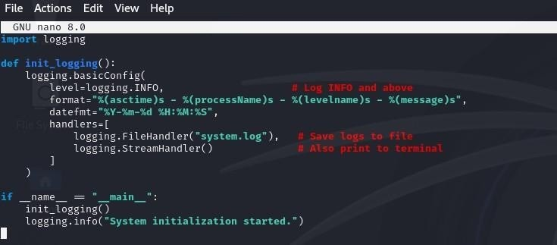

OUTPUT :
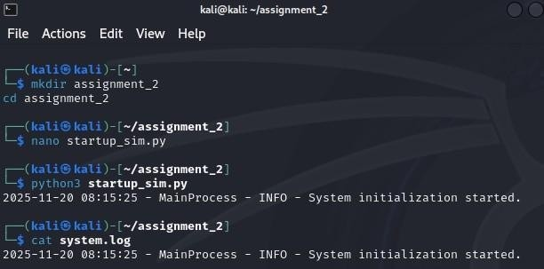

Sub-Task 2: Define a function that simulates a process task (e.g., sleep for 2 seconds).
cODE:
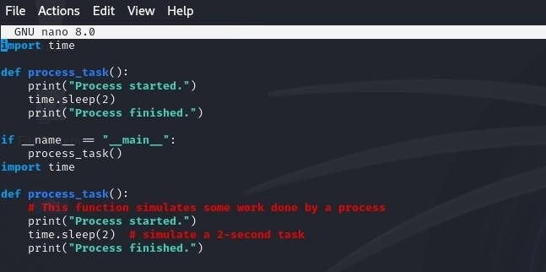
OUTPUT :
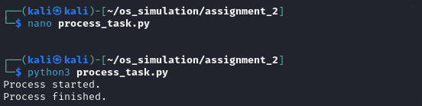

Sub-Task 3: Create at least two processes and start them concurrently.
CODE :
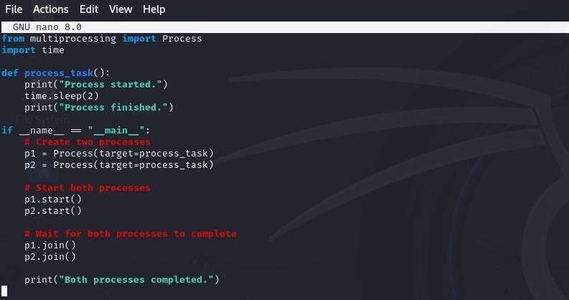
OUTPUT :
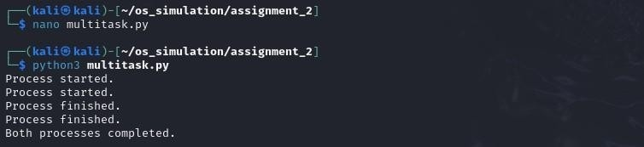

Sub-Task 4: Ensure proper termination and joining of processes, and verify the output in the log file.
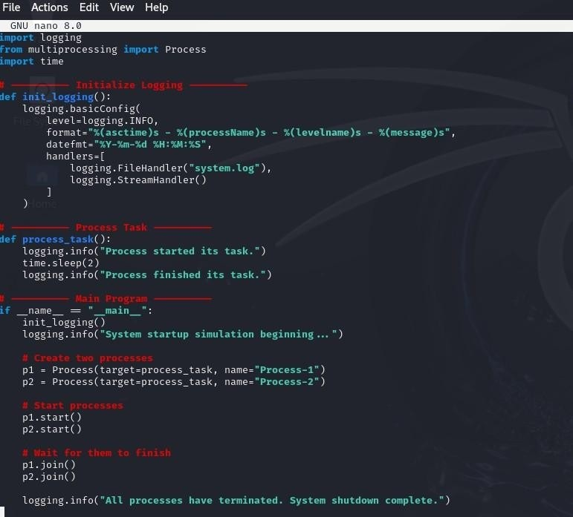
CODE :

OUTPUT :
