sCure Box — How the Machine Works
DOct 21, 2026 · @Origin

The machine at a glance
The sCure Box is a closed chamber. It heats, dries, shines light on and cools the parts inside.
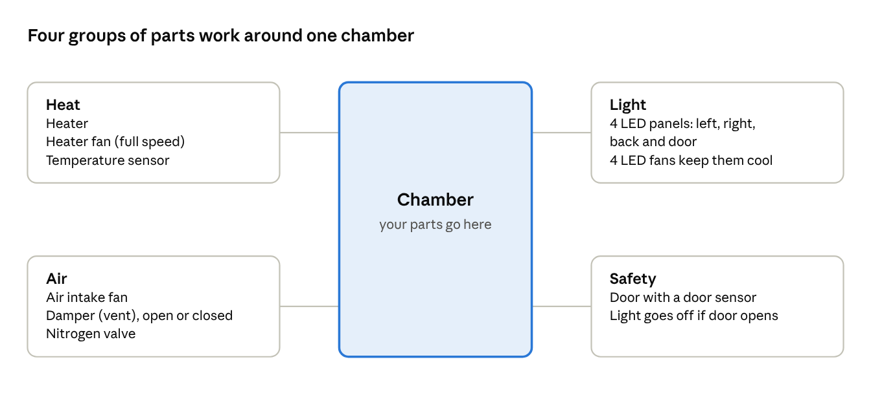
machine parts by job · not to scale
The heat and air parts look after the temperature, the light does the curing, and the safety parts make sure nothing runs while the door is open.

What runs in each mode
Many parts work together at once. In Cure, for example, the heater keeps the chamber warm while the light is on. Here's what every part is doing in each mode.
Mode | Heater | Heater fan | Air intake fan | Damper (vent) | UV LEDs | LED fans | Nitrogen valve
Heating | On, holds the set temperature | 100 % | Off | Closed | Off | Off | Closed
Drying | On, holds the set temperature | 100 % | 30 % PWM, once at temperature | Closed, opens once at temperature | Off | Off | Closed
Cure 405 nm | On, holds the set temperature | 100 % | Off | Closed | On at the set power | All 4 at 100 % | Closed
Bleaching 450 nm | On, holds the set temperature | 100 % | Off | Closed | On at the set power (door panel only) | Door fan only, 30 % | Closed
Cure or Bleaching with heating off (UV only) | Off | Not used | 60 % if Ventilation is on | Open if Ventilation is on | On at the set power | 100 % in Cure, 30 % in Bleaching, for each lit panel | Closed
Cooling | Off | 100 % | Fast 100 %, Medium 60 %, Slow 30 % | Open | Off | Fast: all 4 at 100 %. Medium and Slow: off | Closed
Nitrogen purge | No change | No change | No change | No change | No change | No change | Open for 120 s
After the program ends | Off | 30 % for 15 minutes, then off | Off | Closed | Off | Off | Closed
"No change" means the part stays as the step before left it.

Timing diagram
The same information, shown over time for one example program: Drying, then Heating, a nitrogen purge, Cure and Cooling. Read each row left to right to see when that part switches on and off.
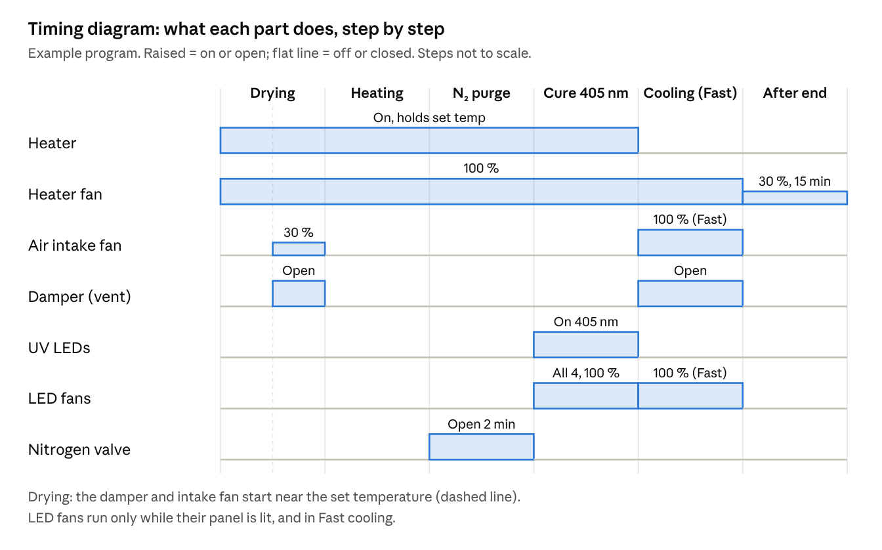
timing diagram · example program, not to scale
Notice that the heater stays on through the nitrogen purge and the Cure step, and only switches off when Cooling starts. After the program ends, the heater fan keeps running at 30 % for 15 minutes to cool the heater down.

Heating
Heating brings the chamber up to the temperature you set and holds it there. It can overshoot a little on the way up, but never by more than 2.5 °C. This limit is for heating alone: when the UV light is on, the light itself adds heat (see Cure and Bleaching).
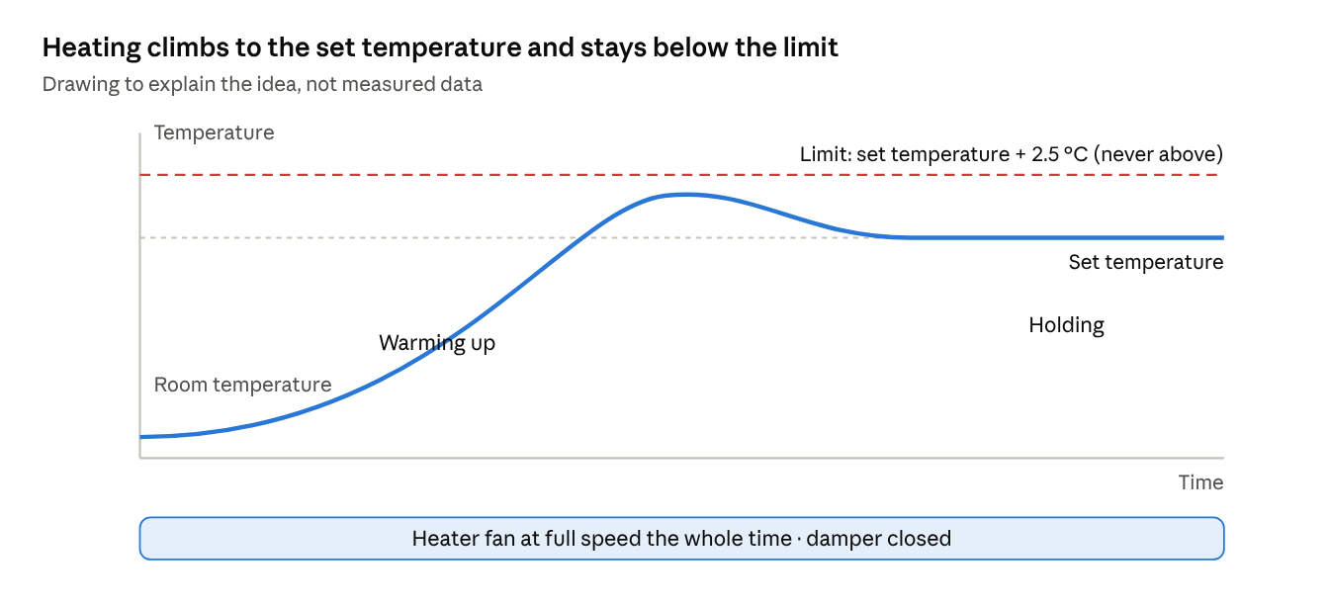
heating step · illustration
What happens, step by step:
- You close the door. The machine will not heat with the door open.
- The machine checks its temperature sensor and its heater fan before it starts.
- The heater fan runs at full speed (about 3,500 RPM) for the whole time the heater is on. It spreads the heat evenly. The damper (vent) stays closed, so the heat stays inside.
- The chamber warms up to the set temperature (30 to 80 °C).
- The machine holds that temperature until the step time ends.
The machine stops heating by itself if:
- the heater fan is unplugged or stops turning,
- the temperature sensor is unplugged,
- the temperature reading freezes (does not change for 1.5 minutes),
- the heater is on but the chamber does not get warmer (for example, the voltage selector is not set or the heater fuse is blown).
In each case the heater turns off and an error appears on the screen.

Drying
Drying starts out just like Heating. Once the chamber is close to the set temperature, the damper (vent) opens and the air intake fan starts blowing in fresh air at 30 % PWM. That flow of warm air carries the moisture out of the chamber.
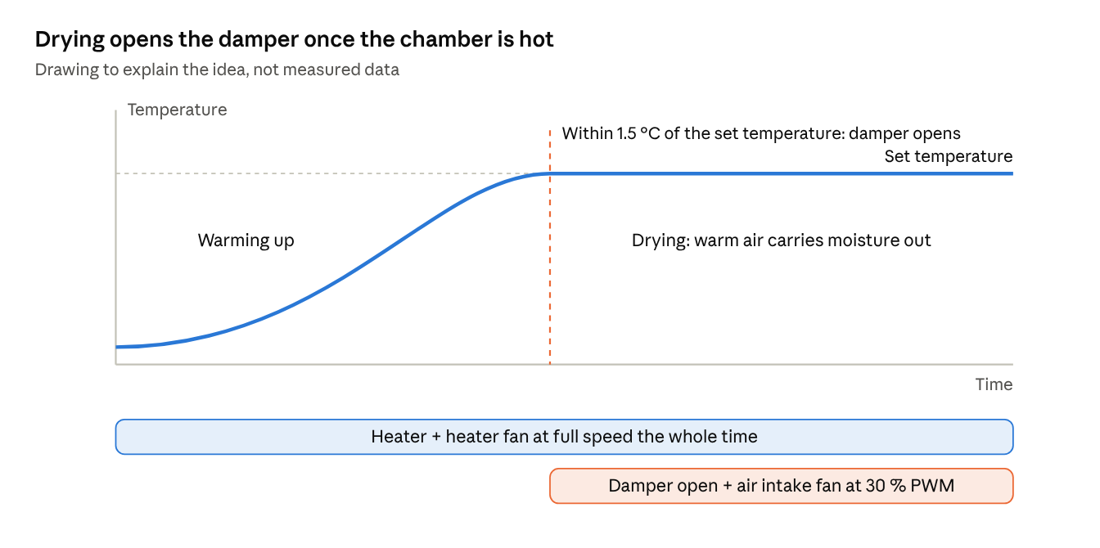
drying step · illustration
What happens, step by step:
- You close the door.
- The machine checks its temperature sensor, the heater fan and the air intake fan.
- The heater and the heater fan (full speed) warm the chamber to the set temperature (30 to 50 °C). The damper stays closed while it warms up.
- When the chamber is within 1.5 °C of the set temperature, the damper opens and the air intake fan starts at 30 % PWM. This happens once per step.
- The machine holds the temperature until the step time ends.
The machine stops by itself if:
- anything from the Heating list happens (heater fan, sensor, frozen reading, heater not heating),
- the air intake fan does not turn when the step starts. Then the step does not start.

Cure and Bleaching
In Cure, the machine shines UV light (405 nm) on the parts to harden them. Bleaching works the same way with blue light (450 nm). On this machine only the door LED panel is used at 450 nm. The light comes on only when the door is closed and the LED fans it needs are turning.
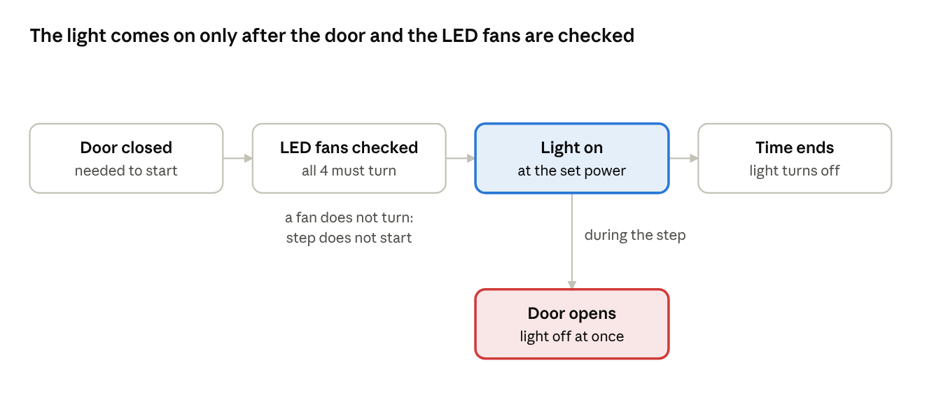
cure and bleaching step · flow
What happens, step by step:
- You close the door.
- The machine spins the fans of the panels it is about to light (all four for Cure, the door fan for Bleaching) and checks that each one turns.
- The light comes on at the power you set. If the step has a temperature, the heater and the heater fan (full speed) hold the chamber at it at the same time, with the damper closed.
- Each LED panel has its own fan. The fan starts the moment its panel lights up and stops when the panel goes dark: 100 % in Cure, 30 % in Bleaching. In Bleaching only the door panel is lit, so only the door fan runs, at 30 %.
- When the step time ends, the light turns off.
Heat from the light. The UV LEDs give off heat into the chamber. The heater can only add heat, it can't cool, so while the light is on the chamber can climb above the set temperature and the machine can't hold it exactly. This is expected, not a fault. The stronger the light and the longer the step, the more the chamber warms.
Light without heat (UV only). You can also run Cure or Bleaching with heating switched off. The heater then stays off the whole step. If you also turn Ventilation on for that step, the damper opens and the air intake fan blows in fresh air at 60 %.
The machine stops the light by itself if:
- the door opens (the light goes off at once),
- an LED fan stops or does not turn at the start,
- an LED panel does not warm up when it is lit (check the LED cable),
- an LED panel cools down while it should be lit.

Cooling
Cooling brings the chamber down to the temperature you set. The heater switches off, the damper (vent) opens, and the air intake fan pulls in room air. The heater fan keeps running at full speed to keep the air moving. You pick how fast: Fast, Medium or Slow.
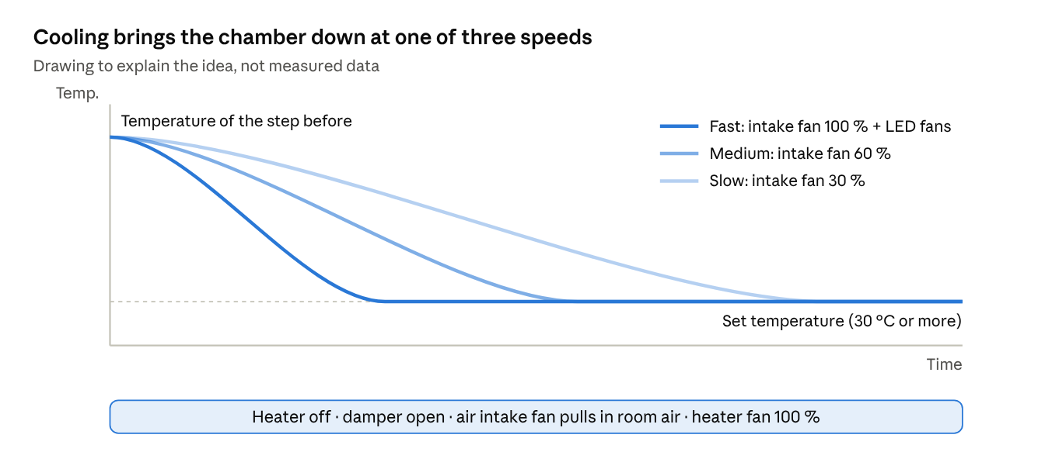
cooling step · illustration
What happens, step by step:
- The heater and the light turn off.
- The machine checks that the air intake fan turns.
- The damper (vent) opens.
- The air intake fan runs at the speed you chose: Fast 100 %, Medium 60 %, Slow 30 %. In Fast, the four LED fans also run at full speed to help.
- The step ends when the chamber reaches the set temperature.
The set temperature is at least 30 °C and at least 5 °C below the step before. The room temperature limits how low the chamber can go.
The machine stops by itself if:
- the air intake fan does not turn when the step starts. Then the step does not start.
- a fan stops or runs much too slow during the step.

Nitrogen purge
A nitrogen purge fills the chamber with nitrogen just before the light step, to push the air out. It only opens the nitrogen valve for 2 minutes. The heater, the fans, the damper and the light all stay exactly as the step before left them.
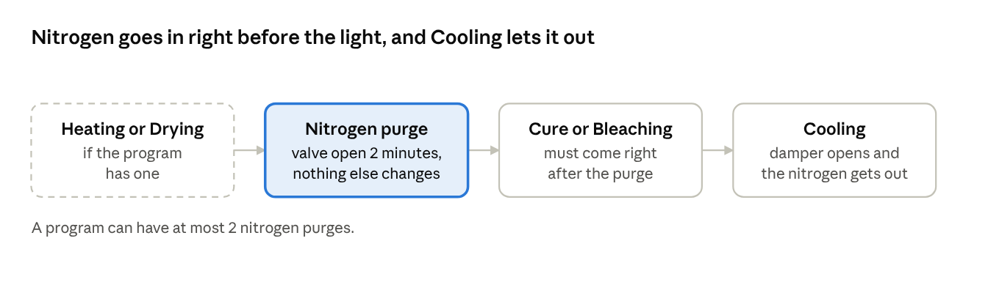
where a nitrogen purge sits in a program
How it works:
- Nitrogen has to be switched on in Settings, and the nitrogen line needs a pressure of at least 1 bar. If it's off, the machine simply skips the nitrogen steps.
- The nitrogen valve opens for 120 seconds.
- The valve closes and the Cure or Bleaching step starts right away.
Rules for a program with nitrogen:
- No more than 2 nitrogen purges in one program.
- A Cure or Bleaching step has to come right after the purge.
- A Cooling step has to come after that. Cooling opens the damper, which lets the nitrogen out of the chamber.
The program editor won't let you save a program that breaks these rules.

When something goes wrong
The machine keeps an eye on itself the whole time. If something fails, it shuts off whatever isn't safe and shows an error number on the screen. Every sensor, fan and LED panel has its own number, so the screen tells you exactly which one needs attention.
What went wrong | What the machine does | Error
A required temperature sensor is unplugged (chamber, left LED or right LED) | Stops the job and does not let a new one start. Heater and light turn off. | 9010 chamber, 9011 left, 9012 right
The back or door LED temperature sensor is unplugged | Warning only. The job keeps running. | 9013 back, 9014 door
A fan stops or runs much too slow (20 % below normal for 1 minute) | Stops the job. | 9020 heater fan, 9021 air intake fan, 9022 left, 9023 right, 9024 back, 9025 door
An LED fan or the air intake fan does not turn at the start | Does not start the step. | 9030 left, 9031 right, 9032 back, 9033 door, 9034 air intake fan
An LED panel does not warm up when lit | Stops the light. Check the LED cable. | 9040 left, 9041 right, 9044 back, 9045 door
An LED panel cools down while it should be lit | Stops the light. | 9042 left, 9043 right
The temperature reading is stuck (no change for 1.5 minutes while heating) | Heater off. The machine restarts itself after 1 minute. | 9006
The heater runs at full power but the chamber does not warm (10 minutes) | Heater off. Check the voltage selector and the heater fuse. | 9007
A fan is getting weak (10 % below normal) | Keeps working. Replace the fan soon. | 9060 heater fan, 9061 air intake fan, 9062 left, 9063 right, 9064 back, 9065 door
The door opens during a process and stays open for more than 10 seconds | The light goes off at once. After 10 seconds the process is aborted and cannot be resumed. | 6016

What to do when an error appears
- Do not open the door while the light is on. Wait until the screen shows the job has stopped.
- Read the error number and the message on the screen.
- Look up the number in the table above.
- Check the simple things first: cables plugged in, fans free to turn, voltage selector set.
- Clear the error on the screen and start the job again.
- If the same error comes back, stop using the machine and call service. Give them the error number.

