ICS Testbed — Component Requirements
& Fidelity Gap Analysis · Project CARS

What it takes to make the testbed a faithful ICS environment — and how to do it on your hardware · July 2026

1. What makes a testbed a real ICS environment
A convincing ICS environment is not just “a PLC on a network.” The field measures realism against the Purdue reference model, which organizes an industrial system into layered zones from the physical process up to enterprise IT. A faithful testbed represents each relevant layer, uses real industrial protocols, drives a physical (or physically-modelled) process, and segments the network the way a plant would. Surveys classify testbeds as physical, software-simulated, semi-physical (hardware-in-the-loop), or virtualized; yours is naturally a semi-physical / hybrid testbed — a real Siemens PLC plus software for everything else, which is a strong, realistic sweet spot.
Your goal is not maximum fidelity at any cost. It is enough fidelity that a reactive-security contribution (CARS) is credible: multiple communicating devices, a live process that can visibly go unsafe, realistic protocols, and plant-like segmentation for the SDN fabric to act on.

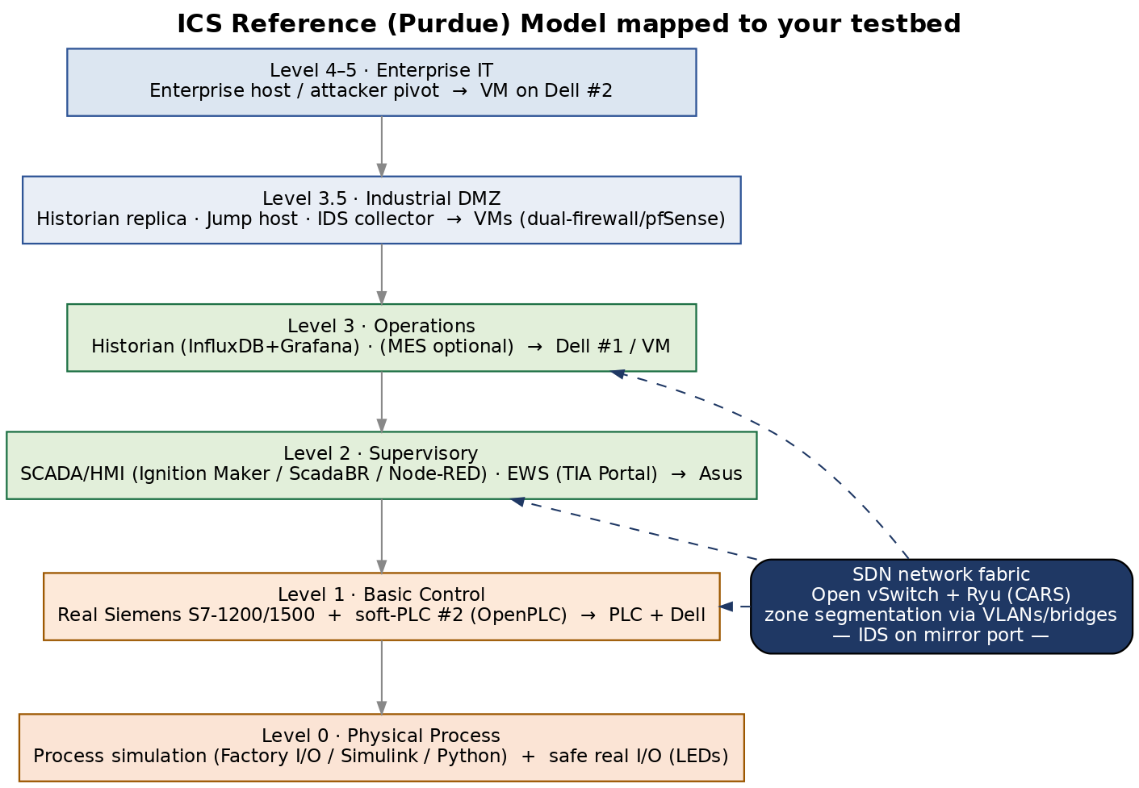

2. Component checklist by Purdue level
For each layer: the real-world component, whether you need it for CARS, and the lowest-effort way to provide it on your kit.
Level | Real component | Need it? | How to provide it (your hardware)
L0 Process | Sensors, actuators, tank/motor | Yes | Software process sim — Factory I/O (visual, on Asus), Simulink, or a Python model via MiniCPS; plus a few safe real outputs (LEDs/relay) on the PLC.
L1 Control | PLC / RTU / SIS | Have + add | Real Siemens S7-1200/1500 (primary). Add a 2nd soft-PLC (OpenPLC) for multi-device realism. Add a simple safety interlock in ladder to represent an SIS.
L2 Supervisory | HMI, SCADA server, EWS | Yes | HMI/SCADA: Ignition Maker Edition (free) or ScadaBR or Node-RED dashboard on the Asus. EWS = TIA Portal. Optional OPC UA server here.
L3 Operations | Historian, MES | Recommended | Historian: InfluxDB + Grafana (time-series of tags) on Dell #1 or a VM. MES optional — skip.
L3.5 IDMZ | Historian replica, jump host | Optional | One VM acting as DMZ host (historian replica + jump box). Adds segmentation realism for the SDN policy; can defer.
L4/5 IT | Enterprise host, AD, email | Optional | A single “corporate” VM on Dell #2 as the attacker's pivot/entry point. Full AD not needed.
Network | Managed switch, firewalls | Yes | Open vSwitch (your OpenFlow switch) + Ryu. Emulate Purdue zones with VLANs/multiple bridges. Optional pfSense VM as IT/OT firewall.
Security | IDS/IPS, SIEM | Yes | Suricata + Zeek/ICSNPP on Dell #2 (the external event source for CARS). Logs/alerts = your dataset.

3. Protocol realism
Real plants are multi-protocol. You already have Modbus TCP and S7comm; adding one or two modern protocols materially raises fidelity and widens the attack/response surface CARS can act on:
- Modbus TCP (have) — primary experimental protocol; easy to allowlist/DPI.
- S7comm (have) — native Siemens; realistic PLC attacks (start/stop, block download).
- OPC UA (add, recommended) — the modern OT standard; provide via Ignition's OPC UA server or open62449/open62541. Bridges L2–L3.
- MQTT / Sparkplug (optional) — IIoT telemetry; Mosquitto broker + Node-RED. Nice for a modern edge angle, not essential.
- DNP3 / EtherNet/IP (skip) — valuable in power/discrete industries but out of scope unless your process demands them.

4. Fidelity tiers — choose your scope
Three coherent scopes. Pick one as the finalized target; you can grow from Tier 1 to Tier 2 without rework.
Tier | What it adds | Verdict for CARS
Tier 1 — Minimum viable | Real PLC + process sim + HMI + IDS + SDN fabric, single zone. | Enough to demonstrate the reactive loop. Good for the first milestone.
Tier 2 — Realistic (recommended) | + 2nd soft-PLC, historian (InfluxDB/Grafana), OPC UA, Purdue VLAN segmentation, safety interlock. | The right target: multi-device, multi-zone, multi-protocol — makes CARS' criticality/safety story credible.
Tier 3 — High-fidelity | + IDMZ + jump host + corporate/IT zone + dual firewalls + MQTT/Sparkplug + richer process (Tennessee Eastman via GRFICS). | Impressive but heavy. Add selectively only if time allows.

5. Frameworks worth borrowing from
Rather than build every piece by hand, lift components/ideas from established open frameworks:
- MiniCPS — your process/physics emulation backbone (already in your reading list; used by Piedrahita).
- GRFICS / GRFICSv2 — full virtual ICS with a 3D-visualized Tennessee Eastman process, OpenPLC + ScadaBR; great for a compelling demo and attack visualization.
- ICSSIM & ICS-SimLab — recent frameworks that containerize PLCs/HMIs/sensors via Docker + a JSON topology file; ideal for spinning up extra soft-devices cheaply and for dataset generation.
- OpenPLC — soft-PLC for your 2nd controller and safe experimentation (you already have the OpenPLC Aqua paper).
Recommendation: use MiniCPS or a lightweight Python/OpenPLC model for the process, keep the real Siemens PLC as the star, and borrow ICSSIM/ICS-SimLab's containerized approach if you want several soft-devices without more machines.

6. Finalized component list & host allocation (Tier 2 target)
Host | Runs | Purdue role
Dell #1 (Ubuntu) | Ryu + CARS + Open vSwitch; InfluxDB + Grafana historian; Event API | Network fabric + L3 Operations
Dell #2 (Ubuntu) | Suricata + Zeek/ICSNPP IDS; attacker (pymodbus, snap7, nmap); optional IT/DMZ VMs | Security + L4/5 + L3.5
Asus (Win 11) | HMI/SCADA (Ignition Maker / ScadaBR / Node-RED); TIA Portal EWS; Factory I/O process sim | L2 Supervisory + L0 visualization
Siemens S7-1200/1500 | Real control logic; Modbus TCP server + S7comm; safe I/O; SIS interlock | L1 Basic Control + L0 real I/O
(soft) OpenPLC | 2nd PLC in a container/VM on a Dell | L1 (multi-device realism)
MacBook Air M1 | Writing / notes only | — (excluded)

7. What you do NOT need (scope control)
To avoid over-building, explicitly out of scope unless a specific experiment demands it: full MES/ERP, Active Directory forest, redundant/HA controllers, real physical actuators beyond safe demo I/O, DNP3/EtherNet/IP/PROFIsafe, and a hardware managed switch (OVS replaces it). Tier 3 items (IDMZ, dual firewalls, corporate zone) are optional polish, not prerequisites.

8. Recommendation & decision point
Adopt Tier 2 as the finalized target. Concretely, add to the current plan: (1) a software process simulation at L0 (Factory I/O on the Asus, or a Python/MiniCPS model); (2) a proper HMI/SCADA at L2 (Ignition Maker Edition recommended — free, OPC UA native, professional); (3) a historian at L3 (InfluxDB + Grafana); (4) a 2nd soft-PLC (OpenPLC) and a simple SIS interlock; (5) OPC UA as a third protocol; and (6) Purdue-style VLAN segmentation on OVS. Everything else stays as in the testbed build plan.
Cost check: all recommended additions are free/open-source except Factory I/O (which has a free trial; a Python/MiniCPS process is the zero-cost substitute). The only hardware you still need is the 2–3 USB-to-Ethernet adapters already noted in the build plan.
Once you confirm Tier 2, we fold these components into the phased build plan (L0 process sim and HMI land in Phase A; historian and OPC UA in Phase B–C; segmentation and 2nd PLC in Phase C–D) and start building from scratch.
Sources: Purdue model (SANS, Inductive Automation); ICS testbed surveys and frameworks (GRFICS, ICSSIM, ICS-SimLab, MiniCPS); OT segmentation and IDMZ guidance; open-source SCADA/historian stacks (Ignition Maker, ScadaBR, Node-RED + InfluxDB + Grafana). Full links in the chat response.

