Tier 3 Finalized Testbed Architecture
& Folded Build Plan · Project CARS (working title)

High-fidelity Purdue-zoned ICS · Factory I/O + real S7-1200/1500 · full IT→OT attack path · July 2026

1. Decisions locked in
Scope note: what is locked here is the testbed, not the research contribution. “CARS” (Criticality-Aware Response) is a working title / lead hypothesis — the final contribution is decided empirically as the testbed matures. The testbed is deliberately general-purpose and supports several candidate directions: (1) safety-constrained response [CARS], (2) source-agnostic event-to-action orchestration, (3) hybrid data-plane/control-plane enforcement, (4) twin-validated response, (5) a graduated deception ladder, (6) a resilient reactive control plane. Nothing below commits to one.
- Fidelity: Tier 3 — full Purdue stack (L0–L5) with Industrial DMZ, corporate/IT zone, and dual firewalls, so attacks can traverse a realistic IT→OT kill chain.
- Level 0 process: Factory I/O (licensed on the university Dells) — 3D-visualized process driven by the real PLC via the Siemens S7 driver.
- Hardware: 2 Dell (full admin, 16GB+ each), 1 Asus (Win 11), real Siemens S7-1200/1500. MacBook M1 excluded.
- Protocols: S7comm (process I/O + realism), Modbus TCP (primary CARS traffic), OPC UA (L2–L3), MQTT/Sparkplug (IIoT edge).
- Orchestration: GNS3 as the virtual-network topology layer on Dell #1 — hosts the pfSense firewalls, DMZ, corporate/attacker and container nodes, with the CARS-controlled OVS as a GNS3 node under Ryu and a Cloud node bridging the real PLC / Factory I/O.

2. Host allocation
Factory I/O is Windows-only and GPU-bound, so it runs bare-metal on Dell #2 (Windows). Dell #1 boots Ubuntu and becomes the SDN core plus the virtualization host for every Linux role. The Asus is the operator/engineering station.
Host / OS | Runs | Purdue zone
Dell #1 · Ubuntu | Ryu + CARS + Open vSwitch (fabric); GNS3 + Docker/KVM host for IDS, historian, DMZ, firewalls, soft-PLC, OPC UA/MQTT, attacker | Network fabric + L1/L3/L3.5/L4-5 (virtualized)
Dell #2 · Windows | Factory I/O (3D process); optional offload of the Kali attacker VM | L0 Physical process (+ L4/5 option)
Asus · Win 11 | HMI/SCADA (Ignition Maker Edition); TIA Portal (EWS) | L2 Supervisory
Siemens S7-1200/1500 | Real control logic; Modbus server + S7comm; safe I/O; SIS interlock | L1 Basic Control + L0 real I/O
MacBook Air M1 | Writing / notes only | — excluded

3. Zoned topology
Every device attaches to Open vSwitch on Dell #1. Purdue zones are realized as VLANs on OVS; two pfSense VMs enforce the IT↔DMZ↔OT boundaries with deny-by-default rules. The SDN controller (CARS) still mediates every flow and the IDS reads a mirror port — so the reactive loop operates across the whole zoned network.

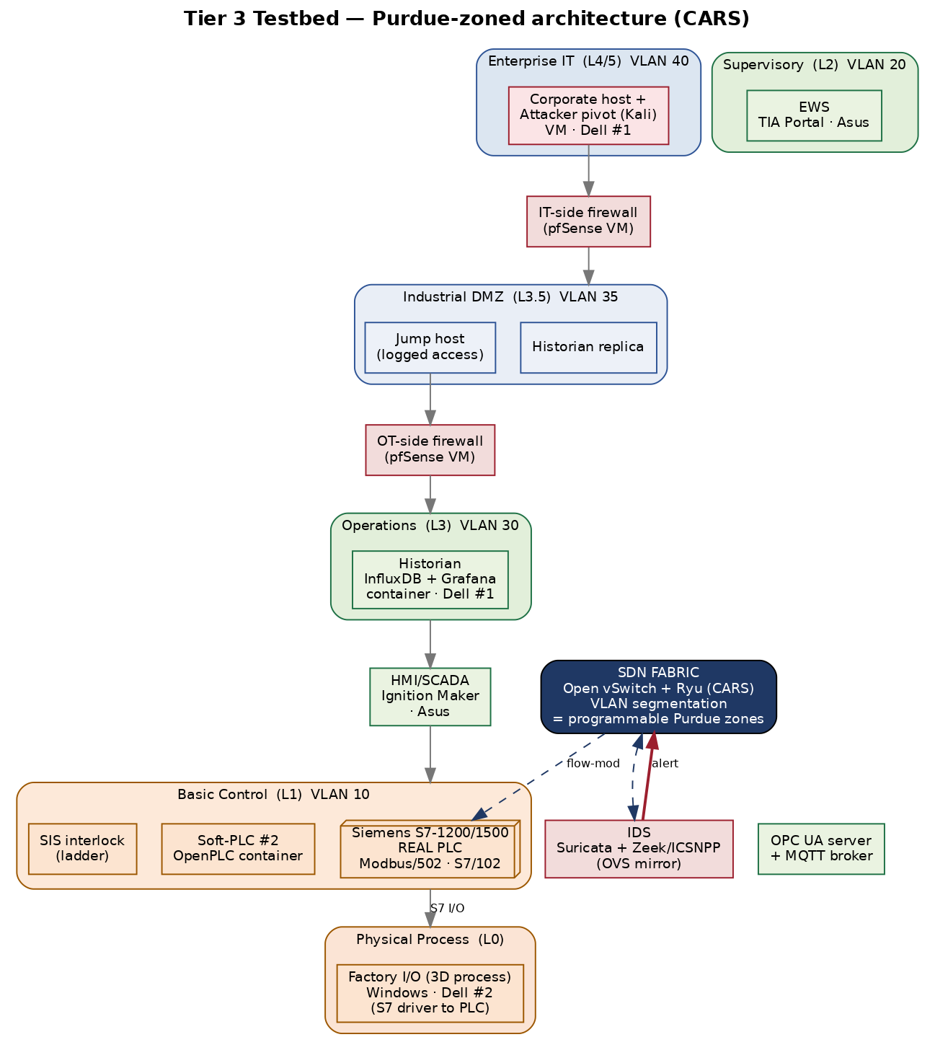

4. Network / VLAN plan
VLAN | Zone | Members
10 | Control (L1) | Real S7-1200/1500, OpenPLC soft-PLC, SIS interlock
20 | Supervisory (L2) | HMI/SCADA (Ignition), EWS (TIA Portal), OPC UA server, MQTT broker
30 | Operations (L3) | Historian (InfluxDB + Grafana)
35 | Industrial DMZ (L3.5) | Historian replica, jump host — between the two pfSense firewalls
40 | Enterprise IT (L4/5) | Corporate host + attacker pivot (Kali)
— | Process (L0) | Factory I/O ↔ PLC over the S7 driver (rides VLAN 10 to the PLC)
mgmt | SDN control | Ryu↔OVS OpenFlow channel; IDS mirror port (out-of-band)
Firewall posture: deny-by-default, allow-by-exception, fail-closed at each zone boundary — the standard OT segmentation model. CARS operates within and across these zones at the SDN layer, complementing (not replacing) the L3 firewalls.

5. Dell #1 RAM budget (fits in 16GB)
Component | Est. RAM | Note
Ubuntu host + Open vSwitch + Ryu/CARS | 2.5 GB | Core; always on
IDS container (Suricata + Zeek/ICSNPP) | 1.5 GB | Reads OVS mirror
Historian (InfluxDB + Grafana) containers | 1.0 GB | Time-series tag logging
IT-side firewall (pfSense VM) | 1.0 GB | Lightweight
OT-side firewall (pfSense VM) | 1.0 GB | Lightweight
DMZ host (historian replica + jump) | 1.0 GB | Container/VM
OpenPLC soft-PLC + OPC UA/MQTT containers | 1.0 GB | Light
Kali attacker VM (during scenarios) | 3.0 GB | Offload to Dell #2 to free RAM
Headroom | ~4 GB | OS cache / spikes
Tip: prefer Docker containers over full VMs for the soft-devices (the ICSSIM / ICS-SimLab approach) — much lighter than VM-per-device. Run the Kali attacker only during Phase E, or host it on Dell #2 alongside Factory I/O, to keep the OT host comfortable.

6. Folded phased build plan (Tier 3)
The six phases from the build plan, updated with the Tier 3 components. Exit criteria and reading mappings from the master list still apply.

Phase A — Bench, process & baseline HMI
- Dell #1: install Ubuntu, Open vSwitch, Ryu, Docker, GNS3; create br0 with VLANs 10/20/30/35/40; add physical ports via USB-Ethernet.
- Dell #2 (Windows): install Factory I/O; build a simple scene (e.g., level/tank or sorting station); configure the Siemens S7 driver to the real PLC.
- PLC: TIA Portal program that reads Factory I/O sensors and drives actuators + a safe LED/relay; enable PUT/GET and a Modbus TCP server; add a basic SIS interlock.
- Asus: install Ignition Maker Edition (HMI) and confirm it can read PLC tags via OPC UA/Modbus.
- Exit: Factory I/O process runs under real-PLC control, visible on the Ignition HMI, with all traffic through OVS.

Phase B — SDN baseline + historian + protocols
- Ryu learning-switch app manages OVS; verify control-loop latency/jitter within budget.
- Stand up the historian (InfluxDB + Grafana container) logging PLC tags; add OPC UA server + Mosquitto MQTT broker.
- Exit: Live process data flows PLC → historian and renders in Grafana; you can add/remove an OVS flow from Ryu.

Phase C — Zones, firewalls & detection
- Build the virtual topology in GNS3: two pfSense firewalls + DMZ host (historian replica + jump); enforce deny-by-default between VLANs 40↔35↔30.
- Deploy IDS (Suricata + Zeek/ICSNPP) on an OVS mirror; write Modbus/S7comm/OPC UA rules; emit alerts to the CARS Event API.
- Exit: An attacker in the enterprise zone is contained by the firewalls, and an OT-network anomaly reaches the Event API.

Phase D — Reactive engine (CARS lead hypothesis; contribution TBD)
- Ryu app installs block / mirror / redirect flows on demand; criticality model tags the PLC control loop vs unknown hosts.
- Safety guard: never hard-block the critical loop — mirror/redirect for inspection; block only untrusted/unseen devices; policy-check before install.
- Exit: Unseen device that alerts is auto-blocked; alert on the critical loop is redirected — Factory I/O process never interrupted.
- Note: this phase realizes the CARS lead hypothesis, but the platform equally supports the other candidate contributions — the final direction is chosen here based on what proves tractable and novel.

Phase E — Full IT→OT attack scenarios & evaluation
- Kill chain from the enterprise zone: pivot → DMZ → OT; plus direct OT attacks (unauthorized Modbus/S7 writes, false-data injection, DoS).
- Metrics: detection-to-mitigation latency; process-safety preservation (watch the Factory I/O process); false positives; controller load. Log for reproducibility; benchmark vs SWaT/WADI/HAI conventions.
- Exit: A repeatable results table per scenario — the dissertation's core evaluation.

Phase F — Stretch
- P4 data-plane allowlist (bmv2); redirect-to-honeypot response; MiniCPS/digital-twin pre-validation of disruptive actions; MQTT/Sparkplug edge scenario.

7. Prerequisites & shopping list
- Hardware: 2–3 USB-to-Ethernet adapters for Dell #1 (to attach PLC, Asus, and uplinks to OVS). This is the only purchase.
- Software (all free unless noted): Open vSwitch, Ryu, Docker, GNS3, KVM (Ubuntu); pfSense; Suricata + Zeek/ICSNPP; InfluxDB + Grafana; OpenPLC; Mosquitto; open62541/python-opcua; Ignition Maker Edition; Kali. Factory I/O (already licensed) and TIA Portal on Windows.
- Verify on PLC: PUT/GET enabled; “optimized block access” setting compatible with the Factory I/O S7 driver and Modbus server block configured.

8. Ready to build — first move
Start with the Phase A minimal loop before wiring the zones: get Factory I/O + real PLC + Ignition HMI working through OVS on a single flat network, then layer in the VLANs, firewalls, IDS, and CARS. Build the fidelity outward from a working core, exactly as the master reading list is ordered. Say the word and I'll write the concrete Phase A setup commands (OVS bridge + VLANs, Ryu install, Factory I/O S7 driver config, and the TIA Portal Modbus/PUT-GET settings).
This supersedes the tier selection in the component analysis. CARS throughout is a working title for the lead hypothesis, not the finalized contribution. Diagram zones are logical VLANs on one OVS, not separate physical switches.

