6-Week Execution Plan
Project CARS — Reactive SDN for Securing ICS (working title)

Indicative dates Wk1 = Mon 6 Jul 2026 → submit ~16 Aug 2026 · anchor to your real deadline

1. Operating principles
- Parallel streams, not phases-in-series. Build, read, and write run concurrently every week. Writing starts Week 1 — never left to the end.
- De-scope fidelity, never the contribution. If behind, cut testbed richness via the ladder in §6. The CARS engine, the evaluation, and the write-up are protected.
- Resolve the crux early. CC-1 (conduit vs intra-zone scope) and CC-3 (how safety is proven) are settled in Week 1, before the engine is coded. CC-4 (does CARS add latency) is measured in Week 2.
- Build outward from a working core. Minimal reactive loop first (Week 1–2); fidelity layered on only once it works.

2. Timeline at a glance
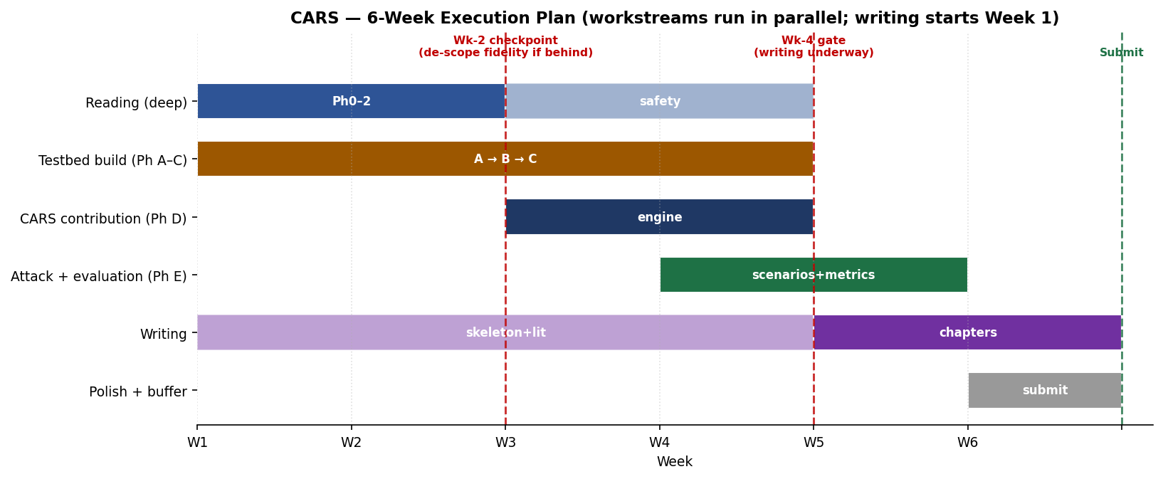
Week | Build | Read / Decide | Write
W1 | Devices ready; Phase A: Factory I/O + real PLC + Ignition HMI on flat OVS | Ph 0–2 deep; LOCK contribution; settle CC-1 & CC-3 | Skeleton + Intro + start Background
W2 | Phase B (Ryu↔OVS; measure latency=CC-4); Ph C-lite (IDS→Event API; manual trigger→flow); historian+OPC UA | Safety cluster (Ph 8) | Methodology + Testbed chapter
W3 | Phase D: CARS engine — criticality model + safety-constrained response + audit log | Taper (policy-checker, twin-IR) | Finish Lit Review; Design chapter
W4 | Zones in GNS3 (pfSense×2, DMZ, corp) as time allows; Ph E attack suite; first metrics | — | GATE: Intro+Bg+Method drafted; Implementation ch.
W5 | Ph E full run: scenario suite + operator metrics; analysis | — | Results + Analysis; Discussion
W6 | Code freeze (bugfix only) | Cite-time checks (CHAOS id, NIST r3) | Conclusion, Abstract, polish, SUBMIT

3. Week-by-week detail

Week 1 — Foundations & the minimal loop
- Complete the pre-build checklist; Phase A: PLC controls the Factory I/O process (S7 driver), visible on the Ignition HMI, all traffic through Open vSwitch on a single flat network.
- Decide & record: lock the single contribution; resolve CC-1 (does CARS act only at conduits or also intra-zone?) and CC-3 (safety proven by envelope-invariant check and/or twin dry-run?). Confirm D4/D5.
- Exit: working process-under-PLC-control through OVS; contribution + safety method locked; dissertation skeleton + Intro drafted.

Week 2 — SDN baseline, detection & reactive skeleton
- Phase B: Ryu manages OVS; measure baseline control-loop latency/jitter (CC-4). Phase C-lite: Suricata/Zeek on an OVS mirror emit alerts to the Event API; a manual trigger makes Ryu install one block/redirect rule. Stand up historian + OPC UA.
- CHECKPOINT (end W2): is the alert→controller→flow-change loop solid AND is the added latency acceptable? If no → trigger the de-scope ladder now.

Week 3 — CARS engine (the contribution)
- Phase D: criticality model (tag the PLC control loop vs unknown hosts); safety-constrained response (allow / block / mirror / redirect); safety guard (never hard-block the critical loop — mirror/redirect instead; policy/twin check before install); reversibility + machine-readable audit log.
- Exit: unseen device that alerts is auto-blocked; alert on the critical loop is redirected; Factory I/O process never interrupted; every action logged.

Week 4 — Zones, attack suite & first evaluation
- Build the virtual zones in GNS3 (two pfSense firewalls, DMZ, corporate/Kali) as far as time allows; implement the attack suite (recon, unauthorized Modbus/S7 write, false-data injection, DoS; full IT→OT kill chain if zones are ready); first metrics run.
- GATE (end W4): writing must be underway — Introduction, Background and Methodology drafted. If not, stop building and write.

Week 5 — Full evaluation & results
- Phase E complete: run the full scenario suite; collect operator-relevant metrics — zero defence-induced process trips, false-block rate on critical flows, mean-time-to-mitigate, controller load, audit-trail completeness; analyse; sensitivity checks if time. Add Tier-3 fidelity only if ahead.
- Exit: complete, reproducible results table per scenario; analysis written.

Week 6 — Writing, polish, buffer, submit
- Freeze code (bugfixes only). Write Discussion (incl. deployability / product argument + limitations), Conclusion, Abstract. Final citation verification (CHAOS article ID; cite NIST SP 800-82 Rev. 3; confirm co-engineering survey authors). Diagrams, proofread, format; leave buffer for supervisor review. Submit.

4. Checkpoints & gates
When | Gate | If it fails
End W1 | Minimal loop (PLC↔Factory I/O↔OVS) up; contribution locked | Extend into W2; cut nothing yet but flag risk
End W2 | Reactive loop solid + latency acceptable (CC-4) | Trigger de-scope ladder (§6) immediately
End W4 | Writing underway (Intro/Bg/Method drafted) | Pause building; writing takes priority
End W5 | Full results captured | Freeze scope; write up what exists honestly
~W6 | Submit | —

5. Definition of a strong submission
- A working CARS engine on the testbed (Tier 3 if achieved; Tier 2 acceptable) with a real S7-1200/1500 and a process that can visibly go unsafe.
- ≥4–5 attack scenarios evaluated with operator-relevant metrics — crucially, zero defence-induced process trips demonstrated.
- Positioned against the key literature including the safety cluster (Piedrahita, process-aware review, TRITON, IEC 62443).
- An explicit deployability / product argument (zone-boundary overlay, brownfield-friendly).
- Verified citations; word count per your programme handbook (confirm the exact limit).

6. De-scope ladder (cut in this order if behind)
Cut fidelity top-down until the schedule is recoverable. Each cut is honestly reported in the write-up as a scope decision + future work.
- 1. Corporate/IT zone + dual firewalls → single IT/OT boundary.
- 2. Industrial DMZ (historian replica + jump host).
- 3. Second soft-PLC (OpenPLC).
- 4. Extra protocols (OPC UA / MQTT) → keep Modbus + S7comm.
- 5. Full IT→OT kill chain → intra-OT attacks only.
Core that must survive every cut: real PLC + Factory I/O + OVS + Ryu + one IDS + the CARS engine + the evaluation + the written dissertation. Never cut: the contribution, the evaluation with metrics, or the writing.

7. Dependencies, assumptions & risks
- Assumption: ~35–40 h/week available (full-time dissertation). Scale the plan if less.
- Dependency: the pre-build checklist (devices, installs, USB-Ethernet adapters) is done before/at the start of Week 1, or Week 1 slips.
- Risk — Ryu/Python: use a Python 3.9/3.10 venv or the os-ken fork if eventlet errors appear.
- Risk — Factory I/O S7 link: verify PUT/GET + non-optimized block access on the PLC early (Week 1).
- Risk — over-building: the single biggest threat to marks. The gates and ladder exist to counter it; honour the Week-4 writing gate.
Dates are indicative (Wk1 = 6 Jul 2026). Anchor to your actual submission date and confirm the word-count limit in your programme handbook. This plan operationalises the Decision Log; gates map to CC-1/CC-3/CC-4.

