Project CARS — Technical Note
The CARS Live Console
A discovery-driven, live-sync NOC for the IT/OT fabric

The differentiator, in one line: most ICS/SDN demonstrations show a hand-drawn network diagram beside a live system. The CARS console instead renders the controller’s own live model — every node, wire, port, and state is discovered, so the picture physically cannot disagree with the network.

1. Why this is a genuine differentiator
A hand-drawn topology is an assertion — it says what the author believes the network is. It cannot catch a mis-cabling, a silent device, a spoofed identity, or a link that just failed. The CARS console is the opposite: it is a projection of ground truth. Every element on screen is derived, live, from the SDN controller’s own view of the data plane — the same view it uses to make security decisions. If the console shows it, the controller believes it; if the controller is wrong, the console shows the network’s reality anyway (a link goes red, a host vanishes, a spoof counter climbs).
This makes the console three things at once: an operator’s situational-awareness tool, a live proof that CARS’s internal model matches the physical fabric, and a debugging instrument that has already surfaced real faults a static diagram would have hidden (Section 5).

2. How it works — one source of truth to the screen
The console has no topology of its own and stores no state. It is a thin renderer over the controller’s read-only feeds. The pipeline is five stages:
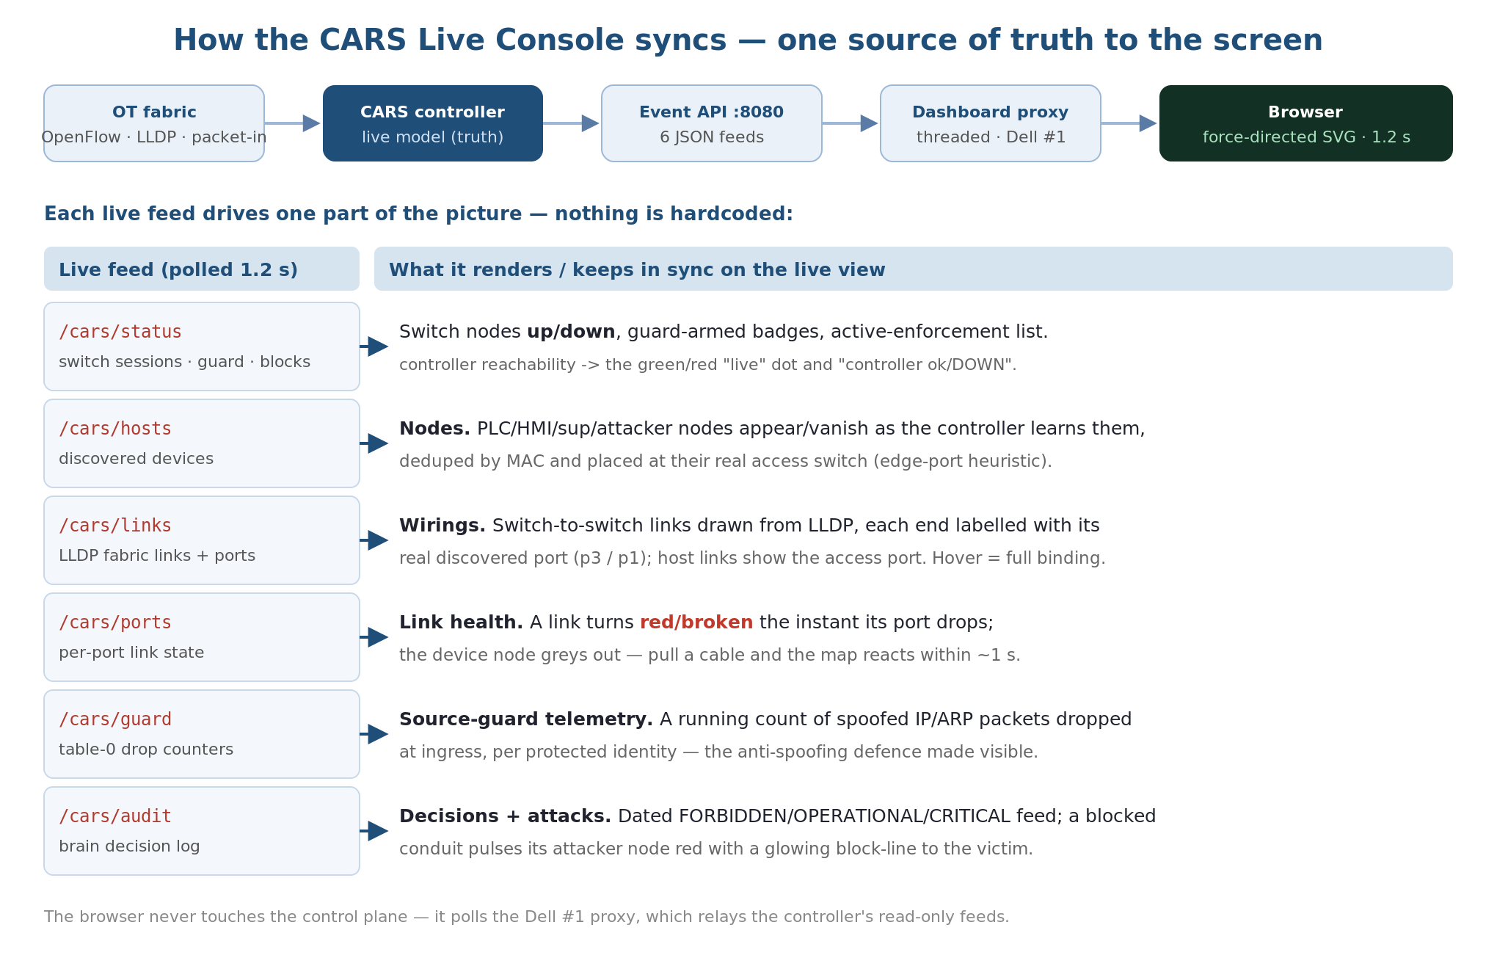
Figure 1 — the sync pipeline: the OT fabric feeds the controller’s live model; six JSON feeds drive six parts of the live view.
- The OT fabric (Open vSwitch) emits OpenFlow events, LLDP, and packet-ins to the controller.
- The CARS controller builds a live model from them — switch sessions, discovered hosts, LLDP links with ports, port up/down, source-guard drop counters, and a decision audit.
- It exposes that model as six read-only JSON feeds on its Event API (:8080).
- A threaded proxy on the OT host (Dell #1) serves the single-page console and relays the feeds — so the browser never talks to the control plane directly (no cross-origin exposure).
- The browser renders a force-directed SVG and re-polls all six feeds every 1.2 s, reconciling the picture to whatever the controller now believes.

3. How every process is kept in sync
Each feed owns one part of the picture. Nothing is hardcoded; add a host or pull a cable and the corresponding element changes on the next 1.2 s tick.
Live feed | Syncs | What you see
/cars/status | Switches, guard, blocks | Switch nodes go grey when a dpid drops; src-guard / arp-guard armed badges; the active-enforcement list; the green/red controller-live dot.
/cars/hosts | Nodes | PLC/HMI/supervisory/attacker nodes appear and vanish as the controller learns them — deduped by MAC and auto-placed at their real access switch.
/cars/links | Wirings | Switch-to-switch links drawn from LLDP, each end labelled with its real discovered port (e.g. p3 ↔ p1); host links show the access port. Hovering a link reveals the full binding.
/cars/ports | Link health | A link turns red/broken the instant its port drops, and the device node greys — physical faults appear within ~1 s.
/cars/guard | Anti-spoof telemetry | A running count of spoofed IP/ARP packets dropped at ingress, per protected identity — the guard’s work made visible as numbers.
/cars/audit | Decisions + attacks | A dated feed of every brain decision (FORBIDDEN/OPERATIONAL/CRITICAL); a blocked conduit pulses its attacker node red with a glowing block-line to the victim.

4. The engineering that makes the sync live and trustworthy
- Discovery, not configuration. Hosts come from passive ARP/IPv4 snooping (keyed by switch + MAC, so identical-IP cells stay distinct); links come from LLDP with port numbers; liveness comes from OpenFlow port-status. The console reads all of this — it declares none of it.
- Node placement is inferred, not fixed. Each device is placed at its true access switch using an edge-port heuristic (an access port carries one MAC; an uplink carries many), then a small force simulation lays the graph out and lets the operator drag/pin nodes.
- Reconciliation each tick. On every poll the renderer diffs the discovered set against what is drawn — adding new nodes, removing departed ones, and recolouring links/nodes from the latest port and block state — so the view converges to ground truth without a reload.
- Safe by construction. The browser only ever reads; the proxy is threaded (concurrent polls never block) and tolerates client disconnects; and it isolates the browser from the control plane. When the controller is unreachable the console flips to an explicit ‘controller DOWN’ state rather than showing stale green.

5. Proof it mirrors reality — faults a static diagram would hide
Because the console shows discovered truth, it has repeatedly caught things that a drawn diagram never could — each became a documented finding:
- Cell 2 isolation: no link to ovs2 — the map correctly showed Cell 2 unlinked, exactly matching the deferred physical transit.
- ARP flux: discovery flagged the insider’s MAC presenting the supervisor’s IP — a real multi-homed-host misconfiguration, fixed once seen.
- Clone-IP collision: both PLCs share an IP; the console’s MAC+switch keying kept them as two distinct nodes where an IP-keyed view would have merged them.
- Boot-time ARP probes: a rebooting PLC briefly announced 0.0.0.0; the console exposed it overwriting a real address, prompting a hardening fix.
- Restart blindness: after a controller restart the console’s empty host list revealed that persistent flows were suppressing re-discovery — driving the clean-slate-on-reconnect fix.

6. What it demonstrates, live
The console turns the whole thesis into something an examiner can watch happen in real time:
- Pull an OT cable (or admin-down a port) → that link turns red and the device greys, within ~1 s.
- Send a spoofed packet → the source-guard drop counter ticks up — the anti-spoofing defence, visible.
- Launch an attack → the offending node pulses red, a glowing block-line snaps to the victim, and the decision feed logs FORBIDDEN — the reactive loop, on screen.
- Ping from the supervisor to the same PLC → logged OPERATIONAL and left flowing — the criticality-aware policy, demonstrated side by side.
In short: the console is not a picture of the system — it is the system, watching itself.

