Project CARS
Criticality-Aware Response System
Reactive SDN for Securing ICS Environments

Progress Report for Supervisor
Testbed · Implementation · Reactive Loop · Hardening · Evaluation
Author: Amit Kiran Deb
Programme: MSc Cyber Security · University of Bristol
Group / Supervisor: Bristol Cyber Security Group · Joe Gardiner
Status as of: 13 July 2026

Contents

Executive summary
This report documents the current state of Project CARS — a reactive Software-Defined Networking (SDN) defence for Industrial Control Systems (ICS). The system consumes intrusion-detection events and enforces criticality-aware network responses that are safe by construction on a live testbed built around real Siemens hardware, so an operator could enable automated response without risking the physical process.
Research contribution, in one line: a safety-constrained, criticality-aware reactive response — a network defence that mitigates threats automatically yet is structurally forbidden from severing the safety-critical control loop, so automated response can be trusted in a live process.
The testbed is fully built and operational: two real Siemens S7-1200 PLCs with HMI panels, a three-switch Open vSwitch SDN fabric, an out-of-band SDN controller running the CARS trust brain, a virtualised IT/DMZ periphery in GNS3, and a Snort IDS wired into the controller to form a closed detect-decide-enforce loop. The reactive loop has been demonstrated end-to-end against both an external (IT to OT) attacker and an on-plane insider.
Beyond the working prototype, the system has been security-hardened and independently audited, and its response latency has been quantitatively evaluated. Headline result: the CARS controller decides and enforces a mitigation in 0.61 ms (sub-millisecond); the end-to-end mean-time-to-mitigate of ~1.13 s is dominated (~99.95%) by the off-the-shelf detector, not the controller.

Dimension | Where the project stands today
Physical testbed | Complete — 2x real Siemens S7-1200 + HMI, 3x Dell hosts, MikroTik control plane, USB-Ethernet OT links.
SDN fabric | 3x Open vSwitch (spine-leaf) under one os-ken/Ryu controller; out-of-band control plane.
Contribution | Conduit-criticality trust brain — working autonomously; the safety invariant is demonstrated on hardware.
Reactive loop | Closed for external + insider attacks (Snort to bridge to brain to block).
Hardening | Data-plane anti-spoofing (IP+ARP), fail-secure, live discovery; independent code audit passed.
Evaluation | MTTM measured — CARS response sub-ms; end-to-end sensor-bounded.

1. How the testbed was built
The testbed follows a Purdue-model / IEC 62443 zones-and-conduits architecture and was built incrementally, fidelity-first, on real hardware rather than pure simulation — a deliberate choice so findings reflect genuine ICS behaviour (e.g. PLC boot-time ARP probes, multi-homed-host ARP flux) that a simulator would never surface.

Build philosophy
- Real over simulated: two physical Siemens S7-1200 PLCs, each driving a real SIMATIC HMI panel, provide authentic process behaviour; nothing about the control loop is emulated.
- SDN as a zone-boundary overlay: Open vSwitch is inserted as the controllable fabric between the process cells and the supervisory/IT world — brownfield-friendly, no change to the PLC programs.
- Out-of-band control: the SDN controller programs the switches over a separate management network, never sitting in the data path.
- One role per machine: clean separation of data plane, control plane, and virtual periphery for clarity and safety.

Build stages (chronological)
Stage | What was done
Base | Ubuntu + Open vSwitch 3.3.4 on the OT host; os-ken 2.8.1 (maintained Ryu fork) controller in a Python venv on the pure controller host; static out-of-band management IPs (10.10.10.0/24) over a MikroTik hAP.
Real OT | Both teaching boxes (PLC+HMI) attached to OVS access ports via USB-Ethernet adapters; each PLC-HMI control loop verified through the switch.
Fabric | Three OVS bridges created — two cell leaf switches (ovs1, ovs2) and a gateway spine (ovsgw) — all pointed at the single controller; the gateway carries the supervisory host, the IDS mirror, the GNS3 seam, and the insider foothold.
Periphery | GNS3 project (cars-killchain) provides the virtual IT attacker, Enterprise firewall, DMZ/jump host and OT firewall (NAT), joined to the OT plane through an internal seam port; Docker hosts the SCADA (FUXA) and Historian (InfluxDB + Grafana).
IDS | An OVS mirror on the gateway copies all gateway traffic to a sink port where Snort listens; a bridge script forwards Snort alerts to the controller — closing the reactive loop.
Harden | Two-table data-plane source-guard, fail-secure switching, ARP-flux fix, clean-slate-on-connect discovery, and an independent code audit.
Evaluate | Instrumented the controller and built a measurement harness for mean-time-to-mitigate (MTTM).

2. How the equipment is connected
Three physical planes are kept strictly separate: the OT data plane (real process traffic through OVS), the SDN control plane (out-of-band, controller to switches), and management / Internet.

Physical links
Link | From | To
OT data — Box1 PLC | S7-1200 -> USB-Eth adapter | Dell #1 -> ovs1 port 1
OT data — Box1 HMI | HMI panel -> USB-Eth adapter | Dell #1 -> ovs1 port 2
OT data — Box2 PLC | S7-1200 -> USB-Eth adapter | Dell #3 -> ovs2 port 1
OT data — Box2 HMI | HMI panel -> USB-Eth adapter | Dell #3 -> ovs2 port 2
Fabric (virtual) | ovs1 port 3 (OVS patch) | ovsgw port 1 (OVS patch)
Control plane | Dell #1 / #2 / #3 RJ45 | MikroTik hAP (VLAN1)
Note: ovs1-ovsgw is an internal OVS patch (virtual link inside Dell #1). Cell 2 (ovs2) is currently isolated from the gateway fabric — the physical transit (P4) is deliberately deferred, see Section 12.

Address plan
Plane / zone | Subnet | Key hosts
OT data plane (L0-L2) | 192.168.2.0/24 | PLC .10, HMI .9, Supervisory .30, Insider .66, OT-FW .1
SDN control (out-of-band) | 10.10.10.0/24 | Controller .1, Dell#1 .2, Dell#3 .3
Enterprise IT (GNS3) | 10.0.40.0/24 | IT attacker .66, corporate
Industrial DMZ (GNS3) | 172.16.35.0/24 | Jump / historian-replica .10

3. What the topology looks like
The logical topology is a spine-leaf SDN fabric mapped onto the Purdue model. Two process cells (each a PLC+HMI control loop) hang off leaf switches; a gateway switch is the OT boundary and the single enforcement point, carrying the supervisory host and the IDS mirror. Above the gateway sits the virtual IT/DMZ periphery (in GNS3). The SDN controller programs all three switches out-of-band.
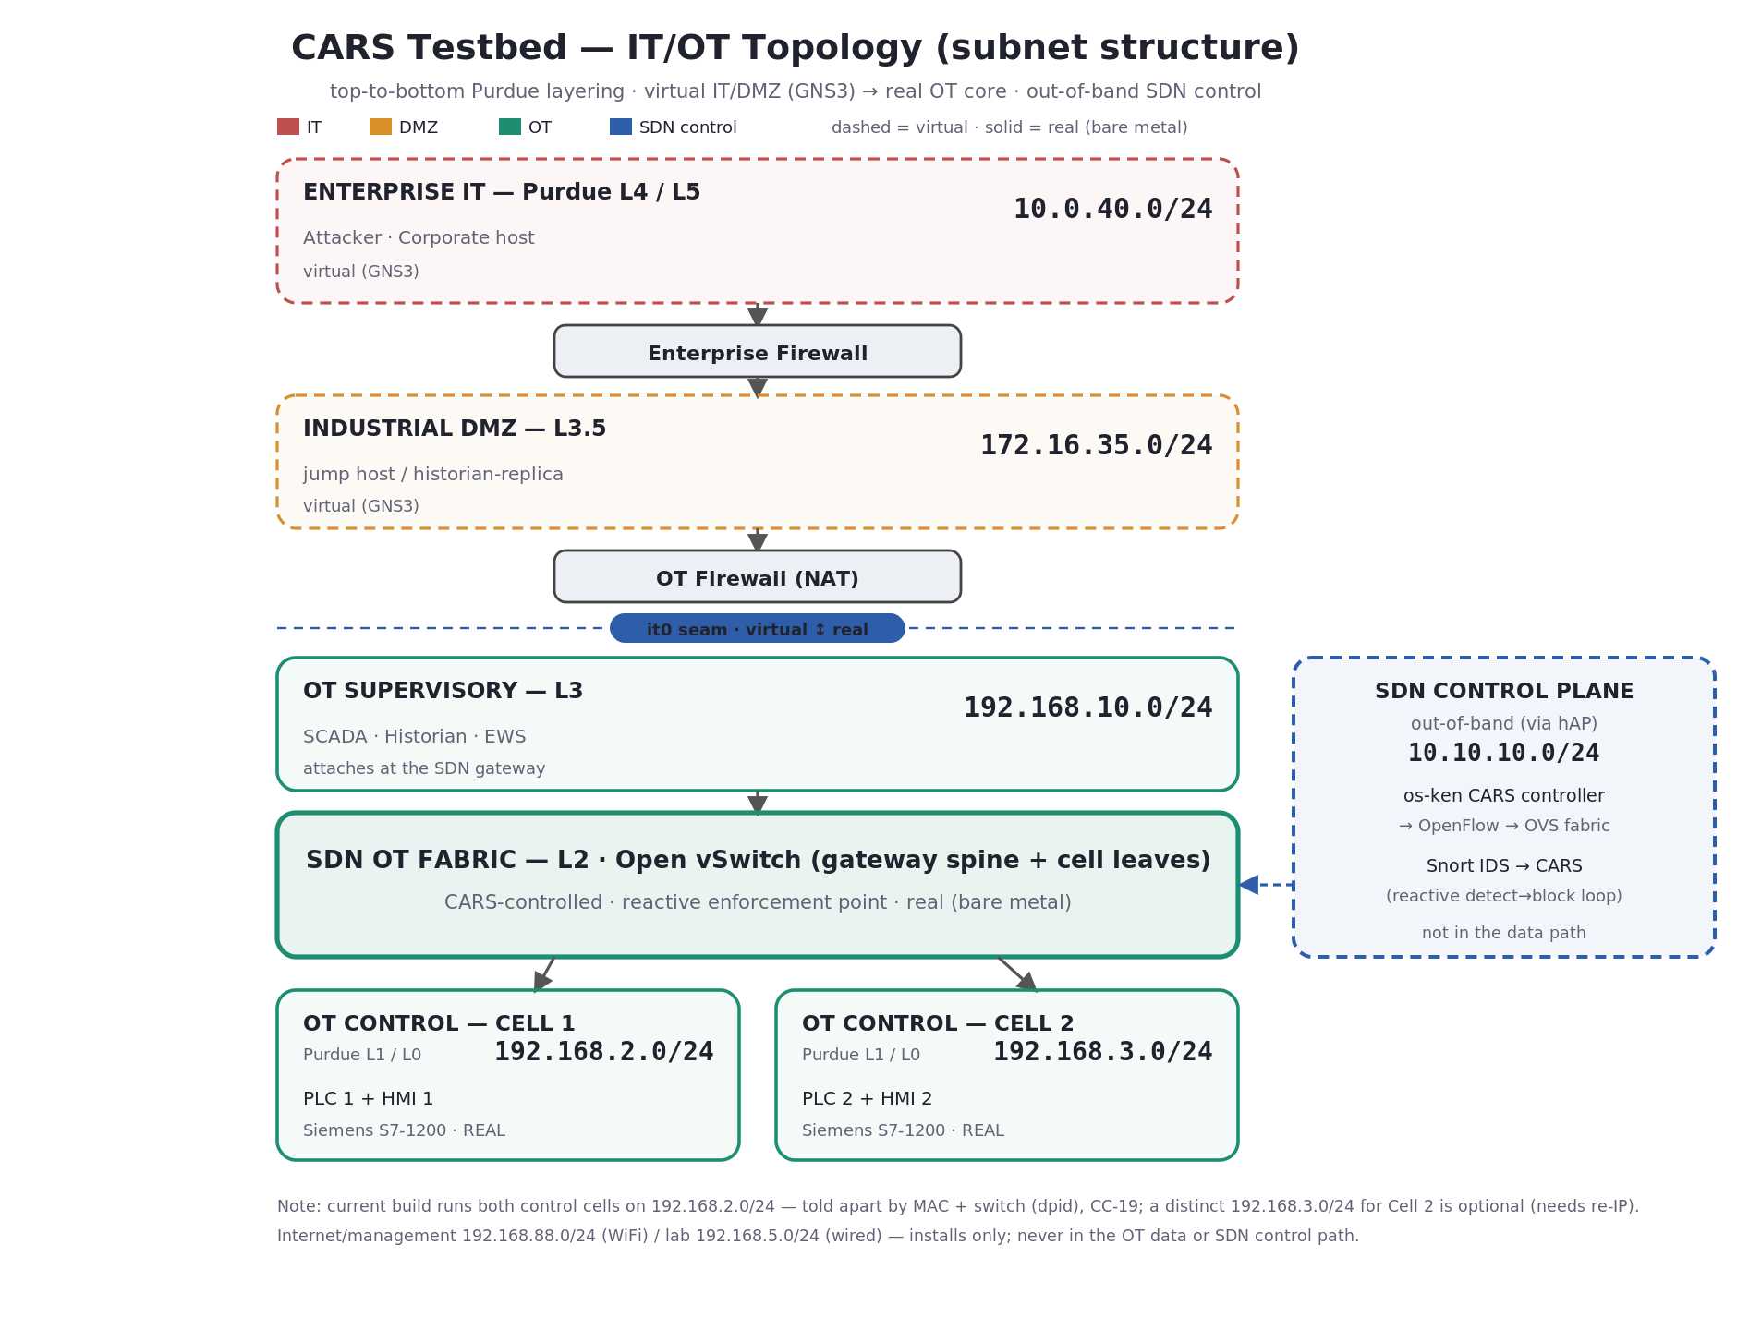
Figure 1 — IT/OT topology, top-to-bottom, with subnets and the SDN enforcement point.

Discovered fabric (ground truth, from the live controller)
Switch | dpid | Ports -> what is attached
ovs1 (Cell 1) | 1 | p1=PLC1, p2=HMI1, p3=uplink patch to ovsgw
ovsgw (gateway/spine) | 3 | p1=patch to ovs1, p2=it0 (GNS3 seam), p3=sup0 (supervisory), p4=snort0 (IDS mirror sink), p5=att0 (insider)
ovs2 (Cell 2) | 2 | p1=PLC2, p2=HMI2 (isolated — no fabric uplink yet)

4. Which component acts as what
Component | Role | Notes
Dell #1 | OT data plane + gateway + services | Runs ovs1 + ovsgw, GNS3, Docker (SCADA/Historian), Snort, and the dashboard. Control IP .2.
Dell #2 | SDN controller (pure) | os-ken/Ryu — the CARS brain. Nothing else runs here (isolated from attackers). Control IP .1; OpenFlow :6653, Event API :8080.
Dell #3 | OT Cell 2 | Runs ovs2 (PLC2 + HMI2). Control IP .3.
2x S7-1200 + HMI | Real process (L0/L1/L2) | The assets CARS protects; the PLC-HMI loop is the safety-critical conduit.
MikroTik hAP | Control-plane switch | Dumb L2 for the out-of-band management network; not the SDN fabric.
sup0 (192.168.2.30) | Supervisory (Historian/SCADA) | OVS internal port on the gateway; a trusted operational conduit to the PLCs.
att0 (192.168.2.66) | Insider attacker | On-plane foothold used to model a compromised OT host / insider.
GNS3 periphery | IT attacker + firewalls + DMZ | External IT-to-OT kill chain; OT-FW SNATs to .1 on the OT plane.
Snort | Intrusion detection | Off-the-shelf IDS on the gateway mirror; the detection source for CARS.

5 & 6. Scripts — role, host, and what each creates
Every piece of the system is a small, purpose-built script. The table gives the role; the paragraphs say where each runs and what it produces.
Script / file | Runs on | Role
cars_engine.py | Dell #2 | The CARS controller — trust brain + data-plane source-guard + live discovery + Event API.
snort_bridge.py | Dell #1 | IDS-to-CARS bridge — tails Snort alerts and reports flows to the brain.
cars_dashboard.py | Dell #1 | Live NOC dashboard — discovered topology, link health, guard telemetry, decision feed.
mttm.py | Dell #1 | Evaluation harness — measures mean-time-to-mitigate over many trials.
cars.conf + cars.rules | Dell #1 | Snort configuration and the CARS detection signatures.
cars-seams.service | Dell #1 | systemd unit — restores the seam-port IPs (sup0/att0) at boot.
99-cars-arp.conf | Dell #1 | sysctl — stops multi-homed-host ARP flux (arp_ignore/announce).

cars_engine.py — the controller (Dell #2)
Launched with osken-manager --observe-links ~/cars/cars_engine.py. An OpenFlow 1.3 application on os-ken (the maintained Ryu fork). It creates: (a) a two-table flow pipeline on every switch (Table 0 = source-guard, Table 1 = L2 switching + enforcement); (b) an HTTP Event API on :8080 (/cars/respond, /status, /hosts, /ports, /links, /guard, /block, /unblock, /restore); (c) a passive host/link discovery model; and (d) an append-only audit log of every decision.

snort_bridge.py — the detection coupling (Dell #1)
Runs tail -F on Snort's alert file, parses each alert into (src, dst, proto), and HTTP-POSTs it to the controller's /cars/respond. It contains no policy of its own — the brain decides. It creates the live coupling that turns detections into decisions.

cars_dashboard.py — the live NOC (Dell #1)
A threaded HTTP server on :8090 that serves a single-page live view and proxies the controller's API (no CORS issues; the browser never touches the control plane). It creates a force-directed, discovery-driven topology with per-link port bindings, real-time link-health (a link turns red the instant its port drops), a source-guard drop counter, and a dated decision feed — refreshed every 1.2 s.

mttm.py — the evaluation harness (Dell #1)
Repeats an attack-mitigate cycle (restore, launch attack, poll until the block appears), timing everything on one clock, and writes ~/mttm_results.csv plus summary statistics.

7. How the reactive loop was created
The reactive loop was assembled from four decoupled stages, each independently testable, so detection, decision, and enforcement are cleanly separated (deliberate, so any detector can be swapped in).
- 1. Sense. An OVS mirror on the gateway (ovsgw) copies all boundary traffic to a sink port (snort0); Snort listens there and raises an alert when a suspicious flow to a protected asset is seen.
- 2. Report. snort_bridge.py tails the alert file and POSTs the offending flow to the controller's Event API — turning a text alert into a structured event.
- 3. Decide. The controller's trust brain classifies the flow by its conduit criticality (Section 8) and chooses an action — block, allow, or refuse-to-block.
- 4. Enforce. If block, the controller installs a drop rule on every switch so the offending conduit is severed wherever it lives; if allow, nothing changes; if the flow is the safety-critical loop, the block is refused.
The loop runs autonomously — no human in the path. A parallel, always-on data-plane source-guard sits in front of the brain and drops spoofed traffic before it can ever be classified, so an attacker cannot impersonate a trusted host to fool the decision.

8. Mitigation flow and current rules

The trust brain — conduit-criticality policy
Criticality is a property of the conduit (source-role to destination-role to service), not of a device. The brain maps each flow to one of four tiers and acts accordingly:
Tier | When | Action
CRITICAL | The real PLC-HMI control loop | REFUSE to block (safety invariant) — mirror/alert only
FORBIDDEN | Unknown / external / gateway to PLC or HMI | BLOCK on sight
SENSITIVE | Engineering station (EWS) to PLC/HMI | Block on anomaly (designed; no EWS deployed yet)
OPERATIONAL | Supervisory (Historian/SCADA) to PLC/HMI | ALLOW — monitor only
The safety invariant is the heart of the contribution: CARS is structurally incapable of severing the legitimate control loop — verified on hardware (a block request for the loop returns refused).

The source-guard — data-plane anti-spoofing (Table 0)
Before traffic reaches the switching/decision logic, Table 0 validates its identity against a fixed binding table (verified from the live switches):
- Each protected host is bound to an exact (switch, port, MAC, IP) tuple; matching IP and ARP traffic is allowed through.
- Any packet claiming a protected IP (.10 / .9 / .30) from the wrong port or MAC — an impersonation attempt — is dropped at ingress, at both L3 (IP) and L2 (ARP).
So an attacker cannot forge the supervisor's address to be waved through, nor forge the HMI's address to steal the CRITICAL never-block shield — both were tested and dropped.

Current detection rules (Snort)
Signature | Protocol | SID
Any to PLC1 (192.168.2.10) | ICMP | 1000001
Any to HMI1 (192.168.2.9) | ICMP | 1000002
Any to PLC1 (TCP SYN) | TCP | 1000003
Any to HMI1 (TCP SYN) | TCP | 1000004
Snort casts a wide net (any source to a protected asset); the brain does the intelligent filtering — e.g. it allows the supervisor to the same PLC while blocking an unknown host, from identical detections.

9. Security hardening (a major achievement block)
After the prototype worked, a dedicated hardening pass made it defensible. Each item was staged carefully, verified on hardware, and recorded in the decision log.
Hardening | What it does / result
Anti-spoofing (IP + ARP) | Two-table source-guard drops forged identities at ingress — verified: forged .30 and .9 dropped.
Safety-invariant hardening | The CRITICAL never-block shield can no longer be stolen by impersonating the loop.
Fail-secure | On controller loss the fabric keeps its rules (no fail-open); a broadcast-flood rule keeps ARP/loops alive during an outage — verified with the controller killed.
Clean discovery | Fixed ARP-flux; clean-slate-on-reconnect so discovery re-learns hosts after a restart.
Per-cell enforcement | Blocks install on every switch, so they reach an isolated Cell 2, not just the gateway.
Independent audit | A skeptical code review validated the core design; findings were fixed or explicitly scoped as documented limitations.

10. Evaluation — mitigation latency (MTTM)
Mean-time-to-mitigate was measured on the insider path over 20 attack-block cycles, timed on a single clock to avoid cross-machine skew. The controller was also instrumented to time its own decide-and-enforce path.
Metric | Value | Detail
CARS decide + enforce (controller) | 0.613 ms | sub-ms · n=21
End-to-end MTTM (mean) | 1.132 s | median 1.127 s
End-to-end MTTM (best case) | 0.139 s | min over 20
CARS share of end-to-end | ~0.05 % | ~99.95% is the IDS
Interpretation: the reactive SDN response layer is effectively instantaneous; the end-to-end mitigation time is bounded by the off-the-shelf detector (Snort's internal buffering), not by CARS. This was proven by tightening the bridge poll — which moved the best case to 48 ms but left the mean unchanged, pinning the residual latency upstream in the sensor. Paired with a faster detector, the sub-millisecond controller keeps up.

11. Impactful goals achieved to date
- A working real-hardware ICS testbed (2x Siemens S7-1200 + HMI) with a 3-switch SDN fabric and out-of-band control.
- The core contribution is implemented and works autonomously — a conduit-criticality trust brain that makes intelligent, role-aware decisions with no human in the loop.
- The safety property is demonstrated on hardware (safe by construction) — CARS refuses to sever the legitimate PLC-HMI control loop; the one residual (the brain trusts detector-reported identities) is documented in Section 12.
- The reactive loop is closed end-to-end for both an external (IT-to-OT) attacker and an on-plane insider — attacks are detected, decided, and blocked automatically, with no human in the loop.
- True data-plane defence — IP + ARP source-guard makes host impersonation infeasible for on-plane (access-port) attackers; forged identities are dropped at ingress.
- Real hardware earned its keep — genuine ICS faults a simulator would never show (multi-homed ARP flux, PLC boot-time ARP probes, identical-cell clone IPs) surfaced during the build, and each became a hardening improvement.
- Resilience — the system fails secure and keeps the process running through a controller outage.
- Independently audited — the design survived a skeptical review; issues were fixed or honestly scoped.
- Live discovery + NOC dashboard — the whole IT/OT space is visualised in real time from the controller's own view.
- Quantitative evaluation — sub-millisecond controller response, with a clean CARS-vs-sensor latency breakdown.

12. Remaining work — what to know

Planned next steps
- P4 transit: wire Cell 2 (ovs2) into the gateway fabric — but harden the uplink source-guard first (see limitation below), so joining Cell 2 does not open a spoofing path.
- Cell-2 detection: add a mirror/sensor for Cell 2 so it is detected, not just enforceable (the IDS mirror currently covers only the gateway).
- External-path MTTM: script the GNS3 attacker to measure the IT-to-OT path over many trials for a like-for-like latency figure.
- Sensor tuning: tune Snort's buffering to lower the end-to-end MTTM for a CARS-plus-tuned-sensor figure.
- Write-up: the contribution, hardening, and evaluation chapters assemble from the decision log (28 recorded decisions).

Known limitations (documented honestly, not defects)
- Anti-spoofing is scoped to access-port attackers: the uplink-trust must be hardened before the physical Cell-2 transit is added.
- SENSITIVE/EWS tier is designed but not deployed (no engineering station on the plane yet).
- The brain trusts detector-reported IPs; a cross-check against the binding table is future work.
- A controller restart momentarily lifts active blocks (the reactive loop re-establishes them); persisting blocks is future work.
- The external NAT makes an IT-origin block coarse (all IT-to-PLC traffic arrives as .1); acceptable in this testbed.

All decisions, numbers, and rationale are locked in the project's decision log (DECISION_LOG.md, entries CC-1 to CC-28), build log, refreshed cold-start runbook, and the MTTM evaluation record — the record is complete and reproducible.

