# ============ Dell#1 (fabric + sensing) ============
# [x] 1. Topology / port map -> backs Fig 2, Fig fig:ovsshow, Section 3.2

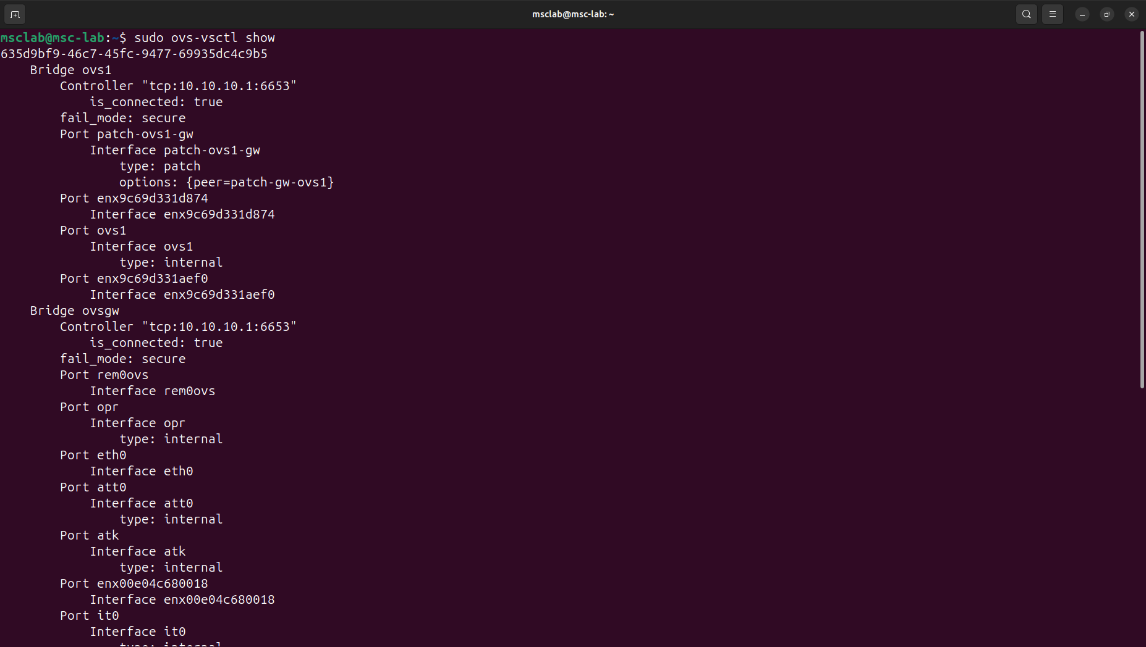
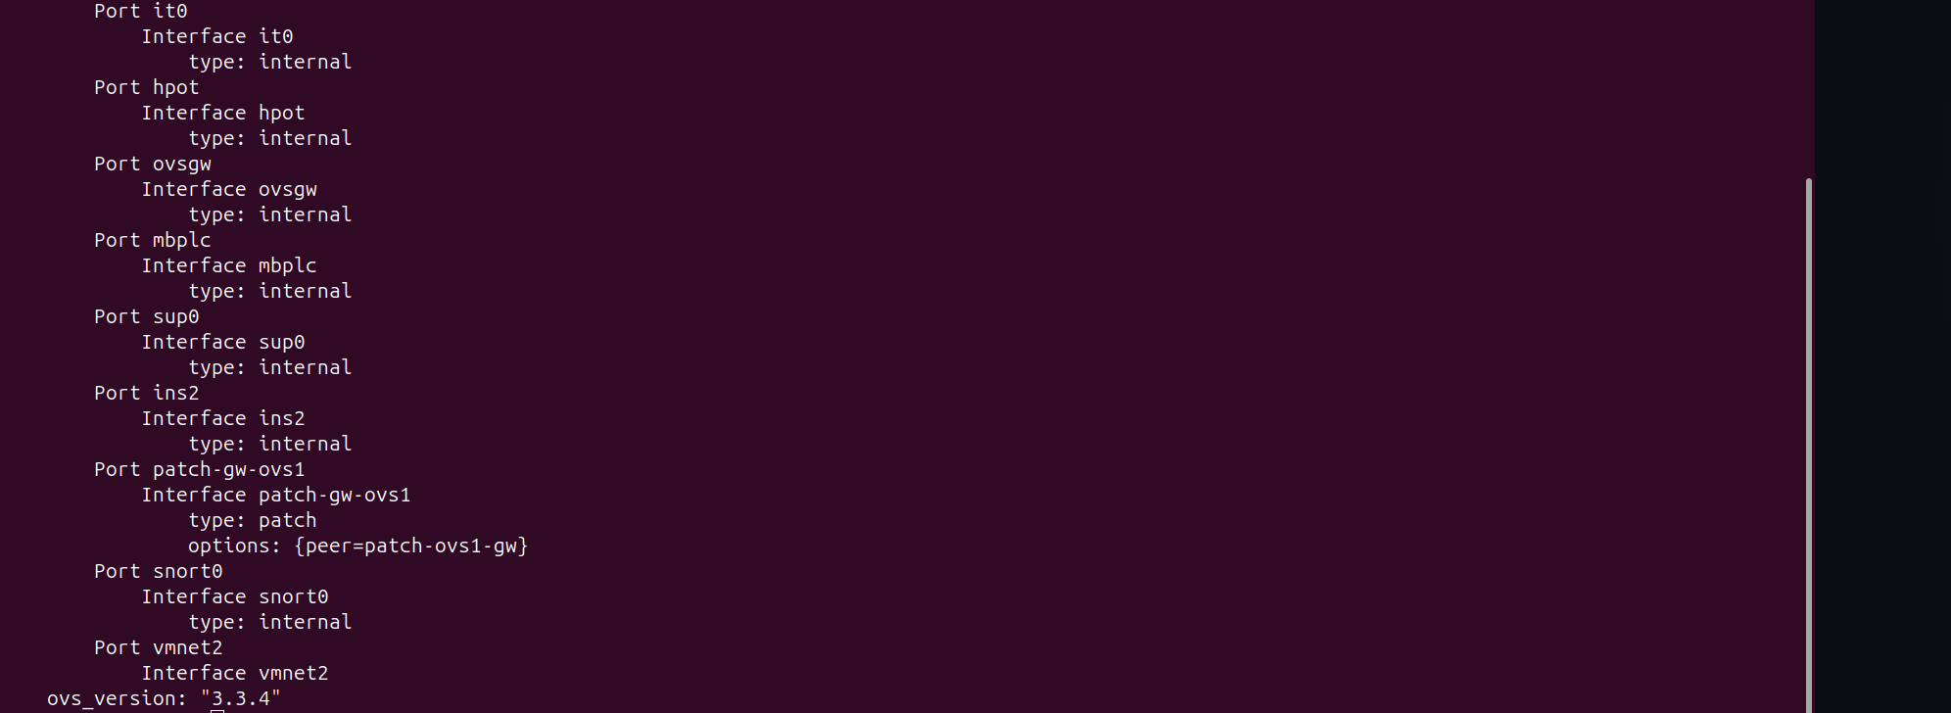
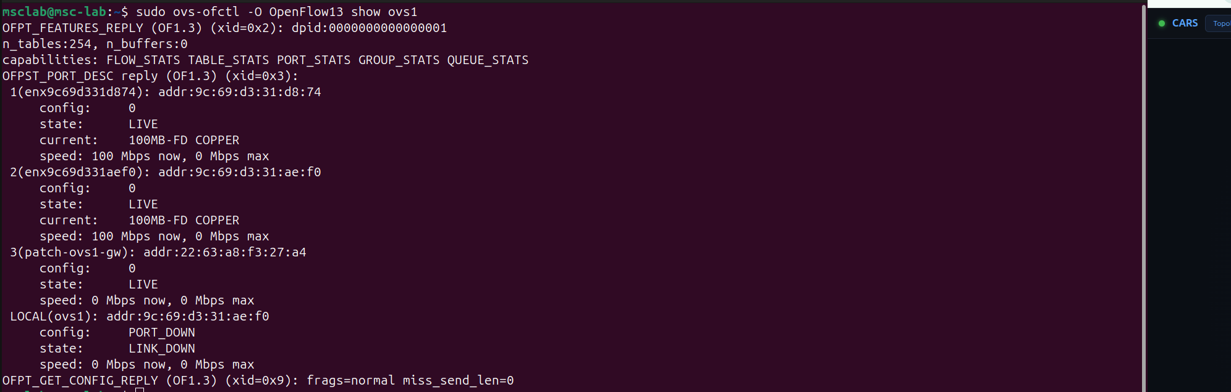

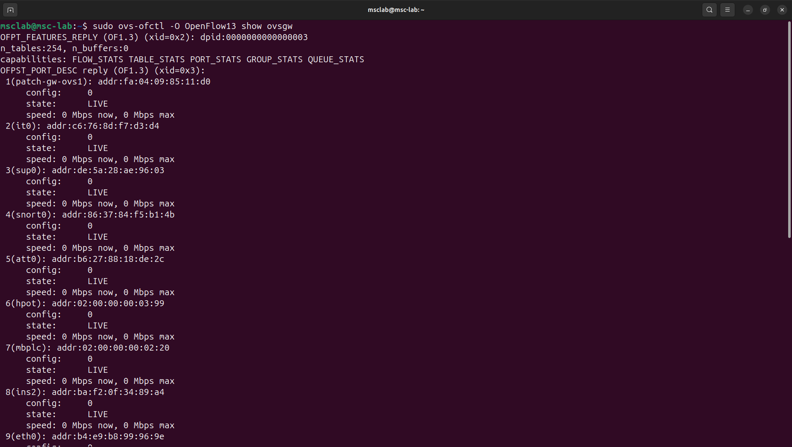
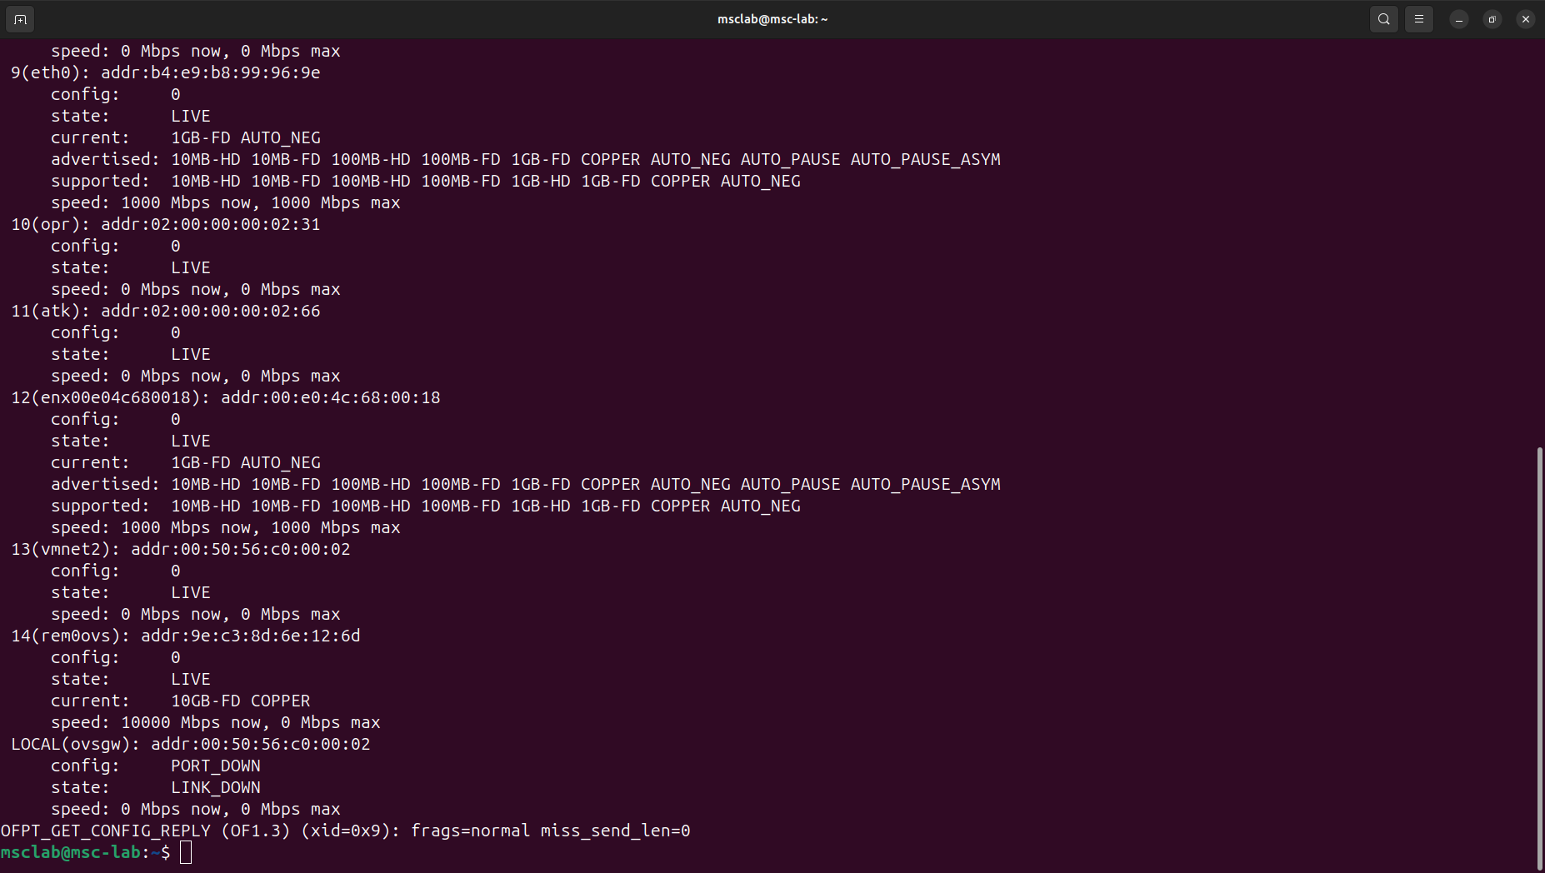

# [ ] 2. Enforcement pipeline -> backs Fig 5, Section 3.4 (HIGHEST PRIORITY)
### ovs1 table=0
cookie=0x0, duration=20378.869s, table=0, n_packets=27920, n_bytes=3464030, priority=65535,dl_dst=01:80:c2:00:00:0e,dl_type=0x88cc actions=CONTROLLER:65535
cookie=0x0, duration=20378.874s, table=0, n_packets=1598927, n_bytes=128822228, priority=200,ip,in_port=enx9c69d331d874,dl_src=e0:dc:a0:63:98:09,nw_src=192.168.2.10 actions=goto_table:1
cookie=0x0, duration=20378.874s, table=0, n_packets=46876, n_bytes=5356173, priority=200,ip,in_port=enx9c69d331aef0,dl_src=e0:dc:a0:62:b7:4c,nw_src=192.168.2.9 actions=goto_table:1
cookie=0x0, duration=20378.874s, table=0, n_packets=673, n_bytes=40380, priority=200,arp,in_port=enx9c69d331d874,arp_spa=192.168.2.10,arp_sha=e0:dc:a0:63:98:09 actions=goto_table:1
cookie=0x0, duration=20378.874s, table=0, n_packets=2354, n_bytes=141240, priority=200,arp,in_port=enx9c69d331aef0,arp_spa=192.168.2.9,arp_sha=e0:dc:a0:62:b7:4c actions=goto_table:1
cookie=0x0, duration=20378.874s, table=0, n_packets=2795418, n_bytes=215929736, priority=150,in_port="patch-ovs1-gw" actions=goto_table:1
cookie=0x0, duration=20378.874s, table=0, n_packets=0, n_bytes=0, priority=100,ip,nw_src=192.168.2.10 actions=drop
cookie=0x0, duration=20378.874s, table=0, n_packets=0, n_bytes=0, priority=100,ip,nw_src=192.168.2.20 actions=drop
cookie=0x0, duration=20378.874s, table=0, n_packets=0, n_bytes=0, priority=100,ip,nw_src=192.168.2.30 actions=drop
cookie=0x0, duration=20378.874s, table=0, n_packets=0, n_bytes=0, priority=100,ip,nw_src=192.168.2.31 actions=drop
cookie=0x0, duration=20378.874s, table=0, n_packets=0, n_bytes=0, priority=100,ip,nw_src=192.168.2.45 actions=drop
cookie=0x0, duration=20378.874s, table=0, n_packets=0, n_bytes=0, priority=100,ip,nw_src=192.168.2.55 actions=drop
cookie=0x0, duration=20378.873s, table=0, n_packets=0, n_bytes=0, priority=100,ip,nw_src=192.168.2.9 actions=drop
cookie=0x0, duration=20378.873s, table=0, n_packets=0, n_bytes=0, priority=100,arp,arp_spa=192.168.2.10 actions=drop
cookie=0x0, duration=20378.873s, table=0, n_packets=0, n_bytes=0, priority=100,arp,arp_spa=192.168.2.20 actions=drop
cookie=0x0, duration=20378.872s, table=0, n_packets=0, n_bytes=0, priority=100,arp,arp_spa=192.168.2.30 actions=drop
cookie=0x0, duration=20378.872s, table=0, n_packets=0, n_bytes=0, priority=100,arp,arp_spa=192.168.2.31 actions=drop
cookie=0x0, duration=20378.872s, table=0, n_packets=0, n_bytes=0, priority=100,arp,arp_spa=192.168.2.45 actions=drop
cookie=0x0, duration=20378.872s, table=0, n_packets=0, n_bytes=0, priority=100,arp,arp_spa=192.168.2.55 actions=drop
cookie=0x0, duration=20378.872s, table=0, n_packets=0, n_bytes=0, priority=100,arp,arp_spa=192.168.2.9 actions=drop
cookie=0x0, duration=20378.872s, table=0, n_packets=0, n_bytes=0, priority=50,ip actions=goto_table:1
cookie=0x0, duration=20378.872s, table=0, n_packets=1, n_bytes=124, priority=0 actions=goto_table:1
### ovs1 table=1
cookie=0xa2, duration=20378.892s, table=1, n_packets=4416490, n_bytes=345191112, priority=90,ct_state=-trk,ip actions=ct(table=1)
cookie=0xa2, duration=20378.892s, table=1, n_packets=4394166, n_bytes=339589437, priority=85,ct_state=+est+trk,ip actions=goto_table:2
cookie=0xa2, duration=20378.892s, table=1, n_packets=0, n_bytes=0, priority=80,ct_state=+new+trk,tcp,nw_src=192.168.2.31,nw_dst=192.168.2.20,tp_dst=502 actions=ct(commit),goto_table:2
cookie=0xa2, duration=20378.892s, table=1, n_packets=1, n_bytes=74, priority=80,ct_state=+new+trk,tcp,nw_src=192.168.2.9,nw_dst=192.168.2.10,tp_dst=102 actions=ct(commit),goto_table:2
cookie=0xa2, duration=20378.892s, table=1, n_packets=0, n_bytes=0, priority=80,ct_state=+new+trk,tcp,nw_src=192.168.2.31,nw_dst=192.168.2.10,tp_dst=102 actions=ct(commit),goto_table:2
cookie=0xa2, duration=20378.892s, table=1, n_packets=0, n_bytes=0, priority=80,ct_state=+new+trk,tcp,nw_src=192.168.3.66,nw_dst=192.168.3.10,tp_dst=102 actions=ct(commit),goto_table:2
cookie=0xa2, duration=20378.889s, table=1, n_packets=2, n_bytes=132, priority=80,ct_state=+new+trk,tcp,nw_src=192.168.2.55,nw_dst=192.168.2.10,tp_dst=102 actions=ct(commit),goto_table:2
cookie=0xa2, duration=20378.889s, table=1, n_packets=5, n_bytes=370, priority=80,ct_state=+new+trk,tcp,nw_src=192.168.2.45,nw_dst=192.168.2.10,tp_dst=102 actions=ct(commit),goto_table:2
cookie=0xa2, duration=20378.889s, table=1, n_packets=5, n_bytes=370, priority=80,ct_state=+new+trk,tcp,nw_src=192.168.2.30,nw_dst=192.168.2.10,tp_dst=102 actions=ct(commit),goto_table:2
cookie=0xa2, duration=20378.889s, table=1, n_packets=0, n_bytes=0, priority=80,ct_state=+new+trk,tcp,nw_src=192.168.2.30,nw_dst=192.168.2.20,tp_dst=502 actions=ct(commit),goto_table:2
cookie=0xa2, duration=20378.889s, table=1, n_packets=0, n_bytes=0, priority=80,ct_state=+new+trk,tcp,nw_src=192.168.2.55,nw_dst=192.168.2.9,tp_dst=102 actions=ct(commit),goto_table:2
cookie=0xa2, duration=20378.889s, table=1, n_packets=0, n_bytes=0, priority=55,ct_state=+new+trk,ip,nw_dst=192.168.2.20 actions=drop
cookie=0xa2, duration=20378.889s, table=1, n_packets=0, n_bytes=0, priority=55,ct_state=+new+trk,ip,nw_dst=192.168.2.10 actions=drop
cookie=0xa2, duration=20378.889s, table=1, n_packets=0, n_bytes=0, priority=55,ct_state=+new+trk,ip,nw_dst=192.168.2.9 actions=drop
cookie=0xa2, duration=20378.889s, table=1, n_packets=22311, n_bytes=4332105, priority=10,ct_state=+new+trk,ip actions=ct(commit),goto_table:2
cookie=0x0, duration=20378.894s, table=1, n_packets=27759, n_bytes=5098769, priority=0 actions=goto_table:2
### ovs1 table=2
cookie=0x0, duration=20378.914s, table=2, n_packets=2735, n_bytes=169833, priority=2,dl_dst=ff:ff:ff:ff:ff:ff actions=FLOOD
cookie=0x0, duration=20378.895s, table=2, n_packets=47206, n_bytes=5223109, priority=1,in_port=enx9c69d331aef0,dl_src=e0:dc:a0:62:b7:4c,dl_dst=e0:dc:a0:63:98:09 actions=output:enx9c69d331d874
cookie=0x0, duration=20378.891s, table=2, n_packets=30961, n_bytes=3466370, priority=1,in_port=enx9c69d331d874,dl_src=e0:dc:a0:63:98:09,dl_dst=e0:dc:a0:62:b7:4c actions=output:enx9c69d331aef0
cookie=0x0, duration=20377.892s, table=2, n_packets=128863, n_bytes=8961760, priority=1,in_port="patch-ovs1-gw",dl_src=92:b7:80:63:54:56,dl_dst=e0:dc:a0:63:98:09 actions=output:enx9c69d331d874
cookie=0x0, duration=20377.883s, table=2, n_packets=71278, n_bytes=5712750, priority=1,in_port=enx9c69d331d874,dl_src=e0:dc:a0:63:98:09,dl_dst=92:b7:80:63:54:56 actions=output:"patch-ovs1-gw"
cookie=0x0, duration=20376.539s, table=2, n_packets=19569, n_bytes=1465943, priority=1,in_port="patch-ovs1-gw",dl_src=de:5a:28:ae:96:03,dl_dst=e0:dc:a0:63:98:09 actions=output:enx9c69d331d874
cookie=0x0, duration=20376.534s, table=2, n_packets=10762, n_bytes=917479, priority=1,in_port=enx9c69d331d874,dl_src=e0:dc:a0:63:98:09,dl_dst=de:5a:28:ae:96:03 actions=output:"patch-ovs1-gw"
cookie=0x0, duration=20269.803s, table=2, n_packets=2022, n_bytes=121384, priority=1,in_port=enx9c69d331aef0,dl_src=e0:dc:a0:62:b7:4c,dl_dst=b4:e9:b8:a4:ce:46 actions=output:"patch-ovs1-gw"
cookie=0x0, duration=20269.755s, table=2, n_packets=0, n_bytes=0, priority=1,in_port="patch-ovs1-gw",dl_src=b4:e9:b8:a4:ce:46,dl_dst=e0:dc:a0:62:b7:4c actions=output:enx9c69d331aef0
cookie=0x0, duration=20268.710s, table=2, n_packets=1485928, n_bytes=117609981, priority=1,in_port=enx9c69d331d874,dl_src=e0:dc:a0:63:98:09,dl_dst=b4:e9:b8:a4:ce:46 actions=output:"patch-ovs1-gw"
cookie=0x0, duration=20268.703s, table=2, n_packets=2600279, n_bytes=196266885, priority=1,in_port="patch-ovs1-gw",dl_src=b4:e9:b8:a4:ce:46,dl_dst=e0:dc:a0:63:98:09 actions=output:enx9c69d331d874
cookie=0x0, duration=20378.914s, table=2, n_packets=44646, n_bytes=9105763, priority=0 actions=CONTROLLER:65535

msclab@msc-lab:~$ for t in 0 1 2; do echo "### ovsgw table=$t"; sudo ovs-ofctl -O OpenFlow13 dump-flows ovsgw table=$t; done
### ovsgw table=0
cookie=0x0, duration=20414.028s, table=0, n_packets=19281, n_bytes=1455423, priority=200,ip,in_port=sup0,dl_src=de:5a:28:ae:96:03,nw_src=192.168.2.30 actions=goto_table:1
cookie=0x0, duration=20414.028s, table=0, n_packets=0, n_bytes=0, priority=200,ip,in_port=opr,dl_src=02:00:00:00:02:31,nw_src=192.168.2.31 actions=goto_table:1
cookie=0x0, duration=20414.028s, table=0, n_packets=129262, n_bytes=8990206, priority=200,ip,in_port=rem0ovs,dl_src=92:b7:80:63:54:56,nw_src=192.168.2.45 actions=goto_table:1
cookie=0x0, duration=20414.028s, table=0, n_packets=0, n_bytes=0, priority=200,ip,in_port=mbplc,dl_src=02:00:00:00:02:20,nw_src=192.168.2.20 actions=goto_table:1
cookie=0x0, duration=20414.028s, table=0, n_packets=2627106, n_bytes=200945835, priority=200,ip,in_port=enx00e04c680018,dl_src=b4:e9:b8:a4:ce:46,nw_src=192.168.2.55 actions=goto_table:1
cookie=0x0, duration=20414.028s, table=0, n_packets=334, n_bytes=14028, priority=200,arp,in_port=sup0,arp_spa=192.168.2.30,arp_sha=de:5a:28:ae:96:03 actions=goto_table:1
cookie=0x0, duration=20414.028s, table=0, n_packets=0, n_bytes=0, priority=200,arp,in_port=opr,arp_spa=192.168.2.31,arp_sha=02:00:00:00:02:31 actions=goto_table:1
cookie=0x0, duration=20414.028s, table=0, n_packets=7, n_bytes=294, priority=200,arp,in_port=rem0ovs,arp_spa=192.168.2.45,arp_sha=92:b7:80:63:54:56 actions=goto_table:1
cookie=0x0, duration=20414.028s, table=0, n_packets=0, n_bytes=0, priority=200,arp,in_port=mbplc,arp_spa=192.168.2.20,arp_sha=02:00:00:00:02:20 actions=goto_table:1
cookie=0x0, duration=20414.028s, table=0, n_packets=2027, n_bytes=121620, priority=200,arp,in_port=enx00e04c680018,arp_spa=192.168.2.55,arp_sha=b4:e9:b8:a4:ce:46 actions=goto_table:1
cookie=0x0, duration=20414.028s, table=0, n_packets=1593195, n_bytes=125806203, priority=150,in_port="patch-gw-ovs1" actions=goto_table:1
cookie=0x0, duration=20414.028s, table=0, n_packets=0, n_bytes=0, priority=100,ip,nw_src=192.168.2.10 actions=drop
cookie=0x0, duration=20414.027s, table=0, n_packets=0, n_bytes=0, priority=100,ip,nw_src=192.168.2.20 actions=drop
cookie=0x0, duration=20414.027s, table=0, n_packets=0, n_bytes=0, priority=100,ip,nw_src=192.168.2.30 actions=drop
cookie=0x0, duration=20414.027s, table=0, n_packets=0, n_bytes=0, priority=100,ip,nw_src=192.168.2.31 actions=drop
cookie=0x0, duration=20414.027s, table=0, n_packets=0, n_bytes=0, priority=100,ip,nw_src=192.168.2.45 actions=drop
cookie=0x0, duration=20414.027s, table=0, n_packets=0, n_bytes=0, priority=100,ip,nw_src=192.168.2.55 actions=drop
cookie=0x0, duration=20414.027s, table=0, n_packets=0, n_bytes=0, priority=100,ip,nw_src=192.168.2.9 actions=drop
cookie=0x0, duration=20414.027s, table=0, n_packets=0, n_bytes=0, priority=100,arp,arp_spa=192.168.2.10 actions=drop
cookie=0x0, duration=20414.026s, table=0, n_packets=0, n_bytes=0, priority=100,arp,arp_spa=192.168.2.20 actions=drop
cookie=0x0, duration=20414.026s, table=0, n_packets=0, n_bytes=0, priority=100,arp,arp_spa=192.168.2.30 actions=drop
cookie=0x0, duration=20414.026s, table=0, n_packets=0, n_bytes=0, priority=100,arp,arp_spa=192.168.2.31 actions=drop
cookie=0x0, duration=20414.026s, table=0, n_packets=0, n_bytes=0, priority=100,arp,arp_spa=192.168.2.45 actions=drop
cookie=0x0, duration=20414.026s, table=0, n_packets=0, n_bytes=0, priority=100,arp,arp_spa=192.168.2.55 actions=drop
cookie=0x0, duration=20414.026s, table=0, n_packets=0, n_bytes=0, priority=100,arp,arp_spa=192.168.2.9 actions=drop
cookie=0x0, duration=20414.026s, table=0, n_packets=29522, n_bytes=2349478, priority=50,ip actions=goto_table:1
cookie=0x0, duration=20414.026s, table=0, n_packets=26072, n_bytes=5289125, priority=0 actions=goto_table:1
### ovsgw table=1
cookie=0xa2, duration=20414.042s, table=1, n_packets=4337104, n_bytes=335271698, priority=90,ct_state=-trk,ip actions=ct(table=1)
cookie=0xa2, duration=20414.042s, table=1, n_packets=4353311, n_bytes=333837310, priority=85,ct_state=+est+trk,ip actions=goto_table:2
cookie=0xa2, duration=20414.041s, table=1, n_packets=0, n_bytes=0, priority=80,ct_state=+new+trk,tcp,nw_src=192.168.2.31,nw_dst=192.168.2.20,tp_dst=502 actions=ct(commit),goto_table:2
cookie=0xa2, duration=20414.041s, table=1, n_packets=0, n_bytes=0, priority=80,ct_state=+new+trk,tcp,nw_src=192.168.2.9,nw_dst=192.168.2.10,tp_dst=102 actions=ct(commit),goto_table:2
cookie=0xa2, duration=20414.041s, table=1, n_packets=0, n_bytes=0, priority=80,ct_state=+new+trk,tcp,nw_src=192.168.2.31,nw_dst=192.168.2.10,tp_dst=102 actions=ct(commit),goto_table:2
cookie=0xa2, duration=20414.041s, table=1, n_packets=5, n_bytes=370, priority=80,ct_state=+new+trk,tcp,nw_src=192.168.3.66,nw_dst=192.168.3.10,tp_dst=102 actions=ct(commit),goto_table:2
cookie=0xa2, duration=20414.041s, table=1, n_packets=2, n_bytes=132, priority=80,ct_state=+new+trk,tcp,nw_src=192.168.2.55,nw_dst=192.168.2.10,tp_dst=102 actions=ct(commit),goto_table:2
cookie=0xa2, duration=20414.041s, table=1, n_packets=5, n_bytes=370, priority=80,ct_state=+new+trk,tcp,nw_src=192.168.2.45,nw_dst=192.168.2.10,tp_dst=102 actions=ct(commit),goto_table:2
cookie=0xa2, duration=20414.041s, table=1, n_packets=5, n_bytes=370, priority=80,ct_state=+new+trk,tcp,nw_src=192.168.2.30,nw_dst=192.168.2.10,tp_dst=102 actions=ct(commit),goto_table:2
cookie=0xa2, duration=20414.041s, table=1, n_packets=0, n_bytes=0, priority=80,ct_state=+new+trk,tcp,nw_src=192.168.2.30,nw_dst=192.168.2.20,tp_dst=502 actions=ct(commit),goto_table:2
cookie=0xa2, duration=20414.041s, table=1, n_packets=0, n_bytes=0, priority=80,ct_state=+new+trk,tcp,nw_src=192.168.2.55,nw_dst=192.168.2.9,tp_dst=102 actions=ct(commit),goto_table:2
cookie=0xa2, duration=20414.041s, table=1, n_packets=0, n_bytes=0, priority=55,ct_state=+new+trk,ip,nw_dst=192.168.2.20 actions=drop
cookie=0xa2, duration=20414.041s, table=1, n_packets=22347, n_bytes=4339197, priority=10,ct_state=+new+trk,ip actions=ct(commit),goto_table:2
cookie=0x0, duration=20414.044s, table=1, n_packets=50929, n_bytes=6773958, priority=0 actions=goto_table:2
### ovsgw table=2
cookie=0x0, duration=20414.064s, table=2, n_packets=2741, n_bytes=170193, priority=2,dl_dst=ff:ff:ff:ff:ff:ff actions=FLOOD
cookie=0x0, duration=20413.048s, table=2, n_packets=129083, n_bytes=8977050, priority=1,in_port=rem0ovs,dl_src=92:b7:80:63:54:56,dl_dst=e0:dc:a0:63:98:09 actions=output:"patch-gw-ovs1"
cookie=0x0, duration=20413.035s, table=2, n_packets=71400, n_bytes=5722528, priority=1,in_port="patch-gw-ovs1",dl_src=e0:dc:a0:63:98:09,dl_dst=92:b7:80:63:54:56 actions=output:rem0ovs
cookie=0x0, duration=20411.696s, table=2, n_packets=19816, n_bytes=1477456, priority=1,in_port=ins2,dl_src=ba:f2:0f:34:89:a4,dl_dst=b4:e9:b8:a4:ce:5f actions=output:eth0
cookie=0x0, duration=20411.694s, table=2, n_packets=19604, n_bytes=1468552, priority=1,in_port=sup0,dl_src=de:5a:28:ae:96:03,dl_dst=e0:dc:a0:63:98:09 actions=output:"patch-gw-ovs1"
cookie=0x0, duration=20411.687s, table=2, n_packets=10780, n_bytes=919046, priority=1,in_port="patch-gw-ovs1",dl_src=e0:dc:a0:63:98:09,dl_dst=de:5a:28:ae:96:03 actions=output:sup0
cookie=0x0, duration=20411.680s, table=2, n_packets=10768, n_bytes=921668, priority=1,in_port=eth0,dl_src=b4:e9:b8:a4:ce:5f,dl_dst=ba:f2:0f:34:89:a4 actions=output:ins2
cookie=0x0, duration=20304.955s, table=2, n_packets=2026, n_bytes=121624, priority=1,in_port="patch-gw-ovs1",dl_src=e0:dc:a0:62:b7:4c,dl_dst=b4:e9:b8:a4:ce:46 actions=output:enx00e04c680018
cookie=0x0, duration=20304.911s, table=2, n_packets=0, n_bytes=0, priority=1,in_port=enx00e04c680018,dl_src=b4:e9:b8:a4:ce:46,dl_dst=e0:dc:a0:62:b7:4c actions=output:"patch-gw-ovs1"
cookie=0x0, duration=20303.862s, table=2, n_packets=1488511, n_bytes=117814329, priority=1,in_port="patch-gw-ovs1",dl_src=e0:dc:a0:63:98:09,dl_dst=b4:e9:b8:a4:ce:46 actions=output:enx00e04c680018
cookie=0x0, duration=20303.859s, table=2, n_packets=2604793, n_bytes=196607589, priority=1,in_port=enx00e04c680018,dl_src=b4:e9:b8:a4:ce:46,dl_dst=e0:dc:a0:63:98:09 actions=output:"patch-gw-ovs1"
cookie=0x0, duration=20414.064s, table=2, n_packets=67082, n_bytes=10751672, priority=0 actions=CONTROLLER:65535

# [ ] 3. Throttle meter -> backs THROTTLE rung, Section 3.6

# [ ] 4. Detection rules (S7 + Modbus op classes) -> backs Fig 6, Fig 7, Section 3.6
msclab@msc-lab:~$ sudo grep -nE "s7comm|modbus|byte_test|content:\"\|32 01\"|offset" /etc/snort/cars.rules | head -60
9:# --- A3 Modbus DPI: function-code detection (payload offset 7; proto-id anchor offset 2) ---
10:alert tcp any any -> 192.168.2.20 502 (msg:"CARS-MODBUS-CONTROL-coil"; content:"|00 00|"; offset:2; depth:2; content:"|05|"; offset:7; depth:1; sid:1000020; rev:3;)
11:alert tcp any any -> 192.168.2.20 502 (msg:"CARS-MODBUS-WRITE-reg"; content:"|00 00|"; offset:2; depth:2; content:"|06|"; offset:7; depth:1; sid:1000021; rev:3;)
12:alert tcp any any -> 192.168.2.20 502 (msg:"CARS-MODBUS-CONTROL-coils"; content:"|00 00|"; offset:2; depth:2; content:"|0F|"; offset:7; depth:1; sid:1000022; rev:3;)
13:alert tcp any any -> 192.168.2.20 502 (msg:"CARS-MODBUS-WRITE-regs"; content:"|00 00|"; offset:2; depth:2; content:"|10|"; offset:7; depth:1; sid:1000023; rev:3;)
14:alert tcp any any -> 192.168.2.20 502 (msg:"CARS-MODBUS-READ-holding"; content:"|00 00|"; offset:2; depth:2; content:"|03|"; offset:7; depth:1; sid:1000024; rev:3;)
16:alert tcp any any -> 192.168.2.10 102 (msg:"CARS-S7COMMPLUS-session-PLC1"; content:"|03 00|"; depth:2; content:"|72|"; offset:7; depth:1; sid:1000040; rev:1;)
18:alert tcp any any -> 192.168.2.20 502 (msg:"CARS-MODBUS-DIAG-diagnostics"; content:"|00 00|"; offset:2; depth:2; content:"|08|"; offset:7; depth:1; sid:1000025; rev:1;)
19:alert tcp any any -> 192.168.2.20 502 (msg:"CARS-MODBUS-PROGRAM-mei"; content:"|00 00|"; offset:2; depth:2; content:"|2B|"; offset:7; depth:1; sid:1000026; rev:1;)
20:alert tcp any any -> 192.168.2.20 502 (msg:"CARS-MODBUS-ILLEGAL-fc"; content:"|00 00|"; offset:2; depth:2; byte_test:1,>,43,7; sid:1000027; rev:1;)
22:alert tcp any any -> 192.168.2.10 102 (msg:"CARS-S7-CONTROL-write"; content:"|03 00|"; depth:2; content:"|32 01|"; offset:7; depth:2; content:"|05|"; offset:17; depth:1; sid:1000041; rev:1;)
24:alert tcp any any -> 192.168.2.10 102 (msg:"CARS-S7-DIAG-stop"; content:"|03 00|"; depth:2; content:"|32 01|"; offset:7; depth:2; content:"|29|"; offset:17; depth:1; sid:1000042; rev:1;)
25:alert tcp any any -> 192.168.2.10 102 (msg:"CARS-S7-DIAG-control"; content:"|03 00|"; depth:2; content:"|32 01|"; offset:7; depth:2; content:"|28|"; offset:17; depth:1; sid:1000043; rev:1;)
27:alert tcp any any -> 192.168.2.10 102 (msg:"CARS-S7-READ-var"; content:"|03 00|"; depth:2; content:"|32 01|"; offset:7; depth:2; content:"|04|"; offset:17; depth:1; sid:1000044; rev:1;)
29:alert tcp any any -> 192.168.3.10 102 (msg:"CARS-S7-CONTROL-write"; content:"|03 00|"; depth:2; content:"|32 01|"; offset:7; depth:2; content:"|05|"; offset:17; depth:1; sid:1000045; rev:1;)
30:alert tcp any any -> 192.168.3.10 102 (msg:"CARS-S7-DIAG-stop"; content:"|03 00|"; depth:2; content:"|32 01|"; offset:7; depth:2; content:"|29|"; offset:17; depth:1; sid:1000046; rev:1;)
31:alert tcp any any -> 192.168.3.10 102 (msg:"CARS-S7-READ-var"; content:"|03 00|"; depth:2; content:"|32 01|"; offset:7; depth:2; content:"|04|"; offset:17; depth:1; sid:1000047; rev:1;)
33:alert tcp any any -> 192.168.3.10 102 (msg:"CARS-S7-DIAG-control"; content:"|03 00|"; depth:2; content:"|32 01|"; offset:7; depth:2; content:"|28|"; offset:17; depth:1; sid:1000048; rev:1;)

# [ ] 5. Services running -> backs Section 3.6, 3.7
systemctl --no-pager status cars-snort cars-bridge cars-flowaudit cars-remediation
All active and running

# [ ] 6. Flow-integrity self-check line -> backs Section 3.6 (flow-audit)
msclab@msc-lab:~$ journalctl -u cars-flowaudit -n 20 --no-pager
Aug 03 20:38:45 msc-lab python3[2285]: [FLOW-AUDIT] CLEAN - live policy matches trusted baseline (reactive isolates ignored)

# [ ] 7. Namespaces (operator/attacker/service endpoints) -> backs Section 3.7
msclab@msc-lab:~$ ip netns list
for ns in opns atkns remns mbns hpotns; do echo "== $ns =="; sudo ip netns exec $ns ip -4 addr; done
atkns (id: 4)
remns (id: 3)
opns (id: 2)
hpotns (id: 0)
mbns (id: 1)
Output in short

# ============ Dell#3 (Cell-2) ============
# [x] 8. Cell-2 switch -> backs Fig 2, Fig fig:ovsshow
msclab@msc-lab:~$ for t in 0 1 2; do echo "### ovs2 table=$t"; sudo ovs-ofctl -O OpenFlow13 dump-flows ovs2 table=$t; done
### ovs2 table=0
cookie=0x0, duration=20884.122s, table=0, n_packets=8353, n_bytes=2330534, priority=65535,dl_dst=01:80:c2:00:00:0e,dl_type=0x88cc actions=CONTROLLER:65535
cookie=0x0, duration=20884.124s, table=0, n_packets=37677, n_bytes=6254142, priority=200,ip,in_port=enx9c69d3413f16,dl_src=e0:dc:a0:46:ff:ce,nw_src=192.168.2.10 actions=goto_table:1
cookie=0x0, duration=20884.124s, table=0, n_packets=48038, n_bytes=7138971, priority=200,ip,in_port=enx9c69d3283cf9,dl_src=e0:dc:a0:5c:60:44,nw_src=192.168.2.9 actions=goto_table:1
cookie=0x0, duration=20884.124s, table=0, n_packets=947, n_bytes=56820, priority=200,arp,in_port=enx9c69d3413f16,arp_spa=192.168.2.10,arp_sha=e0:dc:a0:46:ff:ce actions=goto_table:1
cookie=0x0, duration=20884.124s, table=0, n_packets=341, n_bytes=20460, priority=200,arp,in_port=enx9c69d3283cf9,arp_spa=192.168.2.9,arp_sha=e0:dc:a0:5c:60:44 actions=goto_table:1
cookie=0x0, duration=20884.124s, table=0, n_packets=0, n_bytes=0, priority=100,ip,nw_src=192.168.2.10 actions=drop
cookie=0x0, duration=20884.124s, table=0, n_packets=0, n_bytes=0, priority=100,ip,nw_src=192.168.2.20 actions=drop
cookie=0x0, duration=20884.124s, table=0, n_packets=0, n_bytes=0, priority=100,ip,nw_src=192.168.2.30 actions=drop
cookie=0x0, duration=20884.124s, table=0, n_packets=0, n_bytes=0, priority=100,ip,nw_src=192.168.2.31 actions=drop
cookie=0x0, duration=20884.124s, table=0, n_packets=0, n_bytes=0, priority=100,ip,nw_src=192.168.2.45 actions=drop
cookie=0x0, duration=20884.124s, table=0, n_packets=0, n_bytes=0, priority=100,ip,nw_src=192.168.2.55 actions=drop
cookie=0x0, duration=20884.124s, table=0, n_packets=0, n_bytes=0, priority=100,ip,nw_src=192.168.2.9 actions=drop
cookie=0x0, duration=20884.123s, table=0, n_packets=0, n_bytes=0, priority=100,arp,arp_spa=192.168.2.10 actions=drop
cookie=0x0, duration=20884.123s, table=0, n_packets=0, n_bytes=0, priority=100,arp,arp_spa=192.168.2.20 actions=drop
cookie=0x0, duration=20884.123s, table=0, n_packets=0, n_bytes=0, priority=100,arp,arp_spa=192.168.2.30 actions=drop
cookie=0x0, duration=20884.123s, table=0, n_packets=0, n_bytes=0, priority=100,arp,arp_spa=192.168.2.31 actions=drop
cookie=0x0, duration=20884.123s, table=0, n_packets=0, n_bytes=0, priority=100,arp,arp_spa=192.168.2.45 actions=drop
cookie=0x0, duration=20884.123s, table=0, n_packets=0, n_bytes=0, priority=100,arp,arp_spa=192.168.2.55 actions=drop
cookie=0x0, duration=20884.123s, table=0, n_packets=0, n_bytes=0, priority=100,arp,arp_spa=192.168.2.9 actions=drop
cookie=0x0, duration=20884.123s, table=0, n_packets=19718, n_bytes=1488405, priority=50,ip actions=goto_table:1
cookie=0x0, duration=20884.123s, table=0, n_packets=622, n_bytes=26868, priority=0 actions=goto_table:1
### ovs2 table=1
cookie=0xa2, duration=20884.141s, table=1, n_packets=85715, n_bytes=13393113, priority=90,ct_state=-trk,ip actions=ct(table=1)
cookie=0xa2, duration=20884.141s, table=1, n_packets=105419, n_bytes=14713428, priority=85,ct_state=+est+trk,ip actions=goto_table:2
cookie=0xa2, duration=20884.141s, table=1, n_packets=0, n_bytes=0, priority=80,ct_state=+new+trk,tcp,nw_src=192.168.2.31,nw_dst=192.168.2.20,tp_dst=502 actions=ct(commit),goto_table:2
cookie=0xa2, duration=20884.141s, table=1, n_packets=1, n_bytes=74, priority=80,ct_state=+new+trk,tcp,nw_src=192.168.2.9,nw_dst=192.168.2.10,tp_dst=102 actions=ct(commit),goto_table:2
cookie=0xa2, duration=20884.141s, table=1, n_packets=0, n_bytes=0, priority=80,ct_state=+new+trk,tcp,nw_src=192.168.2.31,nw_dst=192.168.2.10,tp_dst=102 actions=ct(commit),goto_table:2
cookie=0xa2, duration=20884.141s, table=1, n_packets=0, n_bytes=0, priority=80,ct_state=+new+trk,tcp,nw_src=192.168.3.66,nw_dst=192.168.3.10,tp_dst=102 actions=ct(commit),goto_table:2
cookie=0xa2, duration=20884.141s, table=1, n_packets=0, n_bytes=0, priority=80,ct_state=+new+trk,tcp,nw_src=192.168.2.55,nw_dst=192.168.2.10,tp_dst=102 actions=ct(commit),goto_table:2
cookie=0xa2, duration=20884.140s, table=1, n_packets=0, n_bytes=0, priority=80,ct_state=+new+trk,tcp,nw_src=192.168.2.45,nw_dst=192.168.2.10,tp_dst=102 actions=ct(commit),goto_table:2
cookie=0xa2, duration=20884.140s, table=1, n_packets=0, n_bytes=0, priority=80,ct_state=+new+trk,tcp,nw_src=192.168.2.30,nw_dst=192.168.2.10,tp_dst=102 actions=ct(commit),goto_table:2
cookie=0xa2, duration=20884.140s, table=1, n_packets=0, n_bytes=0, priority=80,ct_state=+new+trk,tcp,nw_src=192.168.2.30,nw_dst=192.168.2.20,tp_dst=502 actions=ct(commit),goto_table:2
cookie=0xa2, duration=20884.140s, table=1, n_packets=0, n_bytes=0, priority=80,ct_state=+new+trk,tcp,nw_src=192.168.2.55,nw_dst=192.168.2.9,tp_dst=102 actions=ct(commit),goto_table:2
cookie=0xa2, duration=20884.140s, table=1, n_packets=0, n_bytes=0, priority=55,ct_state=+new+trk,ip,nw_dst=192.168.2.20 actions=drop
cookie=0xa2, duration=20884.140s, table=1, n_packets=0, n_bytes=0, priority=55,ct_state=+new+trk,ip,nw_dst=192.168.2.9 actions=drop
cookie=0xa2, duration=20884.140s, table=1, n_packets=13, n_bytes=1066, priority=10,ct_state=+new+trk,ip actions=ct(commit),goto_table:2
cookie=0x0, duration=20884.142s, table=1, n_packets=1910, n_bytes=104148, priority=0 actions=goto_table:2
### ovs2 table=2
cookie=0x0, duration=20884.160s, table=2, n_packets=342, n_bytes=20502, priority=2,dl_dst=ff:ff:ff:ff:ff:ff actions=FLOOD
cookie=0x0, duration=20883.742s, table=2, n_packets=48377, n_bytes=7002655, priority=1,in_port=enx9c69d3283cf9,dl_src=e0:dc:a0:5c:60:44,dl_dst=e0:dc:a0:46:ff:ce actions=output:enx9c69d3413f16
cookie=0x0, duration=20883.735s, table=2, n_packets=27217, n_bytes=5334395, priority=1,in_port=enx9c69d3413f16,dl_src=e0:dc:a0:46:ff:ce,dl_dst=e0:dc:a0:5c:60:44 actions=output:enx9c69d3283cf9
cookie=0x0, duration=20879.689s, table=2, n_packets=20314, n_bytes=1513045, priority=1,in_port=cell2gw,dl_src=9e:e4:8a:2b:46:5d,dl_dst=e0:dc:a0:46:ff:ce actions=output:enx9c69d3413f16
cookie=0x0, duration=20879.684s, table=2, n_packets=11063, n_bytes=945623, priority=1,in_port=enx9c69d3413f16,dl_src=e0:dc:a0:46:ff:ce,dl_dst=9e:e4:8a:2b:46:5d actions=output:cell2gw
cookie=0x0, duration=20884.160s, table=2, n_packets=30, n_bytes=2496, priority=0 actions=CONTROLLER:65535

# [ ] 9. Cell-2 NAT clone -> backs Section 3.2 (address-translation clone)
msclab@msc-lab:~$ sudo iptables -t nat -L -n -v
Chain PREROUTING (policy ACCEPT 1101 packets, 153K bytes)
pkts bytes target prot opt in out source destination
5 300 DNAT 0 -- eth0 * 0.0.0.0/0 192.168.3.10 to:192.168.2.10

# ============ Dell#2 (controller / API) ============
# confirm the port
# [x] 10. Controller running + live decisions -> backs Fig fig:decisionlog, Section 3.7
# [ ] 11. Criticality tiers + weights -> backs Table 3.1, Section 3.5
# [ ] 12. Deployed rulebook (must show ews->plc = OPERATIONAL) -> backs Table 3.2, Section 3.5
msclab@msc-lab:~/cars$ grep -nE "RULEBOOK" -A40 /home/msclab/cars/cars_engine.py
98:RULEBOOK = [
99- ("hmi", "plc", "any", "CRITICAL"),
100- ("plc", "hmi", "any", "CRITICAL"),
101- # F2: authorise the CARS remediation agent (.2.45) BEFORE the dangerous-ops block (first-match-wins),
102- # so its last-good CONTROL restores classify OPERATIONAL, not FORBIDDEN. Mirrors runtime rulebook.json.
103- ("remediation", "plc", "CONTROL", "OPERATIONAL"),
104- ("remediation", "plc", "any", "OPERATIONAL"),
105- # CC-98: EWS/Factory-IO (.2.55) trusted process-I/O source (Approach A).
106- ("ews", "plc", "READ", "OPERATIONAL"),
107- ("ews", "plc", "WRITE", "OPERATIONAL"),
108- ("ews", "plc", "CONTROL", "OPERATIONAL"),
109- # CC-51: DANGEROUS operations FORBIDDEN regardless of source
110- ("any", "plc", "CONTROL", "FORBIDDEN"),
111- ("any", "hmi", "CONTROL", "FORBIDDEN"),
112- ("any", "plc", "DIAG", "FORBIDDEN"),
113- ("any", "hmi", "DIAG", "FORBIDDEN"),
114- ("any", "plc", "PROGRAM", "FORBIDDEN"),
115- ("any", "hmi", "PROGRAM", "FORBIDDEN"),
116- ("any", "plc", "ILLEGAL", "FORBIDDEN"),
117- ("any", "hmi", "ILLEGAL", "FORBIDDEN"),
118- ("ews", "plc", "any", "OPERATIONAL"),
119- ("ews", "hmi", "any", "SENSITIVE"),
120- ("supervisory", "plc", "WRITE", "SENSITIVE"),
121- ("historian", "plc", "WRITE", "SENSITIVE"),
122- ("scada", "plc", "WRITE", "SENSITIVE"),
123- ("supervisory", "hmi", "WRITE", "SENSITIVE"),
124- ("historian", "hmi", "WRITE", "SENSITIVE"),
125- ("scada", "hmi", "WRITE", "SENSITIVE"),
126- ("supervisory", "plc", "any", "OPERATIONAL"),
127- ("historian", "plc", "any", "OPERATIONAL"),
128- ("scada", "plc", "any", "OPERATIONAL"),
129- ("supervisory", "hmi", "any", "OPERATIONAL"),
130- ("historian", "hmi", "any", "OPERATIONAL"),
131- ("scada", "hmi", "any", "OPERATIONAL"),
132- ("any", "plc", "any", "FORBIDDEN"),
133- ("any", "hmi", "any", "FORBIDDEN"),
134- ("any", "any", "any", "FORBIDDEN"),
135-]
136:RULEBOOK_FILE = "/home/msclab/cars/rulebook.json"
137-
138-def load_rulebook(seed=True):
139- import json as _j, os as _os
140- try:
141: if not _os.path.exists(RULEBOOK_FILE):
142- if seed:
143: with open(RULEBOOK_FILE, "w") as _f:
144: _j.dump([list(r) for r in RULEBOOK], _f, indent=2)
145: return "built-in default", len(RULEBOOK)
146: with open(RULEBOOK_FILE) as _f:
147- rules = _j.load(_f)
148: RULEBOOK[:] = [tuple(r) for r in rules]
149: return RULEBOOK_FILE, len(RULEBOOK)
150- except Exception as e:
151: return "error: %s (kept previous)" % e, len(RULEBOOK)
152-A2_FILE = "/home/msclab/cars/a2_policy.json"
153-A2_COOKIE = 0x00A2
154-REACTIVE_COOKIE = 0x00CA # CC-95: distinct cookie for CARS reactive rules
155-def load_a2(seed=True):
156- import json as _j, os as _os
157- try:
158- if not _os.path.exists(A2_FILE):
159- if seed:
160- with open(A2_FILE, "w") as _f:
161- _j.dump({"allowlist": [list(r) for r in ALLOWLIST], "default_deny": [list(r) for r in DEFAULT_DENY]}, _f, indent=2)
162- return "built-in default", len(ALLOWLIST), len(DEFAULT_DENY)
163- with open(A2_FILE) as _f:
164- d = _j.load(_f)
165- ALLOWLIST[:] = [tuple(r) for r in d.get("allowlist", [])]
166- DEFAULT_DENY[:] = [tuple(r) for r in d.get("default_deny", [])]
167- return A2_FILE, len(ALLOWLIST), len(DEFAULT_DENY)
168- except Exception as e:
169- return "error: %s (kept previous)" % e, len(ALLOWLIST), len(DEFAULT_DENY)
170-
171-def classify(src_ip, dst_ip, op=None):
172- s, d = role_of(src_ip), role_of(dst_ip)
173: for rsrc, rdst, rop, tier in RULEBOOK:
174- if (rsrc == "any" or rsrc == s or rsrc == src_ip) and \
175- (rdst == "any" or rdst == d or rdst == dst_ip) and \
176- (rop == "any" or rop == op):
177- return tier, s, d
178- return "FORBIDDEN", s, d
179-
180-
181-class CARSEngine(app_manager.OSKenApp):
182- OFP_VERSIONS = [ofproto_v1_3.OFP_VERSION]
183-
184- def __init__(self, *args, **kwargs):
185- super().__init__(*args, **kwargs)
186- self.mac_to_port = {}
187- self.datapaths = {}
188- self.blocks = set()
189- self.conduit_blocks = set()
190- self.hosts = {}
191- self.port_state = {}
192- self.links = set()
193- self.guard_stats = {}
194- self.guard_prev = {} # CC-92b: guard-drop visibility (spoof alerts)
195- self.resp_ms = []
196- self.conduit_state = {}
197- self.source_state = {} # A3/CC-38 source-level offense (scanner + persistence)
198- self._meters = set()
199- self.enforce_enabled = True # PD-1: reactive enforcement ARMED
200- self.maint_until = 0.0 # FEAT-3: maintenance-window expiry (epoch)
201- self.api_token = os.environ.get("CARS_API_TOKEN") or self._load_api_token() # P0-4: control-API auth
202- _rsrc, _rn = load_rulebook()
203- self.logger.info("A4 rulebook: %s (%d rules)", _rsrc, _rn)
204- _asrc, _na, _nd = load_a2() # FEAT-1: load proactive A2 policy
205- self.logger.info("A2 policy: %s (%d allow, %d deny)", _asrc, _na, _nd)
206- self.logger.info("Asset criticality: %d assets tiered (CRITICAL..LOW)", len(CRITICALITY))
207- hub.spawn(self._serve_api)
208- hub.spawn(self._poll_stats)
209-
210- def _load_api_token(self):
211- f = "/home/msclab/cars/api_token"
212- try:
213- if os.path.exists(f):
--
298: return reply({"file": RULEBOOK_FILE, "count": len(RULEBOOK), "rules": [list(r) for r in RULEBOOK]})
299- if method == 'POST' and path == '/cars/reload':
300- src, n = load_rulebook(seed=False)
301- self.logger.info("A4 rulebook RELOADED: %s (%d rules)", src, n)
302- return reply({"reloaded_from": src, "count": n})
303- if method == 'GET' and path == '/cars/allowlist':
304- return reply({"file": A2_FILE, "allowlist": [list(r) for r in ALLOWLIST], "default_deny": [list(r) for r in DEFAULT_DENY]})
305- if method == 'POST' and path == '/cars/reload-a2':
306- src, na, nd = self.reload_a2()
307- return reply({"reloaded_from": src, "allow": na, "deny": nd})
308- if method == 'POST' and path == '/cars/flowaudit':
309- try:
310- n = int(environ.get('CONTENT_LENGTH') or 0)
311- b = json.loads(environ['wsgi.input'].read(n).decode() if n else '{}')
312- except Exception as e:
313- return reply({"error": "bad JSON", "detail": str(e)}, '400 Bad Request')
314- self._audit({"tier": b.get("tier", "FORBIDDEN"), "src": b.get("src", "0.0.0.0"),
315- "src_role": b.get("src_role", "flowaudit"), "dst": b.get("dst", "0.0.0.0"),
316- "dst_role": b.get("dst_role", "policy"), "proto": b.get("proto", "OF"),
317- "op": b.get("op", "DRIFT"), "action": b.get("action", "FLOW-INTEGRITY DRIFT")})
318- return reply({"logged": True})
319- if method == 'POST' and path in ('/cars/block', '/cars/unblock', '/cars/respond', '/cars/restore'):
320- try:
321- n = int(environ.get('CONTENT_LENGTH') or 0)
322- b = json.loads(environ['wsgi.input'].read(n).decode() if n else '{}')
323- except Exception as e:
324- return reply({"error": "bad JSON", "detail": str(e)}, '400 Bad Request')
325- if path == '/cars/respond':
326- return reply(self.respond(b.get('src'), b.get('dst'),
327- b.get('proto', 'IP'), int(b.get('dpid', 3)),
328- b.get('force'), b.get('op'), b.get('rate')))
329- if path == '/cars/restore':
330- self.unblock_conduit(int(b.get('dpid', 3)), b.get('src'), b.get('dst'))
331- return reply({"restored": True, "src": b.get('src'), "dst": b.get('dst')})
332- try:
333- dpid, src, dst = int(b['dpid']), b['src'], b['dst']
334- except Exception as e:
335- return reply({"error": "need {dpid,src,dst}", "detail": str(e)}, '400 Bad Request')
336- fn = self.unblock if path.endswith('unblock') else self.block
337- ok, msg = fn(dpid, src, dst)
338- return reply({"ok": ok, "msg": msg, "dpid": dpid, "src": src, "dst": dst})

# [ ] 13. Allowlist, the 9 live A2 conduits -> backs Section 3.4, 3.6
{
"allowlist": [
[
"192.168.2.31",
"192.168.2.20",
6,
502
],
[
"192.168.2.9",
"192.168.2.10",
6,
102
],
[
"192.168.2.31",
"192.168.2.10",
6,
102
],
[
"192.168.3.66",
"192.168.3.10",
6,
102
],
[
"192.168.2.55",
"192.168.2.10",
6,
102
],
[
"192.168.2.45",
"192.168.2.10",
6,
102
],
[
"192.168.2.30",
"192.168.2.10",
6,
102
],
[
"192.168.2.30",
"192.168.2.20",
6,
502
],
[
"192.168.2.55",
"192.168.2.9",
6,
102
]
],
"default_deny": [
[
null,
"192.168.2.20"
],
[
1,
"192.168.2.10"
],
[
1,
"192.168.2.9"
],
[
2,
"192.168.2.9"
]
]

# [ ] 14. GUARD bindings/counters -> backs Section 3.4 (anti-spoof)

Lets Shift rest to the appendix

# ============ One reactive rule, live ============
# [ ] 15. Trigger one response, then show the reactive rule (cookie 0x00ca, scaled timeout) -> backs Section 3.6
# (drive an ISOLATE/BLOCK via the campaign, then on Dell#1:)
sudo ovs-ofctl -O OpenFlow13 dump-flows ovsgw table=1 | grep -iE "0x0*ca"

# ============ Full dumps for the Appendix (hard rule 8) ============
# [ ] 16. Save every table for the appendix listings
for b in ovs1 ovsgw; do for t in 0 1 2; do \
sudo ovs-ofctl -O OpenFlow13 dump-flows $b table=$t > ~/flows_${b}_t${t}_$(date +%F).txt; done; done

