ShadowXLab Docker & Kubernetes Capstone Project
Build → Push → Deploy → Scale → Expose → Update → Recover

1. Project Overview
This capstone project demonstrates the complete container lifecycle for the ShadowXLab Cyber Learning Portal. The application is developed using Python Flask, containerized with Docker, published to Docker Hub, deployed on Kubernetes, exposed using a Kubernetes Service, scaled using replicas, updated through a rolling update, and restored using rollback.

2. Business Scenario
ShadowXLab is launching a Cyber Learning Portal that must be containerized and deployed on Kubernetes with high availability and scalability. The solution uses Docker for image creation and Kubernetes for deployment, service exposure, scaling, updates, rollback, recovery, and monitoring.

3. Project Objectives
Build a working web application.
Create a Docker image using a Dockerfile.
Run and test the container locally.
Push the Docker image to Docker Hub.
Create Kubernetes namespace, deployment, and service YAML files.
Deploy the application to Kubernetes.
Expose the application using NodePort service.
Scale the deployment from 2 replicas to 4 replicas.
Perform rolling update from version v1.0 to v2.0.
Perform rollback to the previous version.
Verify recovery and monitoring using kubectl commands.

4. Application Requirements
Application Name: ShadowXLab Cyber Learning Portal
Version: v1.0 initially, updated to v2.0 during rolling update
Hostname: Displayed using container hostname
Date/Time: Displayed dynamically
Environment: production
Health Check Endpoint: /health

5. Project Folder Structure
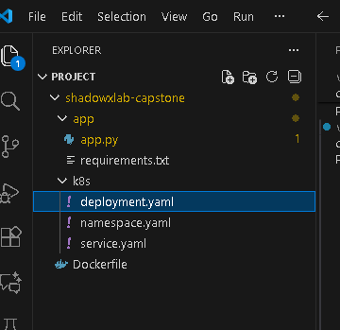
shadowxlab-capstone/
├── app/
│ ├── app.py
│ └── requirements.txt
├── Dockerfile
└── k8s/
├── namespace.yaml
├── deployment.yaml
└── service.yaml

6. Phase 1: Application Development
The application is developed using Python Flask. It displays the application name, version, hostname, date/time, and environment details.

app/app.py
from flask import Flask
import socket
import datetime
import os
app = Flask(__name__)
APP_NAME = "ShadowXLab Cyber Learning Portal"
APP_VERSION = os.getenv("APP_VERSION", "v1.0")
APP_ENV = os.getenv("APP_ENV", "production")
@app.route("/")
def home():
hostname = socket.gethostname()
current_time = datetime.datetime.now().strftime("%Y-%m-%d %H:%M:%S")
return f"""
<html>
<head>
<title>{APP_NAME}</title>
<style>
body {{
font-family: Arial;
background-color: #0f172a;
color: white;
text-align: center;
padding-top: 80px;
}}
.box {{
background-color: #1e293b;
padding: 30px;
border-radius: 12px;
width: 60%;
margin: auto;
}}
</style>
</head>
<body>
<div class="box">
<h1>{APP_NAME}</h1>
<h2>Version: {APP_VERSION}</h2>
<p><b>Hostname:</b> {hostname}</p>
<p><b>Date/Time:</b> {current_time}</p>
<p><b>Environment:</b> {APP_ENV}</p>
</div>
</body>
</html>
"""
@app.route("/health")
def health():
return "Application is healthy", 200
if __name__ == "__main__":
app.run(host="0.0.0.0", port=5000)

app/requirements.txt
flask

7. Phase 2: Docker Containerization
A Dockerfile is used to create a container image for the Flask application.

Dockerfile
FROM python:3.11-slim
WORKDIR /app
COPY app/requirements.txt .
RUN pip install --no-cache-dir -r requirements.txt
COPY app/ .
EXPOSE 5000
CMD ["python", "app.py"]

Docker Build and Local Test Commands
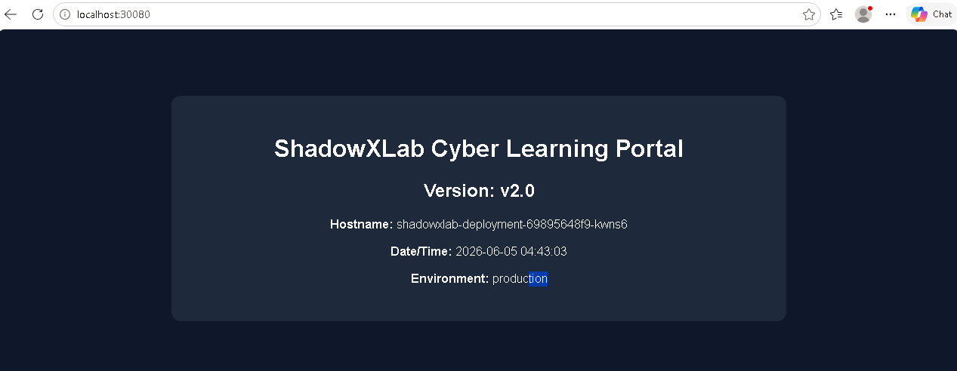
docker build -t shadowxlab-portal:v1 .
docker images
docker run -d -p 5000:5000 --name shadowxlab shadowxlab-portal:v1
curl http://localhost:5000
curl http://localhost:5000/health
docker stop shadowxlab
docker rm shadowxlab

8. Phase 3: Registry Operations
The Docker image is tagged and pushed to Docker Hub. Replace <dockerhub-username> with the actual Docker Hub username before running the commands.
docker login
docker tag shadowxlab-portal:v1 amitesh7668/shadowxlab-portal:v1
docker push amitesh7668/shadowxlab-portal:v1

9. Phase 4: Kubernetes Deployment
The application is deployed on Kubernetes using namespace and deployment YAML files.

k8s/namespace.yaml
apiVersion: v1
kind: Namespace
metadata:
name: shadowxlab

k8s/deployment.yaml
apiVersion: apps/v1
kind: Deployment
metadata:
name: shadowxlab-deployment
namespace: shadowxlab
labels:
app: shadowxlab
spec:
replicas: 2
selector:
matchLabels:
app: shadowxlab
template:
metadata:
labels:
app: shadowxlab
spec:
containers:
- name: shadowxlab-container
image: <dockerhub-username>/shadowxlab-portal:v1
ports:
- containerPort: 5000
env:
- name: APP_VERSION
value: "v1.0"
- name: APP_ENV
value: "production"

Deployment Commands
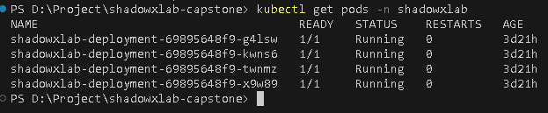
kubectl apply -f k8s/namespace.yaml
kubectl apply -f k8s/deployment.yaml
kubectl get pods -n shadowxlab
kubectl get deployment -n shadowxlab

10. Phase 5: Service Exposure
The application is exposed using a Kubernetes NodePort service.

k8s/service.yaml
apiVersion: v1
kind: Service
metadata:
name: shadowxlab-service
namespace: shadowxlab
spec:
type: NodePort
selector:
app: shadowxlab
ports:
- port: 80
targetPort: 5000
nodePort: 30080

Service Commands
kubectl apply -f k8s/service.yaml
kubectl get svc -n shadowxlab
kubectl get all -n shadowxlab
Access URL format: http://ShadowXLab Cyber Learning Portal

11. Phase 6: Scaling
The deployment is scaled from 2 replicas to 4 replicas to demonstrate application scalability.
kubectl scale deployment shadowxlab-deployment --replicas=4 -n shadowxlab
kubectl get pods -n shadowxlab
kubectl get deployment -n shadowxlab
Evidence to capture: screenshot of kubectl get pods -n shadowxlab showing 4 running pods

12. Phase 7: Rolling Update
The application is updated from version v1.0 to v2.0. Update app.py or environment value, build a new Docker image, push it, and update the Kubernetes deployment image.
# Change APP_VERSION default or deployment env value from v1.0 to v2.0
docker build -t shadowxlab-portal:v2 .
docker tag shadowxlab-portal:v2 <dockerhub-username>/shadowxlab-portal:v2
docker push <dockerhub-username>/shadowxlab-portal:v2
kubectl set image deployment/shadowxlab-deployment shadowxlab-container=<dockerhub-username>/shadowxlab-portal:v2 -n shadowxlab
kubectl rollout status deployment/shadowxlab-deployment -n shadowxlab
kubectl rollout history deployment/shadowxlab-deployment -n shadowxlab
kubectl get pods -n shadowxlab
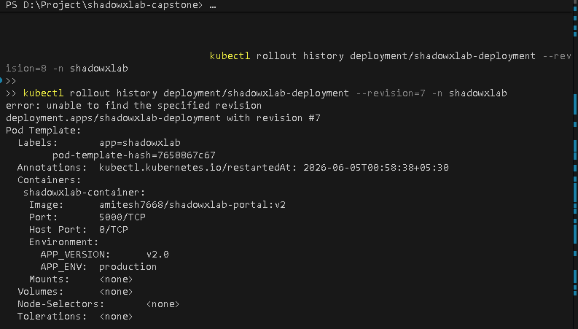
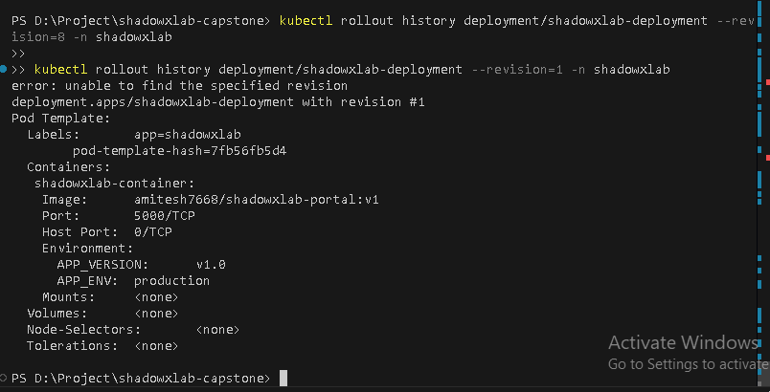
Evidence to capture: screenshot of rollout status and rollout history.
Version : V2.0
Version : V2.0

13. Phase 8: Rollback
Rollback is performed to restore the previous working version of the application.
kubectl rollout undo deployment/shadowxlab-deployment -n shadowxlab
kubectl rollout status deployment/shadowxlab-deployment -n shadowxlab
kubectl rollout history deployment/shadowxlab-deployment -n shadowxlab
kubectl get pods -n shadowxlab
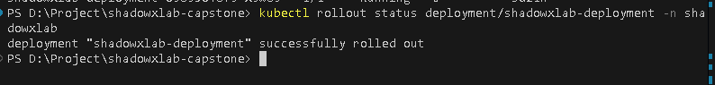
Evidence to capture: screenshot showing successful rollback status.

14. Phase 9: Failure Recovery
Kubernetes automatically recreates pods when one pod is deleted. This proves self-healing and recovery.
kubectl get pods -n shadowxlab
kubectl delete pod <pod-name> -n shadowxlab
kubectl get pods -n shadowxlab
kubectl describe deployment shadowxlab-deployment -n shadowxlab

15. Phase 10: Monitoring
Basic monitoring is performed using kubectl commands to check resources, pod details, and application logs.
kubectl get all -n shadowxlab
kubectl describe pods -n shadowxlab
kubectl logs <pod-name> -n shadowxlab
kubectl get events -n shadowxlab

16. Evidence Checklist
docker images
docker run / docker ps output
docker push output
kubectl get pods -n shadowxlab
kubectl get svc -n shadowxlab
kubectl get deployment -n shadowxlab
kubectl get all -n shadowxlab
kubectl rollout status deployment/shadowxlab-deployment -n shadowxlab
kubectl rollout history deployment/shadowxlab-deployment -n shadowxlab
kubectl rollout undo deployment/shadowxlab-deployment -n shadowxlab
kubectl logs <pod-name> -n shadowxlab

17. Final Project Summary
The ShadowXLab Cyber Learning Portal was successfully developed, containerized, pushed to Docker Hub, deployed on Kubernetes, exposed using a NodePort service, scaled to multiple replicas, updated using rolling update, rolled back to a previous version, recovered after pod failure, and monitored using kubectl commands.

18. Conclusion
This project satisfies the mandatory capstone requirements for Docker and Kubernetes. It demonstrates practical knowledge of building Docker images, running containers, publishing images to a registry, deploying applications on Kubernetes, exposing services, scaling workloads, performing rolling updates, executing rollbacks, validating recovery, and monitoring Kubernetes resources.

19. Final Execution Order
mkdir shadowxlab-capstone
cd shadowxlab-capstone
mkdir app k8s
# Create app/app.py, app/requirements.txt, Dockerfile, and k8s YAML files
docker build -t shadowxlab-portal:v1 .
docker run -d -p 5000:5000 --name shadowxlab shadowxlab-portal:v1
curl http://localhost:5000
docker login
docker tag shadowxlab-portal:v1 <dockerhub-username>/shadowxlab-portal:v1
docker push <dockerhub-username>/shadowxlab-portal:v1
kubectl apply -f k8s/namespace.yaml
kubectl apply -f k8s/deployment.yaml
kubectl apply -f k8s/service.yaml
kubectl get all -n shadowxlab
kubectl scale deployment shadowxlab-deployment --replicas=4 -n shadowxlab
kubectl get pods -n shadowxlab
# Build and push v2 image, then update deployment
docker build -t shadowxlab-portal:v2 .
docker tag shadowxlab-portal:v2 <dockerhub-username>/shadowxlab-portal:v2
docker push <dockerhub-username>/shadowxlab-portal:v2
kubectl set image deployment/shadowxlab-deployment shadowxlab-container=<dockerhub-username>/shadowxlab-portal:v2 -n shadowxlab
kubectl rollout status deployment/shadowxlab-deployment -n shadowxlab
kubectl rollout undo deployment/shadowxlab-deployment -n shadowxlab
kubectl rollout status deployment/shadowxlab-deployment -n shadowxlab

