**Power Electronics Lab**

**Experiment 1 (Part B)**

**EEE & INST F342**

**Names and IDs of Group No. 1 Students :**

| **S. No.** | **ID No.** | **Name** |
| --- | --- | --- |
| **1** | **2018B2A30728H** | **Muskan Khanna** |
| **2** | **2018B2A30764H** | **Amitesh Badkul** |
| **3** | **2018B5A30801H** | **Manish Patil** |
|  |  |  |

**BATCH & TIME : P1 (11:00 - 1:00)**

**File Name: P1_G1_Exp1**

**Prepared by**

**Department of EEE**



**BITS Pilani, Hyderabad Campus**

**Date: January 2021**

**RESULTS**

**I) R-Load**

1. Attach the waveforms of a) Input voltage b) Output Voltage c) Output Current d) Diode Voltage

e) Diode current in Simulink

Answer :

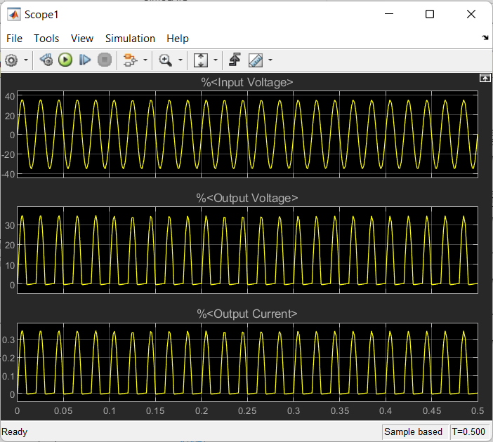

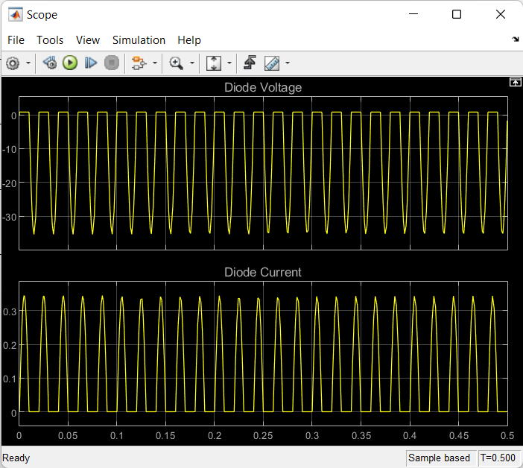

2.Attach the waveforms of a) FFT plot of output voltage b) FFT plot of output current in Simulink

a)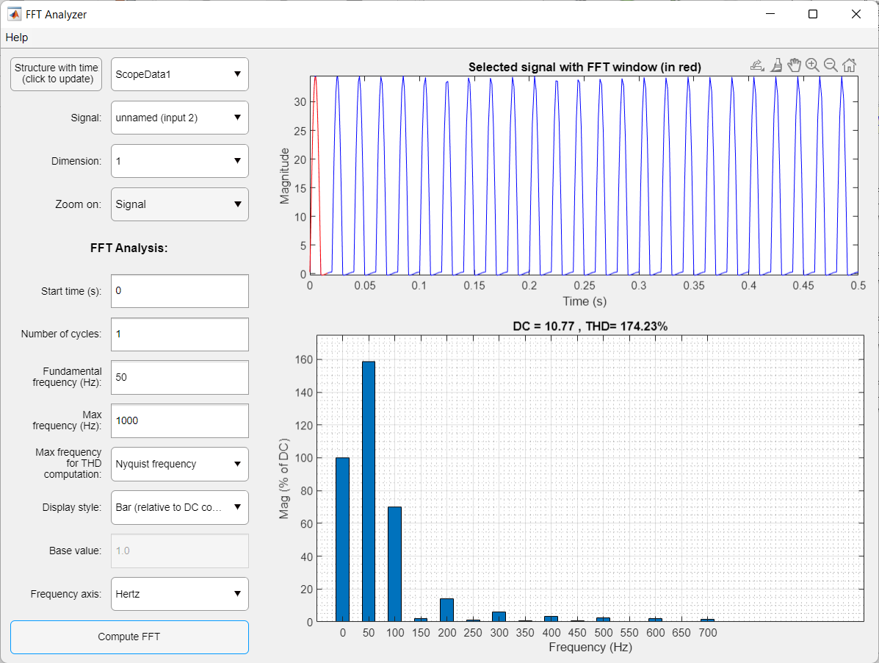

b)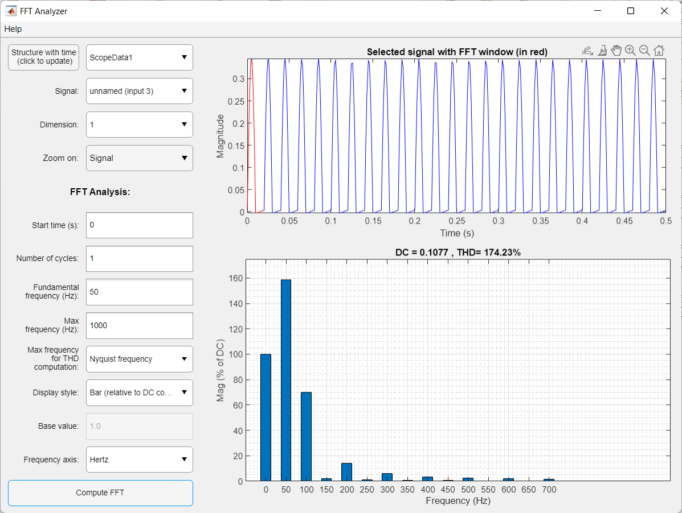

1. Calculate Performance parameters for R-Load

|  | **Theory** | **Simulation** |
| --- | --- | --- |
| VRMS | 17 | 17.11 |
| IRMS | 0.17 | 0.1711 |
| VAVG | 15.315 | 10.72 |
| IAVG | 0.15321 | 0.1072 |
| Form factor | 1.1102 | 1.5961 |
| Ripple Factor | 1.21 | 1.2439 |
| PIV | -50 | -50 |

1. FFT Calculation for R-Load

|  | **Simulation** |
| --- | --- |
| Vfnd (rms) | 12.09 |
| VTHD (rms) | 5.4768 |
| V 2ND HAR  (rms) | 5.3365 |
| V 3RD HAR  (rms) | 0.1620 |

20 log (VFundamental (RMS)) = 21.648dB

**II) RL-Load**

**(L= 20mH)**

1. Attach the waveforms of a) Input voltage b) Output Voltage c) Output Current d) Diode Voltage

e) Diode current in Simulink

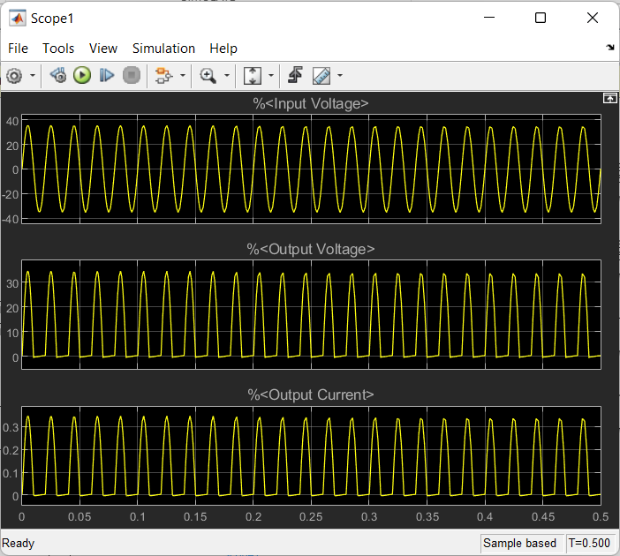

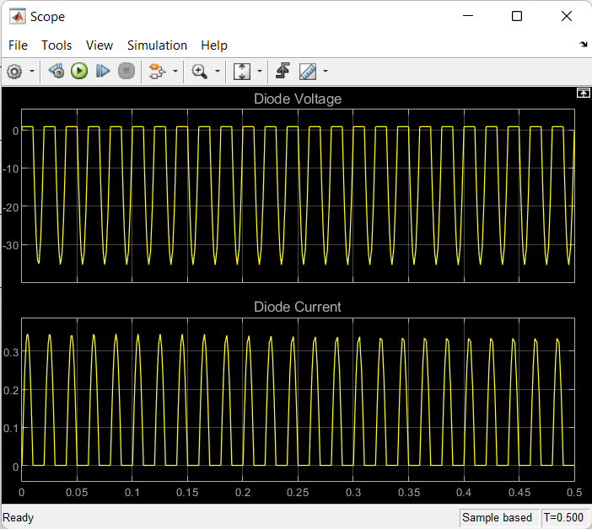

1. Attach the waveforms of a) FFT plot of output voltage b) FFT plot of output current in Simulink

a)

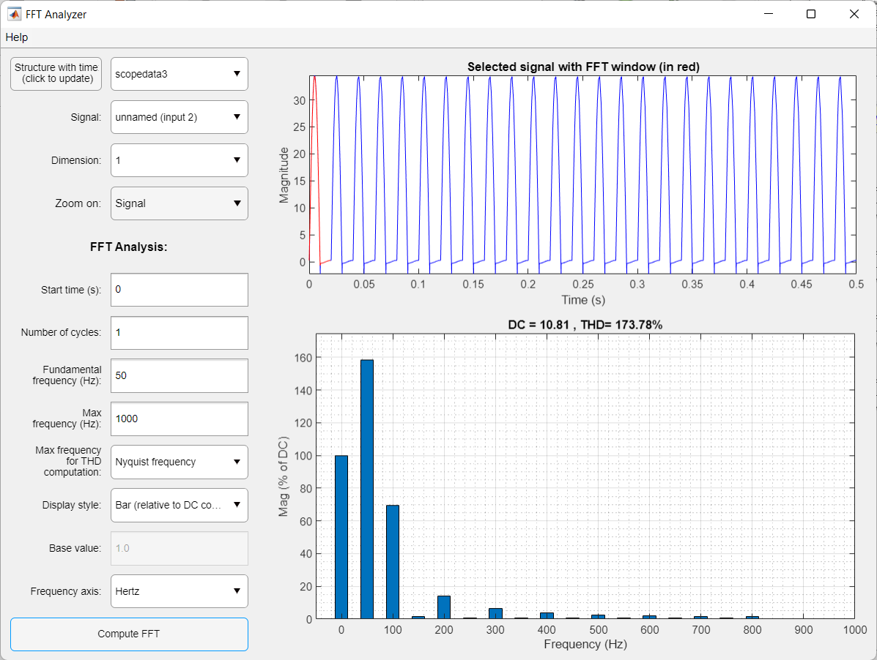

b)

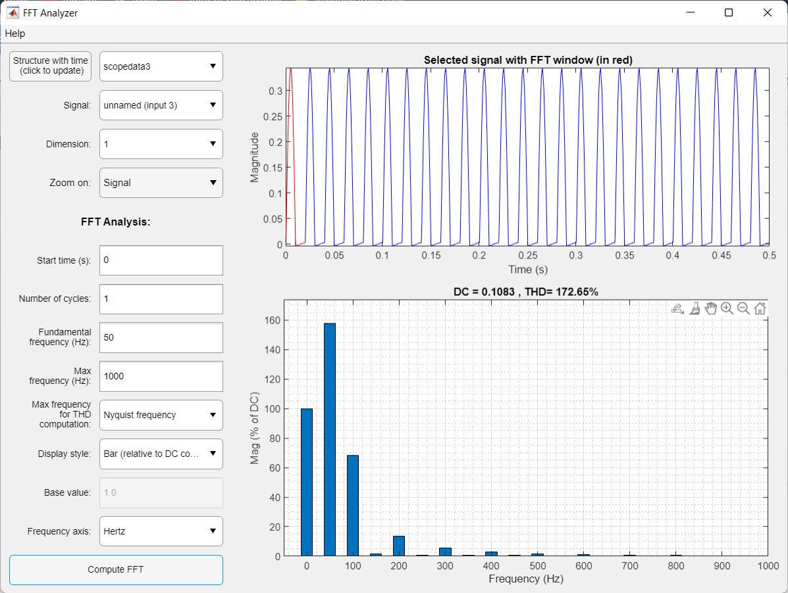

1. Calculate Performance parameters for RL-Load

|  | **Theory** | **Simulation** |
| --- | --- | --- |
| VRMS | 17 | 17.12 |
| IRMS | 0.17 | 0.1708 |
| VAVG | 15.312 | 10.78 |
| IAVG | 0.15312 | 0.1078 |
| Form factor | 1.1102 | 1.5881 |
| Ripple Factor | 1.21 | 1.2338 |
| PIV | -50 | -50 |

1. FFT Calculation for RL-Load

|  | **Simulation** |
| --- | --- |
| Vfnd (rms) | 12.11 |
| VTHD | 5.4628 |
| V 2ND HAR | 5.3139 |
| V 3RD HAR | 0.1150 |

THD = x 100 %

20 log (VFundamental (RMS)) = 21.662 dB

**CONCLUSION:**