**Power Electronics Lab**

**Experiment 2 (Part B)**

**EEE & INST F342**

**Names and IDs of Group No. 1 Students :**

| **S. No.** | **ID No.** | **Name** |
| --- | --- | --- |
| **1** | **2018B2A30728H** | **Muskan Khanna** |
| **2** | **2018B2A30764H** | **Amitesh Badkul** |
| **3** | **2018B5A30801H** | **Manish Patil** |
|  |  |  |

**BATCH & TIME : P1 (11:00 - 1:00)**

**File Name: 1_P1_Exp_2**

**Prepared by**

**Department of EEE**



**BITS Pilani, Hyderabad Campus**

**Date: January 2021**

**RESULTS**

**I) R-Load**

1. Attach the waveforms of a) Input Voltage b) Output Voltage c) Input current and d) Output Current in Simulink

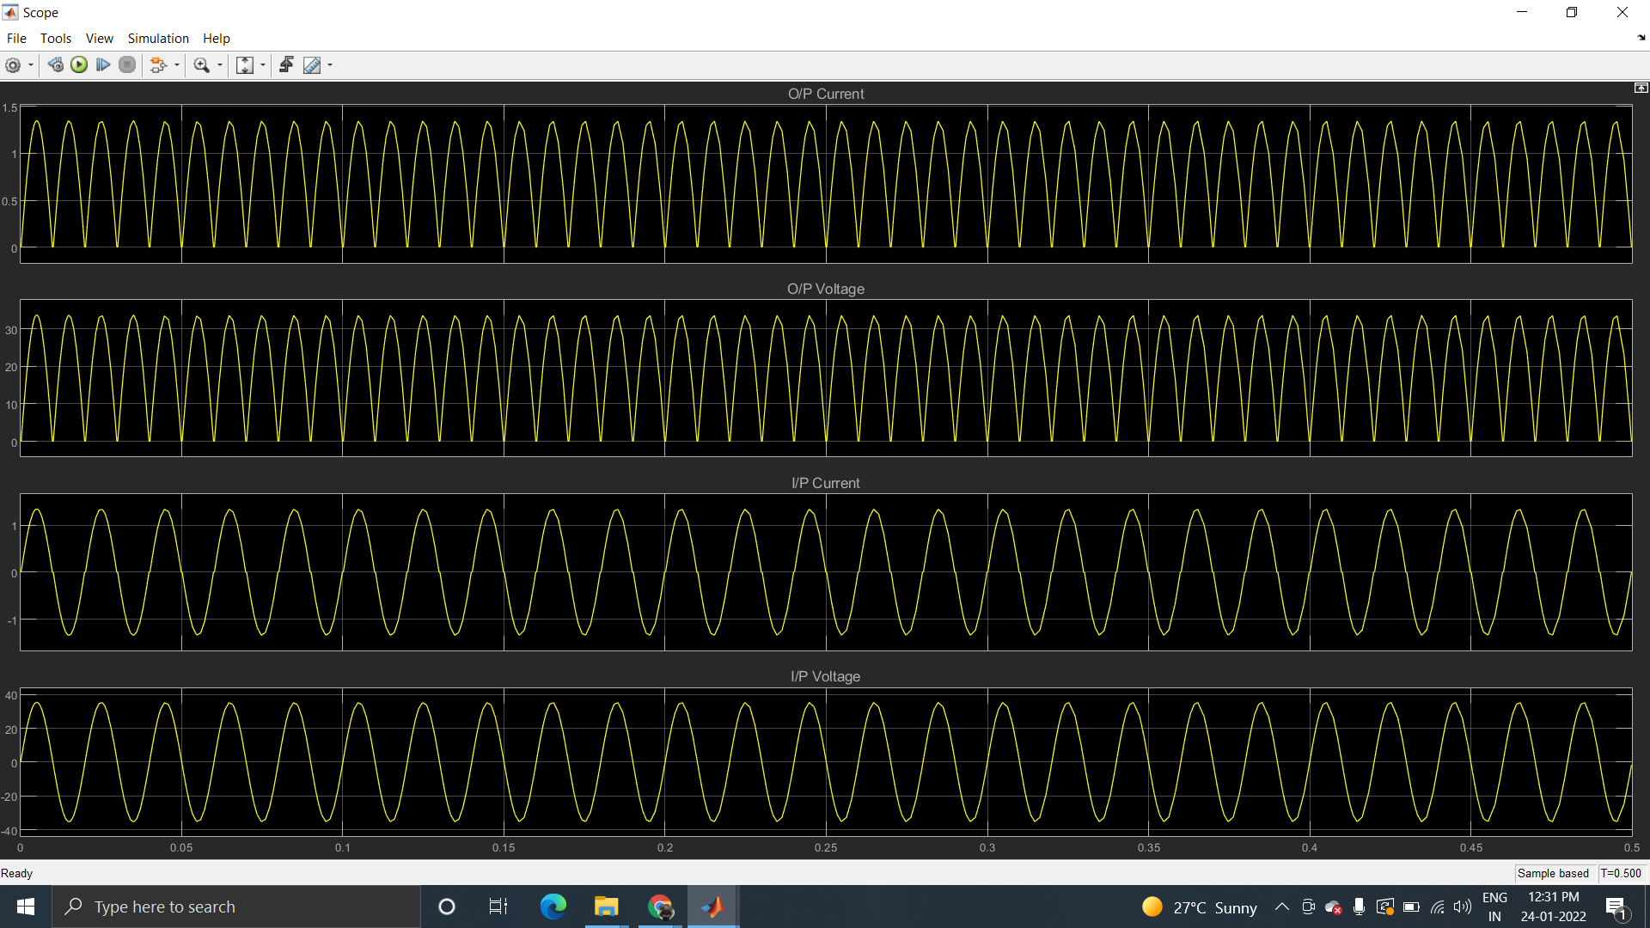

1. Attach the waveforms of a) Diode Voltage b) Diode current for both positive half cycle (Diode D1) and negative half cycle (Diode D3) in Simulink

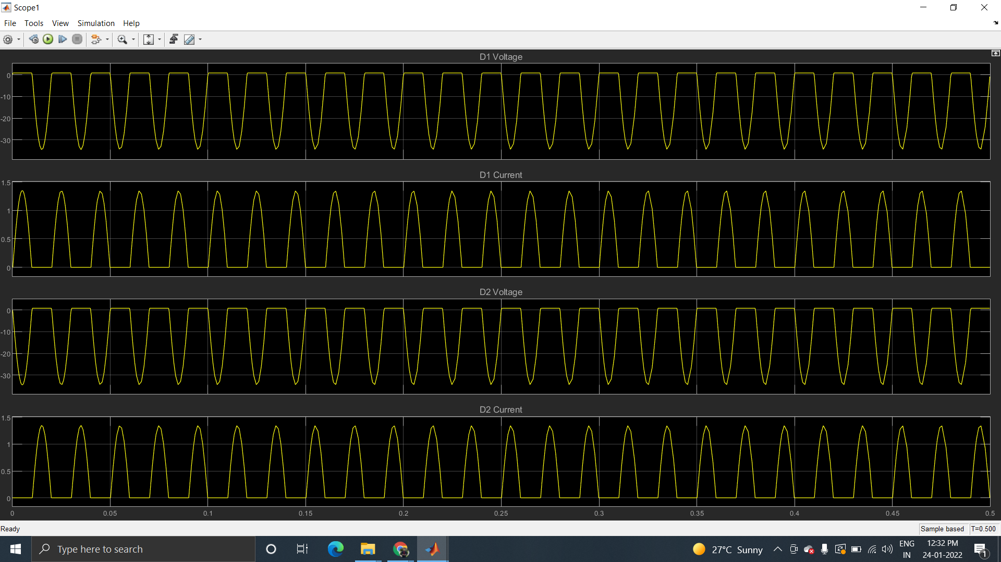

1. Attach the FFT bar chart along with the corresponding waveforms for Input current in Simulink

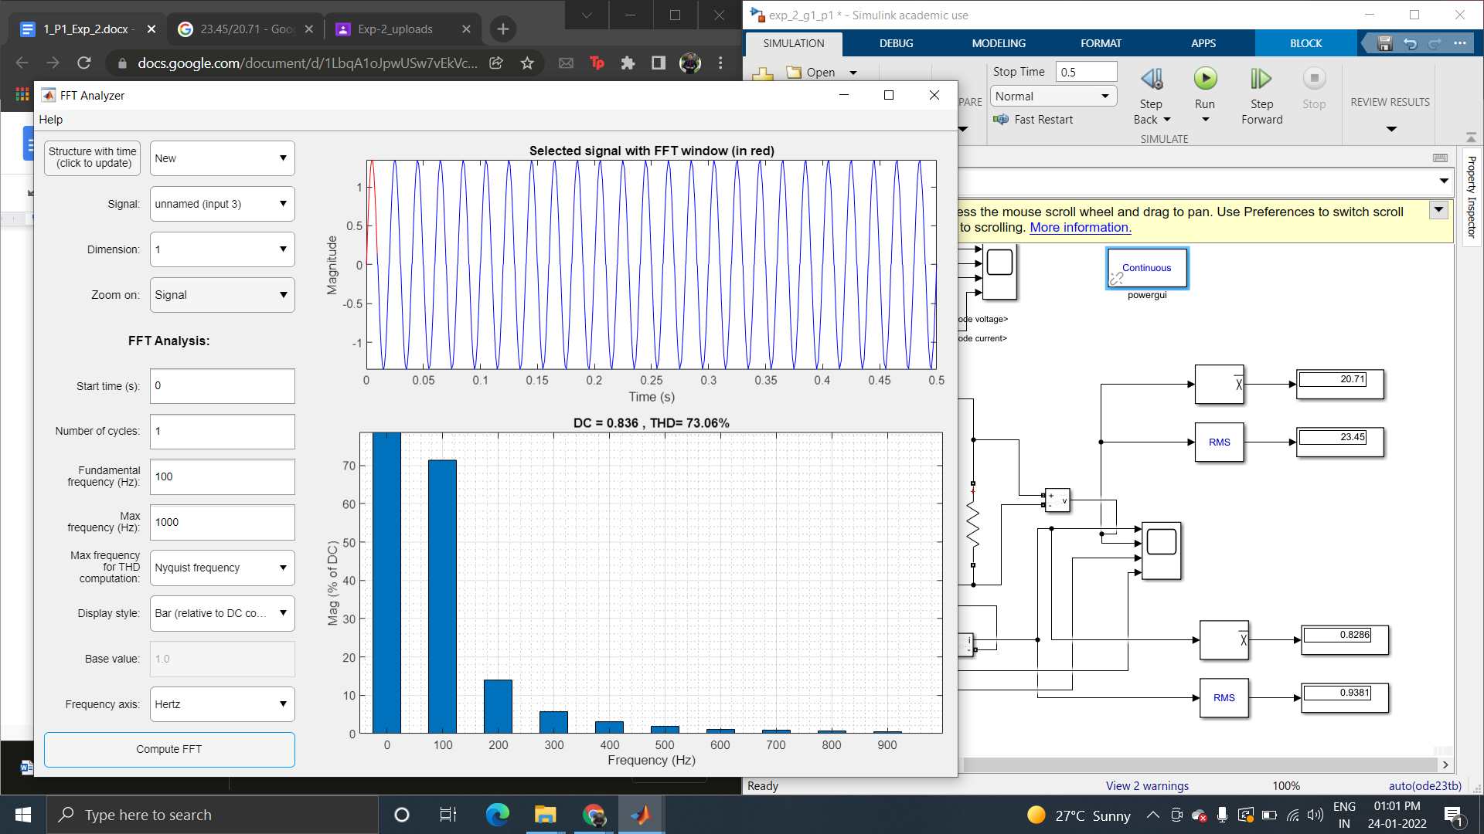

**II) RL-Load**

1. Attach the waveforms of a) ) Input Voltage b) Output Voltage c) Input current and d) Output Current in Simulink

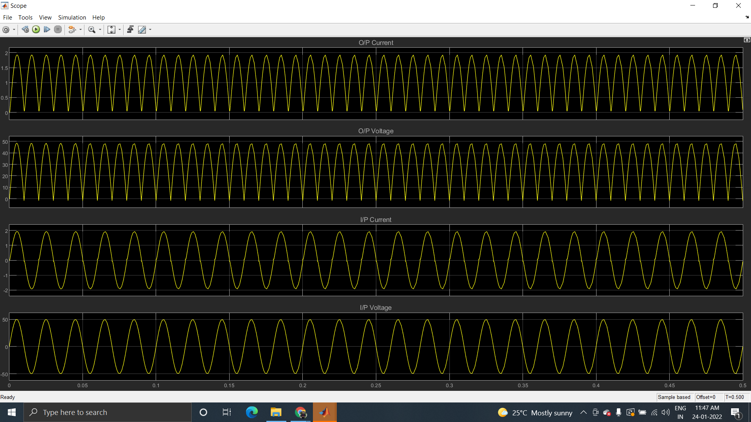

1. Attach the waveforms of a) Diode Voltage b) Diode current for both positive half cycle (Diode D1) and negative half cycle (Diode D3) in Simulink

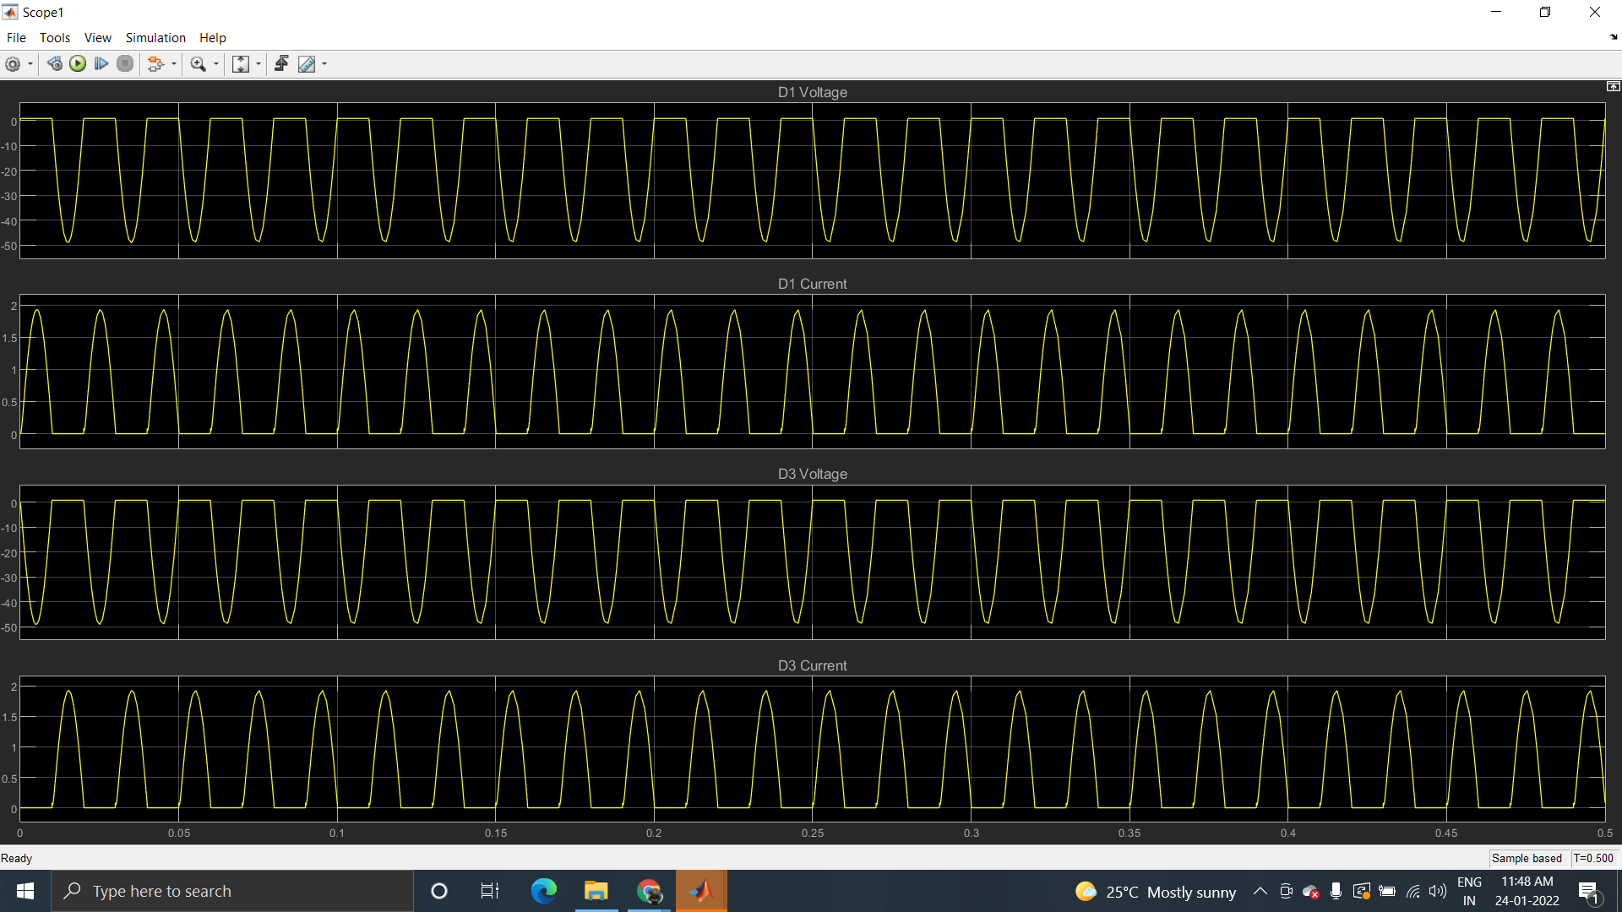

1. Attach the FFT bar chart along with the corresponding waveforms for Input current in Simulink

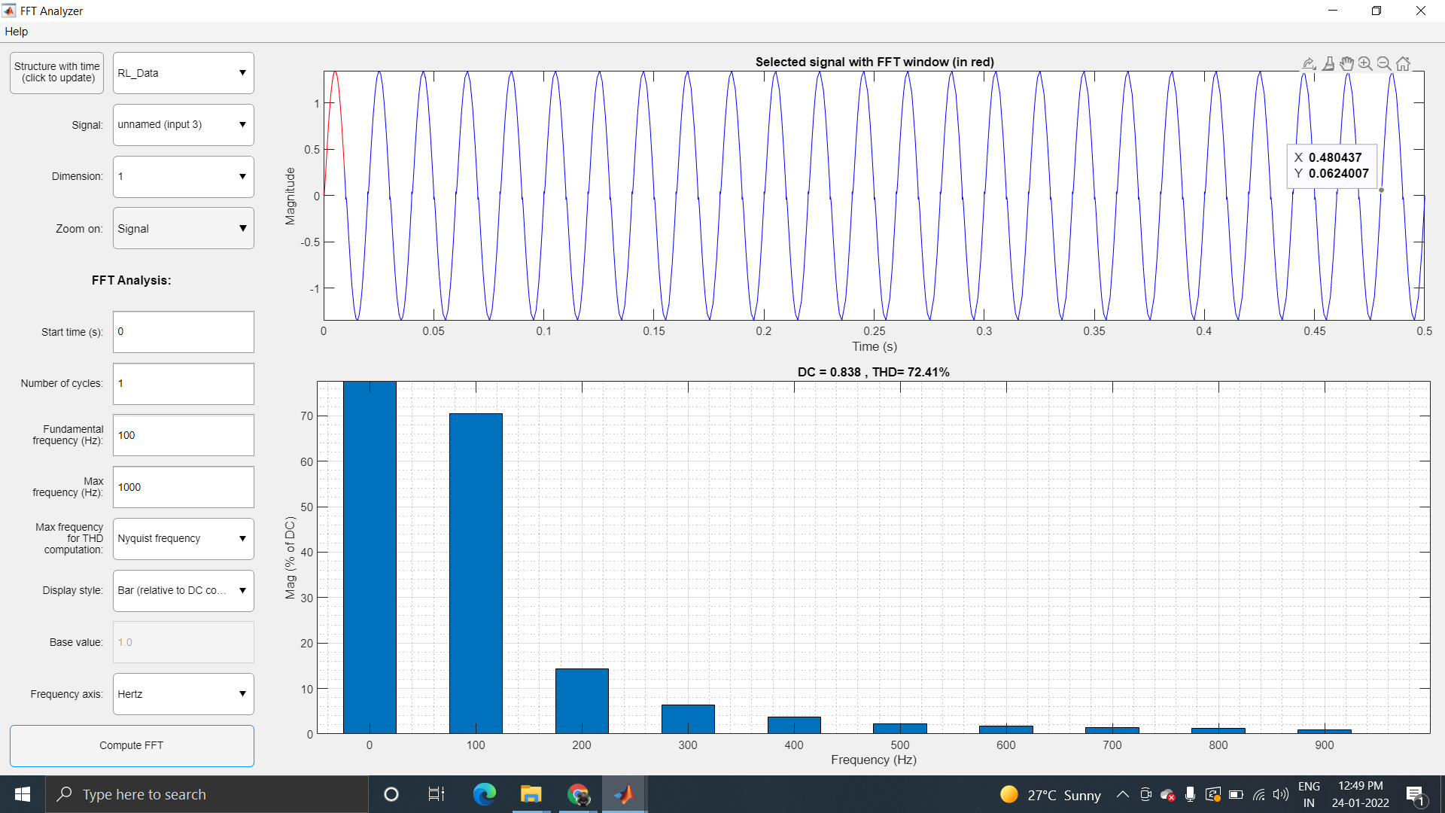

1. Calculate Performance parameters (Simulink)

|  | **R Load** | **RL load** |
| --- | --- | --- |
| VRMS | 23.45 V | 23.48 V |
| IRMS | 0.9381 A | 0.9362 A |
| VAVG | 20.71 V | 20.76 V |
| IAVG | 0.8286 A | 0.8304 A |
| Form factor | 1.13 | 1.131 |
| Ripple Factor | 0.5262 | 0.5283 |
| FFT Analysis | | |
| Output Voltage | | |
| THD in % | 21.91% | 23.44% |
| VFundamental (RMS) | 0.4221 | 0.4186 |
| 2nd Harmonics (V) (RMS) | 0.0823 | 0.0850 |
| 3rd Harmonics (V) (RMS) | 0.0344 | 0.0377 |
| Input Current | | |
| THD in % | 21.85% | 23.26% |
| IFundamental (RMS) | 0.422 | 0.4179 |
| 2nd Harmonics (I) (RMS) | 0.0822 | 0.0844 |
| 3rd Harmonics (I) (RMS) | 0.0343 | 0.0372 |

THD = x 100 %

-20 log (VFundamental (RMS)) = 7.49 dB

**DISCUSSIONS:**

**There is a little distortion in the input voltage signal . This is due to the fact that we are sending the distorted current into the voltage source . injecting impurities into the source will result in distortion. Hence , the power factor will be low for small devices due to the distorted current. This makes fft analysis crucial and we need it to design filters for our rectifier.**

**Inductor acts like a current source and as soon as it gets some current then it will start discharging. If values are large enough then the value of current wont come back to zero. In R-L load, the inductor will sustain the value of current leading to continuous current. When this current goes to the source cycle, the source current changes its shape. The advantage of simulation is we can try different values in simulation to gain different form-factor and ripple-factor.**