**ASSIGNMENT 1**

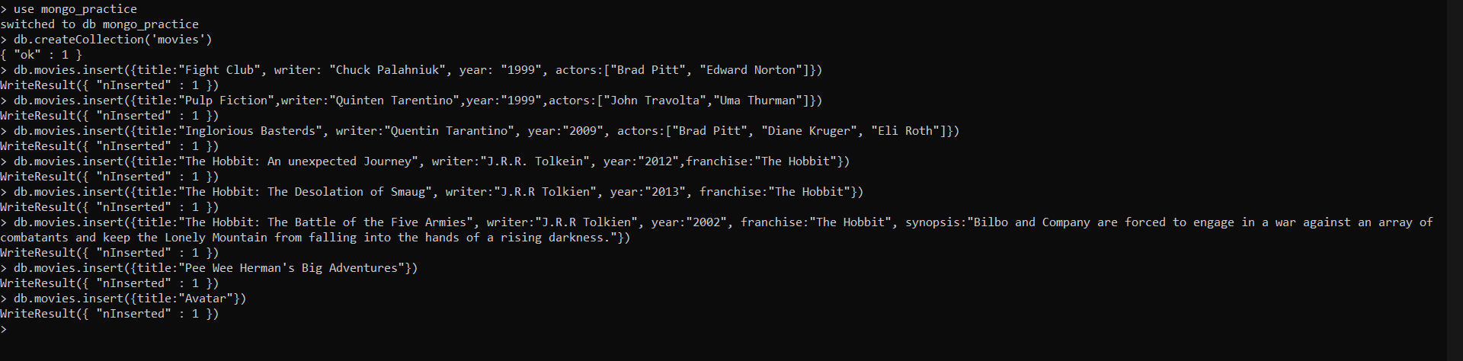

Query/Find Commands

Q.1,2,3,4,5,6

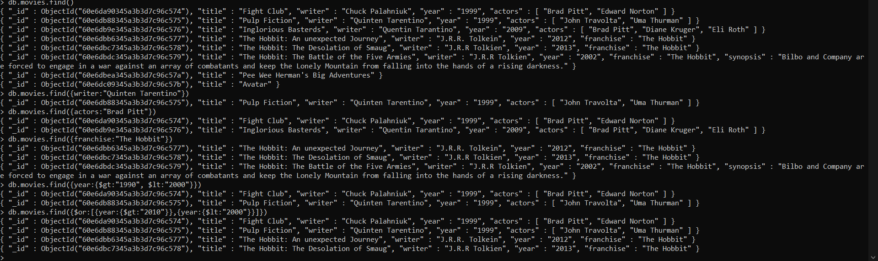

Update Documents

Q.1,2,3



Text Search

Q.1,2,3,4,5

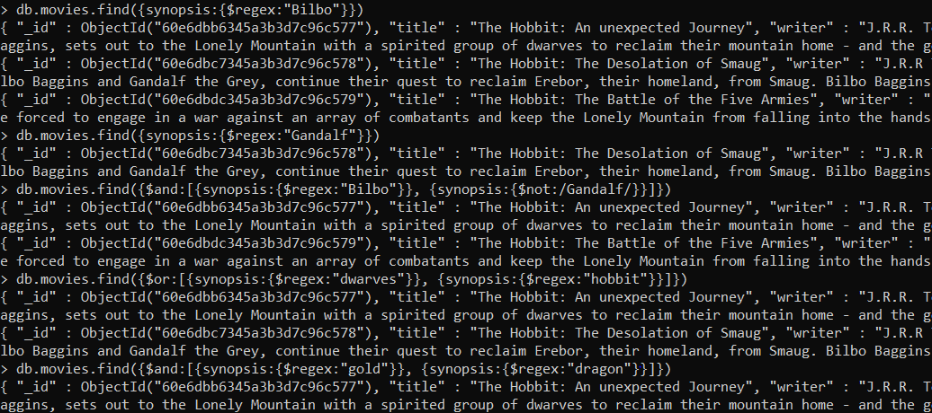

Delete Documents

Q.1,2

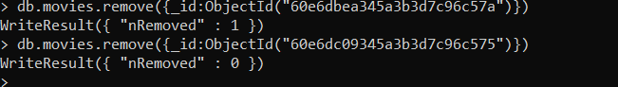

Relationships

Inserted all the documents

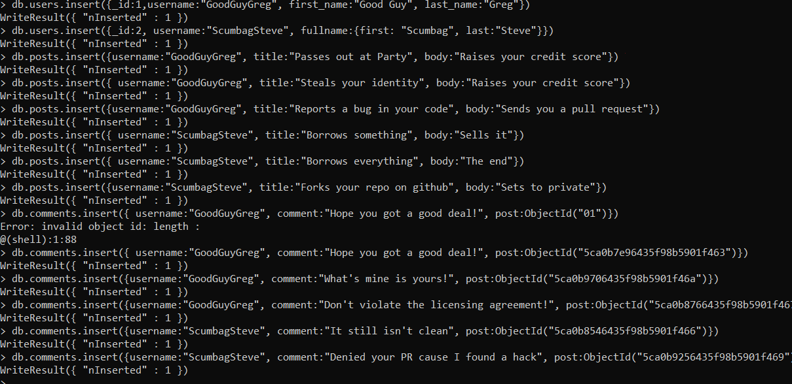

Q.1

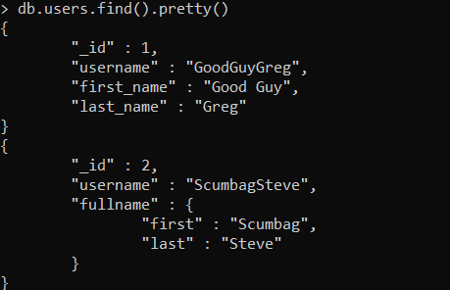

Q.2

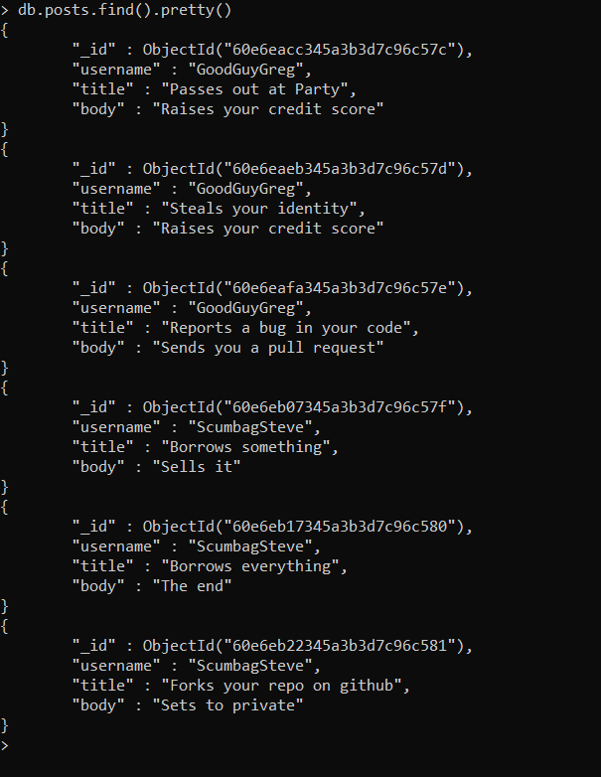

Q.3,4

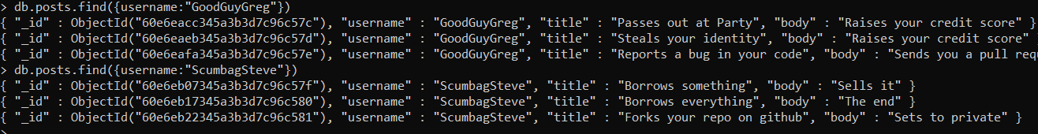

Q.5

