**PRACTICAL-13**

AIM: **Create Web Application having different Modules: Admin and User**

**Home page.aspx:**

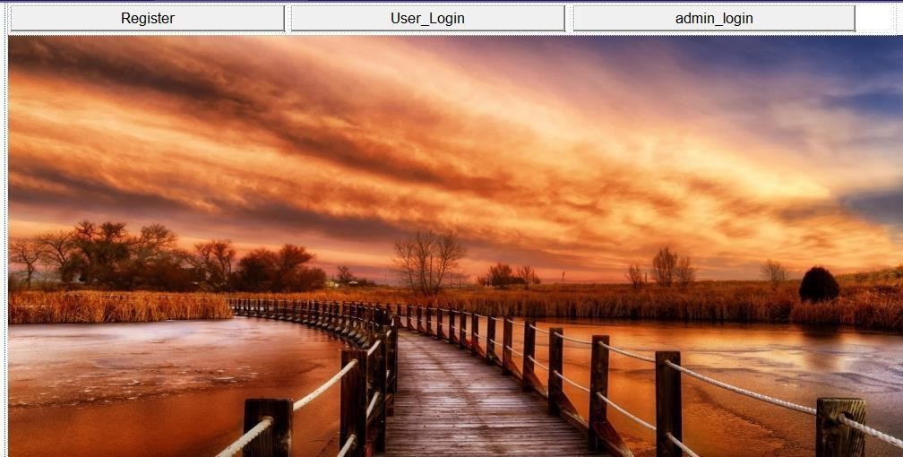

**Home page.aspx.cs:**

using System; using System.Collections.Generic; using System.Linq; using

System.Web; using System.Web.UI; using System.Web.UI.WebControls;

namespace Practical_13_1

{

public partial class homepage : System.Web.UI.Page

{

protected void Page_Load(object sender, EventArgs e) {

} protected void Button1_Click(object sender, EventArgs e) {

Response.Redirect("registration.aspx");

} protected void Button2_Click(object sender, EventArgs e) {

Response.Redirect("user_login.aspx");

} protected void Button3_Click1(object sender, EventArgs e) {

Response.Redirect("admin_login.aspx");

}

}

**}**

**Output:**

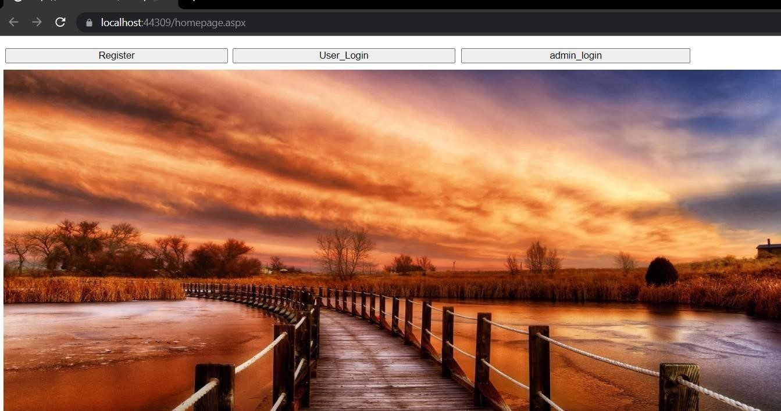

**1). Design ASP.net web forms to create User module for registration using various server controls, ajax and validation controls. Registration form accepts first name, last name, username, password, date of birth, contact no, email, country, state, city and address All the information entry is compulsory. Password should be reconfirmed. Email id should be valid. Username should have at least a capital letter and digit as well as length should be between 7 and 20 characters. Write ADO .Net code to insert record of user registration into user table.**

**Registration.aspx**

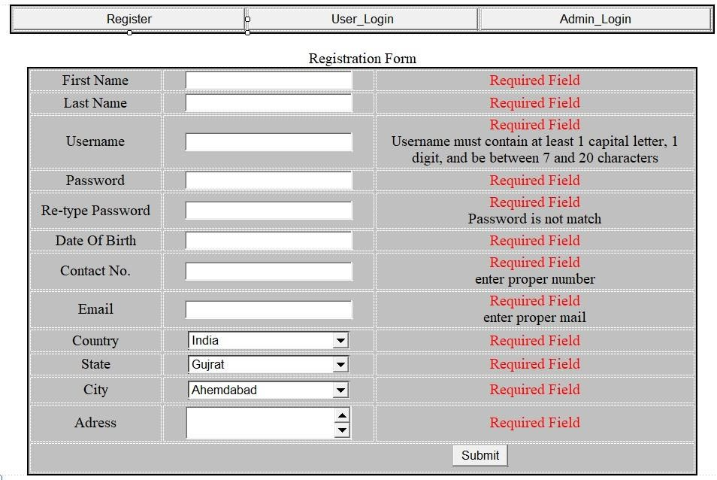

**Registration.aspx.cs**

using System;

using System.Collections.Generic; using System.Linq; using System.Web; using System.Web.UI; using System.Web.UI.WebControls; using System.Data.SqlClient; using System.Data;

namespace Practical_13_1

{

public partial class WebForm1 : System.Web.UI.Page

{

SqlConnection con = new SqlConnection("Data

Source=(LocalDB)\\MSSQLLocalDB;AttachDbFilename=C:\\Users\\Dell\\Documents\\Practice

.mdf;Integrated Security=True;Connect Timeout=30"); protected void Page_Load(object sender, EventArgs e)

{

ValidationSettings.UnobtrusiveValidationMode =

UnobtrusiveValidationMode.None;

} protected void fn_TextChanged(object sender, EventArgs e) {

}

protected void Button1_Click(object sender, EventArgs e)

{ con.Open();

SqlCommand cmd = con.CreateCommand(); cmd.CommandType = CommandType.Text;

cmd.CommandText = ("insert into Practical_13 values('" + fn.Text + "','" +

ln.Text + "','" + un.Text + "','" + pd.Text + "','" + dob.Text + "','" + cn.Text + "','" + email.Text + "','" + dropdown_country.Text + "','" + dropdown_state.Text +

"','" + dropdown_city.Text + "','" + adress.Text + "')"); int result = cmd.ExecuteNonQuery();

con.Close();

if (result > 0)

{

ClientScript.RegisterStartupScript(Page.GetType(), "validation",

"<script language='javascript'>alert('Registration sucessfuly')</script>");

} else

{

ClientScript.RegisterStartupScript(Page.GetType(), "validation",

"<script language='javascript'>alert('Error in registration')</script>");

}

un.Text = "";

}}}

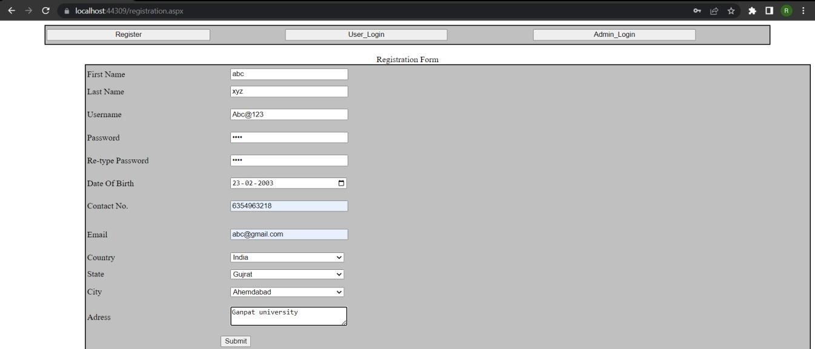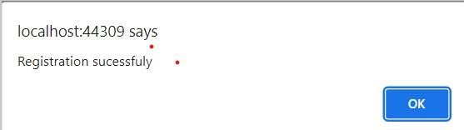

**2). Develop Login Module of user by checking username and password using database. If user has entered correct login credentials then store the information into session and redirect user to welcome page and display welcome message**

**User_login.aspx:**

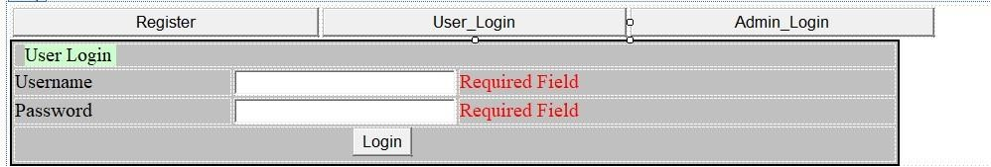

**Welcome.aspx**

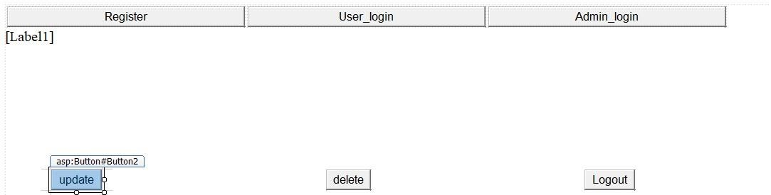

**User_login.aspx.cs:**

using System; using System.Collections.Generic;

using System.Data.SqlClient; using System.Data; using

System.Drawing; using

System.Linq; using System.Web; using System.Web.UI;

using System.Web.UI.WebControls;

namespace Practical_13_1

{

public partial class update_user : System.Web.UI.Page

{

SqlConnection con = new SqlConnection("Data

Source=(LocalDB)\\MSSQLLocalDB;AttachDbFilename=C:\\Users\\Dell\\Documents\\Practice

.mdf;Integrated Security=True;Connect Timeout=30"); protected void Page_Load(object sender, EventArgs e)

{

}

protected void Button1_Click(object sender, EventArgs e)

{

con.Open();

SqlCommand cmd = con.CreateCommand(); cmd.CommandType = CommandType.Text;

cmd.CommandText = ("update Practical_13 set Firstname='" + fn.Text + "',Lastname='" + ln.Text + "',Username='" + un.Text + "',Password='" + pd.Text +

"',DateOfBirth='" + dob.Text + "',ContactNo='" + cn.Text + "',Email='" + email.Text + "',Country='" + dropdown_country.Text + "',State='" + dropdown_state.Text +

"',City='" + dropdown_city.Text + "',Address='" + adress.Text + "'where Username='"

+ un.Text + "' ");

int result = cmd.ExecuteNonQuery();

con.Close();

if (result > 0)

{

ClientScript.RegisterStartupScript(Page.GetType(), "validation",

"<script language='javascript'>alert('Update sucessfuly')</script>");

} else

{

ClientScript.RegisterStartupScript(Page.GetType(), "validation",

"<script language='javascript'>alert('Error in Update')</script>");

}

}

protected void Button2_Click(object sender, EventArgs e)

{

Response.Redirect("user_login.aspx");

}

protected void Button3_Click(object sender, EventArgs e) {

Response.Redirect("admin_login.aspx");

}

protected void Button4_Click(object sender, EventArgs e)

{

Response.Redirect("registration.aspx");

}

}

**}**

**Welcome.aspx.cs:**

using System; using System.Collections.Generic;

using System.Data; using System.Data.SqlClient; using System.Linq; using System.Web; using System.Web.UI;

using System.Web.UI.WebControls;

namespace Practical_13_1

{

public partial class welcome : System.Web.UI.Page

{ protected void Page_Load(object sender, EventArgs e)

{

Label1.Text = "Welcome " + Session["username"];

} protected void Button1_Click(object sender, EventArgs e) {

Session.Remove("username");

Response.Redirect("user_login.aspx");

}

protected void Button2_Click(object sender, EventArgs e) {

Response.Redirect("update_user.aspx");

}

protected void Button3_Click(object sender, EventArgs e) {

SqlConnection con = new SqlConnection("Data

Source=(LocalDB)\\MSSQLLocalDB;AttachDbFilename=C:\\Users\\Dell\\Documents\\Practice

.mdf;Integrated Security=True;Connect Timeout=30"); con.Open();

ClientScript.RegisterStartupScript(Page.GetType(), "validation",

"<script language='javascript'>alert(' suceuser deleted ssfuly')</script>"); SqlCommand cmd = con.CreateCommand(); cmd.CommandType = CommandType.Text;

cmd.CommandText = ("delete Practical_13 where username='" + Session["username"] + "' "); int result = cmd.ExecuteNonQuery();

con.Close();

if (result > 0)

{

Response.Redirect("homepage.aspx");

} else

{

ClientScript.RegisterStartupScript(Page.GetType(), "validation",

"<script language='javascript'>alert('Error in delete')</script>");

} }

protected void Button9_Click(object sender, EventArgs e)

{

Response.Redirect("registration.aspx");

} protected void Button7_Click(object sender, EventArgs e)

{

Response.Redirect("user_login.aspx");

}

protected void Button8_Click(object sender, EventArgs e)

{

Response.Redirect("admin_login.aspx");

}

}

**}**

**Output:**

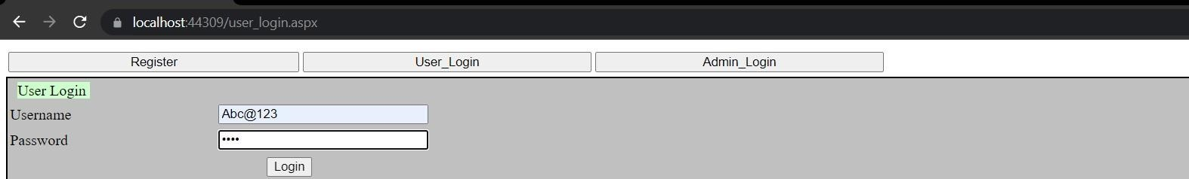

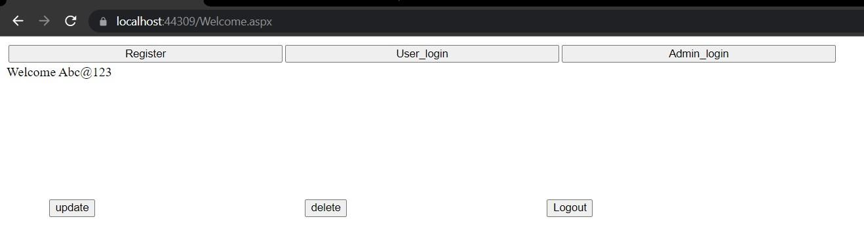

**3). Create a Admin Module to display list of user to admin using grid view and ajax controls using database.**

**4). Develop Login Module of admin by checking username and password using database. If admin has entered correct login credentials then store the information into session and redirect user to welcome page and display welcome message**

**Admin_login.aspx:**

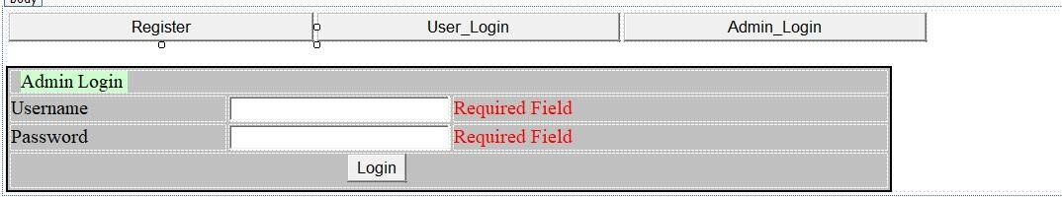

**Admin_panel.aspx:**

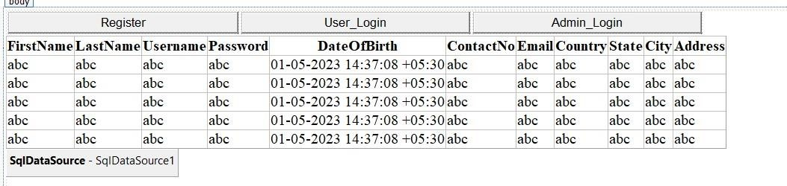

**Admin_login.aspx.cs:**

using System; using System.Collections.Generic;

using System.Data; using System.Data.SqlClient; using System.Linq; using System.Web; using System.Web.UI;

using System.Web.UI.WebControls;

namespace Practical_13_1

{

public partial class admin_login : System.Web.UI.Page

{

SqlConnection con = new SqlConnection("Data

Source=(LocalDB)\\MSSQLLocalDB;AttachDbFilename=C:\\Users\\Dell\\Documents\\Practice

.mdf;Integrated Security=True;Connect Timeout=30"); protected void Page_Load(object sender, EventArgs e) {

ValidationSettings.UnobtrusiveValidationMode =

UnobtrusiveValidationMode.None;

}

protected void Button1_Click(object sender, EventArgs e)

{

con.Open();

SqlCommand cmd = con.CreateCommand(); cmd.CommandType = CommandType.Text;

cmd.CommandText = ("select * from Practical_13 where Username='" +

un.Text + "' and Password ='" + pd.Text + "'"); int result =

(int)cmd.ExecuteScalar();

con.Close();

if (result > 0) {

Session["username"] = un.Text;

Response.Redirect("admin_panel.aspx");

} else

{

ClientScript.RegisterStartupScript(Page.GetType(), "validation", "<script language='javascript'>alert('Error in login (username and password are not mathch)')</script>");

} un.Text = ""; pd.Text = "";

}

}

}

**Admin_panel.aspx:**

using System; using System.Collections.Generic;

using System.Data; using System.Data.SqlClient; using System.Linq; using System.Web; using System.Web.UI;

using System.Web.UI.WebControls;

namespace Practical_13_1

{ public partial class admin_panel :

System.Web.UI.Page {

SqlConnection con = new SqlConnection("Data

Source=(LocalDB)\\MSSQLLocalDB;AttachDbFilename=C:\\Users\\Dell\\Documents\\Practice

.mdf;Integrated Security=True;Connect Timeout=30"); protected void Page_Load(object sender, EventArgs e)

{

}

protected void GridView1_SelectedIndexChanged(object sender, EventArgs e)

{ con.Open();

SqlCommand cmd = con.CreateCommand(); cmd.CommandType = CommandType.Text;

SqlDataAdapter dataAdapter= new SqlDataAdapter("SELECT * FROM

Practical_13",con);

DataTable dt = new DataTable(); dataAdapter.Fill(dt);

GridView1.DataSource = dt;

GridView1.DataBind();

}

} }

Output

:

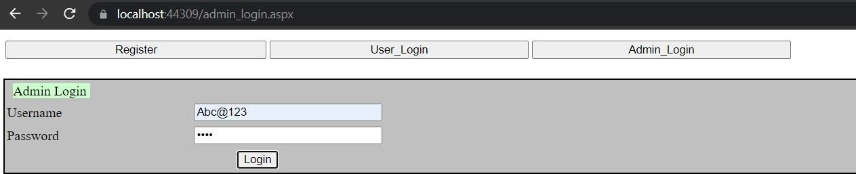

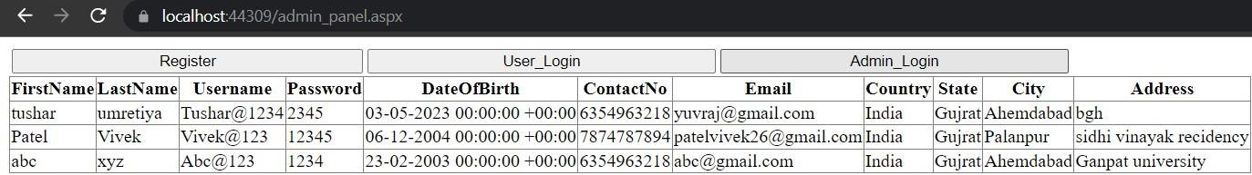

**5).Write ADO .Net code in User Module to update and delete profile of user from database.**

**Update_user.aspx:**

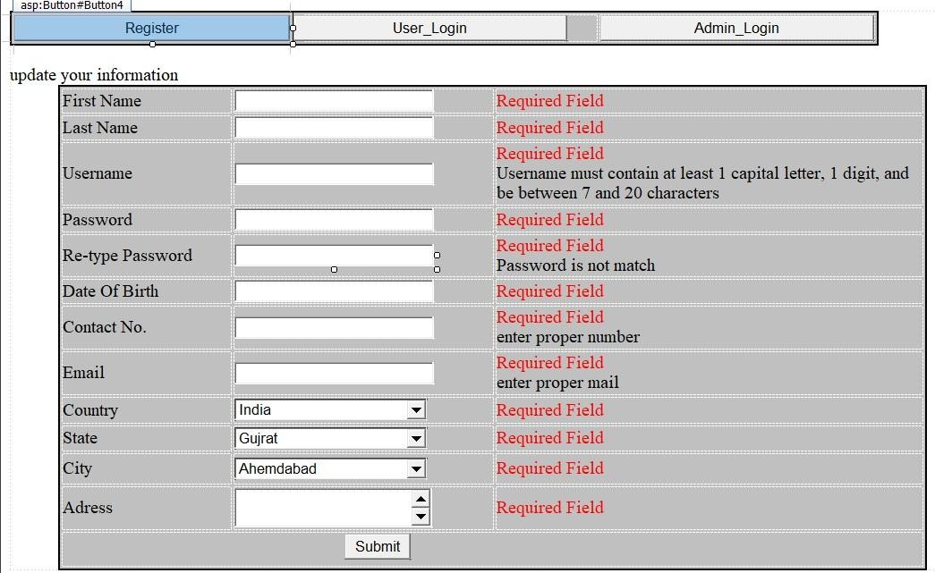

**Update_user.aspx.cs:**

using System; using System.Collections.Generic;

using System.Data.SqlClient; using System.Data; using

System.Drawing; using

System.Linq; using System.Web; using System.Web.UI;

using System.Web.UI.WebControls;

namespace Practical_13_1

{ public partial class update_user : System.Web.UI.Page {

SqlConnection con = new SqlConnection("Data

Source=(LocalDB)\\MSSQLLocalDB;AttachDbFilename=C:\\Users\\Dell\\Documents\\Practice

.mdf;Integrated Security=True;Connect Timeout=30"); protected void Page_Load(object sender, EventArgs e) {

ValidationSettings.UnobtrusiveValidationMode =

UnobtrusiveValidationMode.None;

}

protected void Button1_Click(object sender, EventArgs e)

{

con.Open();

SqlCommand cmd = con.CreateCommand(); cmd.CommandType = CommandType.Text;

cmd.CommandText = ("update Practical_13 set Firstname='" + fn.Text + "',Lastname='" + ln.Text + "',Username='" + un.Text + "',Password='" + pd.Text +

"',DateOfBirth='" + dob.Text + "',ContactNo='" + cn.Text + "',Email='" + email.Text + "',Country='" + dropdown_country.Text + "',State='" + dropdown_state.Text +

"',City='" + dropdown_city.Text + "',Address='" + adress.Text + "'where Username='"

+ un.Text + "' "); int result = cmd.ExecuteNonQuery();

con.Close();

if (result > 0)

{

ClientScript.RegisterStartupScript(Page.GetType(), "validation",

"<script language='javascript'>alert('Update sucessfuly')</script>");

} else

{

ClientScript.RegisterStartupScript(Page.GetType(), "validation", "<script language='javascript'>alert('Error in Update')</script>");

}

}

protected void Button2_Click(object sender, EventArgs e)

{

Response.Redirect("user_login.aspx");

} protected void Button3_Click(object sender, EventArgs e)

{

Response.Redirect("admin_login.aspx");

} protected void Button4_Click(object sender, EventArgs e)

{

Response.Redirect("registration.aspx"); }

}

}

**Output:**

